


United Nations Development Programme
Project Document template for projects
financed by the various GEF Trust Funds

Project title: Sustainable Management and Resilient Thinking for our Energy Revolution (SMARTER)
Country: Barbados | Implementing Partner (GEF Executing Entity): Ministry of Energy and Business (MEB) |  |  |  | Execution Modality: National Implementation Modality (full NIM)
UNMSDCF 6 Caribbean countries manage natural resources and ecosystems strengthening their resilience and enhancing the resilience and prosperity of the people and communities that depend on them. UNMSSDCF Indicator 13.2.1Number of countries that have communicated the establishment or operationalization of an integrated policy, strategy or plan that increases their ability to adapt to the adverse impacts of climate change and foster climate resilience and low greenhouse gas emissions development in a manner that does not threaten food production (including a national adaptation plan, nationally determined contribution, national communication, biennial update report or other)
Output 3.1: Populations, including the most vulnerable, have enhanced access to affordable, reliable and sustainable energy. Relevant Indicators 3.1.1: Number of megawatts generated from new solar photovoltaic, bioenergy or other renewable energy system installations. 3.1.2: Number of new financing mechanisms in place to support the implementation of efficient energy and renewable energy transitions.
UNDP Social and Environmental Screening Category: Moderate risk |  |  | UNDP Gender Marker: GEN2.
Quantum Award ID: |  |  | Quantum Project ID:
UNDP-GEF PIMS ID number: 6451 |  |  | GEF Project ID number: 10849
LPAC meeting date:
Last possible date to submit to GEF: 11 November 2023
Latest possible CEO endorsement date: 11 November 2023
Project duration in months: 48 months
Planned start date: 01-Oct-2023 |  |  | Planned end date: 30 Sept 2027
Expected date of Mid-Term Review: 1 Oct 2025 |  |  | Expected date of Terminal evaluation: 30 Jun 2027
Brief project description:
The Government of Barbados seeks to achieve the goal of 100% renewable energy by 2030 as set by the Barbados National Energy Policy (BNEP) 2019-2030 through the installation of solar photovoltaic plants and distributed systems, on- and off-shore wind energy, battery storage and bioenergy systems. The SMARTER project will support the government in achieving this goal by supporting the government in achieving renewable energy with a focus on the development of biomass and organic waste resource for energy.
The project design proposal has five components:
- The first component focuses on strengthening the Government's capacity to lead Barbados’ transition towards a low-emission, resilient, and affordable energy sector
- The second project component aims to enable Barbados to successfully exploit sustainable biomass resources for energy generation and promote the circularity of agricultural and other organic waste streams.
- The third component aims to assist the Government to accelerate renewable energy pipeline development by supporting licensing and feasibility studies for investment in bioenergy pilot/demonstration activities (for biofuels and electricity).
- A fourth component in the project consists of increased knowledge, awareness and network opportunities in the minigrid market, and assisting the Government in establishing project oversight and monitoring systems.
- The fifth component covers monitoring and evaluation activities.
The project will result in a direct lifetime emission reduction of 215.5 ktCO₂ and indirect emission reduction of 329.3 ktCO₂, increased installed RE capacity of 1.61 MW and energy generation of 209 GWh (electricity) and 3,367 TJ (fuels) over the lifetime of 20 years of the investments. The number of expected direct beneficiaries is at least 766 (direct employment and training)
Financing Plan
GEF Trust Fund grant |  |  | USD 1,593,836
- Total Budget administered by UNDP |  |  | USD 1,593,836
- Total confirmed co-financing to this project not administered by UNDP |  |  | USD 11,400,000
- Grand-Total Project Financing (1)+(2) |  |  | USD 12,993,836
Signatures:
Signature: |  | Agreed by Ministry of Energy and Business (MEB) |  | Date/Month/Year: within 6 months of GEF CEO endorsement
Signature: |  | Agreed by UNDP |  | Date/Month/Year: within 6 months of GEF CEO endorsement

Table of Contents

1. Table of Contents 3
List of boxes 5
List of acronyms and abbreviations 6
2. Development Challenge 8
2.1 Context and global significance 8
2.2 Baseline situation 10
2.3 Relevance to national priorities 20
3. Strategy 23
3.1 Barriers to bioenergy development and use in Barbados 23
3.2 SMARTER’s approach to lowering barriers to bioenergy development 26
3.3 Linkages with SDGs 28
4. Results and Partnerships 30
4.1 Components and outputs 30
4.2 Expected results 42
4.3 Stakeholders, partnerships and co-financing 43
4.4 Risk and assumptions 50
4.5 Mainstreaming gender 54
4.6 Sustainability, innovativeness and potential for scaling up 56
5. Project Results Framework 59
6. Monitoring and Evaluation (M&E) Plan 63
7. Governance and management arrangements 66
8. Financial Planning and Management 71
9. Total UNDP Budget and Work Plan 73
10. Legal context 78
11. Risk management 78
Annexes
Annex A. Gef budget template 82
Annex B. Additional budget information 83
Annex C. Project map 86
Annex D. Multi-Year Work Plan 87
Annex E. Monitoring Plan 89
Annex F. RISK REGISTER 92
Annex G. Bioenergy potential in Barbdos energy transition 97
G.1 Feedstock availability 97
G.2 Business case 1: biogas from swine manure 100
G.3 Business case 2: biogas for power production from various feedstock 101
G.4 Business case 3: biogas production to feed into the natural gas network 102
G.5 Business case 4: biodiesel production 104
G.6 Business case 5: ethanol production and bagasse power generation 106
G.7 Business case 6: vehicles running on bio-CNG 109
G.8 Environmental aspects of anaerobic digestion 110
G.9 Potential of bioenergy production in Barbados’ energy transition 111
Annex H. GEF core indicators and GHG emission reduction 114
H.1 Introduction; applicable GEF core indicators 114
H.2 Project’s target contributions to GEF-7 Core Indicators 115
Annex I. Project staff, consultancies and subcontracts 119
Annex J. Gender analysis and action plan 125
J.1 Gender assessment 125
J.2 Gender action plan (GAP) 130
Annex K. Stakeholder engagement plan 136
K.1 Stakeholder engagement plan 136
K.2 Grievance mechanism 141
K.3 Communication and knowledge management plan 143
Annex L. Social and environmental Screening template (SESP) and SES Risk Management 145
L.1 Social and environmental Screening carried out in PPG phase 145
L.2 SMARTER’s ocial and environmental safeguards risk mitigation approach 161
Annex M. GEF Taxonomy 171
Annex N. Procurement plan 173
Annex O. Project capacity and HACT assessment 174
Annex P. UNDP quality assurance report 174
Annex Q. Agreements (co-financing letters) 174

List of boxes

Box 1 Energy balance, Barbados (2020) and annual electricity generation 9
Box 2 Feed-in tariffs, Barbados 10
Box 3 Energy pathway towards the 100% renewable energy target, Barbados 12
Box 4 Overview of bioenergy resources – conversion -applications 16
Box 5 Policy and plans related to energy and electricity 20
Box 6 Barriers and challenges that SMARTER seeks to address 23
Box 7 Impacts of bioenergy development and utilization 26
Box 8 Linkages of rural and renewable electricity with SDGs 28
Box 9 Theory of change: how SMARTER’s interventions address identified barriers and challenges 29
Box 10 Pilots and demos and expected GHG emission reduction 39
Box 11 GEF 7 core indicators 42
Box 12 Renewable energy stakeholders and their role in the SMARTER project 43
Box 14 Co-financing and sources 47
Box 13 Overview of SMARTER-relevant baseline projects (recently closed, current or under development) 48
Box 15 Project risks, including impact and probability, and mitigation measures (as per the ERM and risk log) 51
Box 16 Monitoring and evaluation plan and budget 64
Box 17 Project governance arrangements: Full NIM with Government as Implementing Partner 67
Box 18 Biomass feedstock and methane production 96
Box 19 Methane production potential, Barbados 96
Box 20 Base data used in business case calculations 97
Box 21 Analysis biogas plant for pig farm 98
Box 22 Analysis biogas plant with various feedstock for power generation 99
Box 23 Analysis of a biogas plant with various feedstock for bio-methane production 101
Box 24 Bio-methane (renewable natural gas) needs and feedstock potential 101
Box 25 Biodiesel production process 102
Box 26 Analysis biodiesel production from used cooking oil 103
Box 27 Sugarcane processing into ethanol and sugar 105
Box 28 Production of ethanol in Barbados for energy and non-energy purposes and use of bagasse 105
Box 29 Production costs and benefits of using E10 and bagasse power generation 106
Box 30 Annual cost and benefits of substation of gasoline and diesel by ethanol E10 and biodiesel B20 107
Box 31 Analysis of bio-CNG production for fueling 3,000 vehicles 108
Box 32 Feedstock availability and potential to generate the bioenergy requirements of the business cases 109
Box 33 Potential bioenergy production for electricity or fuel needs 110
Box 34 Contribution of bioenergy to energy supply and demand in 2020 and 2040 111
Box 35 Assumed grid emission factor evolution 114
Box 36 Project results – expected at PIF and at CEO endorsement 114
Box 37 Indirect GHG emission reduction 115
Box 38 Female representation across public and private companies in Barbados 124
Box 39 Ownership and land acreage of farms by sex 125
Box 40 Gender and access challenges 125
Box 41 Role of stakeholders in mainstreaming approach 127
Box 42 UNDP gender marker and checklist 128
Box 43 Indicative timeline for GAP activities 129

List of acronyms and abbreviations

BAMC Barbados Agricultural Management Corporation
BAU Business as usual
BESS Battery energy storage system
BIDC Barbados Investment Development (Export Barbados)
BLPC Barbados Light and Power Company Ltd.
BNEP Barbados National Energy Plan
BNSI Barbados National Standards Institute
BNTC Barbados National Terminal Company Ltd.
BSIL Barbados Sugar Industry Limited
BREA Barbados Renewable Energy Association
BWA Barbados Water Authority
CAPEX Capital expenditure
CCCC Caribbean Community Climate Change Cente
CCREEE Caribbean Centre for Renewable Energy and Energy Efficiency
CO₂-eq Carbon dioxide (equivalent)
CDR Combined Delivery Report
CEO Chief Executive Officer
CNG Compressed natural gas
CO Country Office
CPD Country Programme Document (UNDP)
CSO Civil Society Organization
DREAM Disaster Risk & Energy Access Management
EEq Energy efficiency
EoP End of Project
ERC Evaluation Resource Center (of UNDP)
ESIA Environmental and social impact assessment
EU European Union
EUR Euro
FiT Feed-in tariff
GAP Gender Action Plan
GCF Green Climate Fund
GDP Gross Domestic Product
GEF Global Environment Facility
GHG Greenhouse gas
GIS Geographical information system
GIZ Deutsche Gesellschaft für Internationale Zusammenarbeit
GOB Government of Barbados
GWh Gigawatt-hour (billion watt-hours)
IDB Inter-American Development Bank
IGDS Institute for Gender and Development Studies
IPP Independent power producer
IRRP Integrated Resources and Resilience Plan
IRENA International Renewable Energy Agency
IT Information technology
km Kilometre
kW Kilowatt
kWh Kilowatt-hour
LCOE Levelized cost of energy
LEDS Low-Emissions Resilient Development Strategies
LPG Liquified petroleum gas
M&E Monitoring and evaluation
MAFS Ministry of Agriculture and Food Security
MEB Ministry of Energy and Business
MENB Ministry of Environment and National Beautification
MTWW Ministry of Transport, Works and Water Resources
NAP National Agricultural Policy
NPC National Petroleum Company Ltd
MSW Municipal solid waste
MTR Mid-Term Review
MW Megawatt (million watts)
MWh Megawatt-hour
NDC Nationally Determined Contributions
NPD National Project Director
O&M Operation and maintenance
OLADE Latin American Energy Organization
OPEX Operational expenditure
PIR Project Implementation Review
PM Project Manager
PMU Project Management Unit
PPA Power purchase agreement
PPG GEF Project Preparation Grant
PSC Project Steering Committee (Project Board)
PTA Principal Technical Advisor
PV Photovoltaics
QAMF Quality assurance and monitoring framework
R&D Research and development
RE Renewable energy
RTA Regional Technical Advisor
SAMS Barbados Sargassum Adaptive Management Strategy
SBRC Sustainable Barbados Recycling Centre
SDG Sustainable Development Goal
SESP Social and Environmental Screening Procedure
SHS Solar home system
SMARTER Sustainable Management and Resilient Thinking for our Energy Revolution
SSECC Sustainable Solutions, Energy and Climate Change
tCO₂ Metric ton of carbon dioxide
TE Terminal evaluation
TJ Terajoules (trillion joules)
ToC Theory of change
ToR Terms of Reference
UNDP United Nations Development Programme
UNIDO United Nations Industrial Development Organization
USD United States dollar
UWI University of West Indies
VAT Value added tax
W_{p} Watt-peak
WHO World Health Organization

Development Challenge

Context and global significance

Country context

Barbados has a population of about 287,708 people in 2021 on a land area of 430 km². The country had a gross domestic product (GDP) of USD 4.90 billion in 2021 (USD 3.9 billion in power purchase parity in 2020). It scores high on the Human Development Index and the gender development index but the last poverty survey still accounted for almost 20% of persons living in poverty. With a GDP per capita of USD 15,163 in 2020, it is ranked as a high-income country. On the other hand, many products and items need to be imported leading to a high import bill and a high cost of living. Given its small economy and dependency on imports (including most of its fuel needs), the country is highly susceptible to global economic shocks.

Energy and electricity

Energy policy and planning are under the responsibility of the Ministry of Energy and Business (MEB). Until 2013, the state-owned Barbados Light and Power Company Limited (BLPC) had the exclusive right to supply energy for all public and private purposes. BLPC was privatised with the Canadian-based Emera Inc. requiring a total of 79.9% of shares during 2010-11. Tariffs, quality standards and other matters concerning the relationship between BLPC and its customers, are regulated by the Fair Trading Commission (FTC) under the Utilities Regulation Act (2002; amended 2020). Barbados’ oil and gas sector is concentrated around a few key players, the state-owned National Petroleum Company (NPC) and its daughter company Barbados National Oil Company Limited (BNOC) together with the private fuel distributors Sol and Rubis. In principle, market pricing is adopted, the main exception being natural gas (which is imported/produced along with crude by BNOC and has traditionally been sold at sub-market prices, i.e., prices below competing fuels).

Barbados’ total primary energy consumption hovers around 15-17 exajoules (EJ) and this level of consumption is about the same level as in the early 1990s. Most of Barbados’ energy is imported, although the country does produce crude oil, natural gas, and biomass. The share of energy produced indigenously as a proportion of the total energy supply has fallen since 1990, from 34% to 15-17% in recent years. Over the period 1990 to 2019, oil products have been the dominant energy type in Barbados. The reduction in bio-energy use reflects the decline in the sugar industry and the use of its residues for (on-site) power and heat generation. Electricity generation accounts for almost 40% of total fossil fuel imports (diesel and heavy fuel oil), while 40% is consumed by the transport sector. Fuel imports amounted to about USD 250 million, equivalent to about 11% of GDP, in 2018. As a result, energy costs are relatively high in Barbados, as is the case in many Small Island Developing States (SIDS). The fuel bill for electricity generation alone was USD 176 million in 2017 (3.8% of GDP).

Electricity in Barbados is produced by thermal power plants, 252 megawatts (MW) in total owned by the now privatized utility Barbados Power & Light Company (BPLC) and by about 51.8 MW of solar capacity (10 MW in plants and 41.8 MW distributed). Energy production was about 983 GWh in 2020 and 985 GWh in 2021, of which 68.7 GWh was renewable energy in 2020 and 84.6 GWh in 2021.
Box 1 Energy balance, Barbados (2020) and annual electricity generation

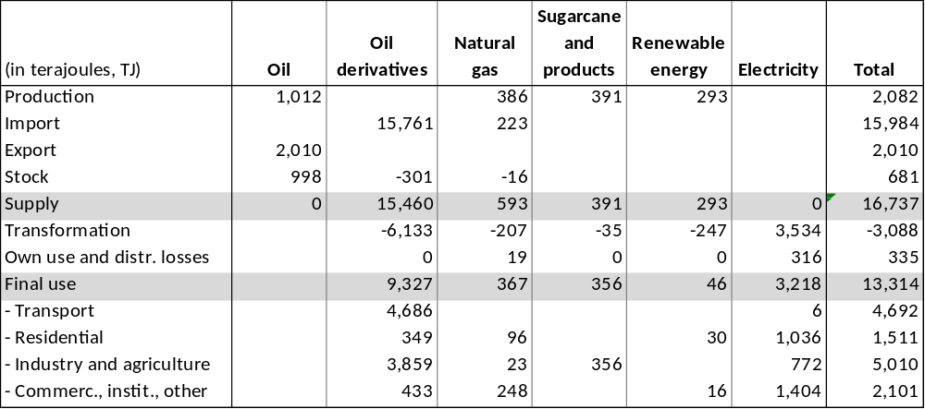
Source: compiled from UN, OLADE, BLPC and MEB Statistics

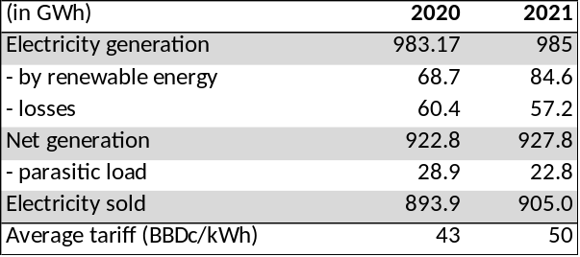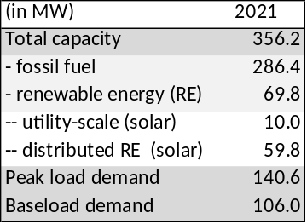
Source: Data compiled from MEB’s Energy Bulletins 2020 and 2021, BLPC website, and the IRRP (MottMcDonald, 2021)
Distributed solar power had increased to 55 kW in 2021 (provided by 2503 connections) and currently (Oct 2022) stands at 60 kW (provided by 2639 connections) and expected to increase to 100 kW by 2030. See: https://energy.gov.bb/dashboard/.
Exchange rate has been stable at USD 1 = two Barbadian dollar (BBD) during 2020-2022 (www.exchangerates.co.uk)

Greenhouse gas emissions

According to the Second National Communication (2018), Barbados’ net greenhouse gas emissions amounted to 1,930 kilotons of CO₂ equivalent (CO₂e) in 2010, which represents less than 0.01% of the global total in that year. Total emissions were 1,984.5 ktCO₂e, of which the energy sector was responsible for 74% of the emissions (1457 ktCO₂e) and the waste sector 15% (295 ktCO₂e). Total removals were 54.5 tCO₂e. Of the total emissions, 1,490 kilotons were CO₂ (and 325 ktCO₂e) of methane emissions. OLADE gives an estimate of energy-related emissions of 1737 ktCO₂e in 2010, 1575 ktCO₂ in 2015 and 1161 kilotons of CO₂e in 2020; indicating that emissions are declining over time indicating lower energy intensity of the economy and a beginning penetration of renewables (solar) in the energy supply.

The country is also vulnerable to the effects of climate change, in particular, flooding and wind damage (although less so than other Eastern Caribbean nations). Barbados ranks among the countries with the lowest available freshwater resources per capita in the world.

Baseline situation

Energy and electricity

Barbados’ energy mix is dominated by fossil fuels which are subject to the volatility of the global market price. The Government of Barbados (GoB) is well aware of the unsustainability of the country’s energy sector both from the economic viewpoint of expensive fossil fuel imports as well as the global environmental perspective. Also, MEB has taken steps to put the sector, including BLPC, on a pathway towards a more competitive, low-carbon electricity generation market.
Box 2 Feed-in tariffs, Barbados

Technology, Size Category | FIT  BDS cents/kWh | Allocation MW
Customers below 1 MW
Solar, up to 10 KW | 42.75 | 5
Solar, above 10 KW to 100 KW | 44.75 | 5
Solar, above 100 KW to 250 KW | 41.75 | 8
Solar, above 250 KW to 500 KW | 38.25 | 8
Solar, above 500 KW to 1 MW | 36.25 | 12.7
Land-Based Wind up to 10 KW | 39.75 | 3
Land-Based Wind up Above 10 KW up to 1 MW | 38.25 | 3
Anaerobic Digestion, up to 1 MW | 44.25 | 2
Solid Biomass, up to 1 MW | 52.25 | 2
Total Allocation |  | 32.7
Customers between 1 and 10 MW
Solar PV, above 1 MW and up to 5 MW | 23.25 | 30
Land-Based Wind 1 MW and up to 50MW | 22.25 | 10
Total Allocation |  | 40
Solar PV Above 5 MW and up to 10 MW | 21.75 | 25
Land-Based Wind Above 5 MW and up to 10 MW | 20.25 | 10
Total Allocation |  | 35

Tariffs valid from 01/10/2019 to 31/12/2021. Source: BLPC website

Independent power production

In recent years there has been a growing interest in decentralised electricity generation, both at the household level (based on increasingly affordable roof-top PV) and also for MW scale distribution or transmission-connected PV generation. This has been encouraged under the Feed in Tariff (FiT) arrangement. In 2010, a FiT pilot was started, known as the Renewable Energy Rider (RER) program. With the new Electric Light and Power Act (ELPA) of 2013, the market opened to independent power producers (IPPs) while respecting the rights granted under BLPC’s licence until 2028. In September 2019, the FTC approved a feed-in tariff (FIT) framework for RE technologies for installations up to 1 MW. FIT tariffs are differentiated by technology and project size, based on their levelized cost of energy (LCOE) and a multiple criteria analysis (MCA) of costs and benefits.

Customers must obtain BLPC’s approval before interconnection to the grid. Any power generator above 5 kW domestic or 25 kW non-domestic that is connected to the utility grid must apply for a licence, to be reviewed and granted by MEB. A connection impact assessment, conducted by BL&P, is required for RE systems sized 150 kW and above. The (generation) licensing process verifies that a project complies with all relevant regulations including the existence of a Grid Connection Agreement, Power Purchase Agreement, and General Liability Insurance.

As of 2021, the licensing process for RE project developers is partly integrated with a web-based software application. The FiT targets power plants below 10 MW, while larger power plants will be developed as IPPs under tenders led by MEB. The renewable energy industry is supported through a series of tax incentives introduced by the GoB. Some of these incentives are a zero value-added tax rate on all renewable energy and energy-efficient systems and products produced in Barbados; an income tax holiday of 10 years for developers, manufacturers, and installers of renewable energy products; and a 150 % deductible on expenditures for staff training, marketing of products for the sale of electricity, and product development or research that is related directly to the generation and sale of electricity. Accelerated depreciation or “frontloading” of FiT tariffs to improve the cash flow during early project years is not foreseen in order to oblige RE operators to maximise energy production over the full 20-year period.

Energy policy

Barbados is ahead of other Caribbean island nations in its energy transition progress, leading the region in the implementation of renewable energy feed-in tariffs, public renewable energy demonstrations (solar PV and solar thermal), and energy efficiency appliance labelling standards. As an expression of the need to continue transitioning the country’s energy sector, the Barbados National Energy Policy (BNEP 2019-2030) sets the goal of 100% renewable energy by 2030. Barbados has embarked on an ambitious plan to introduce renewable energy (RE) generation, energy storage systems and electric mobility to replace fossil-based technologies. Reaching the 100% RE goal will require the installation of 635 MW of renewable energy of which solar energy (205 MW solar plants and 105 MW distributed) and on- and off-shore wind (300 MW). To be able to absorb the variable solar and wind supply, the grid would need battery storage of about 200 MW (68 MW decentralised and 132 MW centralised). About 15 MW is to be provided by biomass and waste-to-energy facilities. The Integrated Resource and Resilience Plan (IRRP, 2021) has slightly different figures with about 860 MW of installed renewable energy capacity by 2030 (of which about 23 MW installed bioenergy capacity). Bioenergy plays an important role in supplementing BESS (battery energy storage systems) to stabilise the energy supplied by the variable solar and wind energy. The Energy Policy and other related frameworks are neither gender sensitive nor gender responsive and are still somewhat limited in their approach to stakeholder engagement beyond the energy sector itself.

The National Petroleum Corporation (NPC) currently has approximately 21,200 customers of which approximately 1,000 are commercial entities. There is continued demand for piped natural gas for cooking as an alternative to liquified petroleum gas (LPG) influenced by the current pricing mechanism for natural gas and convenience. Similarly, industries use natural gas as the fuel source for their boilers. With a significant amount of distributed rooftop solar PV and battery storage, widespread use of electric vehicles and the discontinuation of the use of natural gas, it is anticipated that consumers (households currently using natural gas or LPG) may switch to energy-efficient, modern electric stoves.
Box 3 Energy pathway towards the 100% renewable energy target, Barbados

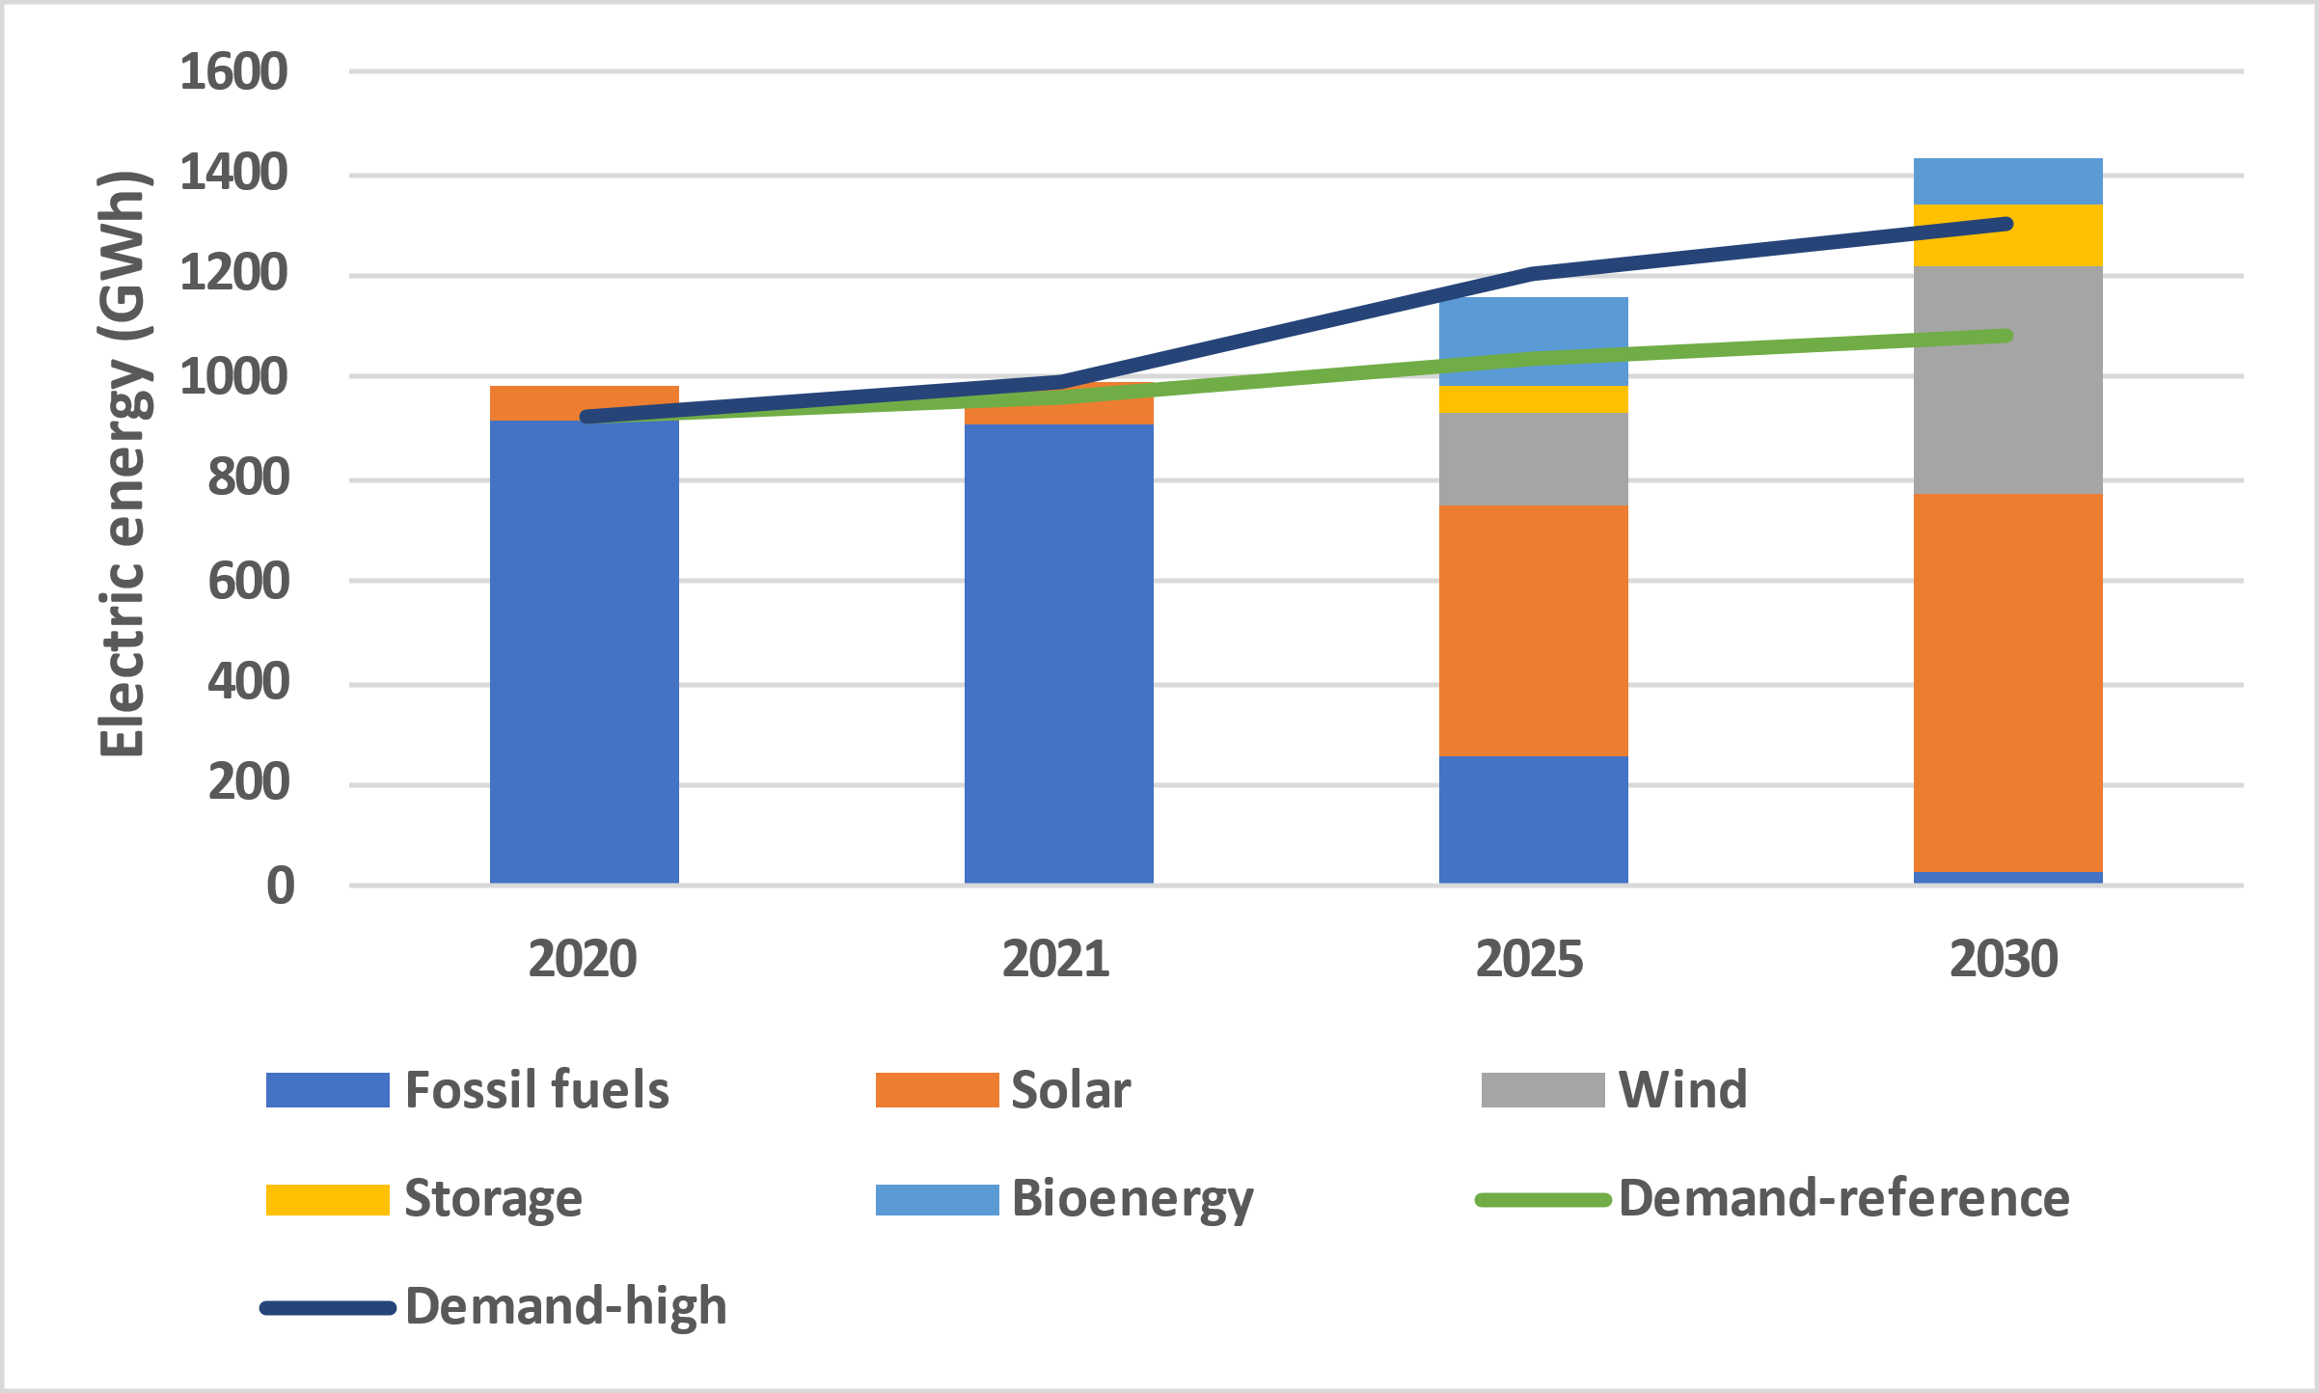
Left: electric energy generated (column), following IRRP scenario 3 and projected electricity demand (lines)
Right: installed capacity (in MW) in IRRP scenario 3.

Source: Data compiled from Draft Integrated Resource and Resilience Plan (IRRP), MottMcDonald (2021). Of the three scenarios developed in the IRRP, scenario 3 (with about 98-99% renewable power generation by 2030) was taken as a basis for the Barbados IRRP Action Plan (Acelerex, 2022)
Utility-scale and distributed renewable energy

Starting in 1974, amid an international oil crisis, Barbados invested in the area of solar water heating (SWH). Currently, there are approximately 50,000 solar water heaters in Barbados, with more than 35,000 domestic installations. With about 100,000 dwelling units in Barbados, this shows a significant penetration by the industry into the domestic market. On the other hand, penetration seems to have reached its peak for some time and has been slowing down in recent years as tax incentives have been removed. The government has the target to raise the number of domestic SWHs by 50% before 2025.

In the ‘RE 100%’ goal scenarios, about 750MW of installed RE-based power capacity would be needed by 2030. To be able to accommodate such a large amount of variable RE, storage capacity needs to be built, in conjunction with smart grid technology. Lithium-ion (Li) batteries are a technically and commercially proven technology with widespread adoption, in particular in applications that support the adoption of variable renewable energy. A project is being developed by Hidrogène de France (HDF) Energy and Rubis with a capacity for 128 MWh of green hydrogen storage that will be coupled with 50 MW of solar power.

Solar PV is seen as having a strong potential for development in the Barbados market due to the ease with which it can be integrated into areas such as electric vehicles, construction in sustainable and hurricane-resilient roofs, and battery storage systems being developed by BLPC. It is modular nature and the ease with which it can be expanded in installed systems makes it an attractive choice. It is also a well-understood and accepted technology by both people within the industry and general consumers. In the IRRP scenario (100% RE), about half of the renewable power would be generated by solar (496 MW generating 750 GWh annually in 2030). The first utility-scale solar PV farm was commissioned in 2018, the 10 MW ground-mounted facility in Lambert’s, St. Lucy (owned by BLPC), is generating an estimated 20.2 GWh annually.

While wind energy has not taken off significantly, there are plans to develop this technology to complement existing solar installations, including off-shore wind, of about 180 MW in total (generating 442 GWh annually in 2030). Apart from Pavana Energy Ltd.’s 1 MW onshore wind installation in the southwest parish of St. John (consisting of four 2.5 kW turbines), BLPC is investigating the possibility of establishing a wind farm in Lambert’s, St. Lucy alongside the existing PV farm there (10 MW, consisting of five 2.3 MW turbines).

Net metering has been allowed in Barbados since 2010, and consumers with wind and/or solar self-generation facilities have been able to supply energy to the national grid until recently, via the Renewable Energy Rider and Feed-in Tariff programmes. Until the large utility-scale RE facilities are set up, decentralized PV is likely to become the most significant contributor to the renewable energy mix in the short run. The government has set a distributed generation target of having at least 35,000 buildings with rooftop or ground-mounted solar PV systems that are resilient to extreme wind events (e.g., Category 4 Hurricanes). In the IRRP (2021), the generation by distributed renewables (rooftop PV) is expected to increase to about 100 MW by 2030 (generating 150 GWh annually. Total installed capacity stood at about 41.8 MW in 2021 (see Box 1). The development of distributed RE has been facilitated by the Feed-in Tariff policy and projects supported by development partners. However, some barriers and gaps remain to achieve a doubling of the distributed RE capacity as envisaged in the IRRP (2021) and are targeted to be addressed in the SMARTER project (discussed in Section 2).

Bioenergy resources and potential

Bioenergy potential and resources

There is significant potential to scale up biomass production at a national level during the transition to a 100% renewable energy matrix. Biomass resources can be converted following various pathways to provide fuel for thermal application or electricity generation or as biofuel for transportation, and other uses (see Box 4 for an overview).

Biomass resources: bagasse, vinasse and energy crops

Historically the vast majority of the Caribbean islands were highly dependent on sugar cane cultivation before tourism became predominant. Sugar was introduced to Barbados by the colonizers in the 15th century and provided Britain with sugar and rum. In this period, the arable land crop rotation was one-third sugar cane, one-third food crops of yam, sweet potatoes, guinea corn or maize, and one-third pasture for the plantation animals. There were 500 plantations on the island. However, over the past decades, sugarcane production has declined from 1.23 million tonnes in 1971 to 146,831 in 2018 and 81,064 tonnes in 2020 .

Barbados classifies about 16,000 ha of its surface area as arable land. Farming still represents an important land use (about 10,000 hectares). Apart from sugarcane, other crops are yams, sweet potatoes, corn, eddoes, cassava, and several varieties of beans and vegetables. The sugarcane area harvested fell gradually from 19,000 ha in 1971 to 2,160 ha in 2020. With the decline, the number of factories was shrunk, from about ten to the two that are still operational today, Andrews Sugar Plantation and Factory in St. Joseph and Portvale in St. James. The public holding company Barbados Agricultural Management Corporation (BAMC) owns the Portvale sugar mill. Private farmers and producers are organised in the Barbados Sugar Industry Limited (BSIL).

With sugar exports dropping farmers have looked for other opportunities. New speciality products have begun appearing in the retail market, carrying the Barbadian sugar trademark. Also, producing feedstock (molasses) for the growing rum distilleries is an assured market. Plans have been put forward for a large-scale switch to high-fibre canes for energy purposes (in particular, elephant grass, and king grass) that are currently grown as fodder by farmers, for energy purposes. King grass has also been proposed for dedicated energy crop production. Apart from the king grass, other plants, such as Leucaena (river tamarind), are being explored. Energy crops may be grown as dedicated annual crops (harvested once a year on the same land), part of double cropping (harvesting twice in a year), part of rotational cropping (different crops grown on the same piece of land in rotation) or as cover crops (crops grown when land would normally be left fallow between 2 harvests). Cover crops or double crops, on the other hand, help in avoiding the food-and-fuel conflict and prevent land use change and soil erosion. Digesting the crops in bio-methanation and applying the left-over digestate contributes towards maintaining the soil carbon content and overall fertility.

During the sugar and ethanol processes, waste products are produced that can be used to generate biogas. These are the straw, bagasse, vinasse and filter cake, that is, 1000 kg of sugarcane stalks generate as waste 140 kg of straw (dry basis), 280 kg of bagasse (wet basis) and 40 kg of filter cake (wet basis). In Barbados, straw is left on the field as mulch to provide nutrients to the land after a harvest. Bagasse is the dry, pulpy, fibrous material that remains after the sugarcane stalk has been crushed to extract its juice and is used as a fuel within the sugar industry. Following the production of sugarcane juice by milling the cane stalks, the juice is clarified, concentrated, and centrifuged to produce sugar and a syrup called molasses. Molasses is sent to be fermented in tanks where a liquid known as wine or fermentation wine is retrieved. This wine is centrifuged to recover the fermentation yeast which will be reused, and the liquid portion is sent to be distilled. In rum production, the distillation of wine separates the ethanol from the waste product also known as vinasse, which has a high organic content. The vinasse is either treated onsite and used to fertilize fields in irrigation systems or pumped through a pipeline and dumped into the sea.

The sustainable domestic food production has, on the other hand, also received increased attention,in view of Barbados’ expenditures worth over USD 300 million on food imports affecting its commercial balance and food security. With the larger share of inputs for the tourism sector being imported, domestic supplies would provide an opportunity to add value and retain a larger part of earnings in the country. Therefore, the Ministry of Agriculture prioritizes using land for food production rather than other uses, and due to the limited land space in Barbados, the growth of plants in monoi-cropping for energy purposes is disfavoured. Local cultivation of king grass in rotation with sugar cane (or other crops) offers a possibility of feedstock supply whilst ensuring that supporting industries are not affected. This may offer opportunities for the financial viability of sugar farmers with additional revenue yearly outside of the sugar industry.

Another option considered, given local constraints, is the exploration of cultivating and harvesting king grass, wild cane or other dedicated energy crops in other countries in the region such as Guyana and Suriname. Such crops may offer even higher yields than traditional sugar cane, but it has not been demonstrated yet that new crops (dedicated, inter-cropped or as imported feedstock) are agronomically, environmentally and economically appropriate.

Moreover, a reconversion to other commodity crops is unlikely to happen as long as a broader orientation on future agricultural land use in Barbados has not taken place. This orientation will take place in the framework of population growth and structural changes in the economy, with a view to (i) land conservation, (ii) local food production, (iii) reduced labour availability for the agricultural sector; (iv) land use conversion (from sugar production into non-agricultural uses including construction and tourism); (v) search for economic diversification and job opportunities, and, (vi) analysis of this potential and or ways identified to ensure that women farmers and other actors can benefit from such opportunities.

Biomass resources: crop and animal residues

The collection and valorisation of organic waste streams fit into a circular economy approach. Besides sugar cane trash and stalks, significant biomass waste flows are available in the form of bagasse (from sugar processing), vinasse (from rum production), food and waste oil residues, animal waste (manure), as well as the organic content in municipal solid waste (MSW) and wastewater.

The Ministry of Agriculture does not support the use of arable lands to grow crops for the specific means of biomass (as mentioned, it is considered detrimental to the food supply). However, the Ministry is supportive of waste-to-energy. Crop residues are materials such as leaves, stems and roots that are left unused after a harvest and lower quality crops not fit for consumption. These have the potential to be used as bioenergy in thermochemical conversion or biochemical. However, crop residues are a great source of organic matter that can be highly advantageous in maintaining or improving soil quality or, used as animal fodder. Additionally, crop residue can be used to make compost which can be tilled into the soil to provide nutrients and residues. In Barbados, the largest amount of crop residue comes from the sugar cane plant. Other sources of crop residues include cotton stalks and root crop residues.

Livestock is part of the local agriculture industry providing food such as dairy, meat, and eggs for local consumption. Manure can be obtained from dairy farms, beef lots, poultry and pig farms. The manure of farm animals found locally (cattle, pigs, sheep and chicken) may be treated via anaerobic digestion. The digestion of cattle/pig manure is an established technology and has been implemented widely all around the globe on varied scales. Digestion of poultry manure is trickier and often mixed with other manure. Pigs are often contained in sties or pens resulting in easier management of their manure. Cows and sheep are often left on pastures to graze (making it difficult to collect their manure), although both sheep and cow manure are commercially available and used by crop farmers in Barbados.

Biomass resources: municipal solid waste and wastewater

The Barbados Waste Characterization Study 2015 estimates the amount of municipal solid waste as about 26,036 tons a month in 2015 with an organic content of 15,667 tons a month, implying a total of 4.07 kg of waste per person per day. Of this amount, 24,921 tonnes a month passed through the Sustainable Barbados Recycling Centre (SBRC) facility at Vaucluse, St. Thomas (a public-private partnership) and 1,115 tonnes by the different recycling entities. After recovering materials for recycling, the waste ends up in the Mangrove landfill next to SBRC. The Sanitation Service Authority (SSA) is responsible for the collection and delivery of waste to the Mangrove Landfill. The commercial and industrial sectors utilize private waste haulers for the collection and delivery of waste to the Mangrove Landfill.

At SRBC some separation of organic waste occurs. This happens at their facility before landfilling occurs, however, the only organic materials utilized as compost are clean organics (grass cuttings, coconut husks etc.). The bulk of food waste (from the residential, business and tourism sectors) is likely to be mixed with residual waste ending up in the landfill. An estimated 44% of the waste going to the landfill is food waste. This organic content will decompose over time but the resulting landfill gas (a mixture of methane and carbon dioxide) is vented and not used.

The Barbados Water Authority (BWA) is the entity in Barbados charged with supplying the island with potable water as well as the provision of wastewater treatment and disposal services. Wastewater management happens in two sewage treatment plants on the island – Bridgetown & South Coast. Both treatment plants discharge the effluent water out to sea but the sludge generated from the Bridgetown Plant is disposed of on land.

Box 4 Overview of bioenergy resources – conversion -applications
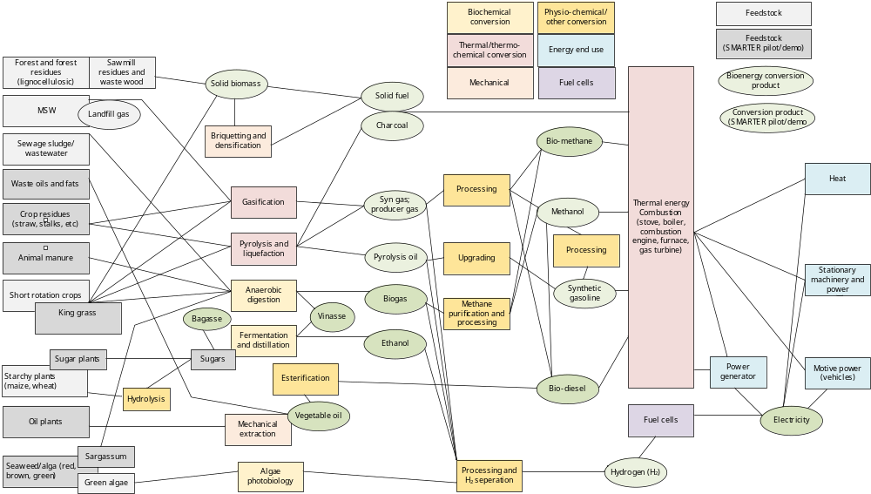

The waste from the South Coast is collected in a ‘skip’ and disposed of in the island’s landfill. There have been some problems recently with the South Coast Sewerage system. There is no gas usage from the waste treatment system.

Biomass resources: sargassum

Caribbean countries, including Barbados, have battled abnormally large influxes of sargassum seaweed since 2011 due to a combined oceanic-atmospheric event in 2011 concurrent with increased eutrophication of the ocean in estuaries of the Amazon and Orinoco River deltas. The species has become a plague in coastal seas around Barbados and on other Caribbean coasts affecting the ecosystem The phenomenon has been affecting tourism and fisheries negatively, resulting in economic losses. Rotting Sargassum seaweed on coastlines cost USD 120 million in beach restoration costs throughout the Caribbean in 2018; this number does not include the economic effect of hotel closures and occupancy drops because of sargassum which also has regional economic implications. Sargassum should be removed promptly from the shoreline to avoid vast accumulations of unsightly decomposing seaweed which makes its collection more difficult. Besides producing public health risks, it has an unpleasant smell. Manual collection of shored Sargassum with rakes or by hand is simple but tedious incurring costs proportional to the size of the workforce employed. More efficient is using a combination of beach grooming and self-propelled collection vehicles such as mechanized surf rakes (which can go together with beach cleaning in tourist areas). An even better solution to collect Sargassum seaweed in terms of its environmental impact is near-shore collection, by seaweed harvesters and shallow water vessels.

Anaerobic digestion has been proven successful at converting a wide array of brown algal species into bio-methane . Sargassum seaweed is now arguably the region’s largest single biomass resource, for example, delivering 24 million tonnes of biomass influx into the Caribbean Sea in June 2022 and showing a cyclic but reliable year-long presence in floating rafts visible by satellite . In Barbados, the University of West Indies (UWI) is exploring the co-digestion of Sargassum with other forms of organic waste (such as manure from sheep farms and vinasse from rum distilleries) to produce bio-CNG to fuel cars.

Conversion routes: thermochemical

Biomass cogeneration has been used by the sugar cane industry in Barbados for years by combustion of the bagasse. With the decline of the sugarcane industry, also the use of its residues in the energy supply went down from an average 1,820 TJ in 1970-1979 to 391 TJ in 2020. The Portvale sugar mill, the only one remaining in operation, produces electricity from co-generation but is not connected to the main grid (about 10 GWh generated in 2020 by about 1.5 MW during crop season). The potential to generate power from bagasse is larger, about 5-6 MW, which could generate about 40 GWh of power per year. The bagasse production was 60,000-70,000 tonnes around 2014 but down to about 25,000 tons by 2020.

For environmental and other reasons, the public has not been receptive of incineration. The Vaucluse Biogas Power Plant is a 20-25 MW biopower project. It is planned in Saint Thomas, Barbados, which uses municipal solid waste as feedstock with gasification as the conversion process to release the energy value of the feedstock. The project (with an estimated USD 320 million cost) is currently in permitting stage, and if approved, could start construction in 2023 or thereafter.

Conversion routes: biochemical

Anaerobic digestion involves a series of biological processes in which microorganisms break down biodegradable material in the absence of oxygen. The process initially produces biogas (composed primarily of methane, 50–70% and carbon dioxide, 30–50%), leaving digestate, a nutrient-rich solid fraction that can be used as an organic fertiliser. A wide range of biomass feedstocks are indigenous to the Barbadian environment and can be processed by anaerobic digestion, such as manure, crops and crop residues, wastewater, beverage waste, and the organic portion of municipal solid waste (e.g., food waste). Beyond these industries, the recent introduction of invasive species such as river Tamarind and Sargassum seaweed are also viable sources of freely available and can be processed by anaerobic digestion.

A separate collection of food waste is necessary for the recovery of energy and nutrients via anaerobic digestion. Separate food waste collection from households and businesses is not yet a local practice but is expected for local inclusion as the country transitions to sustainable energy practices. It is envisioned that organic waste normally delivered to the landfill is diverted to a biogas plant. Also, the commercial and industrial sectors can be encouraged to separate organic waste with the provision of waste bins to collect materials including food waste and delivered them to the plant using the same private waste haulers currently utilized. The digestion of the collected food waste will result in reduced GHG emissions from landfills (less methane) and extend the operation years of local landfill cell sites. In order to capture all available food waste for anaerobic digestion by 2030, associated policy and legislation must be implemented to ensure the separation of organic waste from other municipal solid waste.

Several stakeholders, Barbados Agricultural Management Company (BAMC), Barbados Sugar Industry Limited (BSIL) and private farmers, have been in discussion to establish Grow Energy, a company aimed at producing sugar cane by-products and biomass energy. Other initiatives have also looked at using biomass feedstock for biomethane generation. A collaboration between Circular Fuels LLC and West Indies Rum Distillery (WIRD) has been proposed to utilize sugar cane residues and other feedstocks like sargassum to generate biogas.

The Barbados Investment and Development Corporation (BIDC) recently issued a Terms of Reference (ToR) for the design and installation of a 250 kWh anaerobic digestion plant, estimated to require 6000-12,000 tons of biomass input annually to generate 2 GWh of electricity annually. Feedstock proposed includes food waste, roadside grasses, and industrial wastewater from BIDC’s industrial estates, the biogas generates is then to be injected into the national energy grid.

End-use: electricity or direct use of biomethane

The above-mentioned project concepts prioritize using waste to generate electrical energy. Another option is to use upgraded biogas as a natural gas substitute (to be injected into the natural gas grid) or as an LPG alternative. In the BNEP 2019-2030, the demand for natural gas and other fossil fuels would need to be replaced by electricity (e.g., electric cooking or electric vehicles) or gradually substituted by biomass-derived fuels. Currently, BNOC provides about 1.6 million ft³ of natural gas to its approximately 21,000 customers and produces about 1 million ft³ of natural gas a day. The demand for natural gas is likely to grow (due to demand growth in sectors such as tourism and due to replacing of oil products to achieve fossil fuel-free status by 2030).

To ensure economies of scale and cost efficiencies concerning the size of anaerobic digestion plants and biomethane upgrading facilities, NPC-BPOC envisages a central bio-methanation facility at the BNOC natural gas plant at Woodbourne, St. Philip that should be able to produce 700 million ft³ of gas to feed into NPC’s pipeline system. The biogas would be procured from a range of feedstock, including vinasse, food waste, and pig slurry year-round, while Sargassum could be used when blooms arise, and king grass will be cultivated for use alongside Sargassum seaweed. With IDB support, a feasibility study will be carried out on the potential of the above-mentioned feedstock, while a ‘request for proposals’ for such a facility is under preparation.

Biofuels for transportation

There were 135,742 vehicles on the island in 2020 of which 19,214 ran on diesel, 116,182 on gasoline and 346 electric vehicles. The transport sector was responsible for 33% of the energy consumed in the country (see Box 1). The 2030 “100% RE” vision calls for the elimination of the use of diesel and gasoline for local transport over the next decade. This will require either retrofitting the existing fleet and/or restricting the importation of conventional vehicles and incentivising the importation of electric and alternative renewable fuel vehicles. Incentives have been introduced for electric vehicles. The ‘high demand’ scenario in the IRRP (2021) assumes a penetration of electric mobility approaching 100%, while a base (reference) scenario assumes 60% (and a low demand scenario a more modest 30%). These strategies currently do not include significant considerations of gender and women’s empowerment.

Apart from the increasing electrification of the vehicle fleet, the other sustainable option is replacing fossil fuels (gasoline and diesel) through the increased use of ethanol and biodiesel as transport fuels. Biodiesel can be produced from waste vegetable oil and certain crops, such as rapeseed, soybean, coconut, sunflower and other oily crops.

Regarding the replacement of gasoline, a low-hanging hanging fruit is the installation of CNG kits into gasoline cars, which can then be driven on biomethane from upgraded biogas derived from anaerobic digesters. This transition activity could gradually transition the whole gasoline fleet. Any gasoline car, via a 4-hour CNG kit installation, can drive on either its original liquid fuel or the gaseous renewable fuel. This would coincide with the sale of CNG cars currently on sale in neighbouring Trinidad and Tobago. A disadvantage for many car owners will be the CNG tank occupying most of the boot space, especially in smaller vehicles. A second option, which would be comparable in cost but slower in implementation, is mixing ethanol at 10% (E10) for the whole gasoline fleet, followed by a gradual insertion of hydrous ethanol usage (E100) driven by the replacement of the gasoline vehicle fleet for imported flex-fuel vehicles. This may be time to implement as it would require switching to E10 nationwide at the fuelling stations (see Annex G.6 for more details)

Similar to gasoline, biodiesel would be mixed with mineral diesel at 20% (B20) for the whole diesel fleet, followed by the gradual inclusion of B100 usage driven by the diesel vehicle fleet renewal through the import of vehicles approved for the use of B100. Currently, a biodiesel pilot is implemented by Barbados National Terminal Company Limited (BNTC) on the mixing of bio-diesel (produced locally from cooking oil waste). To be able to produce B10 in sufficient quantities to transform the diesel market (currently, demand is about 6.40 million litres a month) would require 0.64 litres of bio-diesel, which cannot be produced from the country’s cooking oil waste alone. Land use as well as biofuel production and cost will pose limitations on local production of crops, thus requiring the (expensive) import of bio-diesel, or import of feedstock (e.g., soybean oils) or the cultivation of crops of leased land abroad.

Relevance to national priorities

This Project is aligned with Barbados’ priorities and reports under the UNFCCC including its Second National Communication (SNC, 2018) and the Nationally Determined Contribution (NDC, 2015; update 2021). The SNC explicitly mentions that “Barbados is dedicated to the implementation of sustainable energy technologies, including wind, solar, cogeneration and waste-to-energy strategies”. Barbados has not submitted a Biennial Update Report (BUR). The SMARTER initiative is closely aligned with Barbados National Energy Policy (BNEP 2019-2030) and its Implementation Plan (2018). It is also supportive of the Barbados Physical Development Plan (PDP, amended 2016), specifically Chapter 3 – Land Use and Built form Policies; the National Agricultural Policy (NAP, 2013) and the 2020 Water Protection and Land Use Zoning Policy. The Project is also aligned with the National Climate Change Policy Framework which is monitored by the National Climate Change Committee of the Ministry of Environment and National Beautification (MENB).

At a regional level, as a CARICOM member, Barbados has been actively involved in the formulation and implementation of the CARICOM Energy Policy and the underlying Caribbean Sustainable Energy Roadmap and Strategy (C-SERMS) that were approved in 2013). CARICOM’s Caribbean Centre for Renewable Energy and Energy Efficiency is hosted by Barbados.

Box 5 Policy and plans related to energy and electricity

Policy / planning document | Relevance
Barbados Sustainable Development Policy (2004) | The over-arching goal of this policy is to ensure the optimisation of the quality of life for every person by ensuring that economic growth and development do not occur to the detriment of our ecological capital. Although formulated well before, the Policy links with actions plans for 24 sectors with the UN Sustainable Development Goals (see Box 8) adopted in 2050
Barbados National Energy Policy (and Implementation Plan), 2019 | The BNEP aims to achieve a 49% fossil fuel reduction by 2023 and a 100% fossil fuel reduction  by 2030. The above fossil fuel reduction targets can be stated as increased production of energy from renewable energy targets for electricity generation of 52% in 2023 and 100% by 2030. It is the Government’s policy to phase out local consumption of natural gas by 2030, replacing natural gas with an appropriate renewable fuel(s). Significant additional investments are now needed for the BNEP goal of 100% renewable energy to be attained by 2030. To this end, a draft Integrated Resource and Resilience Plan (IRRP) has been formulated that will guide the implementation of the BNEP
Electric Light and Power Act (ELPA), 2013 and subsequent Amendment Bills (2015, 2019) | The Electric Light and Power Act, 2013 (ELPA) sets the government’s priorities in the electricity sector which are to reduce electricity prices, increase energy security, promote the use of cleaner fuels, and reduce negative environmental impacts. The Electric Light and Power Act 2013 (ELPA) is “an Act to revise the law relating to the supply and use of electricity, to promote the generation of electricity from sources of renewable energy, to enhance the security and reliability of the supply of electricity and to provide for related matters”. It replaced the original 116-year-old Electric Light and Power Act which was passed in 1899 and was further amended in 2015.
Fair Trading Commission Act, 2002 and subsequent Amendment Bill (2020) | The Fair Trading Commission assumed regulatory responsibilities on January 2, 2001, under the Fair Trading Commission Act, CAP. 326B. The Commission is responsible for the enforcement of the provisions of the Utilities Regulation Act, CAP. 282, the Telecommunications Act, CAP. 282B, the Fair Competition Act CAP. 326C and the Consumer Protection Act
National Climate Change Policy (2012)  Second National Communication (SNC; 2018)  Barbados Nationally Determined Contribution (2016; update 2021) | The SNC explicitly mentions that “Barbados is dedicated to the implementation of sustainable energy technologies, including wind, solar, cogeneration and waste-to-energy strategies”. Barbados has not submitted a Biennial Update Report (BUR) as yet.  The Barbados Nationally Determined Contribution (NDC) of 2015 mentions that Barbados intends to achieve an economy-wide reduction in GHG emissions of 44% compared to its business-as-usual (BAU) scenario by 2030; i.e. in absolute terms, translating to a reduction of 23% compared with the baseline year, 2008. A fossil fuel-free electricity sector represents a significant enhancement of the 2015 NDC target of 65% renewable energy, alongside a 22% improvement in energy efficiency in the electricity sector. In the 2021 NDC Update, Barbados’ conditional mitigation contribution for 2030 consists of: 1. a 95% share of renewable energy in the electricity mix, 2. 100% electric or alternatively-fueled vehicles in the passenger fleet; 3. a 20% increase in energy efficiency across all sectors as compared to BAU; 4. a 29% decrease in industrial, commercial and residential fuel consumption as compared to BAU; and 5. a 20% decrease in waste emissions. Barbados adopts the following ambitious contributions for 2030:  - 35% reduction relative to business-as-usual emissions in 2030 without international support (unconditional).  - 70% reduction relative to business-as-usual emissions in 2030 conditional upon international support.
Barbados Sargassum Adaptive Management Strategy (SAMS) | After the Prime Minister declared Sargassum to be a national emergency, the country is postured via the SAMS to find uses of Sargassum that meet the crisis at its current scale. The question of bioenergy for Barbados is the only at-scale question when it comes to Sargassum management .
Barbados Physical Development Plan (PDP) (Draft) Amendment, 2017 | Requirements for the Environmental and Social Impact Assessments (ESIA) vary and have been identified in relevant sections of the PDP policies but may also be subject to the discretion of the Environmental Impact Assessment Committee. However generally the several types of industrial plants require an ESIA, a) chemical or petroleum manufacturing, c) desalination plant; d) power generation plant; e) cement plant (or other plants for the burning of lime or bricks). This also applies to any other industry where the process is potentially obnoxious or dangerous to health and amenity because of excessive smell, fumes, smoke, dust, grit, ash, noise or vibration.
Planning and Development (Environmental Impact  Assessment) Regulations, 2021 | According to these regulations, an Environmental Impact Assessment Committee, appointed by the Board, functions to screen applications for planning permission to determine whether an environmental impact assessment is required in any case.
Institutional frameworks and conventions, signed by Barbados | Biodiversity and sustainable resource management  - Convention on wetlands of international importance, especially as waterfowl habitat (1971)  - Convention on international trade in endangered species of wild fauna and flora, with appendices (1973)  - Convention on Biological Diversity (1992)  Climate change and natural disasters  - Vienna Convention for the Protection of the Ozone Layer (1985)  - United Nations framework convention on climate change, with annexes (1992)  - Kyoto Protocol (1997)  - Agreement Establishing the Caribbean Community Climate Change Centre (CCCCC) (2002)  - Agreement Establishing the Caribbean Disaster Emergency Management Agency (CDEMA) (2008)  - Paris Agreement on the United Nations Framework Convention on Climate Change (2015)  Community health, safety and security  - Universal Declaration on Human Rights (1948)  - Inter-American convention on the granting of political rights to women (1948)  - Convention on the Political Rights of Women (1953)  - International convention on the elimination of all forms of racial discrimination (1965)  - International Covenant on Civil and Political Rights (ICCPR) (1966)  - Convention on the Elimination of all Forms of Discrimination Against Women (CEDAW) (1979)  - Convention on the Rights of the Child (CRC) (1989)  - UN Declaration on the Elimination of Violence Against Women (1993)  - Inter American Convention on the Prevention, Punishment and Eradication of Violence (1994)  - Beijing Declaration on and Platform for Actions (1995)  - CARICOM Charter of Civil Society (1997)  - Convention on the Rights of Persons with Disabilities (2007)  Cultural heritage, labour and working conditions  - International Covenant on Economic, Cultural and Social Rights (ICECSR) (1966)  - Labour and Working Condtions  - Equal Remuneration Convention (1951) (No.100)  - Discrimination (Employment and Occupation) Convention (1958) (No. 111)  Pollution prevention and resource efficiency  - Montreal protocol on substances that deplete the ozone layer, with annexes (1987)  - Basel Convention on hazardous wastes (1989)  - Rotterdam Convention on the Prior Informed Consent Procedure for Certain Hazardous Chemicals and Pesticides in International Trade (1998)  - Stockholm Convention on Persistent Organic Pollutants (2001)  - Agreement establishing the Caribbean Centre for Renewable Energy and Energy Efficiency (CCREEE) (2017)

There is no country-level Gender Policy currently that would guide gender aspects of bioenergy production and gender has not been a significant consideration to date in energy policy and planning. However, the MEB has recently commissioned a “Gender Equality Strategy and Action Plan for the Electricity Sector” which could be relevant to electricity production elements of bio-energy production.

Strategy

Barriers to bioenergy development and use in Barbados

Energy and power sector planning and governance

Barbados has formulated the BNEP with the ambitious goal of 100% renewable energy in its energy supply (both electricity and fuels). The electricity sector framework is in full development and important progress was reported by 2021, including the finalization of the first Integrated Resource and Resilience Plan (IRRP, 2021) and ongoing negotiations regarding the role of BLPC and its post-2028 license. While a draft IPPR has been formulated for the power sector, cross-sectorial analyses at the systemic level and for the energy sector as a whole (fuels and electricity) are particularly important given the need to replace fossil fuels for transport (mobility), residential (e.g., cooking) and steam production (e.g., hotel and industrial sectors) by low-carbon energy carriers (such as electricity from renewable sources and biomass-derived fuels). Sector-wide scenario-based planning is needed for the energy sector as a whole to steer the transition from fossil fuels to net-zero carbon alternatives.

Currently, only mature technologies are included with great detail in IRRP, while for bioenergy or new technologies (electric vehicles, hydrogen, ocean energy) the input data are largely based on assumptions (provided by international experiences). A comprehensive bioenergy assessment will help provide based Barbados-based data. The assessment should encompass current ongoing local R&D efforts and target the various end-uses. Biomass could be a “game-changer” which allows the provision of sufficient backup generation for the variable RE sources in the 100% RE vision while providing a cheaper alternative for battery or hydrogen storage. Also, the assessment should encompass the use of bioenergy in transportation.

The UNDP-supported and GEF-financed DREAM project (see Box 13) helped to bring forward the installation of decentralized solar PV. Specific terms and criteria for solar PV technology were elaborated under DREAM and incorporated into the licensing process. Since 2021, registration for renewable energy generation is through an online system, known as the ELPA system (app.energy.gob.bb). However, some regulatory and legislative constraints still exist in Barbados. Various bottlenecks affect the throughput time of RE project development processes. In the first place, the authorities need sufficient staffing, capacity and tools to handle project requests:
- This concerns “front-office” processes including RE licensing by MEB and the evaluation of project applications under the FIT scheme by FTC. In the “back-office”, staff capacity is needed for dialogue with partners including BLPC, monitoring of IRRP implementation progress, interpretation of forthcoming electricity system data, incorporation of regulatory updates into the licensing process, and more. For larger-scale projects, bidding documents must be prepared and the tender process organized and implemented.
- In the past, it was very challenging for the Government of Barbados (GOB) to gain more control of sector planning as historically, the know-how, operational data and staff capacity had been with BPLC and NPC/BNOC. While the capacity gap (asymmetry) between MEB and the utility has become smaller, it remains challenging for GOB to sustain staffing and skills for sector purview, including setting up the electricity market system, and design of standard agreement with the system operator and independent power producers,
- The GOB lacks methodologies and tools for holistic planning of bioenergy, land-use and green transformation of the end-use sectors as well as for integrating renewable energy in general in the grid, (dispatch, curtailment, etc.). Increasingly, energy system monitoring is not at the central level, but at the building and customer levels
- In the above-mentioned planning and monitoring activities, digitalization will become more important, and there is a need for specialized skills for developing ICT.

Bioenergy

Feedstock and resources

Bioenergy systems are complex and comprise not only the power plant itself but also the feedstock supply chain, transport and storage facilities, the efficiency of logistics, residue management, water usage, and mitigation of local pollution and nuisance. Support for such ongoing R&D initiatives is needed. The availability of feedstock is typically dependent on various providers and its potential and economics need to be realistically assessed. Social impacts and gender considerations as well as trade-offs between economic, social and environmental considerations also need to be carefully weighed. The SESP (see Annex L) flags the need for consideration of the social impacts of local pollution, transport of waste and water usage including mitigation strategies, clear communication to the public and the conduct of Environmental and Social Impact Assessments as necessary for demonstration projects.

Bioenergy requires feedstock typically produced by actors outside the energy sector (agriculture, waste, seaweed), while its end-use is in various forms (electricity, gas, liquid) in various sectors (residential and commercial, transport and the productive sectors), creating an urgent need for coherence in policy and planning and coordination with other sectors. Concerning resources, there are conflicting land uses (for agriculture and food production, for VRE power plants (solar and wind), as well as land needed for housing and tourism development) that affect land availability for growing biomass for biomethane or biofuels. These land uses may not be mutually exclusive and further studies should be undertaken to find how all three of these land-use can be accommodated. Uncertainty about biomass potential and suitability of feedstock, and organization of supply chains for dry and wet biomass streams that may have to encompass both local production and imported feedstock given the limited land availability. Studies have been carried out on particular bioenergy feedstock and end-use but not in the form of an overall comparative assessment that compares the multitude of possible feedstock-conversion-use combinations with one another and with other renewable energy options.

Promising opportunities for bioenergy-based electricity generation exist in Barbados based on a variety of dry and wet residue streams. These are or have been subject to pilot studies and feasibility assessments for specific feedstock-application combinations but no holistic assessment has been carried out that compares the potential, costs and benefits of the various feedstock-conversion-application routes vis-à-vis one another and with other renewable energy options, thus, analysis in national planning, such as BNEP, IRRP and transport sector planning is based on assumptions regarding bioenergy from international sources rather than based on Barbadian data.

Policy and planning

Barbados lacks a national bioenergy policy covering aspects such as biomass resource mapping, spatial and land-use planning, siting, financial incentives, value chain development, capacity building, and more. Bio-economy and circular economy concepts provide useful guidance for policy development and structuring of value chains, including higher-value uses of biomass supplies. Integrated physical planning, involving all stakeholders and considering all possible constraints including competing land uses and water limitations, will define the biomass potential that is effectively available in Barbados. Stakeholder engagement has been limited to date to more obvious energy stakeholders and other key industries but has not always engaged more socially-driven stakeholders and this is a gap that would need to be addressed for the uptake and uses of bioenergy.

Even with the development of the Barbados National Energy Policy and the efforts within many other sectors to develop their own policies to contribute to national development, there has been a barrier related to the lack of coordination, in particular concerning the use of bioenergy in various sectors (residential, commercial, transport, productive). In many cases, Ministries have been observed to act in 'silos' rather than try to identify synergies and work together. Inter-ministerial coordination needs to be improved for mainstreaming low-carbon energy supply, climate resilience, and circular economy aspects across all relevant sectors.

Thus, data on bioenergy feedstock production, costs of conversion routes and bioenergy end-uses (electricity or direct use as gas or liquid) must be significantly developed for detailed policy development and renewable energy integrated resource planning.

On-grid power producers require a license from MEB, which is essentially a verification and registration process, followed by permits to install and operate the RE plant if all criteria are met. While this licence system is well-established for solar PV and wind energy, there is no real reference framework for assessing the technical, environmental, social and economic aspects of bioenergy projects, including biomass production and transport. There is little expertise on safety and occupational hazards associated with bioenergy systems and regulation is not in place.

Capacity and knowledge

Regarding conversion routes (from feedstock to end use), these have been subject to studies but not demonstrated yet, except for the bagasse cogeneration. Consequently, the ecosystem for the preparation, design, operation and maintenance of bioenergy facilities is incipient; trained and certified technicians are not available yet. Unlike the experience obtained in solar PV and solar water heaters with private and government agencies providing training for PV installations, there is a need to support local strategies for increased human resource capacity in existing embryonic plans for large bioenergy projects. On the other hand, fewer staff will be employed in the fossil fuel industry (as the country proceeds towards the 100% RE goal and there will be a need for re-skilling and training of these employees to be able to work in the expanding renewable energy sector (covering solar, wind, electric vehicles, storage, hydrogen and bioenergy). It must be stated though, that due to its technological similarities to the needs of the fossil fuel, bioenergy will usher in the gentlest transition among the energy labour market in this primarily fossil-fuel-powered island nation, and for this reason, within the emerging national renewable energy mix, biofuels can play a key role in the transition.

Barbados has little experience with advanced bioenergy technology, thus, building national capacity is critical. Some educational institutions in Barbados are involved in the promotion or educational activities in sustainable energy. These include the University of the West Indies (UWI), Samuel Jackman Prescod Institute of Technology (SJPI) and the Barbados Community College (BCC). The reader is referred to Box 11 for more details. While these institutions have ideas to equip the workforce in this area, however at the moment, there is a consensus that current levels do not provide the necessary human resource quantities. A recent employment analysis indicates that 700 persons would need some kind of special training (short or long term) to be fit for the transformation to the sustainable energy industry and services at the national level and in specific niche areas (observing that the analysis did not particularly focus on bioenergy).
In many areas, bioenergy will need local R&D, from finding the best way to take advantage of Sargassum seaweed as a feedstock, to proper agricultural techniques to growing bio-energy crops and the proper design and operation of bio-energy plants at different scales. The University of the West Indies and several other stakeholders consider biogas technology as an opportunity for Barbados. There is also a need for stronger cooperation between applied science institutions and the private sector to work on innovative energy technology solutions with high GHG emission reduction and value creation potential. The country could benefit from bioenergy technology as well as outside expertise and know-how to be drawn into the country to aid and bolster ongoing research efforts for which local experts in the area can outline the needs.

Investment and financing

Bioenergy has, by and large, not been demonstrated in Barbados and the development costs of the first projects may not be recovered. The investor’s risk can be reduced through public funding of biomass resource studies and facilitating permitting and consultation processes. Additional incentives including grants and tax benefits can help mitigate upfront capital costs, moreover, if the environmental benefits of organic waste processing in biomass plants, and the creation of employment along the value chain, are taken into account. Apart from benefits (environmental and socio-economic), bioenergy may also have negative impacts depending on feedstock and bioenergy conversion route that are summarized in Box 6. There is expected to be some broader scepticism on the part of the broader public about any cost increases (fuel prices), promised opportunities (e.g., employment) and negative impacts (e.g., land use) and so information and advocacy campaigns will need to be well designed and targeted.

Bioenergy and gender

There has been little analysis up to now on bio-energy and gender and the still limited analysis of and work exists on energy and gender in Barbados (see section 4.5 for more info on the gender subject). An assessment of employment opportunities as well as livelihoods, given the current gender segregation in the labour market (see section 4.5), needs also to be considered as well as potential barriers to women’s participation and access to bioenergy resources in the most useful form. Noting the male dominance in the energy and other related sectors and the lack of awareness of the need for gender experts in planning, women may not have the opportunity to be involved in this planning to voice their issues and make contributions to the overall long-term strategy. The sustainable energy industry in Barbados has recently started to organize itself through the Barbados Renewable Energy Association (BREA), but in general, the degree of cooperation and collaboration of the stakeholders remains limited, in particular in the bioenergy area with its range of possible feedstock and conversion routes that will involve stakeholders from various sectors. Transversal challenges include a lack of inter-sectorial dialogue and information on the application of bioenergy in various end-use inks of bioenergy with land-use and water resources as well as with circularity, resilience and gender.
Box 6 Impacts of bioenergy development and utilization

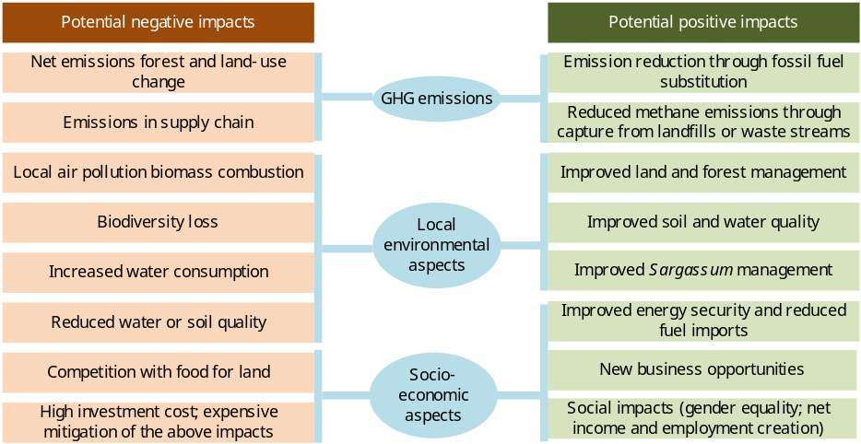

Source: figure S1 in Bioenergy for the Energy Transition (IRENA, 2022), adapted to the Barbadian context and circumstances

Source:

SMARTER’s approach to lowering barriers to bioenergy development

While Barbados has advanced with renewable energy planning and independent power production, important barriers and gaps remain regarding bioenergy development. These barriers are present to a larger or lesser extent, affecting Barbados’ capacity to achieve its goal to become a 100% RE country by 2030 and foster the utilization of domestic bioenergy. The previous section 3.1 is describing the baseline situation and barriers and gaps regarding a) government capacity for energy and electricity planning, b) enabling conditions for bioenergy deployment and mobilization of actual investments, and c) availability and accessibility to knowledge and information. The barriers that can reasonably be addressed within the framework of a GEF MSP are sector governance and energy asset management; access to (bioenergy) technology; and RE (bioenergy) pipeline development. The hypothesis for the project is that by significantly reducing the policy, knowledge and capacity barriers and investment risks for developing bioenergy in Barbados, the adoption of bioenergy solutions will help the realization of the ‘100% renewables’ energy policy goal of the country. Accelerating the adoption of ‘net zero’ will contribute to greater GHG emission reductions.

The project objective is “to strengthen Barbados´ institutional and technological capacities to transit towards a resilient, affordable and low-carbon energy infrastructure”. The SMARTER Project seeks to address the barriers and the underlying causes (see Box 7) by means of four components with outcomes and outputs , as shown in Box 7 . The proposed strategy is aligned with the GEF Strategic Focal Areas CCM-1-1 “Promote innovation and technology transfer for sustainable energy breakthroughs for de-centralized renewable power with energy storage”.

Box 7 Barriers and challenges that SMARTER seeks to address

Objective: to strengthen Barbados´ institutional and technological capacities to transit towards a resilient, affordable and low-carbon energy infrastructure.
Core problem: the production and application of sustainable bioenergy as a low-carbon solution in Barbados’ energy transition towards 100% RE faces significant barriers and challenges including uptake and application as well as sustained innovation, financing and investment.

Barriers and challenges | SMARTER outcomes and outputs
Outcome 1 Government capacity for resilient, low-emission energy planning and energy system purview has been strengthened
- Reportedly, there are asymmetries between GOB and the utility with respect to access to information affecting planning and cost optimisation (dispatch, efficiencies, operational costs). Electricity data (on distributed systems) is not always available in detail in a timely manner affecting optimisation of system planning and operation, and determination of tariffs and incentives. Building on ongoing electricity sector integrated planning (IRRP), scenario-based planning is needed that integrates electricity with fuels to steer transition from away from fossil fuels in electricity sector but also in the end-use sectors that use fuels (gasoline, diesel, fuel oil).  - While analysis has focussed on least-cost and potential (such as IRRP) more analysis is needed on socio-economic impacts (costs of living, income distribution, differences in impacts and opportunities on man and women; land-use implications) and local environmental (marine and terrestrial) to make the energy transition a ‘just’ transition, as well as climate-related impacts (e.g., increased vulnerability to hurricanes, sargassum issue). | 1.1 Support provided for reviewing relevant sector policies to identify opportunities for incorporation of various bioenergy in Barbados’ just energy transition  1.2 Support provided for the management of renewable energy systems
Outcome 2 Enabling conditions for successful bioenergy deployment in Barbados have been created.
- Data on bioenergy feedstock production, pros and cons of various conversion routes and applications are insufficient for detailed policy development and RE project planning. Existing information is scattered among various stakeholders (waste, agriculture, fuels, electricity, waste, transport)  - Government of Barbados lacks methodologies and tools for holistic planning of land use in relation to bioenergy and the role of agriculture and the sugarcane sectors. Lack of knowledge of regulations or guidelines for safety and hazard mitigation for bioenergy systems.  - Uncertainty about biomass potential and suitability of feedstock, and organisation of supply chains for dry and wet biomass streams for their use for power generation, as natural gas replacement or as transport fuel. Uncertainty on land-use implication.  - Municipal waste streams are not separated sufficiently at the source into organic and non-organic waste streams.  - The ecosystem for preparation, design, operation and maintenance of bioenergy plants is incipient and trained and certified technicians are not available yet. Renewable energy systems developers have difficulties to find skilled people for design, installation and operation and maintenance, while vocational and educational need to be upgraded to provide these relatively new skills.  - Ministries have been observed to act in 'silos' rather than try to identify synergies and work together across sectors (fuels and electricity; end-use sectors, land-use). Inter-ministerial coordination and stakeholder engagement needs to be improved in view of the multi-sectoral characteristics of bioenergy (energy, transport, waste, agriculture) and links with other themes such as circular economy, climate resilience, marine environment. | 2.1 Mapping and assessment of possible biomass resources – conversion – bioenergy carriers (gas, liquid) and applications (electricity, bio-methane, liquid biofuels) in various sectors  2.2 National dialogue advanced and appropriate national bioenergy policy formulated  2.3 Capacity strengthened for bioenergy technology development and implementation  2.4 National dialogue and information exchange facilitated by a “bioenergy task force”
Outcome 3 A pipeline of bioenergy (and decentralized RE) projects has been developed and some put into operation
- Private developers are unwilling or unable to assume upfront investment costs given current RE project risk profile, in particular for biomass projects. In general, capital costs for individual countries in the Caribbean are higher above business standards due to lack of project scale and volume and high transaction costs.  - Small market size requires careful dimensioning of power systems and ensuring availability of spare parts and skills for maintenance and servicing.  - Entities (public and private alike), have little or no experience with bioenergy technology, in particular anaerobic digestion and biofuels production, while entities that produce waste streams may not be aware of their bioenergy production potential.  - Project developers face limitations (know-how, human resources, information) to deliver mature project proposals. | 3.1 Investment prospectus of bioenergy (and RE) projects.  3.2 Detailed feasibility studies of pilot-scale bioenergy facilities to appropriately choose biomass feedstock and formation of ‘bioenergy pilot plan’  3.3 Implementation of bioenergy demo/pilot facilities and increased investment in decentralised RE
Outcome 4 The Project’s knowledge management, outreach and promotion have been implemented
- There is no designated entity in Barbados to act as a focal point to collect a sector information (related to bioenergy systems), and to collate lessons learned and case studies for reaching out to project developers, investors and the general public.  - Bioenergy requires feedstock typically produced by actors outside the energy sector, which urges for coordination with other sectors and holistic development planning. Existing information on feedstock and possible end-uses is often scattered among stakeholders and is not easily shared. | 4.1 Scientific, technological, engineering, operational and social experiences with bioenergy development in Barbados, collected, promoted and shared, nationally and regionally.

Linkages with SDGs

Energy is addressed directly by Sustainable Development Goal #7 (SDG7), whose overarching aim is to ‘Ensure access to affordable, reliable, sustainable and modern energy for all’ with three targets to be reached by 2030, namely 7.1: Ensure universal access to affordable, reliable and modern energy services; 7.2: Increase substantially the share of renewable energy in the global energy mix, and 7.3: Double the global rate of improvement in energy efficiency.
Box 8 Linkages of rural and renewable electricity with SDGs

Sustainable Development Goals | Linkage with bioenergy (positive + or negative -)
5: Ensure gender equality | Sustainable bioenergy may create new economic opportunities to empower women (business, decision-making) (+)
6: Ensure availability and sustainable management of water and sanitation for all | Improved wastewater treatment can imply the increased of biogas (if captured and used for energy purposes) through biomass cultivation and processing (+). Large-scale production of biomass feedstock may increase water stress levels (-)
7: Ensure access to affordable, reliable, sustainable and modern energy for all | Bioenergy can provide clean and affordable renewables, including for power, heat and transport fuels. (+)
8: Promote sustained, inclusive and sustainable economic growth, full and productive employment and decent work for all | Bioenergy in the energy transition can be a partial driver of SDGs by increased investments in bioenergy for (rural) employment and income, and creation of new bioenergy-related businesses
9: Build resilient infrastructure, promote inclusive and sustainable industrialization and foster innovation. | Biomass provides opportunities to decarbonize industrial heat (replacing natural gas and oil products) (+)
11: Make cities and human settlements inclusive, safe, resilient and sustainable | The use of biofuels in vehicles implies increased sustainable transport, a main energy end-use, as well as sustainable provision of bio-energy generated power and bio-methane for use in residential and productive sectors (+). Bioenergy could  improve the management of MSW and reduce pollution (+), although biomass combustion can increase air pollution (-)
12: Ensure sustainable consumption and production patterns | Increased use of biomaterials linked with circular economy and bioenergy supply (+)
13: Make urgent action to combat climate change and its impacts | If sustainably produced biomass is a net-zero or low-carbon source for energy and materials and substitute for high-carbon fuels in power and heat applications. Bioenergy is a key part of  national energy and policies and plans (+)
14: Conserve and sustainably use the oceans, seas and marine resources for sustainable development | Development and/or use of aquatic biomass for bio-materials and bioenergy supply. Sargassum seaweed influx is a result of climate change, and an at-scale use of sargassum as a biofuel feedstock is a great adaptation mechanism (+)
15: Protect, restore and promote sustainable use of terrestrial ecosystems, sustainably manage forests, combat desertification, and halt and reverse land degradation and halt biodiversity loss | Bioenergy plays a role in terms of restoring degraded land through biomass (+) while biomass sustainability needs to be safeguarded (protecting biodiversity, reducing land degradation) (-)
Compiled from Transforming our World: the 2030 Agenda for Sustainable Development (UN, 2015), Linkages between the Sustainable
Development Goals (SDGs) and the GBEP Sustainability Indicators for Bioenergy (GSI), International Institute for Sustainability Analysis and Strategy (IINAS), 2018. Bioenergy for the Energy Transition (IRENA, 2022). .See also: https://tapsec.org/sargassum-seaweed-for-green-transportation/

Bioenergy is intrinsically linked with many other SDGs. Sectoral governance, access to technology and pipeline development all have gender and social inclusion implications including ensuring space and opportunities for marginalized groups including women, youth and persons with disabilities as part of meaningful representation and social inclusion. In addition, the SMARTER Project also presents significant opportunities for partnership on multiple goals (SDG 17) as well as can enhance industry, innovation and energy infrastructure (SDG 9) as well as indirect impacts on 8 (Decent Work and Economic Growth, 3 (Good Health and Wellbeing) and 5 (Gender Equality). Box 8 gives a summary of the linkages of modern uses of bioenergy in Barbados with the SDGs.

Box 9 Theory of change: how SMARTER’s interventions address identified barriers and challenges

Results and Partnerships

Components and outputs

This section describes in detail activities under each output of the four components of the Project that are summarized in Box 6 and the Theory of Change diagram in Box 9. The realization of these activities will require inputs (consultancy, subcontracts, project staff, etc.) of which a summary is provided in Annex B.

The results framework in Section 5 shows both the project progress indicators of the project’s objectives and each of its outcomes. Several organisations and institutes will be involved in the Project’s implementation. For a description of partner organizations, see Section 4.4 and Annex J.

Component 1 Institutional strengthening for resilient, low-emission energy planning

Outcome | Outputs
1. Government capacity for resilient, low-emission energy planning and energy system purview has been strengthened | 1.1 Sector policies strengthened for incorporation of bioenergy in Barbados’ just energy transition  1.2 Enhanced management of distributed renewable energy systems

Component overview

The purpose of this component is to strengthen the capacities of the Ministry of Energy and Business (MEB) to lead Barbados’ transition towards a low-emission, resilient, and affordable energy sector. Under the baseline scenario, Barbados will continue progressing towards a more competitive and open electricity sector taking benefit from new technologies for energy generation, transmission and distribution (T&D) and grid operation. The Government of Barbados (GOB), through MEB, will gradually strengthen its role to govern the sector. Notwithstanding, the transition towards a low-carbon electricity sector will unlikely meet the 2030 target if GOB is not supported by international cooperation partners, given Barbados’ circumstances as a SIDS. The UNDP-GEF intervention will address various challenges (identified in the preceding Section) and provide support including MEB staffing, skills and ICT infrastructure; technical backstopping during utility negotiations; technical assistance to implement the Integrated Resources and Resilience Plan (IRRP); development of sector regulation including grid code and bioenergy license process; access to new technologies including bioenergy linked with development in other sectors (smart grids, electric vehicles), energy sector digitalization, net-zero fuels; resilient sector development addressing key energy nexus; strengthening of RE technology ecosystems; and access to finance.

Output 1.1 Sector policies strengthened for incorporation of bioenergy in Barbados’ just energy transition
Activities:

1.1.1. Assessment of the potential of renewable energy sources (incl. bioenergy) in the planning of energy and electricity and review of relevant sector policies (power, transport, waste, marine, other)

Key tasks include support for the analysis of energy sector needs and reviewing energy end-use expansion plans and budgets (investment costs). This will cover prioritization of options (e.g., in transport, the role of electric vehicles versus low-carbon fuels, such as bio-CNG or biodiesel) or choices in the use of energy carrier (bioenergy production for power generation, versus direct use of bio-methane, or liquid biofuels or electricity generated by other renewable sources) as well as regarding the role of bioenergy in grid stabilization and back-up (storage by batteries, hydrogen, bioenergy or other means). In addition, there will be a focus on incorporating environmental and climate resilience aspects (hurricanes, seaweed growth), the role of the circular economy and strengthening the agriculture-water-energy nexus, in ways that are also gender-sensitive and socially inclusive. A gender assessment of energy-relevant policies will be carried out as part of the broader review of sector policies (see section 4.5). Given women’s lower employment rates in relevant sectors such as energy, transportation, agriculture and construction, they may not benefit directly from project activities without deliberate intervention and/or design. Supporting women’s skills, removing barriers to entry or incentivizing women’s interest in the project can aid in helping women benefit directly from employment opportunities.

The activity will build on the current IRRP and BNEP scenarios and at the same time will provide the information for future revisions of these plans, including the possibilities to expand scenarios from the electricity sector only to the energy sector as a whole (i.e. including gaseous and liquid fuel use in the residential commercial, transport and productive sectors). The main question to answer is what is the optimal mix of various renewable energy sources in the coming net-zero strategy. The bioenergy resources and conversion pathway assessment of Output 2.1 will provide the necessary input data for the activity.

Output 1.2 Enhanced management of distributed renewable energy systems

Activities:

1.2.1 Capacity building of MEB-Energy Division of operational competencies for RE licensing and monitoring of distributed electricity generators and (future) independent power producers.

Building on the assistance for the deployment of solar PV in public buildings in the UNDP/GEF DREAM project (see Box 13, the SMARTER Project will further assist MEB in detailing the management scheme for public RE assets (i.e., solar PV systems on public buildings) to ensure operational performance and accountability. While government entities such as MEB-GEED can be trained to carry out O&M, alternative management models shall be investigated including concessions to private suppliers. A sustainable operational model covering O&M costs and insurance could be made budgetary neutral by setting aside the electricity expenditures avoided by the installed solar-PV (and other distributed RE) systems. Centralised supervision can enable benchmarking, standardisation of working routines and best practices, and the design of preventive maintenance strategies. This output will closely involve gender-sensitive capacity building and knowledge for end-users and the corresponding Government entities. Gender-sensitive aspects of licensing and monitoring will be also addressed (see section 4.5).

1.2.2 Capacity strengthening for energy sector planning and monitoring, including updating MEB ICT systems

The GEF project will complement GOB funding to update and enhance available ICT infrastructure including existing and new electricity sector planning tools and GIS platform (location of demand and supply; balancing competing uses for land given that renewable energy generation); and integration with weather forecasting systems. Support will be provided to improve data gathering and processing (including gender and age-disaggregated data).

Support will also be provided to enhance the webpages of the current online application system to secure swift processing of licensing applications to avoid delays in RE pipeline development. GEF funding will be oriented to ensure incrementality in activities in progress to formalise the RE IPP industry, i.e., complementing studies on energy production, smart grid and distributed generation and storage studies that may be undertaken by other entities (BLPC) and be supported by other development partners (such as IDB).

Component 2 Bioenergy policy and technology

Outcome | Outputs
2. Enabling conditions for successful bioenergy deployment in Barbados have been created | 2.1 Mapping and assessment of possible biomass resources – conversion – bioenergy carriers (gas, liquid) and applications (electricity, bio-methane, liquid biofuels) in various sectors  2.2 National dialogue advanced and appropriate national bioenergy policy formulated  2.3 Capacity strengthened for bioenergy technology development and implementation  2.4 National dialogue and information exchange facilitated by a “bioenergy task force”

Component overview

The project component aims to enable Barbados to successfully exploit sustainable (domestically available) biomass resources for energy generation and promote circularity of agricultural and other organic waste streams vis-à-vis other sources of renewable energy. Unlike wind and solar, biomass for energy has a modest place in the 100% RE target as formulated in the BNEP 2019-2020, and IRRP. Biomass forms a dispatchable energy technology and therefore could be a key element in reliable renewable electricity production. Where electrification of an energy end-use is not possible or viable as an option, bioenergy in the form of gas or liquid may be one of the few alternatives (together with new technologies such as hydrogen and derivative fuels) for natural gas (bio-methane) or transport fuel (biodiesel or bio-ethanol). However, these alternatives are far from well-defined yet in current energy policies and plans.-

To generate more data informing decisions in bioenergy planning, the Project will support the mapping of the potential biomass resources with an assessment of the pros and cons of the various conversion route and end-use combinations (summarised in Box 4). Potential risks and issues will be mapped and considered, including those related to community health and safety, labour and employment, pollution, waste as well as gender-specific risks. In a land-scarce country like Barbados, risks may also include competition with land for food, threats to other livelihood activities and expensive storage solutions.

Technical assistance to MEB to implement the licencing process for bioenergy is instrumental to allow projects to interconnect to the grid. This licensing should be gender-sensitive and offer opportunities that are inclusive of age, gender, ability and geographic distribution. With respect to licensing and permits, the Project will compile evaluation criteria (including gender-sensitive criteria) and term sheets, differentiated per type of bioenergy. Without standards and certifications, it is difficult to assure the quality of services and products within the sector. The Project will promote the adoption of international standards, adapted to the Barbadian situation and feedstock.

While combustion of biomass is a mature technology in the region (and has widely been applied for heat production by sugar mills), gasification and thermolysis (for dry biomass) and bio-digestion (for wet biomass) are more complex and these technologies are not well-known in the Eastern Caribbean region. The Project will support strengthening national training and R&D institutes to be able to offer training of (candidate) operators and technicians (in collaboration with technology suppliers). Business managers will need to be trained on operational aspects including feedstock logistics, compliance with safety procedures and regulations, as well as the commercial-financial aspects of bioenergy business operation. SMARTER aims at gender-balanced training activities with women’s equitable participation that fulfils specific gender criteria (as outlined in the Results Framework).

Output 2.1 Mapping and assessment of possible biomass resources – conversion – bioenergy carriers (gas, liquid) and applications (electricity, bio-methane, liquid biofuels) in various sectors

Activities:

2.1.1 Integral bioenergy resource mapping and assessment of conversion & end-use options

The starting point is the mapping of biomass streams in the country. This component will assist the country to complement available information, mapping existing biomass streams and assessing the potential, costs and benefits of various feedstock-conversion-application combinations in various demand scenarios. Cost aspects and suitability of (foreign) technologies under local conditions will be reviewed, as well as land constraints, logistics, effects on employment, and social and environmental externalities. Apart from their use for energy purposes, the value-added of biomass resources or its residues (e.g., fertilizer,) will be assessed as well as their environmental role (e.g., wastewater and water treatment). This activity will further evaluate the opportunities for local production or import of biomass feedstock in view of the constraints related to Barbados’ limited land availability and will provide recommendations for policy design.

The assessment will build on earlier feasibility studies done or undertaken assessments and will try to integrate their results to consider costs, benefits, and options from a holistic point of view:

1. Define and streamline the roles and responsibilities of all the relevant stakeholders needed to implement and promote biomethane and biofuel production;
2. Assess biomethane and biofuels potential considering indigenous feedstocks, biomass and conversion technologies and alternative (often competing) end-uses vis-à-vis other technologies (solar/wind and hydrogen storage in power generation; electric vehicles in transport; conventional fossil fuels);
3. Assumptions on feedstock availability include considerations such as whether or not energy crops are included, removal rates for the extraction of agricultural residues, and the potential to collect waste streams such as manure or organic wastes from the food and beverage industry as well as the marine environment (Sargassum). Any potential social and environmental risks from collection, transport, use and disposal will also be considered (see also Annex L on SESP);
4. Consider constraints such as land area (including agricultural land and tree cover), climate suitability, population and livestock number and projections trends on how these may develop over time. Assessment of pros and cons of local feedstock production versus trade (feedstock import or biofuel imports);
5. Establish guidelines on framing a proper financial cost-benefit analysis of biogas/biomethane/biofuels projects for different types of end-uses (power, gas, liquid fuel);
6. Conduct an overall socio-economic assessment and costs-benefit analysis (including investment needs, employment effects, social inclusion and affordability) as well as the environmental implications (positive or negative);
7. Assessing the social acceptance of biogas/biomethane/biofuel projects (land use, local pollution, employment); and
8. Gender aspects (see section 4.5)

2.1.2 Characterisation of biomass feedstock samples for energy production by qualified laboratories and institutes

Biodigester technology is essentially mature but requires adjustment of biochemical processes as well as material choices in accordance with local availability and climate conditions. The UNDP-GEF Project aims to become a catalyst for biogas technology development in Barbados. In support of bioenergy policy making and resource mapping, the Project will finance the characterisation of biomass samples by specialised providers of such service. The goal is to get feedstock characteristics based on local data sets beyond internationally published literature, as composite feedstock such as mixed food waste, can vary widely in its bioenergy production potential. In addition, further understanding of the barriers and unique conditions in handling and processing these feedstocks should be based on local conditions and standards, although Barbados can benefit from advances in other countries related to the treatment of by-products of the anaerobic digestion process (for removal of pathogens).

Output 2.2 National dialogue advanced and appropriate national bioenergy policy formulated

Activities:

2.2.1 Policy analysis and formulation of bio-energy policy

Bioenergy development needs an adequate policy that anticipates land and water use aspects, organic waste management, utilization of agricultural and agro-industrial residues, opportunities for the circular economy, employment and the development of a local ecosystem in support of bioenergy technology.

While the exact outline of the bioenergy policy will be determined by stakeholder consultations (organised through a bioenergy task force) and the results of the supportive study of Output 2.1, the bioenergy policy may include the following elements:
- Objective and goals of the policy and position within overall BNEP 2019-2030 and integrated energy planning;
- Feedstock options (municipal waste, wastewater, sugarcane and crops, seaweed), conversion technologies (thermochemical, biochemical, other), fuel types (gas, liquid) and application (injection in the natural gas system, electricity generation or as vehicle fuel);
- Environmental aspects (marine environment, waste and residue management), value chain development and non-energy alternative uses of biomass. Physical planning and land use and water issues;
- Social-economic issues (including employment, gender). Adaptations to energy infrastructure (transport, import/export, storage);
- Production costs and pricing of biofuels and bioenergy end-use technologies, and definition of feed-in tariffs;
- Governance structures, legislation, and regulations (permits, licenses, standards and quality control; health and safety; enforcement), including strengthening multi-sectoral coordination of entities and regional cooperation in the Caribbean region;
- The need for incentives supplementing market mechanisms to get the transition started;
- Marketing and demand stimulation; stakeholder consultations (see also Annex K);
- Research and development and capacity strengthening; and
- Roadmap for implementation of the policy with targets, demonstration activities, budget and sources of financing; monitoring and evaluation.

2.2.2 Supportive studies and technical assistance on legal-regulatory aspects of bioenergy investments

The Project will support the bioenergy formulation process by providing input to the discussion in the form of gap analysis, best practice reports, and suggestions for delivery models to make sure that the probable consequences of any decision taken for the overarching policy framework are evaluated and well understood. In particular, SMARTER will provide technical assistance to MEB to streamline the regulations and permit approval process to accelerate bioenergy pipeline development (including authorisation of land-use, environmental, grid connection or fuel supply permits and licenses), using the experiences on legal-regulatory aspects coming out of the pre-feasibility studies of Output 3.1.

Similarly, the possible use of biofuels (biodiesel and ethanol) raises questions on norms, regulatory measures, and standards in the storage and distribution of these fuels. In this respect, the SMARTER project will contribute to the development of quality and certification standards for bioenergy services and personnel. This activity will be undertaken by the cluster in close partnership with BREA, the Barbados National Standard Institute (BNSI), CCREEE and the CARICOM Regional Organization for Standards and Quality (CROSQ), based in Bridgetown, Barbados.

Output 2.3 Capacity strengthened for bioenergy technology development and implementation

Activities:

2.3.1 Assessment of technical skills needs for job creation and formulation of capacity building plan

An analysis of the needs of private and public entities for technical, skilled labour well as renewable energy business operations and management will be conducted through a survey. It will identify current gaps in bioenergy-related capacity and know-how at the university level and vocational training as related to the landscape of the emerging bioenergy job market. This will include an assessment of capacity needs for gender mainstreaming and ensuring gender equality and women’s empowerment outcomes in bio-energy production. The baseline assessment will support the results framework across the project and specifically for outcome 1 but will also inform all four components. Conducted online, it will be as wide-ranging as possible, considering knowledge, attitudes, practice and behaviour in the context of gender mainstreaming in the sector generally and bioenergy specifically and will inform policy and planning as well. The capacity needs assessment will result in a set of gender-sensitive recommendations for training and education in governance and planning and technical skills and abilities in bioenergy production, conversion and application.

2.3.2 Strengthening the capacity of education and vocational training

The University of the West Indies (UWI), Samuel Jackman Prescod Institute of Technology (SJPI), the Barbados Community College (BCC) and the Barbados Vocational Training Board will be important partners for the Project component on capacity building. The SMARTER Project will facilitate the training of experts throughout the project duration by making use of train-the-trainer approaches and partnerships with educational institutions and course modules that can be incorporated into their educational programmes (see Box 12). The MSc in Renewable Energy Management was previously offered by the Department of Pure and Applied Sciences at UWI. development. This MSc has now been suspended but is expected to be restarted as a MSc in the Centre for Resource Management and Environmental Studies (CERMES) Department at UWI Cave Hill. The Project can support the implementation or design of course modules on bioenergy either in the MSc or in the present BSC biology and chemistry curricula.

The Project will strive at enhancing impact by mobilising its partners to build human resources at the regional scale by seeking cooperation with R&D and training institutes in the Caribbean region. To create synergies and make use of co-funding arrangements, the national activities will be coordinated with the regional capacity-building activities of CCREEE (and its development partners, such as the German GIZ) and LEDS LAC, a network of organizations and individuals working in the promotion, design and implementation of low-emission development strategies (LEDS) in Latin America and the Caribbean.

2.3.3 Training of bioenergy staff on process monitoring, safety and operational aspects, feedstock logistics and technical and financial optimization

The Project will offer training of (candidate) operators and technicians in collaboration with national training institutes and technology suppliers, as part of the above-mentioned technical and managerial or through specialised training workshops on specific topics (geared towards implementation of the activities of Outputs 3.1 and 3.2, and, as defined in the capacity assessment of activity 2.3.1). Similarly, business managers will need to be trained on operational aspects including feedstock logistics, compliance with safety procedures and regulations, and financial aspects of plant operation. Training under this activity specifically on safety and operational aspects will be informed by the SESP analysis and any related assessments carried out during the life of the project.

Output 2.4 National dialogue and information exchange facilitated by a “bioenergy task force”

A range of stakeholders (see Box 12) from the government and public sector, private sector, consumers and NGOs involved may not have the same interest, or in the case of companies, may compete with each other rather than cooperate. There is a need for “co-opetition” by means of a formal network (platform) between, national government ministries, academia, industrial associations (e.g., Barbados Investment Development Corporation, Barbados Chamber of Commerce and Industry, Barbados Renewable Energy Association, Barbados Biogas Association, private developers and industry, transport sector, financing institutions, as well as NGOs and foundations.

The Project will support the establishment of a ‘bioenergy task force” that includes all relevant stakeholders from Government entities, local authorities, civil society, local media, private sector, rural populations, and others. Initially set up as the Project’s “technical advisory committee” (see section 7), the Committee will morph into a “task force” (i.e. with an official institutional status) that will continue after the Project ends to continue the national dialogue and guide the formulation and subsequent implementation of the ‘bioenergy policy’. The dialogue platform will have an important function to identify and find solutions for policy and regulatory issues which limit private sector participation (to be addressed in the proposed bioenergy policy, see Output 3.2) and to discuss the prioritization of biomass-for-energy pathways. Within the ‘task force,’ working groups can be formed on specific topics, such as biogas, biofuels, regulations and standards, financing services, etc. This can also entail consulting women organisations to get their input on matters as needed as well as ensuring the presence of gender experts in the task force itself (e.g., the Project can strive at having 30% of this taskforce is comprised of women). In addition to that, the task force should include women bioenergy experts and gender experts as well as representatives of relevant NGOs, some of whom will be identified through the stakeholder engagement described in Annex K.

To maximise communication and information sharing between the participants and facilitate regular meetings, the Task Force will need to have a small secretariat to be hosted physically by one of the participating entities and host a “bioenergy” website. It is proposed that the Task Force will organise a forum or event on bioenergy on a recurrent basis.

Component 3 Preparation and investment for renewable and biomass-based energy systems

Outcome | Outputs
3. A pipeline of bioenergy (and decentralised RE) has been developed and put into operation | 3.1 Investment prospectus of renewable energy (RE) projects with a focus on bioenergy business cases  3.2 Detailed design and engineering studies of pilot-scale bioenergy facilities to appropriately choose biomass feedstock and formation of a ‘bioenergy pilot plan’  3.3 Implementation of bioenergy demo/pilot facility and increased investment in decentralised renewable energy

Component Strategy/Context

The objective of this component is to assist the GOB to accelerate bioenergy pipeline development and stimulate investments in bioenergy technology and production to contribute to the national goal to reach a 100% RE matrix by 2030.
Assuming that SMARTER will be implemented for four years (likely, 2023-2027) the projects in the pipeline will likely be in various stages of development in the project cycle.

1) Project concept (with or without a pre-feasibility study), see Output 3.1
2) Projects with a feasibility study (including detailed design and financial proposal), see Output 3.2
3) Projects in operation, under construction or financially closed, see Output 3.3

Output 3.1 Investment prospectus of bioenergy (and decentralised renewable energy) projects

Activities:

3.1.1 Pre-feasibility studies implemented for bioenergy business cases of feedstock/conversion/end-use combinations

The SMARTER project will carry out a series of pre-feasibility studies for relevant RE project cases, focussing on bioenergy power systems. These case studies will help project proponents develop bankable proposals compliant with applicable regulations and safeguards and eligible for the electricity generation licence. Identified business cases that may be developed under the Project’s time horizon include among others sugar cane co-generation (bagasse), biogas generation from sugarcane/distillation residues, wastewater, organic content in municipal waste, sargassum) at small-scale (in a hotel or animal farm) or larger scale (for more centralised biogas/bio-methane or biofuel production).

The pre-feasibility study will follow a standard type of content, including:
- Business case and context;
- Site description;
- Feedstock supply, storage and transport, costs;
- Bioenergy production facility design and operation description;
- Bioenergy demand;
- Estimates of investment cost, O&M cost and benefits (including non-energy, such as fertilizer sales);
- Impact estimation (environmental, employment, safety and health) and sales framework (e.g., fuel quality requirements, grid connection requirements, licensing and permits; land and water);
- Financing needs and sources;
- Insurance and risks;
- Project partners, organizational setup and project development plan;
- Local environmental impacts and socio-economic aspects (including gender-sensitive employment, and social inclusion); and
- Risk assessment.

The activity will be linked with Output 2.3 to allow young professionals to gain practical experience in carrying out technical and socio-economic feasibility and project design activities. The pre-feasibility assessment will be closely linked with Output 2.1, profiting from the overall bioenergy assessment and providing special data and info coming out of the pre-feasibility as credible Barbadian input data.

3.1.2 Formulation of bioenergy investment prospectus

Building on the pre-feasibility assessments of activity 3.1.1, the first experiences with the pilots/demos undertaken in Output 3.1 (or others, such as BNOC’s biodiesel pilot) an investment prospectus will be formulated as a basis for scaling up bioenergy investments in line with the targets set in the new bioenergy policy (Output 2.2), and as a separate supplement to the bioenergy policy’s roadmap. The activity does not entirely have to start from scratch but can build on assessments done or proposed to be undertaken.

It is expected that some of the proposed bioenergy business cases identified will result in investment agreements that by the end of the SMARTER project will be in three stages of development: a) designed with financial closure and under implementation or construction, b) designed with financial closure or under negotiation, c) concept proposed and/or under design.

3.1.3 Assessment of issues and options and recommendations for bioenergy financing

One important question is how to attract investors to produce biofuels (and other renewable sources) and what are the main funds to finance necessary investments needed? A review of experiences with development and commercial banks (in the region) and the impact of bioenergy incentives (as indicated in the bioenergy policy, (Output 3.1) will be carried out. The project will also assess experiences in blended finance and de-risking instruments (venture capital funds, soft loans, debt and partial risk guarantees, minimum revenue guarantees, and project insurance) as well as non-traditional instruments (e.g., crowd and blockchain funding). This assessment will consider gender and access to financing in terms of ensuring a socially inclusive and gender-responsive approach.

As the Project does not have the intention to set up a separate financing facility, the Project will seek cooperation with and build on existing programmes (such as the Smart Energy Fund II of IADB-EU; see Box 12) that can provide grants and loans to small and medium-sized enterprises for renewable energy and energy efficiency investments). The assessments and investment prospectus can establish the conditions for bioenergy investment and development proposals that could be submitted to GCF-accredited entities or other climate investors (UNDP, development banks and/or others).

Output 3.2 Detailed studies of pilot-scale bioenergy facilities to appropriately choose biomass feedstock and formulation of ‘bioenergy pilot plan’

Activities:

3.2.1 Develop a ‘bioenergy pilot plan’

The PMU will lead and develop, in close collaboration with other stakeholders, a detailed ‘bioenergy pilot plan’). Once prepared, the project’s ‘bioenergy pilot plan’ will first be reviewed for clearance by UNDP (CO and BPPS/CCM), and then shared with the Project Board. This activity should be implemented in year 2, after the finalisation of the pre-feasibility analysis of 3.1.1 and the general bioenergy assessment of activity 2.1.1.
• Clear objective for the pilot(s);
• The ownership structure (owned by public or private enterprise or a combination thereof);
• The proposed type of pilot(s), which can include: (i) anaerobic digestion, (ii) biofuel production, (iii) thermal conversion with different biomass feedstock (agricultural and animal husbandry residues, food waste, wastewater, vinasse, crops, used or virgin vegetable oils, seaweed, other) and source (domestic, imported or a combination) as well different applications (power and/or heat generation or use as gaseous and liquid fuel);
• Site-specific assessments and other requirements (e.g., waste and residue management; alternative feedstock uses; value-added by-products) and stakeholder involvement;
• The project’s approach to ensuring minimal concessionality for the level of GEF INV support to the pilot(s) (when there are private sector beneficiaries);
• Review of the Implementing Partner’s (IP’s) modalities for transfer of GEF INV support to the pilot(s), ensuring they are aligned with UNDP’s policies and financial rules.

Regarding the latter, where there is private sector engagement in the pilot(s), a competitive tender process will be executed and issued in a Call for Proposals. Under this activity, the PMU (working with specialist engineering, financial, procurement, and legal expertise, as needed) will formulate a ‘bioenergy pilot plan’, describing the (tendering) process including requirements, specifications and evaluation criteria. The Call for Proposals itself should be launched before the end of Year 2. Submissions to the tender will be competitively assessed against evaluation criteria (engineering, financial), with the PMU supported by appropriate expertise, while taking into account environmental, social and gender aspects.

3.2.2 Detailed design and engineering studies and business plan formulation of pilot-scale bioenergy facilities

The ‘bioenergy pilot plan’ will be advanced through a more detailed design and engineering study with a business plan. In addition to the elements of the pre-feasibility study, the full feasibility study and business plan will follow the pre-feasibility study outline but will add detailed engineering design and detailed input list and budget, financial and economic cost-benefit analysis, administrative-management setup and financial proposal (equity, loans, grants) with financing sources. The activity is linked with the feedstock sampling of activity 2.1.2 in case a detailed analysis of the feedstock or bioenergy conversion residues and by-products is needed. On an as-needed basis, the Project team can provide financial support (e.g., support hiring international bioenergy experts and national institutes) to design the operational conditions and design parameters, and formulate a business plan (plus financing plan) so that the bioenergy facility can be exploited commercially, once in operation.

Output 3.3 Implementation of bioenergy demo/pilot facilities and increased investment in decentralised renewable energy

The plan will list pilots that are to be implemented during years 2 to 4 and are eligible for some GEF INV support that will be granted depending on size and on an as-needed basis, ensuring minimal concessionality. The GEF contribution (INV) will cover part of the initial investment cost. Several business cases have been analysed on feedstock inputs, investment and operating costs and the levelized cost of energy (LCOE) covering several sizes as well as applications (power generation, natural gas substitution or liquid biofuel). During the PPG (project design) phase of SMARTER, several business cases were analysed that are presented in Annex G. A summary description of the possible bioenergy pilot projects is presented in Box 10.

Some GEF funding will be made available for co-investment in the proposed bioenergy pilot/demo systems to complement co-finance resources. Opportunities will be sought to use GEF funds for highlighting a relevant energy nexus and making a difference in enabling posterior replication of a given business case. One condition of providing GEF INV support will be the willingness to provide technical, financial and operational data; validate the underlying pilot(s) assumptions and business case; (iii) track performance in terms of inputs utilisation and output delivery and (iv) generate insights and lessons learned to share all non-confidential information.

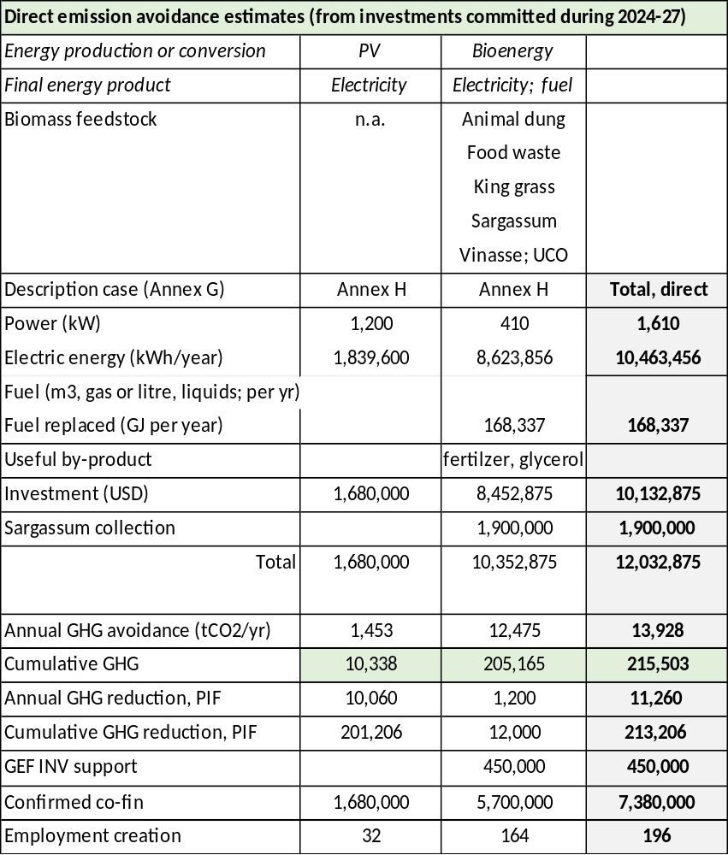
The investment contribution for the pilots may be done through a procurement modality. However, depending on the ownership/ operation type of pilot, other options will be discussed between UNDP and the Implementing Partner, in particular when targeting private sector beneficiaries. Such options could involve, for example, providing a CAPEX subsidy to private companies through a performance-based payment type modality or through other instruments aligned with UNDP Policies and Procedures. The proposed investment mechanism resulting from the pre-feasibility studies for the definition of the bio-energy pilot plan should be reviewed and approved by UNDP Country Office and Regional Technical Advisor.
Box 10 Pilots and demos and expected GHG emission reduction

A number of business cases for various biomass feedstock – conversion route – application combinations, have been assessed, based on own analysis and information available in literature or provided by stakeholders during the project design (PPG) phase. The profiles presented are tentative regarding the number, size, expected electricity or fuel production, source of biomass feedstock. In fact, even the ‘bioenergy pilot plan’ may not be able to fully define the pilots until the developers’ proposals are selected after the Call for Proposals. In order to be able to make an estimate of the expected direct greenhouse gas emission reduction of the pilots, it is assumed that the eventual bioenergy demonstration/pilots will be a superposition of one or more business cases (described in Annex G) that can be grouped in three types:
a) Anaerobic digestion for power production
b) Anaerobic digestion for gaseous fuel (bio-methane) production
c) Production of biofuels

All the business cases (as well as the case of E10 production and supply to the filling station system) are described in Annex G. These have been used, as a basis for estimating the indirect emission reduction of the SMARTER project (see Results framework in Section 5 and calculation methodology in Annex H).

A summary of characteristics of the SMARTER bioenergy pilot/demo activities, and direct GHG emission reduction is given in the table on the left. The methodology for estimation of the GEF indicators (including greenhouse gas emissions reductions) with the calculated SMARTER project targets are included in Annex H.

The direct emission reduction is estimate is the same as Indicator 1) in the results framework table of Section 5 of this report. It should be noted that feedstock supply options, expected power or fuel production and investment needs are indicative and final figures will be based on the feasibility and design studies of the Output 3.1, while the final investment decision will be taken after successful conclusion of these studies.

Pilot/demo projects and the project’s Social and Environmental Safeguards Planning (SESP)

Pilot and demonstration activities that receive investment support from the Project are required to comply with all the relevant national standards of the country as well as UNDP standards on social and environmental safeguards, gender equality and stakeholder consultation. In support of this, specific guidance and inputs have been developed for the program on SES as well as a Gender Action Plan and Stakeholder Engagement Plan which accompany this Project Document (see Annex J and Annex K).

The guidance outlined in the SESP will be incorporated and considered in developing the environmental and social impact assessments and management plans for pilot/demonstration projects. One way to ensure a gender balance is to strive for at least a 25-30% participation of women, who should be involved at various levels of the pilots/demos (decision-making, administrative-financial, operational). A critical consideration is the need to ensure environmentally sound management of residues left after biomass conversion, the positive impacts of proper handling of waste streams with organic content, and to ensure community security as well as health. The responsible handling of waste streams and residues should be clearly documented, budgeted, and monitored in compliance with national and UNDP ESS requirements and national requirements. As a result, specific social-environmental assessments will be carried out for specific demo projects, for example, depending on the type of bioenergy projects, a limited ESIA will also be carried out to ensure that not-so-obvious issues including potential resource-use conflicts (e.g., land and water) are planned for. A Code of Conduct will guide conduct in various contexts including governance, accountability, project design and demonstration project execution in ways that address gender needs as well as issues identified in the SESP relating to stakeholder engagement, community engagement, gender and human rights, local environmental issues and the overall management of risks.

Component 4 Knowledge management and information dissemination

Outcome | Outputs
4. The Project’s knowledge management and M&E plans and outreach activities have been implemented | 4.1 Scientific, technological, engineering, operational and social experiences with bioenergy development in Barbados, collected, promoted and shared, nationally and within the Caribbean region  4.2 Monitoring and evaluation

This project component will establish the Project’s knowledge management framework (KM), implement outreach activities and stimulate intra-regional networking on bioenergy in the Caribbean region.

Output 4.1 Scientific, technological, engineering, operational and social experiences with bioenergy development in Barbados, collected, promoted and shared, nationally and within the Caribbean region
Activities:

4.1.1 Match-making Barbadian stakeholders and foreign knowledge institutes and technology suppliers

To ensure technical availability, a national ecosystem should be created offering design skills, maintenance and equipment and laboratory services as well as collecting and sharing technical, economic and financing information. Rather than starting from scratch, the Project aims to tap into the global resource base by “match-making” of Barbadian stakeholders and foreign knowledge and research institutes (to support the capacity strengthening of local research and training institutes, see Output 2.3). A gender-sensitive approach is encouraged.

Second, the match-making activity will endeavour to systematically interlink Barbadian bioenergy entrepreneurs (and other key actors in sustainable development) with entrepreneurs, investors, venture capitalists and financiers (from other islands, the international level and the diaspora). This will encourage the establishment of joint ventures, foreign investments as well as business-to-business partnerships on the priority bioenergy business cases (identified as part of Output 3.1). Here, close cooperation will be sought as well with the sustainable energy hub of BIDC and other partners (BREA, BBA, CCREEE).

Local stakeholders include UWI, BBA, BAMC, BIDC, BREA, and BNOC. CCREEE’s presence in Barbados can be a valuable asset to build synergies as bioenergy. The Project will seek synergies with national agencies involved in bioenergy in the Caribbean countries as well as regional organisations (CCREEE, OLADE) and international development and other partners (GIZ, IDB, OLADE, UNIDO, IRENA, LEDS LAC). Local stakeholders should also include the Bureau of Gender Affairs and the University of the West Indies Institute for Gender and Development Studies (see

4.1.2 Collation and dissemination of operational experiences, lessons learned and recommendations for value chain development.

The SMARTER project will support the collation and dissemination of operational experiences, lessons learned and recommendations for bioenergy development and applications in the region. The experience of Barbados will also be of interest to other countries in the region. The Project will support the development of at least one ‘insight brief’ capturing (in an accessible format) selected key highlights from the pilot/demo or other successful national project activity. The ‘insight brief’ can cover any activity of the project and take the form of a written brief or video brief. At the end of the Project, a comprehensive end-of-project assessment and lessons learned study will be commissioned (from UNDP co-financing) with detailed recommendations for post-SMARTER action. The brief will include gender and socially-sensitive promising practice and recommendations for value chain development

4.1.3 Outreach and promotional activities to public sector beneficiaries of RE and bioenergy systems (ministries, health, education, sports council), private sector and residential customer

The Project will organise bioenergy promotional events and business-to-business meetings and will conduct workshops and seminars to create awareness and provide accurate information on the application of bioenergy in various end-uses as well as on the pros and cons of bioenergy in terms of improved environmental impacts (water, air quality, marine environment), as well as on the socio-economic cost-benefits). Here, the role of bioenergy in overall energy planning can be clarified and links of bioenergy with land use the circular economy, climate resilience and gender will be stressed.

There have been criticisms of getting correct information from government authorities in terms of applying for and implementing domestic and commercial RE solutions. The awareness program offers the opportunity to explain the process to citizens, including FiT benefits, tax benefits, financing and pay-back based on electricity use savings, incentives, etc. and to do so in a gender-sensitive and socially inclusive way including the use of language as well as images in ways that meet the UNDP and GEF Gender Policy requirements.

Output 4.2 Monitoring and evaluation

This Component will ensure compliance with all mandatory monitoring and reporting requirements of UNDP and the GEF, including the following specific outputs (described in more detail in Section 6). This project component will establish the Project’s knowledge management framework (KM) and assist the GOB in establishing project oversight and monitoring systems, including the Environmental and Social Management Framework (ESMF) and resulting Management Plans (if required), the Gender Action Plan (GAP), the Mid-Term Review (MTR), and the GEF Terminal Evaluation (TE). The MTR and the TE will consider gender as part of the evaluation criteria in keeping with GEF and UNDP guidelines.

Activity 4.2.1 Gender-sensitive M&E and Reporting, including (i) Conducting inception workshop and preparing report, (ii) Ongoing M&E, (iii) Mid-Term Evaluation and (iv) Terminal Evaluation

This Component will ensure compliance with all mandatory monitoring and reporting requirements of the GEF, including the following specific outputs (described in more detail in Section 6):
- Conducting inception workshop and preparing the report;
- Ongoing project monitoring of Results Framework indicators;
- Annual progress reporting;
- Conduct a Mid-term review (MTR) of the project; and
- Conduct a Terminal Evaluation (TE) of the project.

Activity 4.2.2 Final project results and lessons-learned reporting

The experience of Barbados will also be of interest to other countries in the region. At the end of the Project, a comprehensive end-of-project assessment and lessons learned study will be commissioned (from UNDP co-financing) with detailed recommendations for post-SMARTER action. The Project will support the development of a final report’ as well as an ‘insight brief’ capturing (in an accessible format) selected key highlights from the pilot/demo or other successful national project activity as an easy-to-read summary that can cover any activity of the project and take the form of a written brief or video brief. This activity will be under the UNDP grant co-financing (while activity 4.3.1 is implemented with GEF funding).
Box 11 GEF 7 core indicators

As reflected in the Results Framework, the project contributes to the following GEF-7 Core Indicators:
- Core indicator 6: Greenhouse Gas Emissions Mitigated captures the amount of GHG emissions expected to be avoided through the GEF project’s investment in renewable energy minigrids. It should be measured above a baseline value. Mitigation benefits include:
  - Direct emissions reductions attributable to the investments made during the project's supervised implementation period, totaled over the respective lifetime of the investments (215,503 tCO₂)
  - Indirect emissions reductions that could result from a broader adoption of the outcomes of a GEF project plus longer-term emission reductions from behavioral change in the post-project period. Broader adoption of a GEF project proceeds through several processes including sustaining, mainstreaming, replication, scaling-up and market change (329,311 tCO₂)
- Context Sub-indicator 6.4: Increase in installed renewable energy capacity per technology captures the increase in renewable energy generation or storage capacity and is disaggregated by type of renewable energy technology (biomass for fuel or electricity generation, solar photovoltaic, other) – (1,610 kW)
- Core indicator 11: Number of direct beneficiaries disaggregated by gender as co-benefit of GEF investment captures the total number of direct beneficiaries including the proportion of women beneficiaries. Direct beneficiaries are all individuals receiving targeted support from the project (766 people, of which at least 306 women)
The reader is referred to Annex H on how these indicators are calculated for the SMARTER Project.

Expected results

This project will result in GHG emissions reductions which will be measured via the GEF-7 Core indicator 6: Greenhouse Gas Emissions Mitigated. This indicator captures the amount of GHG emissions expected to be avoided through the project’s investment in bioenergy and solar pilots and demo activities.

The indicators will be measured above a baseline value considering that in the absence of the project, the end-users would have been supplied by fossil fuels or power generated by these fuels. Mitigation benefits include both (i) direct emissions reductions attributable to renewable (bioenergy) investments made during the project's implementation period, totalling over a the assumed investment lifetime of 20 years; and (ii) Indirect emissions reductions resulting from the increased uptake of renewable energy technologies due to replication, scaling-up and market change to which the project has contributed by creating a general enabling investment environment and facilitating the design of subsequent investment flows. Annex H describes the methodology used to define targets for direct and indirect GHG emissions mitigated and the related indicators of installed renewable power production and annual energy production (from power as well as gaseous and liquid biofuels). The Annex further indicates how the number of direct beneficiaries disaggregated by gender as co-benefit of GEF investment) are estimated.

Stakeholders, partnerships and co-financing

Stakeholder overview

For optimal impact and contribution to the country, the Project will rely on collaboration across multiple stakeholders drawing on different capabilities, skill sets and resources (see Box 12 for an overview of stakeholders).

The list of stakeholders includes international development partners that are implementing programmes and projects that can be regarded as a baseline for SMARTER (see Box 13). Part of the budget in the NDP project “Improving National Sargassum Management Capacities in the Caribbean” is confirmed co-financing.

Details of partnerships and stakeholder engagement can be found in Annex K (Stakeholder Engagement Plan). In this Annex, a mobilization and communication plan with stakeholders is also outlined. In addition, the Project grievance redress mechanism, which will be set up in accordance with UNDP procedures, is also an essential aspect of inclusive and gender-sensitive stakeholder engagement, particularly engagement with beneficiaries and project-affected communities.

Box 12 Renewable energy stakeholders and their role in the SMARTER project

Stakeholder | Mandate and/or business | Role in SMARTER and specific outcomes
Government and public sector
Ministry of Energy and Business (MEB) | MEB’s Energy Division is responsible for all matters related to energy in Barbados. These include a) energy policy and planning, b) energy licencing (renewable and non-renewable), c) renewable energy and energy efficiency, as well as matters related to oil gas, geology and mining. | MEB will be the Project’s Implementing Partner and, through the Energy Division (Permanent Secretary), oversees various units, such as Project Monitoring and Coordination Team (PMCT), supported by the Division’s Project Execution Unit (PUE), Energy Conservation and Renewable Energy Unit (ECREU) and Planning and Resources Unit (PPRU). This includes activities such as overall planning and strategy, coordination with stakeholders, procurement of goods and services, execution of activities, M&E. The Natural Resources Department (NRD)will also provide support to ESS monitoring and act as a source for lessons learned from the non-renewable sector.
Ministry of Environment and National Beautification (MENB) | MENB is to promote and facilitate the sustainable use of our resources by encouraging the involvement of all citizens and the integration of environmental considerations into all aspects of national development.  - Environmental Protection Department is responsible for protecting the natural and built environment, through the promotion of sustainable practices, education, partnerships and the enforcement of legislation.  - Sanitation Services Authority has responsibility for sanitation and sewerage wastewater management system), solid waste management systems, and drainage systems for rainwater (storm water drainage). | MENB’s Permanent Secretary is the GEF Operational Focal Point. Environmental protection is a key issue in terms of the impacts of feedstock used, bioenergy conversion systems and residues.  The Ministry will be important in the case of sargassum harvesting and its possible use as feedstock for anaerobic digestion. SSA will be involved in SMARTER through its involvement in solid waste management (the landfill and recycling centre at Vaucluse) and the segregation of organic waste streams at the source as well as the Vaucluse collection point. Equally, SSA will contribute to ESS monitoring on waste and pollution management as a reviewer of TORS and draft assessment reports as well as the sharing of relevant SOPs that could be adapted in SMARTER’s ESS management approach.  The EPD plays a critical role in EIAs and in E(SS) monitoring in the country generally and will provide support to aspects of ESS monitoring relating to community health safety and security as well as resource efficiency and pollution management issues.
Ministry of Transport, Works and Water Resources (MTWW) | MTWW is responsible for efficient road network services, proper maintenance of Government buildings and vehicles, effective drainage solutions, special electrical services and public transportation.  - Government Electrical Engineering Department (GEED) is responsible for design approvals and inspections of all RE installations in Barbados to ensure safety and compliance with relevant codes and standards. GEED also maintains electrical systems in government-owned buildings, where PV systems have been installed.  - Barbados Water Authority (BWA) is the entity in Barbados charged with supplying the island with potable water as well as the provision of wastewater treatment and disposal services to the sewered areas of Bridgetown and the South Coast. | GEED will play a role with respect to the installation of decentralised RE systems in government-owned buildings. Regarding the cooperation with BWA, SMARTER will look for synergies with the GCF-funded project (3R-CReWS; see Box 13, currently under preparation) in particular in its Component 1 on this project proposes to employ environmentally friendly bioreactors (BRs), micro-organisms generating bio-hydrogen and biogas and subsequent harnessing of energy using fuel cell technology to effectively treat the wastewater
Ministry of Agriculture and Food Security (MAFS) | The MAFS is responsible for the agricultural sector and agricultural lands and is therefore an important stakeholder in the development of the bioenergy sector. | MAFS’ input is relevant and necessary in the development of policy and regulations as well as the locations for bioenergy production. In its turn, the Project is relevant for MAFS, being currently without a specific policy on agriculture and energy
Fair Trading Commission | Under the purview of the MEB, FTC is the economic regulator of the incumbent utility, responsible for setting tariffs and rates of RE electricity including bioenergy technology. FTC is further responsible for consumer protection and ensuring fair competition in the market | As the regulator FTC will be involved, in discussions with BLPC as an off-taker and IPPs for defining feed-in tariffs for bioenergy. Its role is also in ensuring fair competition (tendering processes) and just distribution of rights and benefits as
National Petroleum Company (NPC) | NPC is the statutory body set up with responsibility for the management of the distribution of natural gas supply in Barbados for domestic, commercial and industrial use.  - Barbados National Oil Company Ltd. (BNOC) is responsible for the production of crude oil, and natural gas and imports of liquefied petroleum gas (LPG) and LNG. Natural gas is sold to the parent company NPC which delivers the natural gas through its pipeline network, and 24.5% is owned by NPC while the GOB holds the remainder of the shares  - Barbados National Terminal Company Ltd.(BNTC) supplies diesel and fuel oil to local major oil and gas retailers who sell these products to the Barbadian public (Sol and Rubis) | It is envisaged that bio-methane and liquid biofuels (biodiesel and ethanol) will play eventually a large role in replacing fossil fuels as Barbados strives to become 100% fossil fuel free. BNTC is currently carrying out a pilot on biodiesel which may evolve into a SMARTER-supported demonstration project. BNOC is looking into options to inject bio-methane from anaerobic digestion into its pipeline system, which is another potential demonstration project
Barbados Agricultural Management Corporation (BAMC) | Under the purview of MAFS, BAMC is responsible for the management and commercialization of the products produced by the proponents of the agricultural sector. BAMC manages and operates around 30% of the sugar industry in Barbados and owns the Port vale sugar cane factory. BAMC’s research department acts as an official advisor for Barbados | BAMC, BSIL and private farmers have been in discussion to establish Grow Energy, a company aimed at producing sugar cane by-products and biomass energy.
Export Barbados (f.k.a. BIDC, Barbados Investment Development Corp.) | BIDC (since 2021 trading as Export Barbados) supports small and medium enterprises (SMEs) and larger companies aimed at developing Barbados’ industrial, export, and other related activities. | BIDC is involved in a proposal to set up an anaerobic digestion plant, using food waste, roadside grasses, and industrial wastewater from BIDC’s industrial estates
Barbados National Standards Institute (BNSI) | Under the purview of MEB, BNSI sets and regulates the standards in Barbados. | BNSI will be an important stakeholder in setting the standards for biomass and biofuels.
Multilateral and bilateral development partners
Development finance | Inter-American Development Bank (IDB), European Union (EU) and Caribbean Development Bank (CDB) support small- and medium-sized sustainable energy projects through a mix of loans and grants (see overview in Box 13) | Synergies will be sought with the IDB-funded Smart Energy Fund II project which makes funding available for RE (and EE) projects in the public sector as well as private sector and there is scope for SMARTER add-value in smarter capacity regarding RE and EE
CARICOM-Caribbean Centre for Renewable Energy and Energy Efficiency (CCREEE) | CCREEEE functions as CARICOM’s CARICOM Energy Knowledge Hub, aiming to complement and strengthens ongoing national/regional activities in the areas of policy and capacity development, knowledge management and awareness raising, as well as investment and business promotion | The Project will closely coordinate with the CARICOM Energy Unit and the CARICOM Caribbean Centre for Renewable Energy and Energy Efficiency (CCREEE)
Caribbean Community Climate Change Cente (CCCC) | CCCC s a regional entity whose work is focused on small island developing States in the Caribbean (incl. capacity building, awareness raising, implementing mitigation and adaptation projects, policy advice and support) | CCCC is a GCF-accredited entity responsible for the 3R-CReWS project (see Box 13), currently in its formulation phase
GIZ (German international cooperation) | GIZ supports Barbados from its office in the Dominican Republic through technical studies and advice for the GOB and its support to CARICOM/CCREEE as its regional partner. Worth mentioning is GIZ’s support in developing the regional C-SERMS regional strategy | GIZ is also a strong partner for technology transfer to Barbados, notably biodigester technology in which Germany is a world leader. GIZ has supported a regional roadmap assessing climate risks in the region, including Barbados.
UN agencies | - UNDP implemented the GEF-funded DREAM (Disaster Risk and Energy Access Management) project from 2015-19. The Project implemented 22 grid-tied PV systems with battery back-up at CRCs (70-kWp in total) and 9 grid-tied PV systems combined with existing diesel generation at polyclinics (171-kWp) and support the delivery of a draft utility license for IPPs (as a basis for negotiations with the utility BLPC).  - UNIDO implements the GEF-funded Strategic Platform to Promote Sustainable Energy Technology Innovation, Industrial Development and Entrepreneurship in Barbados with MEB, BIDC and CCREEE | UNDP is the GEF agency responsible for project oversight (see Section 7). Synergies will be sought with the regional project, Improving National Sargassum Management Capacities in the Caribbean (expected to run during 2022-2025). This Japan-funded initiative will boost marine and near-shore coastal conservation efforts and support integrated coastal management actions. As sargassum is regarded as an imported feedstock in anaerobic digestion the near-shore and off-shore equipment provided under the programme is regarded as co-financing (USD 1.9 million)
LEDS LAC  Low-Emissions Resilient Development Strategies | LEDS LAC is a network of organizations and individuals working in the promotion, design and implementation of LEDS in Latin America and the Caribbean. | The Bioenergy Community of Practice (BioE CoP) was launched in 2015 (with LEDS Global Platform) and is a peer-to-peer learning network of practitioners from governments, the private sector and non-governmental organizations, who work together for advancing the development of bioenergy in Latin America and the Caribbean.
International Renewable Energy Agency (IRENA) | IRENA is a lead global intergovernmental agency for energy transformation that serves as the principal platform for international cooperation, supports countries in their energy transitions, and provides state-of-the-art data and analyses on technology, innovation, policy, finance and investment. IRENA works with countries in, e.g., renewable energy assessments and roadmaps, grid flexibility planning, entrepreneur support as well collaborative frameworks (such as on energy transition and high shares of renewables). | Barbados is a partner in IRENA’s SIDS Lighthouses Initiative is a framework for action which brings together 38 SIDS and 31 partners to support the island's energy transformation and climate action.
NGOs, universities, and other
NGOs | NGOs include Future Center Trust and Barbados Environment Conservation Trust. The NGOs I Am A Girl; Business and Professional Women’s Club of Barbados (BPW Barbados); and Code Red for Gender Justice | The engagement of these NGOs can help deepen the gender assessment as well as for broader stakeholder engagement regarding the job market and capacity building. Conducting consultations with Barbadian women’s groups as well as relevant regional gender organisations can provide the necessary perspectives for SMARTER given its GEN 2 rating.  NGOs can also support capacity-building efforts under Components 1 and 2 related to social inclusion and gender equality (with a specific view to ensuring that Persons with Disabilities are not left behind in SMARTER). At least one NGO is recommended as a member of the Bioenergy Task Force especially in identifying complementarities between bioenergy production/development and other sustainable development initiatives.
Universities and training | - University of the West Indies – Cave Hill has a MPhil/PhD in Environmental Science and BSC in Physics that include sustainable energy courses or topics. Under CERMES, there are also some integrated perspectives in natural resources and environmental management courses. Research is carried out on bioenergy, such as the use of agro-residues and sargassum in anaerobic digestion.  - Samuel Jackman Prescod Institute of Technology offers vocational/professional certificates in photovoltaic, electric installation as well as electric vehicle fundamentals  - Barbados Community College has an Associate Degree in Mechanical Engineering that includes power generation and energy efficiency  - Barbados Vocational Training Board is involved in solar water heater technician training | Execution of capacity building and research activities, knowledge accumulation and dissemination management; providing research inputs on key documents such as the capacity needs assessment, bioenergy assessment and policy. UWI carries out research and pilot activity on biomethane. The MSc in Renewable Energy Management previously offered by the Department of Pure and Applied Sciences at UWI is planned to be restarted. Bioenergy modules could be further developed and integrated into MSC/BSc environmental, physics, biology and chemistry courses
Universities and training | - UWI has the Institute for Gender and Development Studies (IGDS) based at the University of the West Indies on all three campuses. In Barbados, it is also referred to as the Nita Barrow Unit or NBU. Its mission is to produce and disseminate knowledge to transform gender relations in the Caribbean, in support of the University's mission to enhance regional and international development. | The NBU will be an important stakeholder in capacity development and knowledge management components of the project with specific emphasis on Outcomes 1 and 2. Recommended as members of the Task Force.
Private sector and private sector organisations
Barbados Light and Power Company Ltd. (BLPC) | BLPC is a private firm owned by Light & Power Holdings Limited (L&PH) that owns and operates all electricity production, transmission and distribution facilities in Barbados. BL&P’s current license for the exclusive right to supply electricity for any public or private purpose under the Electric Light and Power Act (ELPA) is valid until 2028. As of 2010, 70% of the shares of BL&P were owned by Emera Holdings of Canada with the remaining shares owned by Barbadian investors. | BLPC is a key stakeholder in new bioenergy technologies, policies and procedures being introduced for on-grid power generation
Fuel suppliers | Sol Group is a Barbados-owned petroleum product distribution and retail company active in 23 Caribbean markets. Rubis Caribbean, part of the French-owned Rubis Group, is its main competitor in Barbados. | Fuel suppliers would be involved in B10 biodiesel and E10 ethanol in their filling stations
Associations | - Barbados Sugar Industry Ltd presents the private sugarcane farmers  - Barbados Renewable Energy Association (BREA) is an NGO that represents the interests of (private) companies involved in renewable energy. Members include Blue Circle Energy, HDF Energy, BLPC, Blackstone Megawatt, Caribbean LED Lighting, NGE, Emera, EnSmart, Massy, Solar Genesis, Solargrow and Williams Solar  - Barbados Biogas Association (BBA)’s members come from the sugar industry, attempting to influence policy towards the government repurposing the sugar industry for bioenergy. They have not met since the COVID situation | Stakeholders in various Outcomes including Outcomes 2, 3 and 4. Beneficiaries potentially of capacity assessments under Component 1 and capacity development under Outcome 2.

Project partners and co-financing

Close partnerships are foreseen with a few key players that are formalized through “co-financing letters” (see Annex R).
An overview of the role of the main project co-financiers and project partners is given in Box 12.

Box 13 Overview of SMARTER-relevant baseline projects (recently closed, current or under development)

Loans and grants | RE |  | EE | Transport | Other
Public Sector Smart Energy Programme (PSSEP)  IBD: USD 24.8 million (loan)  EU: EUR 5.8 million (grant)  2013-present | Installation of 3.8 MW of solar PV on 22 public buildings |  | Retrofit about 27,100 public lighting and retrofit EE in 15 public buildings | Electric vehicle and pilot (eight government vehicles | - Study on option off-shore wind and ocean energy  - Cap building, public awareness; public education (EE/RE kits)
Smart Energy Buildings  Rep.of Korea: USD 3million  2019-present | Installation solar PV systems and storage |  | Design of energy management system (EMS)
Deployment of Cleaner Fuels and Renewable Energy  IDB: USD 34 million | Financed by an IDB loan to the National Petroleum Corporation (NPC) and the Barbados National Oil Company Limited (BNOC) supports the diversification of the energy mix, energy efficiency measures and the use of renewable energy and storage technology within the premises of the NPC and the BNOCL.
Sustainable Energy Investment Programme (Smart Fund II)  IBD: USD 30 million (loan)  EU: EUR 13.26 million (grant)  2019-present | Private:  Promotion of RE and EE in SMEs:  - Grants for feasibility studies  - Loans for lighting replacement, EE technologies, solar photovoltaic (PV) installation, energy storage, and electric vehicles will be eligible for funding  - A/C rebate facility |  |  | Public sector  - Pre-investment studies  - Retrofitting of buildings with RE and EE technologies with focus in transport (PV on solar terminal), agriculture (BAMC, agri-solar), health and education  - Expand PSSE with 10 electric buses |  | Other:  Strengthen MESBE units (PEU, EFGL);  - Training, gender, young apprentice  - Studies on EE Action Plan, e-mobility and financing EE/RE
The following GCF projects are under preparation with Ministry of Finance:  - 3R-CReWS (CCCC)  GCF: USD 39 million  Co-fin (USD 10 million)  - Scaling up the deployment of Integrated Utilities Services (IUS) to support energy sector transformation  GCF+cofin: USD 43.5 million | - The R’s (Reduce, Reuse and Recycle) for Climate Resilience Wastewater Systems in Barbados (3R-CReWS) will have the following activities; a) Community-based training and education; b) Reintegration of the wastewater treatment products and by-products (treated water; sludge as fertilizer), c) Resilience building of the wastewater treatment process, including generation and use of generating bio-hydrogen and biogas and adaptation of facilities to extreme weather events (hurricane, storm water filtration)  - The programme aims to reduce/avoid greenhouse gas (GHG) emissions and enhance climate resilience in the participating Borrowing Member Countries (Barbados, Belize, Guyana and Jamaica) by increasing uptake of distributed renewable energy (RE) technologies, energy efficiency (EE) measures and other distributed energy resources (DERs) among the electric utilities’ customers. To do so, the programme will support the electric utilities in these countries to successfully establish the Integrated Utilities Services (IUS) model
UNDP: Disaster Risk & Energy Access Management (DREAM)  GEF: USD 1.55 million and co-financing  2015-2019. Closed | - Strategic plans and licensing regime approved for accelerated RE development (grid stability, (distributed) solar PV planning and licensing; ICT). Institutional and technical capacity and awareness strengthened for clean energy development. Feasibility, installation assistance for solar PV demo projects (35 licenses granted for private PV) - Installation of 2.5-kWp (18), 5-kWp (2) and 7.5-kWp (2) grid-connected PV systems (total 70-kWp) with battery backup on 22 community centres; Installation of 9 on-grid PV systems (total 171-kWp) with existing diesel back-up at 9 polyclinics.  - The final evaluation (2019) provides some recommendations for post-project follow up that have been addressed in the formulation of Component 1 of SMARTER
Supporting Energy Transition Implementation and Smart Energy  Technology Expansion in Barbados  IBD: USD 0.55 million (grant)  2019-present |  | - Development of a tool for modeling and forecasting national energy demand and deployment Conducting demand-side and resource deployment studies, including support for supporting BNOC in the preparation of a Plan for its clean energy transformation  - Training on IRRP, smart metering, smart building and smart grid technologies; and forecasting RE generations, energy demand and energy consumption patterns
UNIDO: Promote sustainable energy technology innovation, industrial development and  entrepreneurship in Barbados  GEF: USD 1.78 million  Other: USD 12.9 million  2019-present (incl. CCREE, BIDC) |  | - A dialogue platform and policy proposals to promote sustainable energy and climate innovation, entrepreneurship and industrial development Improved access of sustainable energy entrepreneurs to regional and international know-how and finance (hub, matchmaking, financing)  - R&D partnerships, training on RE and EE  - Proposals for improved product, service and qualification (e.g. PV, SWH, other)
UNDP: Improving National Sargassum Management Capacities in the Caribbean  Budget: USD 12.46 million  (Equipment: USD 9.76M, of which USD 1.91M Barbados | - Provision of in-water and onshore equipment to remove and collect large quantities of sargassum from territorial waters and coastal areas of five (5) Caribbean countries;  - Develop sargassum management plans using the latest aerial and spatial technologies to monitor and improve coastal ecosystem conservation and integrated coastal zone management  - Strengthen capacities and skills to effectively utilise sargassum removal equipment  - Providing a platform for regional dialogue, communications, sharing experiences and lessons learnt

Box 14 Co-financing and sources

Co-financing source | Co-financing type | Co-financing amount (USD) | Included in project results
MEB | Grant / in-kind | 3,270,000 | Output 3.3
NPC/BNOC | Grant / in-kind | 5,050,000 | Output 3.3
BAMC | Grant / in-kind | 530,000 | Output 3.3
BIDC | Grant / in-kind | 130,000 | Output 3.3
BLPC | In-kind | 20,000
FTC | In-kind | 20,000
UWI | Grant / in-kind | 200,000 | Output 2.3/3.3
BREA | In-kind | 30,000
CCREEE | In-kind | 50,000
UNDP Barbados | Grant / in-kind | 100,000
UNDP/Japan project ‘Improving National Sargassum Management Capacities in the Caribbean | Grant | 1,900,000
TOTAL |  | 13,550,000

It should be noted that none of these funds will flow through UNDP accounts. Some funds are to be utilised for realizing the investment pilot/demo activities of Output 3.3 (for a further description of co-financing, please refer to Section 8 as well as the summary table in Annex B). UNDP is not directly accountable for these funds but will report the realization of co-financing amounts and realization amounts annually in the GEF PIR, at mid-term and at terminal evaluation. Risk management measures identified will be only those within the control of the UNDP project (see section 4.3). Specifically, potential risks associated with co-financing that may affect the Project, (e.g., managing reputational risk) will be considered in safeguards due diligence and the project risk register and monitored accordingly.

South-South cooperation

As a development tool, South-South Cooperation (SSC) will promote cooperation within the Caribbean region through the sharing of best practices and the diversification and expansion of development options and possible economic links.
- In this respect, UWI with campuses in various countries in the region will be instrumental in partnerships and connecting knowledge to opportunities for multi-stakeholder bioenergy solutions with a special Caribbean focus
- CARICOM’s CCREEE will be an important partner when it comes to the promotion of innovative sustainable energy and climate innovations in the wider Caribbean. CCREEE and other regional organisations will also be important to reach out to potential strategic RE and EE investors and financiers as well as suppliers and other stakeholders on the sub-regional and international levels.
- Established by the LEDS LAC Regional Platform and the LEDS GP Energy Working Group, the Bioenergy Community of Practice (BioE-CoP) brings together multiple LAC government leaders and key international experts to exchange good practices and provide tools and resources towards the design and implementation of bioenergy policies and programs.

In addition, the experience will be sought with countries in the region that have experience with bioenergy development (ethanol, gasification, anaerobic digestion), such as Brazil and Argentina. UNDP’s network of country offices will be an important asset in realizing such country-to-country exchanges.

Risk and assumptions

The risks faced by the project and the countermeasures that have been proposed to reduce or eliminate them are detailed in the risk log of Annex F. The risks include those emanating from the SESP shown in Annex L as well as risks related to COVID-19.

Box 15 summarizes only the moderate, substantial and high risks. As per standard UNDP requirements, these risks will be monitored quarterly by the Project Manager. The Project Manager will report on the status of the risks to the UNDP Country Office, which will record progress in the UNDP risk register. Management responses to critical risks will also be reported to the GEF in the annual PIR. Implementation Partner risks identified through HACT (see Annex O) are also covered.

Climate Risk Assessment

The climate resilience of infrastructure in SIDS is a pervasive and long-standing issue. Additionally, it is expected that intensifying ambient air temperatures and drought conditions could have some impact on organic waste production, including animal manures and the biomass content of sargassum, wastewater production and other possible sources of feedstock.

Climate Risk assessment for the Renewable Energy Sector

1) Hazards: Barbados has not experienced a major climate shock since Hurricane Janet in 1965, and nothing on the scale of the catastrophic events that its neighbour countries have experienced in recent years. It has, however, been affected in recent decades by various climatic shocks including Hurricane Tomas in 2011 which damaged approximately 1,500 houses, caused interruptions to 80% of the island’s electricity supply and resulted in approximately USD1.85 million (BBD 37 million) worth of damages (Grainge 2017). Hurricane Matthew in 2014, and a tropical depression in 2016 have led to flooding throughout the island (Robinson and Rogers, 2018).

2) Assessing vulnerability and exposure and rating the risks: According to Grainger (2018), ‘between 1972 and 2010, approximately 70% of damages to infrastructure caused by storms and hurricanes in the Caribbean were to the transport sub-sector, while 25% was to the energy subsector and the remainder to the water and sanitation sub sector’. With the integration of more renewable energy sources, it is important to ensure that the existing and future energy generation and transmission/ distribution infrastructure is climate resilient. In the case of a climatic shock, the power sector is highly exposed, but it is generally the transmission and distribution infrastructure that presents systemic risks.

Studies on the impact of climate change on biomass vegetation serving as (potential) energy feedstock are quite limited in the region. A recent one is on switchgrass and is not immediately relevant to Barbados. Another study focuses on lignocellulosic feedstocks and looks at how changing climate change conditions will affect plant processes including adaptation that could affect bioenergy production. More ongoing work will be needed to monitor possible climate change risks to bioenergy production in islands similar to Barbados, particularly concerning feedstock generation. Current climate scenarios suggest that drought and increased temperatures will be the more significant threats to biomass production while excessive rainfall and tropical cyclones would be the greater threat to infrastructure and installations depending also on the gradient and contours of sites where demo projects may be installed even temporarily.

Regarding decentralised RE regulations and investments in general (see Outputs 1.2 and 3.3), poorly enforced planning regulations and building codes can be key risk factors in solar PV installations. Design specifications will be insignificant if the structures to which they are affixed are not structurally sound or constructed in accordance with the building code. If enforced structures should be able to withstand Category 3 storms, it is important to consider the resilience (to higher category hurricanes) of the roofs and structures to which renewable energy systems are attached as well as the systems themselves.

3) Possible measures to manage the risk: The potentially catastrophic nature of climate risks in the Caribbean, particularly in the context of climate change, means that risk transfer is likely to play an important role in building resilience. This is enabled by the design of appropriate financial instruments, including insurance. Currently, there are significant barriers to risk transfer in the renewable energy sector. As the client of IPPs and sole distributor of electricity on the island, BLPC bears the risk of supply interruptions. Going forward, as it signs more power purchase agreements with IPPs, it may be important to include contractual clauses that require IPPs to implement similar risk management procedures to their projects. The Activities related to Barbados’ bioenergy policy will address the impact of climate change on the availability of land and marine biomass resources in Barbados. The Risk Assessment Matrix (Box 15) highlights the role of climate itself as a risk to the SMARTER project – both project activities and possibly also to rooftop PV and bioenergy installations.

SES Risk Management

Screening and categorising projects is a key requirement of UNDP’s Social and Environment Standards and GEF’s Environmental and Social Safeguard Standards. The SESP screening of the SMARTER project (see Annex L) has an overall risk categorization of moderate risk focused on three main SES standards: labour and working conditions, community health, safety and security and pollution prevention and resource efficiency. In addition to these risks, more general concerns exist on impacts related to the SES principles, of human rights, gender equality and women’s empowerment as well as accountability of the project which includes stakeholder engagement, access to information and the ability to exercise other rights in the context of opportunities and benefits generated from bioenergy production.

A summary description of the project’s environmental and social safeguards mitigation approach has been elaborated and has been added to Annex L and is intended to support the project management team and implementing partners to apply UNDP SES management requirements. Annex L includes a summary of key risks, benefits and proposed actions, relevant legislation and institutional frameworks that guide SES management and monitoring, required procedures for screening, assessment and management, stakeholder engagement and information disclosure, grievance redress mechanism, institutional arrangements and capacity building, monitoring and evaluation arrangements and specific planned actions and timelines.

Box 15 Project risks, including impact and probability, and mitigation measures (as per the ERM and risk log)

Description and [type] | Level | Mitigation Measures
Social and environmental risks (see also Annex L on SESP for more details
- Stakeholders (in particularly marginalized groups) might face restricted access to basic services (electricity) as energy tariffs may become no longer affordable for low-income groups under a 100% RE scenario [social]. | M | The stakeholder engagement plan (Annex K) will guarantee that the perspective of potentially excluded groups and right-holders is heard and integrated to project design and implementation. Enhanced stakeholder engagement measures including expansion of groups to be consulted regularly as part of project implementation. A GRM will be created for the project that can be used by the MEB going forward for gender and stakeholder issues.
- Energy projects may affect livelihoods and access to services by women and men in different ways. Women may not be equally included in decision-making processes regarding decentralised energy projects and may not benefit equally as men in all areas/opportunities such as employment or business development [environmental]. | M | The Assessment identifies a need to focus on women’s participation in the sector as well as the gender sensitivity of institutions and their energy development practice, very much in line with the draft Gender Strategy for the Electricity Sector developed for the Ministry with support from the Inter-American Development Bank (IABD). The Barbados labour market remains segregated by gender particularly the category of jobs that are most closely aligned to energy and electricity generation. Careful attention to these factors is required to mitigate the risks through a socio-economic and livelihood assessment during project implementation.
3. Within demonstration sites, economic displacement (temporary and mid-term) could occur. Loss and gains may occur from transitions from crop agriculture to feedstock production and the competition that may arise between feedstock production and crop and livestock agriculture for resource such as land and water [environmental/social]. | M | To address this, the project will develop a targeted gender-sensitive socio-economic assessment and livelihood assessment. The livelihoods assessment will focus on risks related to project activities, within the pilot sites under the agriculture and tourism sectors. The assessments will enable determining whether a Livelihood Action Plan that could ensure proper compensation of livelihoods by the affected stakeholders.
4. Land use issues may arise, resulting in habitats being negatively affected or even endangered as a result of inappropriate planning and design of RE projects including where BD and CHSS risks may combine [environmental]. | M | For the upstream activities, the project will be designed to establish criteria for zoning bioenergy potential (in line with the Ministries of Environment’s and of Agriculture’s policies) and shaping the licensing process for bioenergy projects. The pilots/demos supported by the GEF intervention will assess constraints. The Project in its Outputs 1.1 and 2.1 (energy/bioenergy policy) will coordinate with existing natural resources, marine environment and biodiversity plans. ESIAs to be conducted before any demo project is initiated should identify potential sources of risks and specific actions that can mitigate these risks.
5. The Caribbean region is susceptible to hurricanes and natural disasters on an annual basis (occurrence and impact intensified by climate change) that can impact the functionality of bioenergy supply and systems (including delays to project implementation). Though Barbados has not had a serious hurricane event, it is regularly impacted by flooding, land degradation and household damage, most recently Hurricane/TS Elsa [climate]. | M | A climate change and natural hazards assessment will be conducted and inform the project strategy. The construction of any bioenergy facility or structure should assess these risks and possible mitigation actions. This may require careful attention to the location as well as the infrastructure in place and or to be built to support project demonstration and pilot activities ensuring, where possible, hurricane as well as flood resistance. Continuous monitoring of climate data particularly for hurricanes and tropical storms should allow the project to respond to this risk. Contingency measures as well as a Business Continuity Strategy are also encouraged.
6. Inadequate construction practices and operation of energy infrastructure/ technology may lead to occupational health and safety hazards for personnel and persons living nearby or those who conduct livelihood activities nearby [social/regulatory]. | M | In the pilot/demos’ targeted assessments/focused ESIAs will inform the pilot site ESMPs, and will delineate specific measures (to be developed and implemented during project implementation) to guarantee adequate construction practices and the scope of presentation of any concerns related to such by stakeholders, beneficiaries or other affected parties. This is expected to include a Grievance Redress Mechanism. A related Constructors Environmental and Social Management Plan (C-ESMP) could be developed to ensure adequate practices. In any case, TORs and bidding documents (in the call for Proposals, Output 3.2) will also include these requirements and contractors will be expected to develop their own ESMPs. The GRM will allow individuals to raise any concerns they may have or any negative experiences for a prompt response and remedial action.
7. The proposed Project activities may involve the handling and transportation of waste (both hazardous and non-hazardous). Waste generated by the project is expected to be minimal, inert and of potential fertilizer values  [health/environmental]. | M | There may be some risks to water quality as well as human health from accidents or spills. Waste management will be addressed at a policy level (bioenergy policy) and, depending on the type of the pilot/demo, on a project level, to guarantee the correct disposal of digestates during the demonstration activities. Waste and pollution assessment to be carried out for demo projects.
Financial, policy and economic
8. Carrying out the implementation plan of the BNEP meets substantial delays and annual targets of RE penetration cannot be met [policy]. | M | Changes in political context or priorities cannot be excluded and are generally beyond the control of a GEF project. However, Barbados’ policy framework towards a low-emission, sustainable energy sector is well-established with the new BNEP (2019-2030). a move away from the established policy seems highly unlikely. However, government budgets are limited, while private investments in RE systems may not come in the scale or timeframe expected. Multi- and bilateral technical assistance and investment programmes will accompany the GOB over the next years.
9. Bioenergy systems would not attain technical and operational maturity within the Project’s timeframe.  [technology/economic] | H | The sustainability of bioenergy in Barbados depends on feedstock and land availability, import prices of feedstock and materials a supportive value chain (ecosystem) including skilled operators, and the levelized cost per energy unit of the electricity or fuel produced with biomass sources. Especially biodigester technology requires strict operating conditions to maintain biochemical processes within the established parameters. While bio-digestion is successfully deployed in several industrialised countries, there is little experience in Barbados so far.  The presence of local counterparts including UWI, BBA, and CCREEE are enabling factors for building a local (or regional) ecosystem, which will be strengthened by the Project. Local partners will be supported in carrying out detailed assessments of various feedstock-conversion-application pathways of bioenergy and of feasibility analysis of specific bioenergy investment proposals in particular.
10. Co-financing of investment in public RE systems will not or only partly materialise.  [financing/operational] | M | Commitment letters have been provided by co-financing partners. These commitments will be tracked and reported on during implementation. The realisation is not only partly dependent on committed co-financing but also equity-financing organised by the private developers to have an active interest..
11. Poor appetite from private investors limits the uptake in Barbados of bioenergy in particular and/or of RE systems in general  [financing] | M | To reduce risk in the area of biomass-generated power, the Project will help in finetuning the current biomass feed-in tariff to values that realistically affect the LCOE (based on bioenergy assessment and feasibility studies supported by the Project. BNOC has an active interest in the injection of bio-methane into its gas pipeline system and currently receives support from IDB (cleaner fuels project). The introduction of biodiesel or ethanol has an extra layer of risk in the sense that the introduction is not a project-by-project but is an ‘all of nothing’ in which all the 40+ filling stations have to provide E10 or B20. The Project’s bioenergy assessments and feasibility studies will help NPC/GoB decision-makers in formulating a ‘go/no-go decision
Operational and COVID
12. The Implementing Partner would face limitations to prepare and implement project activities in accordance with annual work plans [operational] | L | Work plans are inevitably exposed to external factors including Government decision-making and the need to align agendas and timeframes across multiple stakeholders. While implementation delays cannot be discarded, it should be noted that the Ministry (MEB) has extensive experience working with international cooperation agencies and projects. Multi- and bilateral technical assistance and investment programmes (IDB, GEF and GCF-funded) will accompany the GOB over the next years. This provides a solid basis for the SMARTER proposal.
- Resurgence of COVID or new pandemics may cause supply chain delays and disrupt project activities [health/social] | L | New Covid-19 variants may come up leading to new waves of COVID-19 infections. The COVID-19 pandemic can impact project implementation. The COVID-19 pandemic limits social interaction and restricts community activities. This situation may hinder proposed project activities, such as beneficiary needs and impact surveys, the design and installation of the project-supported minigrid pilots as well as the organization of stakeholder and capacity-building promotional events. The economic impact of COVID-19 may shift investment priorities of the individual, government, and companies towards preventing uncertainties. In such cases as mentioned above, a contingency plan will be made by bringing some activities forward as possible, and with online meetings.

Mainstreaming gender

Introduction

Gender is a socially constructed concept and refers to the roles assigned and opportunities ascribed to men and women, within a specific cultural context, and at a particular point in time on the basis of their sex (Hannan 2001, Dunn 2012). Since gender roles are socially constructed and not biologically determined, they can be changed. This change may be desired and it can lead to gender equality. Gender equality is defined as the creation of equal rights, power and opportunities for women and men by allowing them to contribute on an even footing economically, politically, socially and culturally. It entails that society values the roles played by men and women equally. Gender equity leads to equality and is the process by which men and women are treated fairly. This often includes proactively compensating for the disparity in historical and social disadvantages that otherwise reinforce the inequitable basis on which women and men operate. The ultimate goal of gender mainstreaming is to transform unequal social and institutional structures into equal and just structures for both men and women.

Poverty, labour and gender

In 2021, Barbados had a human development index of 0.79, a gender development index of 1.034 and a gender inequality index of 0.268 despite these significant strides in human development, 19.3% of the population live in poverty. Poverty is not necessarily equally distributed with St. John and St. Joseph recorded as having a higher share of poverty and with female-headed households experiencing more poverty than male-headed households. The country has a high cost of living which is partly due to the large fuel importation bill the country which affects the cost of various essentials. Coupled with the pre-existing high cost of living, the COVID-19 pandemic also exacerbated economic situations for many. With COVID-19 restrictions being implemented internationally and nationally, the tourism sector was hit hard as a result, resulting in numerous job losses and temporary business closures. The tourism sector accounted for about 40% of jobs, many of which are held by women (the financial impacts of Covid-19 were felt more disproportionately by women) and the country saw its economy contract by 18% in 2020.

From the 2021 labour market statistics, 85.5% of the female labour force is employed with 14.5% of the female labour force being unemployed. These figures represent the employment status of 57.6% of the total adult female population who participate in the labour force. In the electric, gas, steam, water and air conditioning supply industry, 0.7% of working women are involved in this sector which is half of their male counterparts has 1.4% of working men involved in this sector. Considering the bioenergy aspect of this project, the lower participation rate of women in agriculture should be noted concerning mainstreaming gender and having gender equality as a core principle of this project. Nearly 80% of farms are owned by men and men account for 81.8% of skilled agricultural labourers. In addition to this, there is a discrepancy in the amount of land owned by male and female farmers with men’s land acreage being 0-1,954 and women’s being 0-1,342.

The Barbados Bureau of Gender Affairs Is responsible for the integration of gender in all national development policies and programs to achieve gender equity and equality. A Draft National Policy on Gender has been formulated but has not been made publicly available yet. Regarding energy and climate change policies, gender issues are referred to in places in the documents relating to these policies, but no strategies are articulated by which gender equity can be integrated.

Although legal frameworks guarantee women’s and men’s equal rights in Barbados, the reality is different. For example, access to financial services and opening a bank account or registering a business is less clear or assured. There is evidence of the existence of discriminatory practices that restrict women’s access to financial services. The 2016 Gender Assessment for Barbados (by the Caribbean Development Bank) noted that the majority of self-employed persons and owners/managers of businesses are men, and listed the following challenges faced by women. Even though women receive less credit and receive funds that have an average lower value than that of men, the per cent of collateral required is also higher for women. Therefore, female-headed households, in relation to male-headed households, might face more barriers to accessing the market for external inputs and thus participate in bioenergy production. In May 2021, Deloitte Barbados conducted a study of 30 public and private companies in various industries and showed a start delineation in representation, especially between public and privately owned or managed institutions. The public sector generally tends to surpass the private sector suggesting greater barriers to women’s leadership and empowerment in the latter than the former.

Gender assessment

This aspect of the project is informed by the Gender Assessment (in Annex J1) as well as lessons learned from mainstreaming gender and integrating gender into other energy projects in Barbados, the Caribbean, Latin America and the Caribbean, other SIDS and globally. Key lessons learned from other UNDP projects are also relevant. Goal 5 of the SDGs is also a critical driver for the scale and scope of ambition in this context. Mainstreaming gender in this project takes into consideration the Laws and Policies of the Government of Barbados, the current status of women and women in energy, the guidelines of the GEF as well as UNDP.

The Ministry of Energy and Business has only recently undertaken efforts directed at mainstreaming gender in its work although limited to the electricity sector. Generally, as identified by Ministry staff from units consulted as well as other government Ministries and departments (MENB, SSA, EPD) gender and social considerations are not normally a significant part of their work or review processes and gender specifically is a relatively unknown area to them in terms of its operational relevance to their work. Most government stakeholders noted that their exposure was limited and that capacity building would be needed across the Board. Accordingly, specific attention will be paid to this element in the two capacity-building subcomponents of the project i.e. under Components 1 and 2. Such an investment will also help the MENB in boosting its capacity as the main implementing partner and to facilitate reporting on project results as well as knowledge management under Component 4. Gender is also considered as part of the SESP, particularly for the pilot projects identified under Component 3 to ensure that gender benefits and gender risks are properly identified, responded to, managed and reported on.

Using a gender needs framework of strategic and practical needs, the following elements of Gender Equality and Women’s Empowerment are given due consideration (as aligned with the GEF taxonomy and gender results), a) leadership and decision-making, b) access and control over resources, b) livelihood, c) ecosystems, d) gender-based rights and participation, e) governance; and f) gender-based education and assets. The SMARTER project is positioned to be a ground-breaking example and trendsetter in the region by leading the way as a gender-responsive energy project. It can do this by incorporating the recommendations made in gender assessment report(s), enhancing the level at which gender is meaningfully integrated into this project. Through these actions, the project will not only help Barbados’ transition to be a 100% renewable energy country but also support gender equality and women’s empowerment. It has the potential to not only get more women involved in the energy sector as well as transportation and agriculture but also support women to become active agents in the renewable energy field and the climate change fight.

Gender Action Plan

The Gender Action Plan (Annex J2) outlines specific actions to be taken during the life of the project. Specific activities identified in the GAP are as follows:
- Capacity assessment to inform that capacity building for gender mainstreaming throughout the project: This action will be foundational for not only the capacity building to follow but will also influence what will be needed for gender-responsive tendering and procurement. This capacity assessment will target the project implementation team, related government ministries and agencies, service providers, pilot development and implementation teams and technical course providers. This action is expected to occur within the first year of the project’s lifespan and can be done mostly online. The majority of the time and cost would be for the analysis of the data generated.
- Capacity building for key implementing actors: This action will entail developing training content, and guidance tools and procuring expertise tailored to addressing the identified gaps found in the capacity assessment to support implementing actors’ ability to mainstream gender in their specific activities. This action is expected to occur within the first and second year of the project’s lifespan and will build on the capacity assessment.
- Development of gender-responsive tendering and procurement: This action entails developing guidelines and systems that ensure no one is discouraged or denied the opportunity to apply and offer services to meet the needs of the project. The system would ensure that women and other disenfranchised groups are supported to participate and are given a fair chance. This action is expected to occur within the first year of the project’s lifespan with an indicative budget of $ 7,000.00 which is mainly the cost of consultant time to develop the guidelines, engage with stakeholders on them and conduct sensitization and training. This investment is expected to redound beyond the project and be relevant for other energy projects funded by the GEF as well as the Green Climate Fund, the Adaptation Fund or other sources.
- Development of a Code of Conduct: This project involves a lot of front-facing activities that will have many actors engaging communities and there may be cases where these actors do not have any primary oversight. There is potential gender-based violence (GBV) risk that should be accounted for given the relatively high prevalence across the CARICOM region. Therefore, this is action is recommended to ensure that all actors have a common understanding, agreement and documented guidelines that they must abide by before signing to perform services and while executing those services. This Code of Conduct can be a part of an environmental and social management plan (ESMP) and can be simply done in 1-2 months. Once completed, the CoC can serve the Ministry and any other existing and future energy projects. This action is expected to occur before the start of the project or within the early implementation time period.
- Development of an energy and bioenergy-focused GRM: This project entails various stakeholders working together or performing tasks in communities which runs the potential for issues to pop up throughout the many levels of this project. With the various elements of this project, there is a need for a system that allows stakeholders (project actors, beneficiaries or otherwise) to file official complaints about the project or aspects of the project which are treated in a fair and efficient manner using established procedures. This GRM must be accessible to all, easy to utilise, gender-responsive and inspires confidence in its users.

Initially, the project will use the UNDP’s GRM but in the inception phase of the project, a more gender and energy-specific GRM focused on the Barbados context will be developed, adapted from UNDP’s and other relevant frameworks. This will include considerations specific to bio-energy production and development including possible conflicts and grievances that might arise (see also SESP). This GRM is intended to be a sustained element of SES monitoring for the MENB going forward that addresses general as well as gender-specific concerns that could arise from and in domestic and internationally funded energy initiatives.

Sustainability, innovativeness and potential for scaling up

Sustainability

The sustainability of the outcomes of the SMARTER project is deemed highly probably given the strong baseline initiatives and MEB’s increasing capacity to lead the energy sector, supported by several multi- and bilateral agencies. Policy instruments, regulation, data collection, and supervision tools will strengthen GOB’s capacity to take control of sector planning, increase cost-efficiency and reduce dependency on fossil fuels. RE systems (mainly solar) have been operating satisfactorily. The remaining barriers and challenges will be addressed by the SMARTER project to enhance sustainability for existing and future installations and improve monitoring of performance.

Energy will continue to make up a substantial part of the national GDP. In the longer run, sustainable energy may have lower lifecycle costs, while reducing the dependence on imported fossil fuels. However, most renewable energy (including bioenergy) technologies have higher upfront capital costs (CAPEX). Securing financing for investment in the energy transition towards ‘100% RE’ is challenging given the limitations posed by the state budget. The Fair Trading Commission (FTC) highlights the importance of assuring the affordability of electricity and fuels for low-income, vulnerable citizens in the future. With a view to long-term environmental and social sustainability, project activities will pay attention to the social impact of RE systems including opportunities for employment creation along the value chain (bioenergy production, system operation, digitalization solutions) protection of sensitive areas, and opportunities to strengthen the position of women, including access to energy and participation in decision-making processes and consultations.

The GOB licencing process, under MEB’s mandate, shall ensure the technical, economic, social and environmental sustainability of proposed RE generators. The GEF project will provide knowledge, data, and criteria to deliver an adequate licencing regime for bioenergy systems. The Project will draw on experiences, technical standards, guidelines and best practices from other countries to be adapted to the local context. Given the incipient status of biomass-to-energy conversion technology in the country, the long-term feasibility of such systems cannot be fully guaranteed.

To enhance the attention bioenergy is receiving in academic and training institutions, GEF resources will be used to augment the status of bioenergy as a permanent feature in relevant courses (physics, chemistry, management, other) of these institutions. As different stakeholders may have different interests, it is important that coordination and consultations between stakeholders take place in a neutral body, for which purpose a ‘bioenergy task force’ will be set up with GEF support at a suitable organization or institution that will also host a bioenergy-dedicated website. Thus, the Project will determine the boundary conditions for sustainable operation and ensure a due diligence process. The presence of capable stakeholders including CCREEE and UWI are enabling factors for building a robust bioenergy value chain in Barbados.

Innovation

Barbados can benefit from using its advanced ICT systems for supervision and monitoring distributed electricity generators to build the required business infrastructure, including for example the use of blockchain technology and other digitalization solutions that will be assessed by this project. As such, Barbados’ energy transition may bring along new opportunities for digitalization for sustainable development through business-to-business (B2B) services, ICT systems and high-quality job creation in general. Smart energy management solutions are innovative for Barbados and have the potential to induce substantial energy savings and emission reductions through the optimisation of operations and behavioural changes.

Second, the Project is innovative for Barbados as it introduces dispatchable bioenergy technology (notably biodigesters) and applies in a range of novel applications (e.g. bio-CNG). Alongside the technological aspects to be mastered, business models will be finetuned to enable sustainable operation of the various biomass-to-energy conversion routes. The GEF project further anticipates circular approaches to biomass valorisation (bio-economy principles) and strengthening of the integrated nexus of energy with agriculture, water and waste management, among others. Thus, bioenergy will become a necessary integral part of Barbados to transit towards a 100% RE electricity sector by 2030.

The Project’s planned investments in gender mainstreaming will enable greater consistency and application of a gender lens for bio-energy planning and production as well as innovative gender mainstreaming approaches. Engagements with UWI on bio-energy research, technology innovation as well as gender mainstreaming are also entry points for sustained innovation as an investment in this sector burgeons.

Potential for scaling-up

The Project seeks to create enabling conditions for upscaling of investment in bioenergy (and renewable energy in general). The investment will increasingly rely on private stakeholders (including the utility BLPC) to meet the established target of 100% renewable energy, as mentioned in the Barbados National Energy Policy (BNEP). The investment potential in Barbados is demonstrated by the volume of loan instruments being negotiated by the GOB with development finance institutions to expand renewable capacity in the country and to do so in a gender-sensitive way. Regarding electricity generated from sustainable energy sources, studies underpinning the BNEP aim at about 750 MW of renewable energy capacity, of which about 340 MW of solar and 23 MW of bioenergy/waste-to-energy capacity. These capacities could generate about 1400 GWh annually (of which 750 GWh solar and 92 GWh of bioenergy/waste). Distributed solar PV (including rooftop PV on public buildings) of 100 MW could generate about 150 GWh annually.

How to replace fuels for heat or motive application is less defined. The analysis undertaken as part of the formulation of the SMARTER project (see Annex G) indicates that bioenergy could contribute almost 20% of the primary energy supply as part of ‘100% RE’ (in comparison to less than 1% currently), about 2,211 terajoules (TJ), in the form of biofuels for transport (501 TJ, generated biodiesel from used cooking oil and bio-ethanol and bio-CNG replacing gasoline) and generation of bio-methane (1318 TJ, through anaerobic digestion of suitable biomass feedstock) to generate electricity and to replace natural gas in the pipeline network.

Project Results Framework

Outcomes are short to medium-term results that the project makes a contribution towards the longer-term objective and that are designed to help achieve it. Achievement of outcomes will be influenced both by project outputs and additional factors (that are outside the direct control of the project).
This project will contribute to the following Sustainable Development Goal (s):
Directly to SDG 7 (sustainable energy) and indirectly to other SDGs (see Box 7 for explanatory details)
This project will contribute to the Multi-country programme document for Barbados and the Eastern Caribbean (2022–2026) outcomes, outputs and indicators:
UNMSDCF 6 Caribbean countries manage natural resources and ecosystems strengthening their resilience and enhancing the resilience and prosperity of the people and communities that depend on them. UNMSSDCF Indicator 13.2.1Number of countries that have communicated the establishment or operationalization of an integrated policy, strategy or plan that increases their ability to adapt to the adverse impacts of climate change and foster climate resilience and low greenhouse gas emissions development in a manner that does not threaten food production (including a national adaptation plan, nationally determined contribution, national communication, biennial update report or other)
Output 3.1: Populations, including the most vulnerable, have enhanced access to affordable, reliable and sustainable energy. Relevant Indicators 3.1.1: Number of megawatts generated from new solar photovoltaic, bioenergy or other renewable energy system installations. 3.1.2: Number of new financing mechanisms in place to support the implementation of efficient energy and renewable energy transitions.

 | Objective Indicators |  |  | Baseline |  | Mid-term project |  | End of Project (EoP)
Project objective  To strengthen Barbados´ institutional and technological capacities to transit towards a resilient, affordable and low-carbon energy infrastructure | - Greenhouse gas (GHG) emissions mitigated  [GEF core indicator 6 and sub-indicators]  (units of measure: GJ, MW, tCO₂) |  |  | Installed 10 MW utility-scale PV and 59.8 MW distributed solar PV (2021). No installed bioenergy yet (see Box 1) |  | Core indicators: Lifetime  GHG emission reduction:  [6.2] Direct: 45,868 tCO₂  [6.3] Lifetime energy production: 733,180 GJ  [6.4] Installed power capacity: 0.8 MW |  | Notes: calculations and methodology are explained in Annex H:  [6.2]: Lifetime direct GHG emission reduction (ER): 215,593 tCO_{2.} Indirect GHG ER: 329,311 tCO₂  Sub-indicators (related to direct ER):  [6.3] Lifetime energy production: 4,120,114 GJ  [6.4]: Installed RE power capacity: 1.61 MW.  See the table in the footnote at the end of the section for an overview **
 | - Number of direct beneficiaries disaggregated by gender as co-benefit of GEF investment *  [GEF core indicator 11]  (unit of measure: number of people) |  |  | Zero, since the project has not yet started |  | An estimated 190 beneficiaries (one-fourth of EoP value) |  | Total of 766 direct beneficiaries (266 women),  (see Annex H) due to direct job creation (196, of which 67 women) and recipients of SMARTER training (570, of which 200 women, 35%)
 | - Well-indicated status of bioenergy in 100% RE fuel and electricity planning  (unit of measure: binary 1/0) |  |  | Bioenergy share is zero. IRRP aims at 92 GJ (6%) of biomass in 100% RE power. Renewable fuels (non-electricity) not defined in detail |  | Proposal for BNEP energy action plan expansion developed, including targets (and share) for Biomass and waste/landfill fuel and electricity |  | MEB-approved BNEP action plan with updated energy indicators (incl. share of RE in total energy supply and electricity; share of types of biomass in total energy and in electricity)
 |  |  | Outcome Indicators |  | Baseline |  | Mid-term project |  |  | End of Project (EoP)
Component 1 Policy and regulations
Outcome 1  Government capacity for resilient, low-emission energy planning and energy system purview has been strengthened |  | - Revised RE regulatory framework with respect to distributed RE and feed-in tariffs  (unit of measure: binary 1/0) |  |  | Regulatory framework for distributed RE and feed-in tariff systems existent but in need of regular assessment and updating |  | At least one revision of the regulatory framework for RE finalized (grid connection rules, feed -n tariff assessment, etc…. |  | Revised set of distributed RE (and bioenergy) grid connection regulations and updated feed-in tariffs are endorsed/adopted by GoB
 |  | - Management and monitoring of RE in public buildings  (unit of measure: binary 1/0) |  |  | No systematic monitoring |  | Management and monitoring plan for RE (and EE) in public buildings drafted |  | Management and monitoring plan for RE in public buildings implemented
 |  | - Assessment of the role of bioenergy in 100% RE scenario  (unit of measure: number of assessments) |  |  | Role of biomass (and waste/landfill) indicated for power generation |  | One assessment with electricity-fuels demand and supply scenario, indicating the role of bioenergy options |  | Assessment of the role of bioenergy in the 100% RE scenario is MEB approved
Outputs, Outcome 1 |  | 1.1 Support provided for reviewing relevant sector policies to identify opportunities for incorporation of various bioenergy in Barbados’ just energy transition  1.2 Enhanced management of distributed renewable energy systems

 | Outcome Indicators | Baseline | Mid-term project | End of Project (EoP)
Component 2 Bioenergy policy and technology
Outcome 2  Enabling conditions for successful bioenergy deployment in Barbados have been created. | - Bioenergy policy formulated validated with stakeholders and submitted for endorsement  (unit of measure: binary 1/0) | No bioenergy policy or regulations | Main elements of bioenergy policy drafted. Validation with stakeholders | Full draft bioenergy proposal submitted for government endorsement (as part of overall BNEP action plan, see Indicator 3)
 | - Assessment of bioenergy supply-conversion options  (unit: number of assessments) | Some studies carried out but no integrated assessment | One integrated bioenergy supply-conversion-demand assessment developed (results are linked with Indicator 6) | Assessment is approved by MEB and disseminated among stakeholders
 | - Academic courses offering substantial bioenergy elements  (unit of measure: number of courses) | Renewable energy subjects included in three training institutes | Curricula on bioenergy developed for inclusion in energy or other relevant courses (chemistry, physics, engineering) | At least two courses included in associate and undergraduate level academic curricula: 1) Bioenergy incorporated in re-activated RE course at UWI Cave Hill Campus  re-activated; 2) one other institute (such as Prescott Institute and BCC
 | - Stakeholder coordination and institutionalization of dialogue mechanism *  (unit of measure: binary 1/0) | n/a | Bioenergy task force formally set up (not-for-profit entity) with a defined role in national and sectoral bioenergy management in Barbados. | Bioenergy tasks force formally setup and operational (with 30% women participation)
Outputs, Outcome 2 | 2.1 Mapping and assessment of possible biomass resources – conversion – bioenergy carriers (gas, liquid) and applications (electricity, bio-methane, liquid biofuels) in various sectors  2.2 National dialogue advanced and appropriate national bioenergy policy formulated  2.3 Capacity strengthened for bioenergy technology development and implementation  2.4 National dialogue and information exchange facilitated by a “bioenergy task force”

 | Objective and Outcome Indicators | Baseline | Mid-term project | End of Project (EoP)
Outcome 3  A pipeline of bioenergy (and decentralised RE) has been developed and put into operation | - Status of pilot/demos linked with SMARTER and prospective energy production  (unit of measure: number) | n.a. | Four business case concepts, of which three with a feasibility study, out of which one with business/investment plan | A) Six business case concepts, of which four with a feasibility study.  B) Of the four feasibility cases, three have reached the business/investment plan stage out of these at least one is in operation or in construction
 | - Status of the prospectus with investment opportunities (formulated with SMARTER support)  (unit of measure: number() | Some concepts proposed (biofuels, bio-CNG, bio-methane, anaerobic digestion) but not fully formulated yet | See baseline | Investment prospectus formulated (including investment opportunities of indicator 11)
Outputs, Outcome 3 | 3.1 Investment prospectus of bioenergy (and renewable) projects.  3.2 Detailed studies of pilot-scale bioenergy facilities for appropriately chosen biomass feedstock and formulation of ‘bioenergy pilot plan’  3.3 Implementation of bioenergy demo/pilot facilities and increased investment in renewable energy

 | Outcome Indicators | Baseline | Mid-term project | End of Project (EoP)
Component 4 Knowledge management and information dissemination
Outcome 4  The Project’s knowledge management and M&E plans, outreach and promotion have been implemented | - Awareness of bioenergy and capacity of government staff and practitioners on bioenergy is enhanced *  (unit of measure: binary 1/0) | n/a | Gender-sensitive and socially inclusive knowledge plan is updated at project inception. The capacity of targeted recipients is assessed by a survey towards the end of year 2, and an average score of at least 2 is achieved. | The capacity of targeted recipients significantly improved (as assessed by the survey, including gender and social inclusion aspects) towards the end of the project with an average score of at least 4 (out of five)
 | - Status of the website for the repository of info and external communication established [binary 1/0] and functioning [binary 1/0] | n/a | Website established | Online information repository of bio-energy initiatives established and regularly updated.  Advocacy messages on bioenergy generation including economic, environmental and social benefits produced and available online.
Outputs, Outcome 4 | 4.1 Scientific, technological, engineering, operational and social experiences with bioenergy development in Barbados, collected, promoted and shared, nationally and within the Caribbean region

*) Gender-sensitive indicators. For additional gender-specific indicators, see Annex J and the Monitoring Plan

**) Overview table (for details see Annex G)

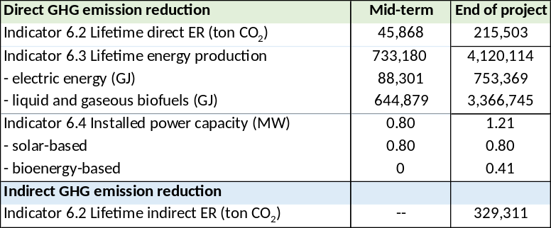

Monitoring and Evaluation (M&E) Plan

The project results, corresponding indicators, and mid-term and end-of-project targets in the project results framework will be monitored annually and evaluated periodically during project implementation. If baseline data for some of the results indicators are not yet available, it will be collected during the first year of project implementation. The Monitoring Plan (Annex C) includes details of the roles, responsibilities, and frequency of monitoring project results.

Project-level monitoring and evaluation will be undertaken in compliance with UNDP requirements as outlined in the UNDP POPP (including guidance on GEF project revisions) and UNDP Evaluation Policy . The UNDP Country Office is responsible for ensuring full compliance with all UNDP project M&E requirements including project monitoring, UNDP quality assurance requirements, quarterly risk management, and evaluation requirements. Additional mandatory GEF-specific M&E requirements will be undertaken in accordance with the GEF Monitoring Policy and the GEF Evaluation Policy and other relevant GEF policies. The M&E plan and budget included below will guide the GEF-specific M&E activities to be undertaken by this project. In addition to these mandatory UNDP and GEF M&E requirements, other M&E activities deemed necessary to support project-level adaptive management will be agreed – including during the Project Inception Workshop - and will be detailed in the Inception Report.

Minimum project monitoring and reporting requirements as required by the GEF:

Inception Workshop and Report: A project inception workshop will be held within 2 months from the First disbursement date, with the aim to:
- Familiarize key stakeholders with the detailed project strategy and discuss any changes that may have taken place in the overall context since the project idea was initially conceptualized that may influence its strategy and implementation.
- Discuss the roles and responsibilities of the project team and engagement of key stakeholders (update the Stakeholder Engagement Plan), including reporting lines, stakeholder engagement strategies and conflict resolution mechanisms.
- Review the results framework and monitoring plan including a review/updating of baselines as well as confirmation of Means of Verification.
- Discuss reporting, monitoring and evaluation roles and responsibilities and finalize the M&E budget; identify national/regional institutes to be involved in project-level M&E; discuss the role of the GEF OFP and other stakeholders in project-level M&E.
- Update and review responsibilities for monitoring project strategies, including the risk log; SESP report, Social and Environmental Management commitments (see relevant sections in this project document)) and other safeguard requirements; project grievance mechanisms; gender mainstreaming strategy/gender action plan; knowledge management strategy, and other relevant management strategies.
- Review financial reporting procedures and budget monitoring and other mandatory requirements and agree on the arrangements for the annual audit.
- Plan and schedule Project Board meetings and finalize the first-year annual work plan. Finalize the TOR of the Project Board.
- Formally launch the Project.

GEF Project Implementation Report (PIR) The annual GEF PIR covering the reporting period July (previous year) to June (current year) will be completed for each year of project implementation. This includes reporting on SES, gender and stakeholder engagement in specific sections, UNDP will undertake quality assurance of the PIR before submission to the GEF. The PIR submitted to the GEF will be shared with the Project Board. UNDP will conduct a quality review of the PIR, and this quality review and feedback will be used to inform the preparation of the subsequent annual PIR.

GEF Core Indicators:
The GEF Core indicators summarised in Box 9 (described in detail in Annex H) will be used to monitor global environmental benefits and will be updated for reporting to the GEF prior to MTR and TE. Note that the project team is responsible for updating the indicator status. The updated monitoring data should be shared with MTR/TE consultants prior to required evaluation missions, so these can be used for subsequent ground-truthing. The methodologies to be used in data collection have been defined by the GEF and are available on the GEF website.

Box 16 Monitoring and evaluation plan and budget

GEF M&E requirements | Responsible Parties | Indicative costs (USD) | Time frame
Inception Workshop | MEB  Project Manager (PM) | 3,500 | Within 60 days of CEO endorsement of this project.
Inception Report | PM | None | Within 90 days of CEO endorsement of this project.
Monitoring of indicators in the project results framework | PM  Subcontract | 8,000 | Annually before GEF PIR and/or by contracted party before TE
GEF Project Implementation Report (PIR) | UNDP RTA –CO  PM | None | Annually typically between June-August
Monitoring all risks (UNDP risk register) | UNDP CO  PM | None | On-going.
Supervision and oversight missions | UNDP CO, RTA and BPPS/GEF | None | Annually, troubleshooting and oversight as needed
Final project workshop | MEB, UNDP CO | 3,500 | Before project closure
Independent Mid-Term Review (MTR) | Independent evaluators | 24,450 | See cover page
Independent Terminal Evaluation (TE) | Independent evaluators | 24,450 | See cover page
TOTAL indicative COST |  | USD 63,900

Independent Mid-term Review (MTR):
The terms of reference, the review process and the final MTR report will follow the standard UNDP templates and UNDP guidance for GEF-financed projects available on the UNDP Evaluation Resource Center (ERC). The evaluation will be ‘independent, impartial and rigorous’. The evaluators that UNDP will hire to undertake the assignment will be independent of organizations that were involved in designing, executing or advising on the project to be evaluated. Equally, the evaluators should not be in a position where there may be the possibility of future contracts regarding the project under review. The GEF Operational Focal Point and other stakeholders will be actively involved and consulted during the evaluation process. Additional quality assurance support is available from the BPPS/NCE-VF Directorate. The final MTR report and MTR TOR will be publicly available in English and will be posted on the UNDP ERC by the date included on the cover page of this project document. A management response to MTR recommendations will be posted in the ERC within six weeks of the MTR report’s completion.

Terminal Evaluation (TE):
An independent terminal evaluation (TE) will take place upon completion of all major project outputs and activities. The terms of reference, the evaluation process and the final TE report will follow the standard templates and guidance for GEF-financed projects available at the UNDP Evaluation Resource Center. TE should be completed 3 months before the estimated operational closure date, set from the signature of the ProDoc and according to the duration of the project. Provisions should be taken to complete the TE in due time to avoid delay in project closure. Therefore, TE must start no later than 6 months to the expected date of completion of the TE (or 9 months prior to the estimated operational closure date). The evaluation will be ‘independent, impartial and rigorous’. The evaluators that UNDP will hire to undertake the assignment will be independent of organizations that were involved in designing, executing or advising on the project to be evaluated. Equally, the evaluators should not be in a position where there may be the possibility of future contracts regarding the project being evaluated. The GEF Operational Focal Point and other stakeholders will be actively involved and consulted during the terminal evaluation process. Additional quality assurance support is available from the BPPS/NCE-VF Directorate. The final TE report and TE TOR will be publicly available in English and posted on the UNDP ERC by date included on cover page of this project document. A management response to the TE recommendations will be posted to the ERC within six weeks of the TE report’s completion.

Final Report:
The project’s terminal GEF PIR along with the terminal evaluation (TE) report and corresponding management response will serve as the final project report package. The final project report package shall be discussed with the Project Board during an end-of-project review meeting to discuss lessons learned and opportunities for scaling up.

Agreement on intellectual property rights and use of logo on the project’s deliverables and disclosure of information: To accord proper acknowledgement to the GEF for providing grant funding, the GEF logo will appear together with the UNDP logo on all promotional materials, other written materials like publications developed by the project, and project hardware. Any citation on publications regarding projects funded by the GEF will also accord proper acknowledgement to the GEF. Information will be disclosed in accordance with relevant policies notably the UNDP Disclosure Policy and the GEF policy on public involvement.

Monitoring Plan:

The Monitoring Plan is given in Annex E (of indicators in the Results Framework, Section 5, and of the Gender Action Plan). The project results, corresponding indicators and mid-term and end-of-project targets in the project results framework will be monitored by the Project Management Unit annually (and will be reported in the GEF PIR every year) as well as periodically during project implementation. If baseline data for some of the results indicators are not yet available, it will be collected during the first year of project implementation. Project risks, as outlined in the risk register, will be monitored quarterly.

Governance and management arrangements

Section 1: General roles and responsibilities in the projects’ governance mechanism

Implementing Partner: The Implementing Partner for this project is the Ministry of Energy and Business Development (MEB) through its Energy Division.

The Implementing Partner is the entity to which the UNDP Administrator has entrusted the implementation of UNDP assistance specified in this signed project document along with the assumption of full responsibility and accountability for the effective use of UNDP resources and the delivery of outputs, as set forth in this document

The Implementing Partner is responsible for executing this project. Specific tasks include:
• Project planning, coordination, management, monitoring, evaluation, and reporting. This includes providing all required information and data necessary for timely, comprehensive, and evidence-based project reporting, including results and financial data, as necessary. The Implementing Partner will strive to ensure project-level M&E is undertaken by national institutes and is aligned with national systems so that the data used and generated by the project supports national systems.
- Overseeing the management of project risks as included in this project document and new risks that may emerge during project implementation.
• Procurement of goods and services, including human resources;
• Financial management, including overseeing financial expenditures against project budgets;
• Approving and signing the multiyear work plan;
• Approving and signing the combined delivery report at the end of the year; and,
• Signing the financial report or the funding authorization and certificate of expenditures.

Responsible Parties:
No Responsible Parties have been identified during project design.

Project stakeholders and target groups:
An overview of the main stakeholders and target groups is given in section 4.4, while Annex J provides details on their involvement in the Project.

UNDP:
UNDP is accountable to the GEF for the implementation of this project. This includes overseeing project execution undertaken by the Implementing Partner to ensure that the project is being carried out in accordance with UNDP and GEF policies and procedures and the standards and provisions outlined in the Delegation of Authority (DOA) letter for this project. The UNDP GEF Executive Coordinator, in consultation with UNDP Bureaus and the Implementing Partner, retains the right to revoke the project DOA, suspend or cancel this GEF project. UNDP is responsible for the Project Assurance function in the project governance structure and presents to the Project Board and attends Project Board meetings as a non-voting member.

Section 2: Project governance structure

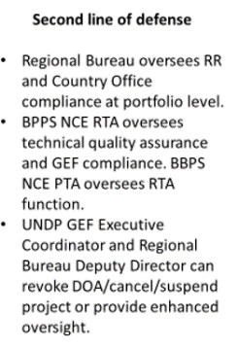
Implementing Partner
MEB Energy Division
Project Board
Development Partners
UNDP Barbados MCO
Resident Representative
Project Executive
Permanente Secretary, MEB
(National Project Director)

Beneficiary Representatives
MENB, MTWW, MAFS, FTC, BAMC, BIDC, BLPC, NPC/BNOC, UWI
Project Assurance
UNDP Barbados
Cluster Head SSECC
Project Organisation Structure
Project Support:
Project Management Unit

The UNDP Resident Representative assumes full responsibility and accountability for oversight and quality assurance of this Project and ensures its timely implementation in compliance with the GEF-specific requirements and UNDP’s Programme and Operations Policies and Procedures (POPP), its Financial Regulations and Rules and Internal Control Framework. A representative of the UNDP Country Office will assume the assurance role and will present assurance findings to the Project Board, and therefore attends Project Board meetings as a non-voting member.

Section 3: Segregation of duties and firewalls vis-à-vis UNDP representation on the project board:

As noted in the Minimum Fiduciary Standards for GEF Partner Agencies, in cases where a GEF Partner Agency (i.e. UNDP) carries out both implementation oversight and execution of a project, the GEF Partner Agency (i.e. UNDP) must separate its project implementation oversight and execution duties, and describe in the relevant project document a: 1) Satisfactory institutional arrangement for the separation of implementation oversight and executing functions in different departments of the GEF Partner Agency; and 2) Clear lines of responsibility, reporting and accountability within the GEF Partner Agency between the project implementation oversight and execution functions.

In this case, UNDP is only performing an implementation oversight role in the project vis-à-vis our role in the project board and in the project assurance function and therefore a full separation of project implementation oversight and execution duties has been assured.

Section 4: Roles and Responsibilities of the Project Organization Structure:

- Project Board: All UNDP projects must be governed by a multi-stakeholder board or committee established to review performance based on monitoring and evaluation, and implementation issues to ensure quality delivery of results. The Project Board (also called the Project Steering Committee) is the most senior, dedicated oversight body for a project.

The two main (mandatory) roles of the project board are as follows:

- High-level oversight of the execution of the project by the Implementing Partner (as explained in the “Provide Oversight” section of the POPP). This is the primary function of the project board and includes annual (and as-needed) assessments of any major risks to the project, and decisions/agreements on any management actions or remedial measures to address them effectively. The Project Board reviews evidence of project performance based on monitoring, evaluation and reporting, including progress reports, evaluations, risk logs and the combined delivery report. The Project Board is responsible for taking corrective action as needed to ensure the project achieves the desired results.
- Approval of strategic project execution decisions of the Implementing Partner with a view to assess and manage risks, monitor and ensure the overall achievement of projected results and impacts and ensure long term sustainability of project execution decisions of the Implementing Partner (as explained in the “Manage Change” section of the POPP).

Requirements to serve on the Project Board:
- Agree to the Terms of Reference of the Board and the rules on protocols, quorum and minuting.
- Meet annually; at least once.
- Disclose any conflict of interest in performing the functions of a Project Board member and take all measures to avoid any real or perceived conflicts of interest. This disclosure must be documented and kept on record by UNDP.
- Discharge the functions of the Project Board in accordance with UNDP policies and procedures.
- Ensure highest levels of transparency and ensure Project Board meeting minutes are recorded and shared with project stakeholders.

Responsibilities of the Project Board:
- Consensus decision making:
  - The project board provides overall guidance and direction to the project, ensuring it remains within any specified constraints, and providing overall oversight of the project implementation.
  - Review project performance based on monitoring, evaluation and reporting, including progress reports, risk logs and the combined delivery report;
  - The project board is responsible for making management decisions by consensus.
  - In order to ensure UNDP’s ultimate accountability, Project Board decisions should be made in accordance with standards that shall ensure management for development results, best value money, fairness, integrity, transparency and effective international competition.
  - In case consensus cannot be reached within the Board, the UNDP representative on the board will mediate to find consensus and, if this cannot be found, will take the final decision to ensure project implementation is not unduly delayed.
- Oversee project execution:
  - Agree on project management’s tolerances as required, within the parameters outlined in the project document, and provide direction and advice for exceptional situations when the project manager’s tolerances are exceeded.
- Appraise annual work plans prepared by the Implementing Partner for the Project; review combined delivery reports prior to certification by the implementing partner.
- Address any high-level project issues as raised by the project manager and project assurance;
- Review and monitor actions as formulated the Gender Action Plan and Stakeholder Plan and SESP;
- Advise on major and minor amendments to the project within the parameters set by UNDP and the donor and refer such proposed major and minor amendments to the UNDP BPPS Nature, Climate and Energy Executive Coordinator (and the GEF, as required by GEF policies);
- Provide high-level direction and recommendations to the project management unit to ensure that the agreed deliverables are produced satisfactorily and according to plans.
- Track and monitor co-financed activities and realisation of co-financing amounts of this project.
- Approve the Inception Report, GEF annual project implementation reports, mid-term review and terminal evaluation reports.
- Ensure commitment of human resources to support project implementation, arbitrating any issues within the project.
- Risk Management:
  - Provide guidance on evolving or materialized project risks and agree on possible mitigation and management actions to address specific risks.
  - Review and update the project risk register and associated management plans based on the information prepared by the Implementing Partner. This includes risks related that can be directly managed by this project, as well as contextual risks that may affect project delivery or continued UNDP compliance and reputation but are outside of the control of the project. For example, social and environmental risks associated with co-financed activities or activities taking place in the project’s area of influence that have implications for the project.
  - Address project-level grievances.
- Coordination:
  - Ensure coordination between various donor and government-funded projects and programmes.
  - Ensure coordination with various government agencies and their participation in project activities.

Composition of the Project Board: The composition of the Project Board must include individuals assigned to the following three roles:

- Project Executive: This is an individual who represents ownership of the project and chairs (or co-chairs) the Project Board. The Executive usually is the senior national counterpart for nationally implemented projects (typically from the same entity as the Implementing Partner), and it must be UNDP for projects that are direct implementation (DIM). In exceptional cases, two individuals from different entities can co-share this role and/or co-chair the Project Board. If the project executive co-chairs the project board with representatives of another category, it typically does so with a development partner representative. The Project Executive is: Permanent Secretary (National Project Director), MEB.

- Beneficiary Representative(s): Individuals or groups representing the interests of those groups of stakeholders who will ultimately benefit from the project. Their primary function within the board is to ensure the realization of project results from the perspective of project beneficiaries. Often representatives from civil society, industry associations, academic institutions, or other government entities benefiting from the project can fulfil this role. There can be multiple beneficiary representatives in a Project Board. Selection should meet the highest standards for impartiality, anti-corruption and non-discrimination. Beneficiary representatives are, Ministry of Environment and National Beautification, Ministry of Transport, Works and Water Resources, Ministry of Agriculture and Food Security; Fair Trading Commission; Barbados Agricultural Management Corporation; Barbados Investment Development (Export Barbados) and Barbados Light and Power Company, Barbados National Oil Company/National Petroleum Corporation, and the University of West Indies.

- Development Partner(s): Individuals or groups representing the interests of the parties concerned that provide funding, strategic guidance and/or technical expertise to the project. The Development Partner is: UNDP Resident Representative.

- Project Assurance: Project assurance is the responsibility of each project board member; however, UNDP has a distinct assurance role for all UNDP projects in carrying out objective and independent project oversight and monitoring functions. UNDP performs quality assurance and supports the Project Board (and Project Management Unit) by carrying out objective and independent project oversight and monitoring functions, including compliance with the risk management and social and environmental standards of UNDP. The Project Board cannot delegate any of its quality assurance responsibilities to the Project Manager. Project assurance is totally independent of project execution.

A designated representative of UNDP playing the project assurance role is expected to attend all board meetings and support board processes as a non-voting representative. It should be noted that while in certain cases UNDP’s project assurance role across the project may encompass activities happening at several levels (e.g. global, regional), at least one UNDP representative playing that function must, as part of their duties, specifically attend board meeting and provide board members with the required documentation required to perform their duties. The UNDP representative playing the main project assurance function is the Cluster Head SSECC, UNDP Country Office, Barbados

- Project Management – Execution of the Project: The Project Manager (PM) is the senior most representative of the Project Management Unit (PMU) and is responsible for the overall day-to-day management of the project on behalf of the Implementing Partner, including the mobilization of all project inputs, supervision over project staff, responsible parties, consultants and sub-contractors. The project manager typically presents key deliverables and documents to the board for their review and approval, including progress reports, annual work plans, adjustments to tolerance levels and risk registers.

A designated representative of the PMU is expected to attend all board meetings and support board processes as a non-voting representative. The primary PMU representative attending board meetings is the Project Manager (PM). Efforts shall be made to mobilise the project team for the full project tenure to ensure the availability of experts and consultants until the end of the Project. Apart from the PM, the structure of PMU will include a Deputy Project Manager with specific responsibilities for the Pilot Project and Monitoring. A Financial-Administrative Officer will be part of the PMU but financed by MESBE co-financing budget (unlike the PM and Deputy PM that are financed from the GEF budget). Detailed job descriptions are provided in Annex G. On an as-needed basis, short-term experts and contracted companies will be hired to work on assignments in research, policy development, communications and outreach, and technical assistance of activities in the various project components. A Lead Advisor (LA) will be hired at the start of the project at the same time as the Project Manager (with a specialization in rural and renewable energy) on an intermittent basis to support the PMU to recommend actions that focus work plans on achieving key milestones in a timely manner; recommend special expertise to be deployed on the Project to assist in its achievement of key milestones; and provide the interface between Project team and key specialist consultants, both domestic and international when appropriate.

Technical Advisory Committee: This Committee will advise the project team on technical issues, thematic aspects or more operational issues. As part of the activities of Output 2.4, a ‘Bioenergy Task Force’ will be setup that will not only function as the Project’s Technical Advisorty Committee but will continue as a body for discussing bioenergy matters after the Project ends. The Committee will have working-level representatives from organisations as indicated in Box 12, such as government entities (Prime Minister’s office and line ministries with relevant Departments), public sector companies (such as BNOC, BIDC and BAMC), cooperating partners and regional organisations (e.g. UNDP, IBD, CCREEE), private sector associations (BREA) and R&D institutions (e.g. UWI), to which other representatives from specially nominated representatives from the private sector could be added. A gender-balanced and socially inclusive participation is desirable.

Financial Planning and Management

The total cost of the project is USD 12,993,836. This is financed through a GEF grant of USD 1,593,836 administered by UNDP,) and additional support of USD 11,400,000. UNDP, as the GEF Implementing Agency, is responsible for the oversight of the GEF resources and the cash co-financing transferred to UNDP bank account only.

Co-financing: The actual realization of project co-financing amounts will be monitored by the UNDP Country Office and the PMU on an annual basis in the GEF PIF and will be reported to the GEF during the mid-term review and terminal evaluation process as follows:

Co-financing source | Co-financing type | Co-financing amount (USD)
Ministry of Energy, and Business Development (MEB) | Grant/public investment | 1,800,000
Ministry of Energy, and Business Development (MEB) | In-kind | 1,350,000
Ministry of Energy, and Business Development (MEB) | Grant | 120,000
National Petroleum Company (NPC)/Barbados Oil Company (BNOC) | Equity/public inv. | 4,900,000
National Petroleum Company (NPC)/Barbados Oil Company (BNOC) | In-kind | 150,000
BAMC | Public inv. | 500,000
BAMC | In-kind | 30,000
BIDC | Grant | 100,000
BIDC | In-kind | 30,000
Barbados Light and Power Company (BLPC) | In-kind | 20,000
Fair Trading Commission (FTCP) | In-kind | 20,000
CCREEE | In-kind | 50,000
University of West Indies (Cave Hill campus) | Grant | 200,000
University of West Indies (Cave Hill campus) | In-kind | 100,000
Barbados Renewable Energy Association (BREA) | In-kind | 30,000
UNDP | Grant | 1,900,000
UNDP | In-kind | 100,000
 |  | 11,400,000

Note: The table includes co-financing confirmed by means of a signed cooperation (co-financing) letter attached as Annex R.

Budget Revision and Tolerance: As per UNDP POPP, the project board may agree with the project manager on a tolerance level for each detailed plan under the overall multi-year work plan. The agreed tolerance should be written in the project document or approved project board meeting minutes. It should normally not exceed 10% of the agreed annual budget at the activity level, but within the overall approved multi-year work plan at the activity level. Within the agreed tolerances, the project manager can operate without intervention from the project board. Restrictions apply as follows:
Should the following deviations occur, the Project Manager/IP through UNDP Country Office will seek the approval of the BPPS/NCE-VF team to ensure accurate reporting to the GEF. It is strongly encouraged to maintain the expenditures within the approved budget at the budgetary account and at the component level:
- Budget reallocations must prove that the suggested changes in the budget will not lead to material changes in the results to be achieved by the project. A strong justification is required and will be approved on an exceptional basis. Budget re-allocations among the components (including PMC) of the approved Total Budget and Work Plans (TBWP) that represent a value greater than 10% of the total GEF grant.
- Introduction of new outputs/activities (i.e. budget items) that were not part of the agreed project document and TBWP that represent a value greater than 5% of the total GEF grant. The new budget items must be eligible as per the GEF and UNDP policies.
- Project management cost (PMC): budget under the PMC component is capped and cannot be increased.

Any over-expenditure incurred beyond the available GEF grant amount must be absorbed by non-GEF resources (e.g. UNDP TRAC or cash co-financing).
Project extensions: The UNDP Resident Representative and the UNDP-GEF Executive Coordinator must approve all project extension requests. Note that all extensions incur costs and the GEF project budget cannot be increased. A single extension may be granted on an exceptional basis and subject to the conditions and maximum durations set out in the UNDP POPP; the project management costs during the extension period must remain within the originally approved amount, and any increase in PMC costs will be covered by non-GEF resources; the additional UNDP oversight costs during the extension period must be covered by non-GEF resources, in accordance with UNDP’s guidance set out in UNDP POPP.
Audit: The project will be audited as per UNDP Financial Regulations and Rules and applicable audit policies. The audit cycle and process must be discussed during the Inception workshop. If the Implementing Partner is an UN Agency, the project will be audited according to that Agencies applicable audit policies.
Project Closure: Project closure will be conducted as per UNDP requirements outlined in the UNDP POPP. All costs incurred to close the project must be included in the project closure budget and reported as final project commitments presented to the Project Board during the final project review. The only costs a project may incur following the final project review are those included in the project closure budget.
Operational completion: The project will be operationally completed when the last UNDP-financed inputs have been provided and the related activities have been completed. This includes the final clearance of the Terminal Evaluation Report (that will be available in English) and the corresponding management response, and the end-of-project review Project Board meeting. Operational closure must happen at the end date calculated by the approved duration after the Project Document signature or at the revised operational closure date as approved in the project extension. Any expected activity after the operational date requires project extension approval. The Implementing Partner through a Project Board decision will notify the UNDP Country Office when operational closure has been completed. At this time, the project should have completed the transfer or disposal of any equipment that is still the property of UNDP.
Transfer or disposal of assets: In consultation with the Implementing Partner and other parties of the project, UNDP is responsible for deciding on the transfer or other disposal of assets. Transfer or disposal of assets is recommended to be reviewed and endorsed by the project board following UNDP rules and regulations. Assets may be transferred to the government for project activities managed by a national institution at any time during the life of a project (it is strongly encouraged to be done before the operational closure date). In all cases of transfer, a transfer document must be prepared and kept on file. The transfer should be done before the Project Management Unit completes its assignments.
Financial completion (closure): The project will be financially closed when the following conditions have been met: a) the project is operationally completed or has been cancelled; b) the Implementing Partner has reported all financial transactions to UNDP; c) UNDP has closed the accounts for the project; d) UNDP and the Implementing Partner have certified a final Combined Delivery Report (which serves as final budget revision).
The project will be financially completed within 6 months of operational closure or after the date of cancellation. If Operational Closure is delayed for any justified and approved reason, the Country Office should do all efforts to Financially Close the project within 9 months after TE is completed. Between operational and financial closure, the implementing partner will identify and settle all financial obligations and prepare a final expenditure report. The UNDP Country Office will send the final signed closure documents including confirmation of final cumulative expenditure and unspent balance to the BPPS/NCE-VF Unit for confirmation before the project will be financially closed in Quantum by the UNDP Country Office.
Refund to GEF: Should a refund of unspent funds to the GEF be necessary, this will be managed directly by the BPPS/NCE-VF Directorate in New York. No action is required by the UNDP Country Office on the actual refund from UNDP project to the GEF Trustee.

Total UNDP Budget and Work Plan

Total Budget and Work Plan
Quantum Business Unit | UNDP-BRB
Quantum Project ID: | 00XXXXXX | Quantum Project Title: | As in Quantum
Quantum Award ID: | XXXXXXX | Quantum Award Title: | As in Quantum
UNDP-GEF PIMS No. | 6451
Implementing Partner | Ministry of Energy and Business (MEB)

Quantum Activity (GEF Component) | Quantum Implementing Agent/Responsible Party | Fund ID | Donor Name | Budgetary Account Code | Budget Account Description | Amount  2023  (USD) | Amount  2024  (USD) | Amount 2025  (USD) | Amount  2026  (USD) | Amount  2027  (USD) | Total (USD) | Budget Note:
Outcome 1: Government capacity for resilient, low-emission energy planning and energy system purview has been strengthenedd | MEB | 62000 | GEF | 71200 | International consultants | 11,250 | 3,750 | 0 | 1,875 | 5,625 | 22,500 | 1
 |  |  |  | 71300 | Local consultants | 4,050 | 3,750 | 0 | 0 | 2,600 | 10,400 | 2
 |  |  |  | 71800 | Contract.serv- indiv. - ImplP | 16,898 | 16,898 | 16,898 | 16,900 | 22,531 | 90,125 | 3
 |  |  |  | 71600 | Travel | 600 | 600 | 112 | 328 | 547 | 2,187 | 4
 |  |  |  | 72100 | Contract.serv. -companies | 0 | 0 | 7,500 | 0 | 2,500 | 10,000 | 5
 |  |  |  | 72400 | Communic & Audio Visual Equip | 3,750 | 3,750 | 0 | 0 | 0 | 7,500 | 6
 |  |  |  | 74200 | Audiovisual-print.prod.costs | 1,000 | 1,200 | 0 | 293 | 0 | 2,493 | 7
 |  |  |  | 75700 | Training, workshops & conf. | 3,750 | 11,250 | 0 | 1,500 | 5,500 | 22,000 | 8
 |  |  |  | Total outcome 1 |  | 41,298 | 41,198 | 24,510 | 20,896 | 39,303 | 167,205
Outcome 2: Enabling conditions for successful bioenergy deployment in Barbados have been created (in gender-sensitive and socially inclusive way) | MEB | 62000 | GEF | 71200 | International consultants | 8,438 | 8,437 | 0 | 0 | 5,625 | 22,500 | 9
 |  |  |  | 71300 | Local consultants | 3,900 | 3,900 | 3,900 | 3,900 | 5,200 | 20,800 | 10
 |  |  |  | 71800 | Contract.srv- indiv. - ImplP | 16,899 | 16,898 | 16,898 | 16,899 | 22,531 | 90,125 | 11
 |  |  |  | 71600 | Travel | 1,125 | 1,500 | 750 | 170 | 1,180 | 4,725 | 12
 |  |  |  | 72100 | Contract.serv.-companies | 15,000 | 30,000 | 20,625 | 7,500 | 24,375 | 97,500 | 13
 |  |  |  | 72300 | Materials and goods | 0 | 0 | 12,750 | 0 | 4,250 | 17,000 | 14
 |  |  |  | 72400 | Communic & Audio Visual Equip | 0 | 0 | 6,615 | 0 | 0 | 6,615 | 15
 |  |  |  | 74200 | Audiovisual-print.prod.costs | 1,000 | 1,000 | 500 | 0 | 0 | 2,500 | 16
 |  |  |  | 75700 | Training, workshops & conf. | 6,375 | 6,750 | 11,250 | 11,250 | 11,875 | 47,500 | 17
 |  |  |  | Total outcome 2 |  | 52,737 | 68,485 | 73,288 | 39,719 | 75,036 | 309,265
Outcome 3: A pipeline of bioenergy (and decentralised RE) has been developed and put into operation | MEB | 62000 | GEF | 71200 | International consultants | 0 | 15,000 | 7,500 | 0 | 7,500 | 30,000 | 18
 |  |  |  | 71300 | Local consultants | 3,000 | 3,750 | 3,750 | 1,200 | 3,900 | 15,600 | 19
 |  |  |  | 71800 | Contract.serv- indiv. - ImplP | 16,898 | 16,898 | 16,898 | 16,900 | 22,531 | 90,125 | 20
 |  |  |  | 71600 | Travel | 0 | 617 | 617 | 617 | 617 | 2,468 | 21
 |  |  |  | 72100 | Contract.serv. -companies | 0 | 144,000 | 150,000 | 138,000 | 144,000 | 576,000 | 22
 |  |  |  | 74200 | Audiovisual-print.prod.costs | 0 | 750 | 750 | 375 | 625 | 2,500 | 23
 |  |  |  | 75700 | Training, workshops & conf. | 0 | 0 | 2,625 | 2,625 | 1,750 | 7,000 | 24
 |  |  |  | Total outcome 3 |  | 19,898 | 181,015 | 182,140 | 159,717 | 180,923 | 723,693
Outcome 4: Knowledge Management | MEB | 62000 | GEF | 71200 | International consultants | 5,625 | 0 | 5,625 | 0 | 3,750 | 15,000 | 25
 |  |  |  | 71300 | Local consultants | 3,750 | 3,000 | 3,750 | 3,150 | 4,550 | 18,200 | 26
 |  |  |  | 71800 | Contract.serv- indiv. - ImplP | 16,898 | 16,898 | 16,898 | 16,900 | 22,531 | 90,125 | 27
 |  |  |  | 71600 | Travel | 1,875 | 1,500 | 2,250 | 1,525 | 2,384 | 9,534 | 28
 |  |  |  | 72100 | Contract.serv. -companies | 0 | 0 | 11,250 | 11,250 | 7,500 | 30,000 | 29
 |  |  |  | 73300 | Rental-Main. of InfoTech.Eq | 0 | 2,265 | 0 | 0 | 755 | 3,020 | 30
 |  |  |  | 74200 | Audiovisual-print.prod.costs | 750 | 1,125 | 1,125 | 750 | 1,250 | 5,000 | 31
 |  |  |  | 75700 | Training, workshops & conf. | 0 | 3,500 | 3,500 | 3,500 | 3,500 | 14,000 | 32
 |  |  |  | Total Outcome 4 |  | 28,898 | 28,288 | 44,398 | 37,075 | 46,220 | 184,879
Outcome 5:  M&E | UNDP | 62000 | GEF | 71200 | International. consultants | 0 | 14,062 | 0 | 14,063 | 9,375 | 37,500 | 33
 |  |  |  | 71300 | Local consultants | 0 | 3,900 | 0 | 3,900 | 2,600 | 10,400 | 34
 |  |  |  | 71600 | Travel | 0 | 375 | 0 | 375 | 250 | 1,000 | 35
 |  |  |  | 72100 | Contract.serv. -companies | 0 | 0 | 0 | 6,000 | 2,000 | 8,000 | 36
 |  |  |  | 75700 | Training, workshops & conf. | 5,250 | 0 | 0 | 0 | 1,750 | 7,000 | 37
 |  |  |  | Total outcome 5 |  | 5,250 | 18,337 | 0 | 24,338 | 15,975 | 63,900
Project Management Cost | MEB | 62000 | GEF | 71800 | Contract.serv- indiv. - ImplP | 21,263 | 21,263 | 21,263 | 21,261 | 28,349 | 113,399 | 38
 |  |  |  | 71600 | Travel | 938 | 937 | 938 | 937 | 1,250 | 5,000 | 39
 |  |  |  | 72500 | Office supplies | 1,218 | 1,217 | 1,217 | 1,220 | 1,623 | 6,495 | 40
 |  |  |  | 72200 | Equiment & furnitture | 7,500 | 0 | 0 | 0 | 2,500 | 10,000 | 41
Project Management Cost | UNDP | 62000 | GEF | 74100 | Professional services | 1,875 | 1,875 | 1,500 | 2,250 | 2,500 | 10,000 | 42
 |  |  |  | Total PMC |  | 32,794 | 25,292 | 24,918 | 25,668 | 36,222 | 144,894
 |  |  |  | PROJECT TOTAL - GEF |  | 180,875 | 362,615 | 349,254 | 307,413 | 393,679 | 1,593,836

Additional budget information:

Budget note | Description
1 | International consultancy (6 weeks @ 3750/week) for policy and planning support and workshop participation
2 | Local consultancy (8 weeks @ USD 1300/week) for stakeholder engagement, support DREI analysis and for gender/SES consultancy
3 | Tasks of project staff: Technical+Pilot Coord, Social Safeguards and Gender (total USD 82250) as well as Lead Advisor, USD 7875) related to outputs of Component 1
4 | Travel for short-term consultants (and staff but excl. international. ticket of international. experts, in BuLi 71200)
5 | Company contracts for support of planning and licensing related ICT systems services at MEB (USD 5,000) as well as Bioenergy Task Force website maintenance and support (USD 5,000)
6 | Support to MEB and Bioenergy Off-Grid Task Force with the needed information technology equipment and software (Comp.1: USD 7500)
7 | AV and printing cost (newsletters, workshops, reports, etc.) in Comp. 1 (USD 2493)
8 | Workshops (USD 7000) and training (USD 15000) for Component 1
9 | International consultancy (6 weeks @ USD 3750/week) for bioenergy feedstock and conversion assessments; policy formulation and advice on bioenergy-related capacity strengthening
10 | Local consultancy (16 weeks @ USD 1300/week) for stakeholder engagement, bioenergy feedstock and conversion and demand assessment; policy formulation and advice
11 | Tasks of project staff: Technical+Pilot Coord, Social Safeguards and Gender (total USD 82250) as well as Lead Advisor, USD 7875) related to outputs of Component 2
12 | Travel for short-term consultants (and staff but excl. international. ticket of international. experts, in BuLi 71200)
13 | Contracts for bioenergy supply and demand assessment with recommendations (USD 40,000) and for capacity needs assessment (USD 20,000) and capacity strengthened support with selected institutions (USD 30,000) as well as bioenergy website setup and maintenance (USD 7500)
14 | Equipment for measurements of feedstock characteristics (USD 17,000)
15 | Support to MEB and Bioenergy Off-Grid Task Force with the needed information technology equipment and software (Comp.2: USD 6615)
16 | AV and printing cost (newsletters, workshops, reports, etc.) in Component 2 (USD 2500)
17 | Workshops and seminars (05 event.days @ USD 3500/day) related to Component 2 activities as well one or two training courses at selected institutions (USD 30000)
18 | International consultancy (8 weeks @ 3750/week) for selected bioenergy pilot/demo design studies) and participation in related workshops/events
19 | National consultancy to support international consultant (12 weeks @ 1300/week) for cost-benefit analysis; socio-econ assessment related to feasibility and design studies of selected bioenergy investments
20 | Tasks of project staff: Technical+Pilot Coord, , Social Safeguards and Gender (total USD 82250) as well as Lead Advisor, USD 7875) related to outputs of Component 3
21 | Travel for short-term consultants (and staff but excl. international. ticket of international. experts, in BuLi 71200)
22 | Company contract awarded to successful bidders (one or two) in pilot/demo Call for Proposals (USD 450,000) and carrying out feasibility studies (USD 80,000) and compilation of investment opportunities in the prospectus (USD 10,000). Contracts for GRM and code of conduct (USD 8000), waste and pollution risks assessment (USD 10000) and livelihoods assessment (USD 18000)
23 | AV and printing cost (newsletters, workshops, reports, etc.) in Component 2 (USD 2500)
24 | One workshop on call for Proposals and one on investment prospectus (USD 3500 per event). These may be linked or combined organizationally with workshops and events of Component 4
25 | International consultancy on bioenergy (or related planning, financing, etc.) in KM activities (4 weeks @ 3750/week)
26 | Local consultancy to support KM, outreach and stakeholder mobilization activities (14 weeks @ 1300/week)
27 | Tasks of project staff: Technical+Pilot Coord, Social Safeguards and Gender (total USD 82250) as well as Lead Advisor, USD 7875) related to outputs of Component 4
28 | Travel for short-term consultants (and staff but excl. international. ticket of international. experts, in BuLi 71200). Travel for participation in regional events
29 | Company contract for design of bioenergy awareness and promotion plan and campaign (USD 30,000)
30 | Rental/maintenance of info-tech equipment (incl. licensing/maintenance platform software)
31 | Cost of AV, printing production (for workshops and a regional event)
32 | Workshops (USD 14,000 for workshops, regional conferences, including project closure event; note that travel is in a separate budget line)
33 | Budget for consultancy and travel for M&E (final, MTR) is USD 48,900, which is divided as indicated over budgent lines 30A to C. Note 30A: international consultancy (USD 37,500)
34 | National consultancy for MTR and TE (USD 10,400)
35 | Travel MTR and TE (USD 1,000)
36 | Contract for measurement of progress indicators (incl. capacity strengthening survey)
37 | Inception (and/or final project) workshops (USD 3500 each or USDD 7000)
38 | Cost of management & administration tasks (project manager), USD 113,399.
39 | Regional travel project staff
40 | Project management cost: office supplies
41 | Project management cost: office equipment and furniture
42 | Professional hired services for project auditing (USD 10,000)

Legal context

This project document shall be the instrument referred to as such in Article 1 of the Standard Basic Assistance Agreement between the Government of Barbados and UNDP, signed by the parties on 17 November 1993. All references in the SBAA to “Executing Agency” shall be deemed to refer to “Implementing Partner.”

This project will be implemented by the Ministry of Energy and Business (MEB)) in accordance with its financial regulations, rules, practices and procedures only to the extent that they do not contravene the principles of the Financial Regulations and Rules of UNDP. Where the financial governance of an Implementing Partner does not provide the required guidance to ensure best value for money, fairness, integrity, transparency, and effective international competition, the financial governance of UNDP shall apply.

The designations employed and the presentation of material on this map do not imply the expression of any opinion whatsoever on the part of the Secretariat of the United Nations or UNDP concerning the legal status of any country, territory, city or area or its authorities, or concerning the delimitation of its frontiers or boundaries.

Risk management

- Consistent with the Article III of the Supplemental Provisions to the Project Document, the responsibility for the safety and security of the Implementing Partner and its personnel and property, and of UNDP’s property in the Implementing Partner’s custody, rests with the Implementing Partner. To this end, the Implementing Partner shall:
- put in place an appropriate security plan and maintain the security plan, taking into account the security situation in the country where the project is being carried;
- assume all risks and liabilities related to the Implementing Partner’s security and the full implementation of the security plan.
- UNDP reserves the right to verify whether such a plan is in place and to suggest modifications to the plan when necessary. Failure to maintain and implement an appropriate security plan as required hereunder shall be deemed a breach of the Implementing Partner’s obligations under this Project Document.
- The Implementing Partner agrees to undertake all reasonable efforts to ensure that no UNDP funds received pursuant to the Project Document are used to provide support to individuals or entities associated with terrorism and that the recipients of any amounts provided by UNDP hereunder do not appear on the list maintained by the Security Council Committee established pursuant to resolution 1267 (1999). The list can be accessed via http://www.un.org/sc/committees/1267/aq_sanctions_list.shtml.
- The Implementing Partner acknowledges and agrees that UNDP will not tolerate sexual harassment and sexual exploitation and abuse of anyone by the Implementing Partner, and each of its responsible parties, their respective sub-recipients and other entities involved in Project implementation, either as contractors or subcontractors and their personnel, and any individuals performing services for them under the Project Document.
(a) In the implementation of the activities under this Project Document, the Implementing Partner, and each of its sub-parties referred to above, shall comply with the standards of conduct set forth in the Secretary General’s Bulletin ST/SGB/2003/13 of 9 October 2003, concerning “Special measures for protection from sexual exploitation and sexual abuse” (“SEA”).
(b) Moreover, and without limitation to the application of other regulations, rules, policies, and procedures bearing upon the performance of the activities under this Project Document, in the implementation of activities, the Implementing Partner, and each of its sub-parties referred to above, shall not engage in any form of sexual harassment (“SH”). SH is defined as any unwelcome conduct of a sexual nature that might reasonably be expected or be perceived to cause offense or humiliation, when such conduct interferes with work, is made a condition of employment, or creates an intimidating, hostile, or offensive work environment.
- a) In the performance of the activities under this Project Document, the Implementing Partner shall (with respect to its own activities), and shall require from its sub-parties referred to in paragraph 4 (with respect to their activities) that they, have minimum standards and procedures in place, or a plan to develop and/or improve such standards and procedures in order to be able to take effective preventive and investigative action. These should include: policies on sexual harassment and sexual exploitation and abuse; policies on whistleblowing/protection against retaliation; and complaints, disciplinary and investigative mechanisms. In line with this, the Implementing Partner will and will require that such sub-parties will take all appropriate measures to:
  - Prevent its employees, agents, or any other persons engaged to perform any services under this Project Document, from engaging in SH or SEA;
  - Offer employees and associated personnel training on prevention and response to SH and SEA, where the Implementing Partner and its sub-parties referred to in paragraph 4 have not put in place its own training regarding the prevention of SH and SEA, the Implementing Partner and its sub-parties may use the training material available at UNDP;
  - Report and monitor allegations of SH and SEA of which the Implementing Partner and its sub-parties referred to in paragraph 4 have been informed or have otherwise become aware, and status thereof;
  - Refer victims/survivors of SH and SEA to safe and confidential victim assistance; and
  - Promptly and confidentially record and investigate any allegations credible enough to warrant an investigation of SH or SEA. The Implementing Partner shall advise UNDP of any such allegations received and investigations being conducted by itself or any of its sub-parties referred to in paragraph 4 with respect to their activities under the Project Document, and shall keep UNDP informed during the investigation by it or any of such sub-parties, to the extent that such notification (i) does not jeopardize the conduct of the investigation, including but not limited to the safety or security of persons, and/or (ii) is not in contravention of any laws applicable to it. Following the investigation, the Implementing Partner shall advise UNDP of any actions taken by it or any of the other entities further to the investigation.
- The Implementing Partner shall establish that it has complied with the foregoing, to the satisfaction of UNDP, when requested by UNDP or any party acting on its behalf to provide such confirmation. Failure of the Implementing Partner, and each of its sub-parties referred to in paragraph 4, to comply with the foregoing, as determined by UNDP, shall be considered grounds for suspension or termination of the Project.
- Social and environmental sustainability will be enhanced through the application of the UNDP Social and Environmental Standards (http://www.undp.org/ses) and related Accountability Mechanism (http://www.undp.org/secu-srm).
- The Implementing Partner shall: (a) conduct project and program-related activities in a manner consistent with the UNDP Social and Environmental Standards, (b) implement any management or mitigation plan prepared for the project or program to comply with such standards, and (c) engage in a constructive and timely manner to address any concerns and complaints raised through the Accountability Mechanism. UNDP will seek to ensure that communities and other project stakeholders are informed of and have access to the Accountability Mechanism.
- All signatories to the Project Document shall cooperate in good faith with any exercise to evaluate any program or project-related commitments or compliance with the UNDP Social and Environmental Standards. This includes providing access to project sites, relevant personnel, information, and documentation.
- The Implementing Partner will take appropriate steps to prevent misuse of funds, fraud or corruption, by its officials, consultants, responsible parties, subcontractors, and sub-recipients in implementing the project or using UNDP funds. The Implementing Partner will ensure that its financial management, anti-corruption, and anti-fraud policies are in place and enforced for all funding received from or through UNDP.

- The requirements of the following documents, then in force at the time of signature of the Project Document, apply to the Implementing Partner: (a) UNDP Policy on Fraud and other Corrupt Practices and (b) UNDP Office of Audit and Investigations Investigation Guidelines. The Implementing Partner agrees to the requirements of the above documents, which are an integral part of this Project Document and are available online at www.undp.org.
- In the event that an investigation is required, UNDP has the obligation to conduct investigations relating to any aspect of UNDP projects and programs in accordance with UNDP’s regulations, rules, policies, and procedures. The Implementing Partner shall provide its full cooperation, including making available personnel, relevant documentation, and granting access to the Implementing Partner’s (and its consultants’, responsible parties’, subcontractors’ and sub-recipients’) premises, for such purposes at reasonable times and on reasonable conditions as may be required for the purpose of an investigation. Should there be a limitation in meeting this obligation, UNDP shall consult with the Implementing Partner to find a solution.
- The signatories to this Project Document will promptly inform one another in case of any incidence of inappropriate use of funds, or credible allegation of fraud or corruption with due confidentiality.
Where the Implementing Partner becomes aware that a UNDP project or activity, in whole or in part, is the focus of investigation for alleged fraud/corruption, the Implementing Partner will inform the UNDP Resident Representative/Head of Office, who will promptly inform UNDP’s Office of Audit and Investigations (OAI). The Implementing Partner shall provide regular updates to the head of UNDP in the country and OAI of the status of, and actions relating to, such investigation.
- UNDP shall be entitled to a refund from the Implementing Partner of any funds provided that have been used inappropriately, including through fraud or corruption, or otherwise paid other than in accordance with the terms and conditions of the Project Document. Such amount may be deducted by UNDP from any payment due to the Implementing Partner under this or any other agreement. Recovery of such amount by UNDP shall not diminish or curtail the Implementing Partner’s obligations under this Project Document.
Where such funds have not been refunded to UNDP, the Implementing Partner agrees that donors to UNDP (including the Government) whose funding is the source, in whole or in part, of the funds for the activities under this Project Document, may seek recourse to the Implementing Partner for the recovery of any funds determined by UNDP to have been used inappropriately, including through fraud or corruption, or otherwise paid other than in accordance with the terms and conditions of the Project Document.
Note: The term “Project Document” as used in this clause shall be deemed to include any relevant subsidiary agreement further to the Project Document, including those with responsible parties, subcontractors, and sub-recipients.
- Each contract issued by the Implementing Partner in connection with this Project Document shall include a provision representing that no fees, gratuities, rebates, gifts, commissions or other payments, other than those shown in the proposal, have been given, received, or promised in connection with the selection process or contract execution, and that the recipient of funds from the Implementing Partner shall cooperate with any and all investigations and post-payment audits.
- Should UNDP refer to the relevant national authorities for appropriate legal action any alleged wrongdoing relating to the project, the Government will ensure that the relevant national authorities shall actively investigate the same and take appropriate legal action against all individuals found to have participated in the wrongdoing, recover and return any recovered funds to UNDP.
- The Implementing Partner shall ensure that all of its obligations set forth under this section entitled “Risk Management” are passed on to each responsible party, subcontractor, and sub-recipient and that all the clauses under this section entitled “Risk Management Standard Clauses” are included, mutatis mutandis, in all sub-contracts or sub-agreements entered into further to this Project Document.

Annexes

- GEF budget template
- Additional budget information
- Project map
- Multi-year work plan
- Monitoring plan
- UNDP Atlas Risk register
- Business cases minigrids
- GEF indicators and GHG emission reduction details
- Overview of project staff and technical consultancies
- Gender analysis and action plan
- Stakeholder engagement plan
- Social and environmental safeguards planning (SESP)
- Procurement plan
- GEF 7 taxonomy
- Project capacity and HACT assessment’
- UNDP project quality assurance report
- Agreements (co-financing letters, OFP Letter)

- .budget and co-financing overview

Project objective: To strengthen Barbados´ institutional and technological capacities to transit towards a resilient, affordable and low-carbon energy infrastructure.
Project Components | Type | Project outcomes | Project outputs | Trust fund | In USD
 |  |  |  |  | GEF project financing | Co-financing
- Institutional strengthening for resilient, low-emission energy planning | TA | 1. Government capacity for resilient, low-emission energy planning and energy system purview has been strengthened | 1.1 Sector policies strengthened for incorporation of bioenergy in Barbados’ just energy transition  1.2 Enhanced management of distributed renewable energy systems | GEFTF | 167,205 | 220,000
- Bioenergy policy and technology | TA | 2. Enabling conditions for successful bioenergy deployment in Barbados have been created | 2.1 Mapping and assessment of possible biomass resources – conversion – bioenergy carriers (gas, liquid) and applications (electricity, bio-methane, liquid biofuels) in various sectors  2.2 National dialogue advanced and appropriate national bioenergy policy formulated  2.3 Capacity strengthened for bioenergy technology development and implementation  2.4 National dialogue and information exchange facilitated by a “bioenergy task force” | GEFTF | 309,264 | 405,000
- Preparation and investment for renewable and biomass-based energy systems | TA | 3. A pipeline of decentralised RE projects (including bioenergy) has been developed and put into operation | 3.1 Investment prospectus of renewable energy (RE) projects with a focus on bioenergy business cases  3.2 Detailed design and engineering studies of pilot-scale bioenergy facilities for appropriately chosen biomass feedstock and formation of ‘bioenergy pilot plan’ | GEFTF | 273,693 | 170,000
 | INV |  | 3.3 Implementation of bioenergy demo/pilot facility and increased investment in renewable energy | GEFTF | 450,000 | 9,280,000
- Knowledge management and information dissemination | TA | 4. The Project’s knowledge management and M&E plans and outreach activities have been implemented | 4.1 Scientific, technological, engineering, operational and social experiences with bioenergy development in Barbados, collected, promoted and shared, nationally and within the Caribbean region  4.2 Monitoring and evaluation | GEFTF | 248,759 | 325,000
Subtotal |  |  |  |  | 1,448,922 | 10,400,000
Project Management Cost (PMC) |  |  |  | GEFTF | 144,894 | 1,000,000
TOTAL |  |  |  |  | 1,593,836 | 11,400,000

- Additional budget information

Co-financing overview

Name of co-financier | Co-financing source | Co-financing type | Description | Co-financing amount (USD)
Ministry of Energy, and Business Development (MEB) | Country govr’t | Grant/public investment | Investment mobilised: finance the retrofitting of about 100 public buildings RE technologies as well as RE in agriculture (linked with Smart Fund II) – Output 3.3  Recurrent expenditures: PMU financial-administrative staff | 1,800,000  120,000
Ministry of Energy, and Business Development (MEB) | Country govr’t | In-kind | Support and organisation, technical components.  Management-admin support: | 500,000  850,000
National Petroleum Company (NPC)/Barbados Oil Company (BNOC) | Beneficiary (public co.) | Equity/public investment | Investment mobilised: investment (shareholder) in pilot/demo on biodiesel and bio-methane – Output 3.3 | 4,900,000
National Petroleum Company (NPC)/Barbados Oil Company (BNOC) | Beneficiary (public co.) | In-kind | Recurrent expenditures | 150,000
BAMC | Beneficiary (public co.) | Public inv. | Investment mobilised: participation in pilot/demo on biogas for power and bio-methane production (output 3.3) | 500,000
BAMC | Beneficiary (public co.) | In-kind | Recurrent expenditures | 30,000
BIDC | Beneficiary | Grant | Investment mobilised: support for SME bioenergy initiatives (biogas for power) | 100,000
BIDC | Beneficiary | In-kind | Recurrent expenditures | 30,000
Barbados Light and Power Company (BLPC) | Private | In-kind | Recurrent expenditures | 20,000
Fair Trading Commission (FTCP) | Country gov | In-kind | Recurrent expenditures | 20,000
CCREEE | Other | In-kind | Recurrent expenditures (Outcome 4) | 50,000
University of West Indies (Cave Hill campus) | Other | Grant | Investment in pilot biogas-for-CNG and feedstock (sargassum, other) utilisation | 200,000
University of West Indies (Cave Hill campus) | Other | In-kind | Recurrent expenditures: setting up bioenergy modules in UWI courses & curricula; participation in SMARTER activities (outcomes 2 and 4) | 100,000
Barbados Renewable Energy Association (BREA) | CSO | In-kind | Recurrent expenditures | 30,000
UNDP | GEF agency | Grant | Investment mobilised (equipment for sargassum collection in UNDP project | 1,900,000
UNDP | GEF agency | In-kind | Recurrent expenditures (oversight, other) | 100,000
 |  |  |  | 11,400,000

Note: The table includes co-financing confirmed by means of a signed cooperation (co-financing) letter attached as Annex R.

GEF budget per output and budget line

Separate annex

- Project map

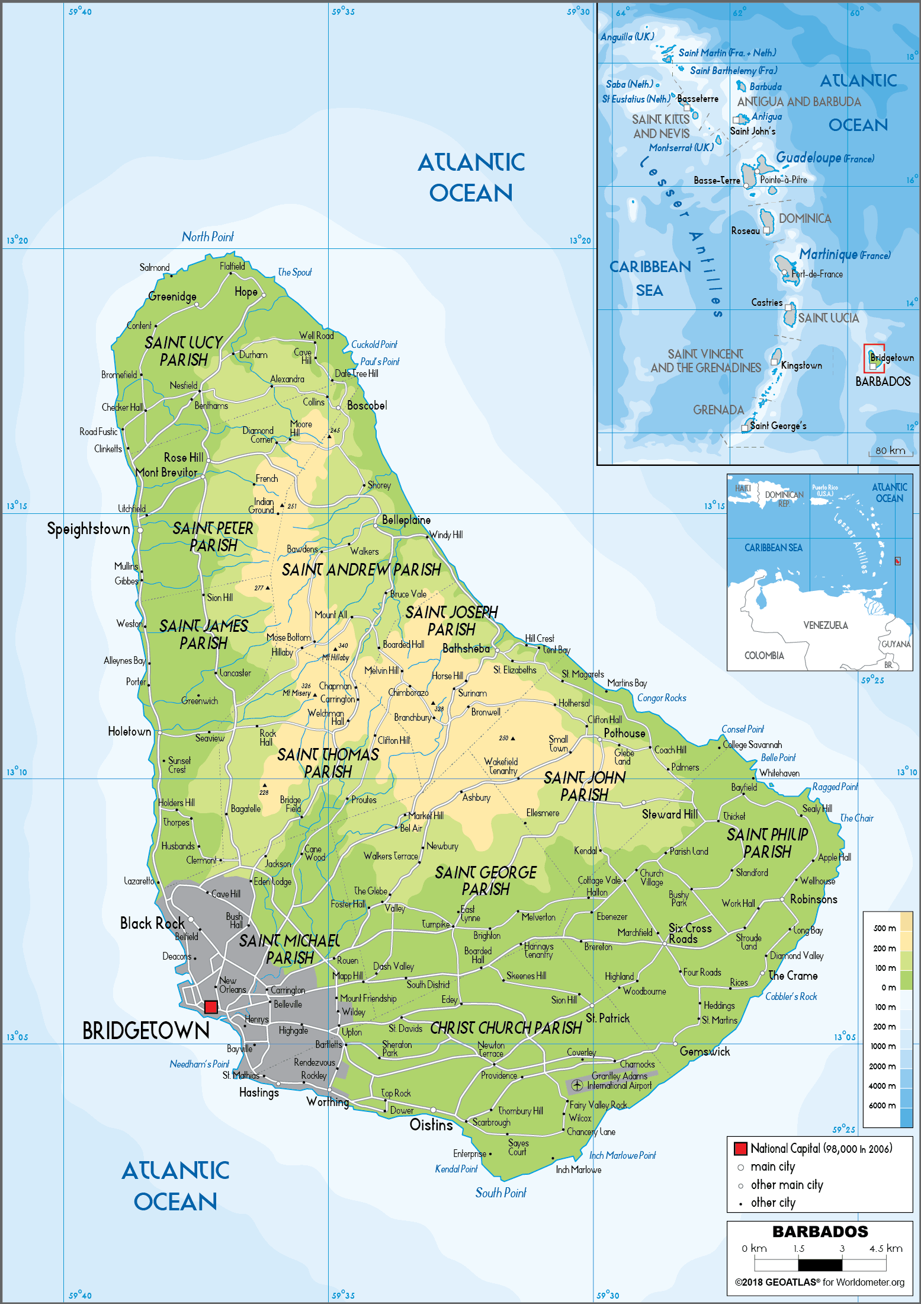
Source: worldometer

- Multi-Year Work Plan

Output  Activity (short title only) | Yr1 Yr2 Y3 Yr4
Output  Activity (short title only) | Q1 | Q2 | Q3 | Q4 | Q1 | Q2 | Q3 | Q4 | Q1 | Q2 | Q3 | Q4 | Q1 | Q2 | Q3 | Q4
Component 1 Government capacity for resilient, low-emission energy planning and energy system purview has been strengthened
Output 1.1 Sector policies strengthened for incorporation of bioenergy in Barbados’ just energy transition
1.1.1 Assessment of the potential of renewable energy sources and review of relevant sector policies
Output 1.2 Enhanced management of distributed renewable energy systems
1.2.1 Capacity building of MEB-Energy Division for RE licensing and monitoring of distributed RE
1.2.2 Capacity strengthening for energy sector planning, including updating MEB ICT systems
Component 2 Enabling conditions for successful bioenergy deployment in Barbados have been created
Output 2.1 Mapping and assessment of possible biomass resources – conversion – bioenergy carriers and applications in various sectors
2.1.1 Integral bioenergy resource mapping and assessment of conversion & end-use options
2.1.2 Characterisation of biomass feedstock samples by qualified laboratories and institutes.
Output 2.2 National dialogue advanced and appropriate national bioenergy policy formulated
2.2.1 Policy analysis and formulation bio-energy policy
2.2.2 Supportive studies and technical assistance on legal-regulatory aspects of bioenergy investments.
Output 2.3 Productive use pathway study
2.3.1 Assessment of technical skills needs and job creation and formulation of capacity building plan
2.3.2 Strengthening the capacity of education and vocational training
2.3.3 Training of bioenergy staff on process monitoring, safety, logistics, technical and financial aspects
Output 2.4 National dialogue and information exchange facilitated by a “bioenergy task force”
Component 3 A pipeline of bioenergy (and decentralised RE) projects has been developed and put into operation
Output 3.1 Investment prospectus of renewable energy (RE) projects with a focus on bioenergy business cases
3.1.1 Pre-feasibility studies implemented for bioenergy business cases .
3.1.2 Formulation of bioenergy investment prospectus
3.1.3 Assessment of issues and options and recommendations for bioenergy financing
Output 3.2 Detailed studies of pilot-scale bioenergy facilities to appropriately choose biomass feedstock and formulation of ‘bioenergy pilot plan’
3.2.1 Develop a ‘bioenergy pilot plan’
3.2.2 Detailed design and engineering studies and planning of pilot-scale bioenergy facilities
Output 3.3 Implementation of bioenergy demo/pilot facilities and increased investment in RE
Component 4 The Project’s knowledge management and M&E plans and outreach activities have been implemented
Output 4.1 Scientific, technological, engineering, operational and social experiences with bioenergy development collected, promoted and shared, nationally and within the Caribbean region
4.1.1. Match-making Barbadian stakeholders and foreign knowledge institutes and technology suppliers
4.1.2 Collation and dissemination of operational experiences, lessons learned and recommendations f
4.1.3 Outreach and promotional activities to public sector beneficiaries of RE and bioenergy systems
Output 4.2 Monitoring and evaluation
4.4.1 Gender-sensitive M&E and reporting
4.4.2 Final project results and lessons learned reporting

- Monitoring Plan

 | Objective and Outcome Indicators | Mid-term project  (end 2023) | End of Project (EoP)  target (2027) | Frequency and  source | Means of verification | Assumptions
Project objective  To strengthen Barbados´ institutional and technological capacities to transit towards a resilient, affordable and low-carbon energy infrastructure | 1) Greenhouse gas (GHG) emissions mitigated  [GEF core indicator 6 and sub-indicators]  (units of measure: GJ, MW, tCO₂) | Installed 10 MW utility-scale PV and 59.8 MW distributed solar PV (2021). No installed bioenergy yet (see Box 1) | Core indicators:Lifetime  GHG emission reduction:  [6.2] Direct: 45,868 tCO₂  [6.3] Lifetime energy production: 733,180 GJ  [6.4] Installed power capacity: 0.8 MW | Frequency:  Annually  Source: Market surveys and/or project data;  MTR and TE reports (M&E);  Annual Implementation reviews (PIR)  Responsible: PMU | Project progress reports:  Direct emissions from pilot monitoring; Indirect from partner reports and statistics;  Expert assessment  MEB and other websites  SMARTER final report | Direct ER:  Pilot/demos are realised as planned and assumptions remain valid.  Indirect ER: Implementation of RE policy (BNEP) is not delayed
 | 2) Number of direct beneficiaries disaggregated by gender as co-benefit of GEF investment *  [GEF core indicator 11]  (unit of measure: number of people) | An estimated 190 beneficiaries (one-fourth of EoP value) | Total of 766 direct beneficiaries (266 women),  (see Annex H) due to direct job creation (196, of which 67 women) and recipients of SMARTER training (570, of which 200 women, 35%) | Frequency: Annually, PIR;  Source:  Monitoring reports of pilot/demos (Output 2.1);  Data provided by developers and institutions  Project quarterly reports  Responsible: PMU | Pilot project reports and monitoring  Project digital platform  Mid-term and end-of-period survey among beneficiaries in pilot projects (see M&E) | Pilot/demos are realised as planned (assuming the willingness of private and public sector developers to participate and invest in bioenergy) and assumptions of Annexes G and H remain valid.  Project developers are able or willing to share data
 | 3) Well-indicated status of bioenergy in 100% RE fuel and electricity planning  (unit of measure: binary 1/0) | Proposal for BNEP energy action plan expansion developed including targets (and share) for Biomass and waste/landfill fuel and electricity | MEB-approved BNEP action plan with updated energy indicators (incl. share of RE in total energy supply and electricity; share of types of biomass in total energy and in electricity)
Outcome 1  Government capacity for resilient, low-emission energy planning and energy system purview has been strengthened | 4) Revised RE regulatory framework with respect to distributed RE and feed-in tariffs  (unit of measure: binary 1/0) | At least one revision of the regulatory framework for RE finalized (grid connection rules, feed-in tariff assessment, etc…. | Revised set of distributed RE (and bioenergy) grid connection regulations and updated feed-in tariffs are endorsed/adopted by GoB | Frequency:  Quarterly and annually;  Source: Project technical and consultancy reports;  BNEP and implementation plans (such as IRRP) | Expert assessment  MEB and other websites  Official government documents, statements and statistics  MEB and BLPC websites  SMARTER final report  Pilot project reports and monitoring | Government remains committed to the goals and timeline of BNEP, IRRP and other energy-relevant plans.  Positive cost-benefit development of bioenergy and other RE (distributed PV) technologies
 | 5) Management and monitoring of RE in public buildings  (unit of measure: binary 1/0) | Management and monitoring plan for RE (and EE) in public buildings drafted | Management and monitoring plan for RE in public buildings implemented
 | 6) Assessment of the role of bioenergy in the 100% RE scenario  (unit of measure: number of assessments) | One assessment with electricity-fuels demand and supply scenario, indicating the role of bioenergy options | Assessment of the role of bioenergy in the 100% RE scenario is MEB approved
Outcome 2  Enabling conditions for successful bioenergy deployment in Barbados have been created. | 7) Bioenergy policy formulated validated with stakeholders and submitted for endorsement  (unit of measure: binary 1/0) | Main elements of bioenergy policy drafted. Validation with stakeholders | Full draft bioenergy proposal submitted for government endorsement (as part of overall BNEP action plan, see Indicator 3) | Frequency: Annual and quarterly  Source:  Monitoring reports of pilots (Output 2.1);  Data provided by developers  Project quarterly reports; PIR; project technical reports  Stakeholder reports (MEB) and official documents  Responsible: PMU and MEB, partner organisations | Project progress reports (incl. PIR)  Private and public sector reports and statements; Stakeholder interviews;  Media and press articles  Official government documents, statements and statistics  MEB and BLPC websites  Website and course description and curricula (UWI and other training institutes)  SMARTER final report  Pilot project reports and monitoring  Bioenergy Task Force website and documents  Workshop and training materials | Government remains committed to the goals and timeline of BNEP, IRRP and other energy-relevant plans.  Positive cost-benefit development of bioenergy technologies  Access to data (including willingness to share by the private sector) and reliability of data;  Interest and willingness of target beneficiaries to participate and attend workshops, meetings and training
 | 8) Assessment of bioenergy supply-conversion options  (unit: number of assessments) | One integrated bioenergy supply-conversion-demand assessment developed (results are linked with Indicator 6) | Assessment is approved by MEB and disseminated among stakeholders
 | 9) Academic courses offering substantial bioenergy elements  (unit of measure: number of courses) | Curricula on bioenergy developed for inclusion in energy or other relevant courses (chemistry, physics, engineering) | At least two courses included in associate and undergraduate level academic curricula: 1) Bioenergy incorporated in re-activated RE course at UWI Cave Hill Campus  re-activated; 2) one other institute (such as Prescott Institute and BCC
 | 10) Stakeholder coordination and institutionalization of dialogue mechanism *  (unit of measure: binary 1/0) | Bioenergy task force formally set up (not-for-profit entity) with a defined role in national and sectoral bioenergy management in Barbados. | Bioenergy tasks force formally setup and operational (with 30% women participation)
Outcome 3  A pipeline of bioenergy (and decentralised RE) has been developed and put into operation | 11) Status of pilot/demos linked with SMARTER and prospective energy production  (unit of measure: number) | Four business case concepts, of which three with a feasibility study, out of which one with business/investment plan | A) Six business case concepts, of which four with a feasibility study.  B) Of the four feasibility cases, three have reached the business/investment plan stage out of these at least one is in operation or in construction | Source:  Monitoring reports of pilots (Output 2.1);  Data provided by developers  Project quarterly reports  Responsible: PMU and project developers/ and co-financing partners | Bioenergy feasibility studies (Project-sponsored and others); Product and technology specification; Pilot/demo progress reports  Workshop materials | Willingness/ability of private developers and project partners (MEB, other) to invest/finance and to participate in the Project;  Access to data, including willingness to share by the private and public sector entities on investment (plans) and performance and reliability of data;
12) Status of the prospectus with investment opportunities (formulated with SMARTER support)
(unit of measure: number)
Outcome 4  The Project’s knowledge management and M&E plans, outreach and promotion have been implemented | 13) Awareness of bioenergy and capacity of practitioners on bioenergy is enhanced *  (unit of measure: binary 1/0 | Gender-sensitive and socially inclusive knowledge plan is updated at project inception. The capacity of targeted recipients is assessed by a survey towards the end of year 2, and an average score of at least 2 is achieved. | The capacity of targeted recipients is assessed by survey (including gender and social inclusion aspects) towards the end of the project, an average score of at least 4 is achieved | Frequency:  Annual, quarterly  Source: workshop and training agenda and materials  Reports from institutions  Project reporting  Responsible: PMU, MEN, UNDP (for M&E) | Regular checks of the WEB and Bioenergy Task Force website;  Consultancy and technical reports; | Interest and willingness of target beneficiaries (MG project proponents and financial sector stakeholders) to participate and attend meetings (incl. women), workshops, conferences
 | 14) Status of the website for the repository of info and external communication established [binary 1/0] and functioning [binary 1/0] | Website established and managed by Bioenergy Task Force | Online information repository of bio-energy initiatives established and regularly updated.  Advocacy messages on bioenergy generation including economic, environmental and social benefits produced and available online. | Frequency:  Annual, quarterly  Source: workshop and training agenda and materials  Reports from financial institutions  Project reporting  Responsible: PMU, organization/institute that hosts Bioenergy Task Force and its website | Regular checks of the WEB and Bioenergy Task Force website;  Consultancy and technical reports; | Willingness to share info for the website.  Sufficient logistic and IT support by host institutions

Gender-specific progress indicators are given in Annex J

- UndP ATLAS RISK REGISTER

Description | Risk Category | Rating (Impact &  Likelihood) | Risk Treatment / Management Measures | Risk Owner
1: Stakeholders (in particularly marginalized groups) might face restricted access to basic services (electricity) as energy tariffs may become no longer affordable for low-income groups under a 100% RE scenario | Social and environmental | I = 3  L = 2 | The stakeholder engagement plan (Annex K) will guarantee that the perspective of potentially excluded groups and right-holders is heard and integrated to project design and implementation. At the technical level, the definition of Feed-in tariffs implemented by the project will internalise the affordability principle. In general terms, the activities of the project will contribute to the greater democratisation and inclusiveness of the energy sector by expanding opportunities for individuals and small businesses to invest in energy production. GRM for the project that can be used by the MEB going forward for gender and stakeholder issues. | MEB  Project
2: Energy projects may affect livelihoods and access to services by women and men in different ways. Women may not be equally included in decision-making processes regarding decentralised energy projects and may not benefit equally as men in all areas/opportunities such as employment or business development. | Social and environmental | I = 3  L = 3 | The gender assessment and action plan (Annex J) focuses on both gender mainstreaming and women’s empowerment. The Assessment identifies a need to focus on women’s participation in the sector as well as the gender sensitivity of institutions and their energy development practice, very much in line with the draft Gender Strategy for the Electricity Sector developed for the Ministry with support from the Inter-American Development Bank (IABD). The Barbados labour market remains segregated by gender particularly the category of jobs that are most closely aligned to energy and electricity generation. Additionally, women were disproportionately impacted by the COVID-19 pandemic including in sectors targeted by this project i.e. tourism. Careful attention to these factors is required to mitigate the risks through a livelihood assessment and action plan during project implementation. Economic displacement temporary and mid-term will be a focus of such a livelihood assessment. One option is to include this aspect in the SESA for those demonstration projects and pilots that are focused on the agriculture and tourism sectors. | MEB  Project
3: Within demonstration sites, Economic displacement (temporary and mid-term) could occur. Loss and gains may occur from transitions from crop agriculture to feedstock production and the competition that may arise between feedstock production and crop and livestock agriculture for resources such as land and water. | Social and environmental | I =3  L =3 | For the upstream activities, the project will be designed to establish criteria for zoning bioenergy potential (in line with the Ministries of Environment’s and of Agriculture’s policies) and shaping the licensing process for bioenergy projects. To mitigate the potential risk of adverse impacts to habitats on ecosystems and ecosystem services from upstream activities, the pilots/demos supported by the GEF intervention will assess constraints related to biodiversity, soil and water protection, social impact, cultural values, etc in compliance with SES requirements, national legislation, international conventions and best practices. Some considerations will need to be considered and these are being integrated into the project document and the how of the approach to these specific components. Limited ESIAs to be conducted before any demo project is initiated should identify potential sources of risks and specific actions that can mitigate this risk. For demonstrative activities, the Project in its Outputs 1.1 and 2.1 (energy/bioenergy policy) will coordinate with existing natural resources, marine environment and biodiversity plans. Carefully monitoring and communication with stakeholders and the Ministry of Environment should assist in proactively identifying any triggers | MEB  Project
4. Land use issues may arise, resulting in habitats being negatively affected or even endangered as a result of inappropriate planning and design of RE projects and the lack of consideration of combined BD and CHSS risks |  | I =4  L =1 | For the upstream activities, the project will be designed to establish criteria for zoning bioenergy potential (in line with the Ministries of Environment’s and of Agriculture’s policies) and shaping the licensing process for bioenergy projects.  This Project will assess conduct tarted risk assessment in each pilot site, related to biodiversity, soil and water protection, social impact, cultural values, etc in compliance with SES requirements, national legislation, international conventions and best practices. Some considerations have been integrated into the project document with respect to the approach for Component 2 and 3, particularly Output 3.3.  Targeted assessments will be conducted before any demonstration site project is initiated and mitigation actions and plans will be developed to mitigate these risks  The pilots/demos supported by the GEF intervention will assess constraints. The Project in its Outputs 1.1 and 2.1 (energy/bioenergy policy) will coordinate with existing natural resources, marine environment and biodiversity plans. ESIAs to be conducted before any demo project is initiated should identify potential sources of risks and specific actions that can mitigate these risks. Community health, safety and security issues may also arise from increased vector activity and habitat expansion engendered by poor storage and or poor disposal of organic waste. These are also considered in Output 3.3.  Stakeholder engagement plan (Annex K) will address CHSS risk management as well the Grievance Redress Mechanism (also see Annex L).
5. The Caribbean region is susceptible to hurricanes and natural disasters on an annual basis (occurrence and impact intensified by climate change) that can impact the functionality of bioenergy supply and systems (including delays to project implementation). Though Barbados has not had a serious hurricane event, it is regularly impacted by flooding, land degradation and household damage, most recently Hurricane/TS Elsa (2021) | Social and environmental/  climate | I = 3  L =3 | The country is also vulnerable to the effects of climate change, in particular, flooding and wind damage (although less so than other Eastern Caribbean nations. Despite the fact that Barbados has not suffered a catastrophic hurricane impact in the last 50 years, it has suffered loss and damage from 13 rainfall events between 1998 and 2017 and 10 tropical cyclone events between 1990 and 2017. Given the Barbadian reality where it is likely that smaller events may occur with frequency as well as the effects of decadal drought, the construction of any bioenergy facility or structure should assess these risks and possible mitigation actions. This may require careful attention to the location as well as the infrastructure in place and or to be built to support project demonstration and pilot activities ensuring, where possible, hurricane as well as flood resistance. Continuous monitoring of climate data particularly for hurricanes and tropical storms should allow the project to respond to this risk. Contingency measures as well as a Business Continuity Strategy is also encouraged. | MEB
6: Inadequate construction practices and operation of energy infrastructure/technology may lead to occupational health and safety hazards for personnel and persons living nearby or those who conduct livelihood activities nearby. | Social and environmental | I = 4  L = 2 | An assessment of the specific risks for labour and working will be defined, for each of the specific technology options as much as possible, as part of the general bioenergy policy formulation (Output 2.1) and for specific pilots/demos depending on the type of feedstock and bioenergy conversion technology). The pilot/demos’ ESIA will delineate specific measures (to be developed and implemented during project implementation) to guarantee adequate construction practices and the scope of presentation of any concerns related to such by stakeholders, beneficiaries or other affected parties. This is expected to include a Grievance Redress Mechanism. A related Constructors Environmental and Social Management Plan (C-ESMP) could be developed to ensure adequate practices. In any case, TORs and bidding documents (in the call for Proposals, Output 3.2) will also include these requirements and contractors will be expected to develop their own ESMPs, a usual practice in infrastructure projects. During implementation and as part of the project’s design, international standards and guidelines shall be adapted to the local context and industry safety measures and procedures applied, with adherence to the UNDP SES. The GRM will allow individuals to raise any concerns they may have or any negative experiences for a prompt response and remedial action. | MEB  Project
7: The proposed Project activities may involve the handling and transportation of waste (both hazardous and non-hazardous). Waste generated by the project is expected to be minimal, inert and of potential fertilizer value | Social and environmental | I = 4  L = 2 | The pilot/demos’ targeted assessments/focused ESIAs will inform the pilot site ESMPs, and will delineate specific measures (to be developed and implemented during project implementation) to guarantee adequate construction practices and the scope of presentation of any concerns related to such by stakeholders, beneficiaries or other affected parties. This is expected to include a Grievance Redress Mechanism. A related Constructors Environmental and Social Management Plan (C-ESMP) could be developed to ensure adequate practices. In any case, TORs and bidding documents (in the call for Proposals, Output 3.2) will also include these requirements and contractors will be expected to develop their own ESMPs. The GRM will allow individuals to raise any concerns they may have or any negative experiences for a prompt response and remedial action.  There may be some risks to water quality as well as human health from accidents or spills. The project will increase awareness among key stakeholders on these risks and include this in proposed capacity-building activities to be carried out under Component The project will also seek synergies with peer initiatives in the region to devise appropriate disposal strategies learning from some of the lessons in addressing pesticides also funded by the GEF through the FAO Subregional Office in the Caribbean. Waste management will be addressed at a policy level (bioenergy policy) and, depending on the type of the pilot/demo, on a project level, to .guarantee the correct disposal of batteries and digestates during the demonstration activities. Waste and pollution assessment to be carried out for demo projects. An Occupational Health and Safety manual and a Code of Conduct will also be developed to support both process and conduct related aspect of risk management in this area and to ensure that workers have clarity on regulations as well as their rights and roles and responsibilities. | MEB  Project
8: Carrying out the implementation plan of the BNEP meets substantial delays and annual targets of RE penetration cannot be met | Social and environmental | I = 3  L = 3 | Changes in political context or priorities cannot be excluded and are generally beyond the control of a GEF project. However, Barbados’ policy framework towards a low-emission, the sustainable energy sector is well-established with the new BNEP (2019-2030). a move away from the established policy seems highly unlikely. However, government budgets are limited, while private investments in RE systems may not come in the scale or timeframe expected. Multi- and bilateral technical assistance and investment programmes will accompany the GOB over the next years. | MEB  Project
9: Bioenergy systems would not attain technical and operational maturity within the Project’s timeframe. | Technology/  Planning | I = 3  L = 3 | The sustainability of bioenergy in Barbados depends on feedstock and land availability, import prices of feedstock and materials a supportive value chain (ecosystem) including skilled operators, and the levelized cost per energy unit of the electricity or fuel produced with biomass sources. Especially biodigester technology requires strict operating conditions to maintain biochemical processes within the established parameters. While bio-digestion is successfully deployed in several industrialised countries, there is little experience in Barbados so far.  The presence of local counterparts including UWI, BBA, and CCREEE are enabling factors for building a local (or regional) ecosystem, which will be strengthened by the Project. Local partners will be supported in carrying out detailed assessments of various feedstock-conversion-application pathways of bioenergy and of feasibility analysis of specific bioenergy investment proposals in particular. | MEB  Project
10: Co-financing of investment in public RE systems will not or only partly materialise | Financial | I = 4  L = 2 | Commitment letters have been provided by co-financing partners. These commitments will be tracked and reported on during implementation. The realisation is not only partly dependent on committed co-financing but also equity-financing organised by the private developers to have an active interest. To reduce risk in the area of biomass-generated power, the Project will help in finetuning the current biomass feed-in tariff to values that realistically affect the LCOE (based on bioenergy assessment and feasibility studies supported by the Project. BNOC has an active interest in the injection of bio-methane into its gas pipeline system and currently receives support from IDB (cleaner fuels project). The introduction of biodiesel or ethanol has an extra layer of risk in the sense that the introduction is not a project-by-project but is an ‘all of nothing’ in which all the 40+ filling stations have to provide E10 or B20 . The Project’s bioenergy assessments and feasibility/design studies will help NPC/GoB decision-makers in formulating a ‘go/no-go decision. | MEB  Project  UNDP
11: Poor appetite from private investors limit the uptake in Barbados of bioenergy in particular and/or of RE systems in general | Financial | I = 3  L = 3 |  | REA  Project
12: The Implementing Partner would face limitations to prepare and implement project activities in accordance with annual work plans. | Operational | I = 3  L = 1 | Work plans are inevitably exposed to external factors including Government decision-making and the need to align agendas and timeframes across multiple stakeholders. While implementation delays cannot be discarded, it should be noted that the Ministry (MEB) has extensive experience working with international cooperation agencies and projects. Multi- and bilateral technical assistance and investment programmes (IDB, GEF and GCF-funded) will accompany the GOB over the next years. This provides a solid basis for the SMARTER proposal. | MEB  UNDP  Project
13: Resurgence of COVID or new pandemics may cause supply chain delays and disrupt project activities | Health and social | I=4  L=1 | New Covid-19 variants may come up leading to new waves of COVID-19 infections. The COVID-19 pandemic can impact project implementation. The COVID-19 pandemic limits social interaction and restricts community activities. This situation may hinder proposed project activities, such as beneficiary needs and impact surveys, the design and installation of the project-supported minigrid pilots as well as the organization of stakeholder and capacity-building promotional events. The economic impact of COVID-19 may shift investment priorities of the individual, government, and companies towards preventing uncertainties. In such cases as mentioned above, a contingency plan will be made by bringing some activities forward as possible, and with online meetings. | MEB  UNDP

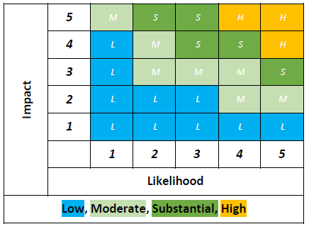 Determination ‘significance’ of risk; P: likelihood; I: impact

- Bioenergy potential in BarbAdos energy transition

A number of business cases are described that were chosen based on probability of implementation, technological status, feedstock potential and availability, stakeholder interest (expressed in public information as well as during the PPG meetings) and replicability or development initiation power. The business cases study the use of available useable agro-industrial substrates of value for the digestion process namely poultry dropping, pig manure, animal waste (slaughterhouse) as well as residues (vinasse) of the rum distilleries and the collection of the sargassum seaweed. The business cases form the basis for the determination of the direct greenhouse emission reduction that can be attributed to the SMARTER projects (see next Annex H).

  - Feedstock availability

Feedstock for anaerobic digestion

Feedstock supply has the task of guaranteeing sustainable biogas productivity and other adjacent benefits of anaerobic digestion (waste management, use of digestate as fertilizer). Based on the long-term plantation sugarcane production and crop cultivation expectations, Barbados agriculture will continue demanding higher quantities of fertilizer. From the agronomical point of view, cultivated soils need to be brought back to have their microorganisms that naturally carry out very important organic matter decomposition and soil amelioration. Biogas production could lead the way. Symbiotic effects of multiple source biomass input and the output of energy and bio-fertilizer should be considered by not only looking for the energy production potential but also with bio-fertilizer to assure higher agriculture productivity and lower imported inorganic fertilizers.

The business cases will focus on available useable substrates of value for the digestion process namely poultry dropping and pig manure. Collecting manure and digesting it in an anaerobic digester significantly reduces the greenhouse gas emissions originating from the manure, provides energy, reduces odour produced from the manure and also provides a nutrient-rich digestate that may be used as organic fertilizer for crop production. Most manure is digested under mesophilic, wet digestion conditions. The decomposition of cattle and pig manure starts soon after excretion, making it important to minimize the time from housing to digester to obtain the full corresponding energy and greenhouse gas abatement benefits. Livestock manure may be digested on its own, with other feedstocks and at varied scales. Not all the manure produced locally will be available to NPC. Pigs are often contained in sties/pens resulting in easier management of their manure. Cows and sheep are often left on pastures to graze and would prove difficult to collect their manure which would be subject to the elements, trampling and contamination. Chickens are raised in coups which are bedded with the substrate, retrieval of manure may be complicated

Manure can be obtained from dairy farms, beef lots, poultry and pig farms. The digestion of cattle/pig manure is an established technology and has been implemented widely all around the globe on varied scales. Digestion of poultry manure is tricky and its mono-digestion is uncommon. Poultry manure has high nitrogen content which causes the production of ammonia which inhibits the production of biogas. This can be avoided by storing pre-digestion, diluting the manure, and stripping ammonia from the liquid or semi-solid state or by co-digesting poultry manure with other feedstocks to obtain a more favourable carbon-to-nitrogen ratio.

King grass as a short-rotation energy crop is utilized in Barbados by private farmers. The opportunity of using high-yielding Napier Grass biomass opens up new possibilities for alternative energy generation. After establishing the culture, low amounts of fertilizers and pesticides are needed. Based on its high growth, its fast growth rate and its abundant forage, the high organic matter can be used for anaerobic digestion.

Land is a key limiting resource in Barbados in general, particularly in agriculture. The Ministry of Agriculture and Food Security (MAFS) has the mandate to maximize the nation’s food supply, by bringing idle lands back into production, and increasing agricultural productivity through national and household food security initiatives. Large-scale growing of crops for biomass threatens these initiatives and Barbados’ self-reliance on food security goals. Any growing of king grass would have to be in a crop rotation methodology to ensure that the production of food crops as well as sugar cane can still be supported. Thus, king grass for energy offers opportunities for the financial viability of sugar farmers with additional revenue yearly outside of sugar and food crop production season.

Sargassum can be collected from the water using a harvesting machine or from the shore by manual labour. It is advised that preference be given to the water collection due to Sargassum beginning its decomposition process 48 hours after washing onto the beach and completing the said process within 8 to 16 days. The presence of lignin components, high salinity, and sulphide production lowers the biogas yield from seaweeds, which can be enhanced by several pre-treatment approaches such as mechanical, physical, chemical, biological, and combined pre-treatments.
Box 18 Biomass feedstock and methane production

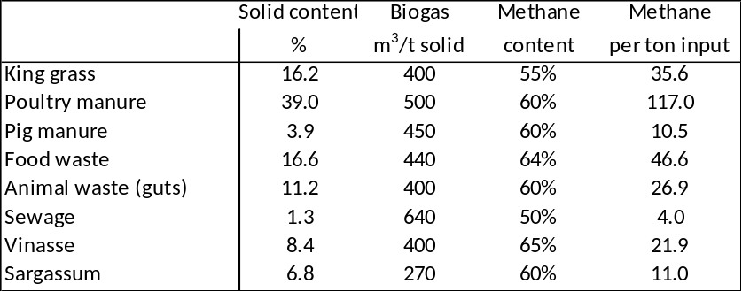
Based on Renewable Natural Gas (Biomethane) Feedstock Potential in Barbados (NPC) and
Bioenergy Assessment in the Caribbean; Promising Bioenergy Projects Concepts (GFA, 2015)
Box 19 Methane production potential, Barbados

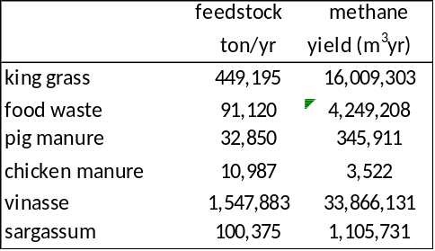

Based on Renewable Natural Gas (Biomethane) Feedstock Potential in Barbados (NPC) and Bioenergy Assessment in the Caribbean. Report on Promising Bioenergy Projects Concepts (GFA, 2015). Vinasse: see Box 28
- About 30,000 pigs were held, producing 4.5 kg of dung per pig per days, of which is 75% can be collected
- About 4.3 million chickens, producing 0.14 kg of manure per animal per day, assuming 50% of droppings can be collected
- Vinasse: 4,240 tons a day (averaged over a year) depending on ethanol production (see Box 27)
- Methane yield calculated from figures of Box 17 Sargassum: 450 tons per day harvested during 220 days (or average 275 ton/day over a year). Assumed availability of 6000 acres for king grass production (75 ton per acre; 1 harvest a year).
There is no quantification present on how much seaweed enters a country’s territorial waters. Sargassum masses generally reach Barbados around April and can last until August, though these dates may differ annually. As a result, sargassum would not be a year-round feedstock but rather seasonal. In this sense, it could be complementary to king grass as feedstock material from September-February when sargassum is not in season. Other feedstock (food waste, manure, vinasse) is, in principle, available year-round.

According to the Barbados Waste Characterization in 2015, 15,668 tons of organics were produced per month, assuming that 44% of organics is food waste. Since there is no updated figure, it is assumed that about 226 tons are being delivered and collected by the Sanitation Service Authority (SSA). This assumes that the organic waste normally delivered to the landfill is ultimately diverted to biogas facilities. This may be hard to realize in practice. Separate collection of food waste would be necessary for the recovery of energy and nutrients via anaerobic digestion but such separate food waste collection from households and businesses is not yet a local practice. In the table of Box 19, it is assumed that with economic growth (tourism) and population increase food waste potential increases to about 250 tons a day maximum.

Crop residues have been used to return beneficial nutrients into the soil to reduce or eliminate the use of chemical fertilizers. After a harvest, the residues can be tilled into the soil, or they can be applied using a no-till method and left atop as mulch.

Crop residues are most often co-digested with livestock manure that is produced on-farm or industrial food waste. The process used for digestion in such a case is wet and the crop residues are macerated for better mixing. The most abundant crop residue in Barbados is of sugar cane.

Sugarcane industry

Sugarcane (Saccharum spp.) is a perennial grass grown primarily to produce sugar for export and rum distilleries. One ton of sugarcane produces 140 kg of straw, 280 kg of bagasse and 40 kg of filter cake. In Barbados, straw is left on the field as mulch to provide nutrients to the land after a harvest. After the sugarcane has been harvested, the cut stalks are transported to the factories where they are washed and crushed to produce sugarcane juice. Bagasse is the dry, pulpy, fibrous material that remains after the sugarcane stalk has been crushed to extract its juice. Bagasse is used as a fuel within the sugar industry, about 356 TJ in 2020 (about 337,420 MMBTU; see Box 1). Bagasse can also be utilized in the production of industrial goods, such as board and paper, fuel production, and as an input in several products, including animal feed.

During the purification process, sugarcane juice is separated from solids that collect at the bottom of the storage material. This fibrous solid component is known as filter cake. Filter cake is used to fertilize soils and replenish nutrients. Following the production of sugarcane juice by milling the cane stalks, the juice is clarified, concentrated, and centrifuged to produce sugar and a syrup called molasses. Molasses is sent to be fermented in tanks where a liquid known as wine or fermentation wine is retrieved. This wine is centrifuged to recover the fermentation yeast which will be reused, and the liquid portion is sent to be distilled. As the yeast suspension is recycled, the yeast cream is diluted with water and treated with sulfuric acid for 2 hours to reduce contamination.
Box 20 Base data used in business case calculations

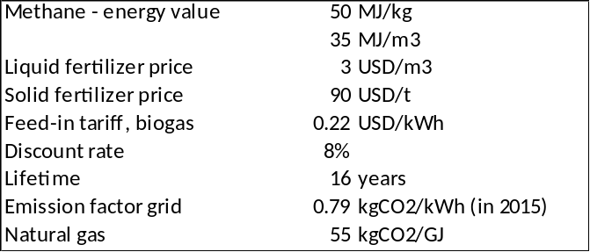
See, for example, www.engineeringtoolbox for energy value and emission factors of fuels, IPCC reports. Feed-in tariffs: BLPC/FTC websites. Fertilizer prices based on internet statistics. Emission factor grid: www.iges.co.jp

The distillation of wine separates the ethanol from the waste product also known as vinasse, typically about 10-15 litres of vinasse per litre of ethanol. Vinasse production is not exactly known but is estimated, assuming to be about 198,000-250,000 m³. Barbados produced an estimated 14 million litres of rum in 2020, which means an ethanol content of 40% of about 5.5 million litres of ethanol. Other sources mention higher feedstock. It is assumed in the business cases that about 23 million litres of ethanol can be produced yielding about 1063 m³ of vinasse per day that can potentially be used as feedstock for biogas generation.

  - Business case 1: biogas from swine manure

Calls have been made to increase the local production of livestock to reduce the importation of foods and support local food security. This shift can see an increase in livestock inventory in Barbados. On the other hand, livestock farms face significant pressure if located in nearby residential areas due to unpleasant odours emanating from the business. Barbados has experience with handling livestock manure in AD. Barnwell farms, the largest pig farm on the island, used anaerobic digestion to digest the slurry produced by 400 pigs. The project was halted due to operational and maintenance issues. However, the experience of this system exists.
Box 21 Analysis biogas plant for pig farm

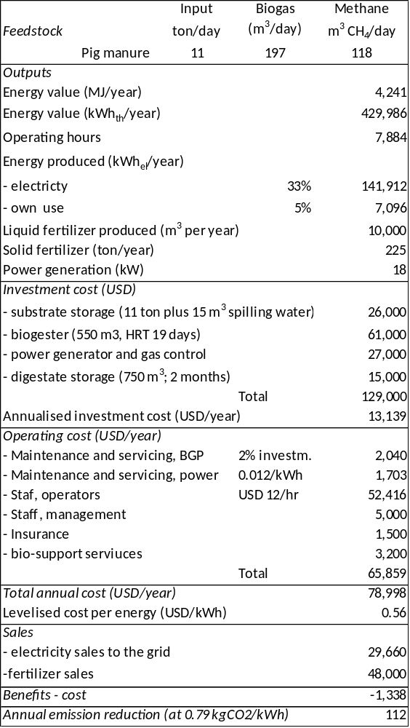
Adapted from Bioenergy Assessment in the Caribbean. Report on Promising Bioenergy Projects Concepts (GFA, 2015)
The following case is adapted from a feasibility analysis, carried out by GFA (2017) with Barnwell Farms as an example. Barnwell is a large farm with about 2000-3000 animals. This amount offers avenues for the energetic and thereafter bio-fertilizer use of both resources. Box 18 gives an indication of the theoretical biogas potential based on daily production of 11 tons of pig manure, yielding 197 m³ of biogas a day with a methane content of 60%. The gas is used in a generator (14 kW) to generate electricity. Some of the electricity is used on-site and the excess power is sold to the grid (assumed at the current feed-in tariff of USD 0.22/kWh).

After being processed inside the digester substrate could be commercialized as a liquid organic fertilizer. The solid fraction of separated fertilizer could be commercialized and due to its high solid content would even be suitable for transport over longer distances. The fertilizer is assumed to be sold to local farmers and communities. Recovery of heat and income from heat sale (or substitution) is not considered in the case.

A summary of costs and benefits is given in the table of Box 20. In this calculation example, the biodigester would yield net monetary benefits (IRR=0%), but the reader should note this will depend on several factors. Apart from the actual investment and O&M cost, the marketability of the resulting fertilizers is a very critical point for economic feasibility. If the fertilizer sale prices are lower, e.g., liquid fertilizer at USD 2 per m³ and solid fertilizer at USD 50 per ton, the costs exceed the combined revenue, leading to a net loss of -18,000 annually. If the feed-in tariff would be raised slightly, to USD 0.24/kWh, annual sales benefits equal annual cost (IRR=8%, i.e., same as the discount rate used).

  - Business case 2: biogas for power production from various feedstock
Box 22 Analysis biogas plant with various feedstock for power generation
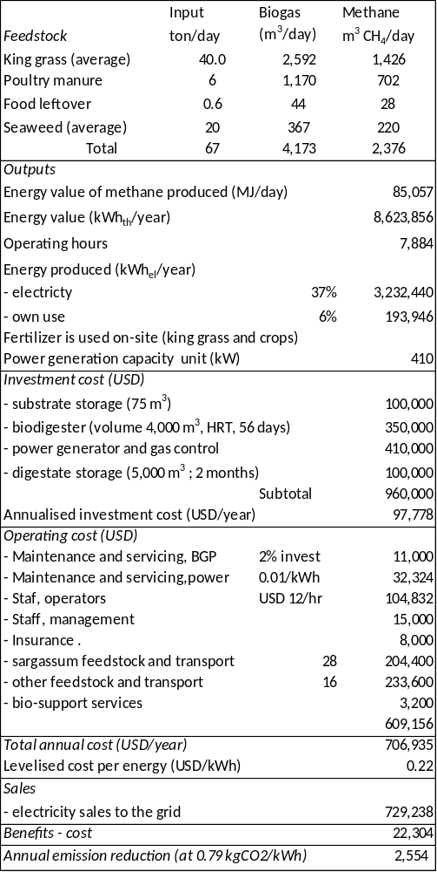
Adapted from Bioenergy Assessment in the Caribbean. Report on Promising Bioenergy Projects Concepts (GFA, 2015), using different feedstock values
The second case describes an anaerobic digestion facility on an agricultural estate that uses feedstock from several farms, food waste, sargassum and king grass. The case is modelled on the description of a biogas plant at Armagh farms (St. Philip) and a chicken manure facility (St. Lucy). The business case describes the use of biogas for power generation. It is assumed that most of the produced digestate is utilized to fertilize Napier grass cultivations; therefore, no income from digestate/fertilizer sales is considered. Heat recovery for sale as heat is not considered in the case. Alternatively, the biogas could be refined to bio-methane and sold to BNOC. This option is not presented in the table as this option is the subject of business case number 3.

A larger facility than Business case 1, the facility is assumed to be situated at or near a chicken farm. Using various feedstock boosts the size of the facility, thus achieving a better economics of scale than business case 1. However, it also increases the logistic cost, in terms of the cost of cropping, harvesting and transporting the king grass from other farms. It is assumed that the king grass (20,075 tons cultivated on 268 acres) is cultivated seasonally, as is sargassum.

The figures mentioned in Box 22 are indicative only, therefore indicate the order of magnitude of benefits and costs and do not replace the analysis that needs to be done in Outputs 2.1 and 3.1 of the SMARTER project (and this applies to the other business cases as well). To determine feedstock production potential, determination of the right feedstock input mix and costs of collection and transport of feedstock would need to be determined in a detailed feasibility study.

The cost of harvesting and transporting the seaweed is a great unknown; USD 28 per ton is assumed here (and USD 16 per ton for other feedstock. If the sargassum cost is USD 18 per ton, the calculation example gives a positive result (USD 24.500; IRR=11%).

With the same feedstock cost, but a higher feed-in tariff (of USD 0.24/kWh) the result (benefits-costs) is positive (USD 22,300; IRR =10%).

  - Business case 3: biogas production to feed into the natural gas network

The third business case adds two more players, the rum distilleries and the natural gas company BNOC. Rum distilleries in Barbados produce substantial amounts of vinasse, also known as ‘spent wash’ (organically highly contaminated wastewater from the distillation process). Besides high energy content, the vinasse contains a high concentration of nutrients (especially potassium) which potentially could be used for fertilizing issues in case of its anaerobic treatment.

The island of Barbados has a comparatively huge natural gas grid sourced by domestic gas. In line with the ‘100% RE goal’ of the country’s National Energy Policy, NPC/BNOC has an active interest in bio-methane production to be fed into its national grid and is seen as a major partner (co-financier) in this business case. It drafted a 2018 Request for Proposals for the Services for the designing, building and commissioning of a Biomethane Facility at the BNOC Natural Gas Plant, Woodbourne, St. Philip, Barbados. The facility should be able to supply a maximum of 700,000 ft³ of bio-methane to flow into the natural gas system via the pipeline at Woodbourne.

Business case 3 is modelled around this idea of producing 700 Mft³ of bio-methane using cases described in the GFA and other studies as the source for input data on production and cost. A daily amount of substrate is provided (about 886 tons a day) consisting of a mixture of king grass, slaughterhouse waste, food waste, vinasse, pig manure and sargassum seaweed. All values are empirical and should be checked on feedstock availability and characteristics to determine an adequate mix of substrates. The digestate can be marketed as a valuable liquid fertilizer (to be used on farms in the proximity of the facility) and the solid fraction of separated fertilizer could be commercialized and due to its high solid content would be suitable for transport over longer distances. It will always be vital to carry out a thorough laboratory analysis of feedstock before and after pre-treatment to find the right mix and dosage for each plant and the contents of the fertilizer.

In the example of Box 23 the biogas produced would be about 40,600 m³ a day. There are several techniques for biogas upgrading available on the market at different development stages. Four of them are well-established on the market: membrane separation, water scrubbing, chemical absorption and pressure swing adsorption (that together have 85% of the biogas-to-methane upgrading market.

Under the assumptions of Box 23, the cost of the bio-methane produced would be about USD 28/GJ. This is slightly higher than the 2020 natural gas sales prices (residential sector, USD 20.0/GJ; commercial: USD 17.43 GJ. However, these prices are based on the cost of LNG import which was around USD 11/GJ before 2020. In 2021, international market prices of LNG have been going up.

Biomethane needs to become commercially available and then rapidly scaled up to realize its full potential. Besides technical innovations, this requires that stakeholders along the value chain are incentivized to produce and trade the feedstock to allow for the deployment of biomethane in the most optimal way. The applied value to energy crops allows farmers to deploy sequential cropping with monetary benefits to their operations and environmental benefits relating to soil quality and biodiversity. The digestate produced from anaerobic digestion brought back to the agricultural soils allows nutrients from energy crops to be recycled back to the farmland. This concept. would interconnect many stakeholders
Box 23 Analysis of a biogas plant with various feedstock for bio-methane production
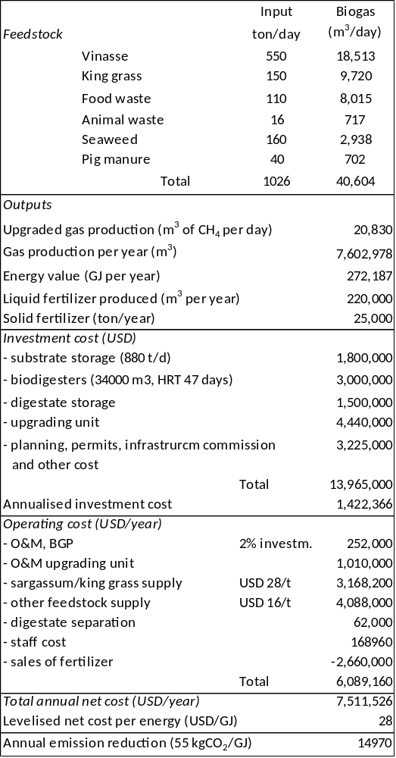
Adapted from Bioenergy Assessment in the Caribbean. Report on Promising Bioenergy Projects Concepts (GFA, 2015); Renewable Natural Gas (Biomethane) Feedstock Potential in Barbados (NPC), and Biogas-to-biomethane upgrading: A comparative review and assessment in a life cycle perspective, by Ardolino, F. et.al. in Renewable and Sustainable Energy Reviews, Vol. 139, April 2021.

An interesting question is how much of the methane needs of NPC-BNOC could be supplied by bio-methane instead of mineral natural gas. Box 19 provides an estimate of feedstock availability and methane potential, which is in the order of 29 million m³ a year (or 79,400 m³ of bio-methane a day). Not all of the feedstock potential will be available due to loss factors such as transportation losses, environmental and land-use issues, spills, as well as alternative uses of feedstock for power generation (see the first two business cases) and non-energy purposes.

Natural gas demand was 367,000 GJ in 2020 (see Box 1), that is, 28,727 m³ per day. To supply future demand with bio-methane (100% RE), NPC estimates bio-methane needs at 39,500 m³ per day. The Box CCVC indicates how potentially this bio-methane can be produced from .vinasse, food waste, pig slurry, slaughterhouse waste, year-round, and from seaweed and king grass on a seasonal basis.
Box 24 Bio-methane (renewable natural gas) needs and feedstock potential

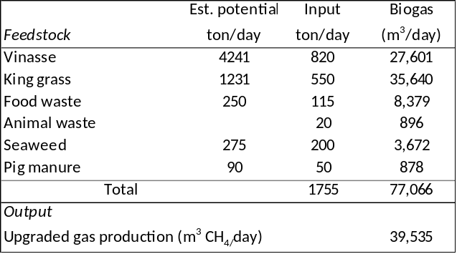

  - Business case 4: biodiesel production

Two following two cases will look at the two different alternatives that generate biofuels that are relevant for Barbados: biodiesel to reduce the fossil fuel content of the diesel fleet bioethanol to replace gasoline.

biodiesel can be mixed with mineral diesel and used in diesel engines without the need for thorough and costly vehicle modifications and adaptations. Blends with concentrations between 6% to 20% can be used for many applications using mineral diesel, with little or no equipment modifications, and pure biodiesel (B100) can be used provided appropriate precautions are taken. In this business the focus is on B20, representing a good balance between cost, emissions, and material compatibility, and explains that, based on user experience, no apparent vehicle modifications are necessary for the use of a 20% biodiesel blend. Trucks, tanks, pumps, and blend facilities can be used for B20 and no changes are required at the gas stations in the case of B20 supply, allowing the use of the same infrastructure for mineral diesel supply.

Currently, the Barbados National Terminal Company (BNTC) is preparing a pilot with the aim of testing imported B100 and B10 fuels for marketing to the general public. The results will determine the strategy for converting the entire market to an appropriate biodiesel blend in close discussion with the main stakeholders (e.g., BLPC and the major oil distributors Sol, Rubis and Harville. The limited infrastructure at petrol stations and dispensing facilities eliminates the possibility of a partial introduction or having ULSD “side by side” with a B10 or a B20. Hence there will be a need for an “all or nothing” changeover.
Box 25 Biodiesel production process

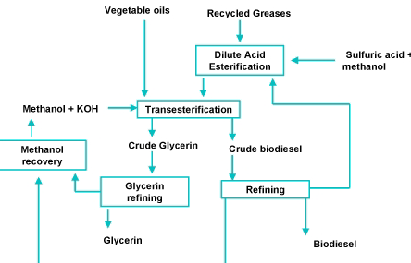
Biodiesel in essence is a plant or animal based oil without glycerine
molecules. In transesterification, the vegetable oil is mixed with an alcohol (methanol) and under presence of a catalyst (KOH or NaOH) the glycerin molecule is separated from the fatty acids in the vegetable oil, producing glycerol and a methylester (crude biodiesel) that is further refined to produce biodiesel with the same characteristics as mineral diesel.

See: http://www1.eere.energy.gov/biomass/abcs_biofuels.html and Building Energy Independence in Small Island Developing States: the Role of Biodiesel, E. Smit and B. Doberstein, 1st International Conference on Governance for Sustainable Development of Caribbean Small Island Developing States. Curaçao
The case looks at the impacts and feedstock options for B20 usage. To have the possibility of meeting the B10, the bio-diesel either has to be directly imported or through domestic production for which it will have to install a biodiesel production plant. The feedstock for domestic production is available in the form of used cooking oil (UCO) or from vegetable oil, such as soybean oil. The soybean oil feedstock either has to be produced on the island or imported.

The BNTC pilot will use biodiesel locally manufactured from UCO supplied at the amount of about 12,000 litres a month. The company Native Sun NRG collects waste vegetable oil from restaurants and hotels that are then processed at the facility in Edgehill, St. Thomas.

The UCO feedstock is higher, maybe about 1,150,000 litres a year. The business case described here looks at the feasibility of setting up a facility that could produce 1000 tons of bio-diesel annually from a similar amount of waste vegetable oil.

It is assumed here that UCO is available at USD 300 per ton. At this price and under other assumptions in Box 26, the biodiesel could be produced at around USD 0.60 per litre. Waste vegetable oil has the advantage that it is much cheaper than using fresh vegetable oil. If imported soybean oil would be used as feedstock (at about USD 1.11 per kg), the price of the soydiesel would be USD 1.59 per litre.
Box 26 Analysis biodiesel production from used cooking oil

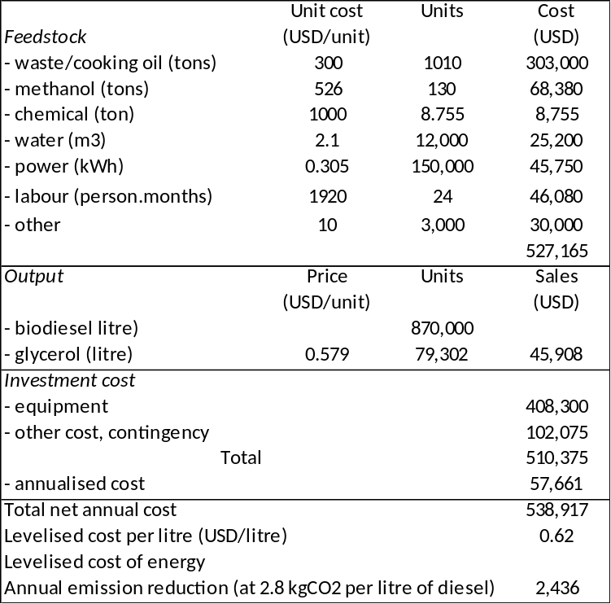
Adapted from Cost Analysis for Biodiesel Production from Waste Cooking Oil Plant in Egypt, A. Al-Gharbawy, in: Smart Grid (January 2017), Comparative Technoeconomic Analysis of Using Waste and Virgin Cooking Oils for Biodiesel Production, E.Sakkari et.al. in: Bioenergy and Biofuels, Frontiers in Energy Research, 2020; Building Energy Independence in Small Island Developing States: the Role of Biodiesel, by E. Smit and B. Doberstein (2011)

The amount of UCO-based biodiesel produced is 870,000 litres, about 5.5% of the need for biodiesel in the B20 scenario. Currently, the demand for diesel is about 40,000 barrels a month. Thus, demand for B20 would be 20%, that is 1,272,000 litres a month or 15.26 million litres of biodiesel annually. Thus, the remaining biodiesel demand of 13.39 million litres would either have to be imported or produced locally in a large biodiesel production facility, or a combination of these two options. At the August 2022 price of biodiesel in the USA (USD 1.8 per litre), the import bill would be USD 25.9 million annually. The biodiesel facility would need to import the soybean oil feedstock. At USD 1.11 per kg, the cost of biodiesel is about USD 1.5 per litre, implicating an import bill of about USD 22.9 million.

Adding the amounts of UCO-based biodiesel plus biodiesel and/or local production with imported feedstock gives a cost of USD 23.4 to 26.5 million annually. These amounts have to be compared with the alternative bill of importing mineral diesel oil; at the May 2022 diesel price of USD 0.9 per litre, the import of 15.26 million litres of mineral diesel would cost about USD 13.7 million.

Not included in the cost estimate is the need for storage facilities. At the amounts mentioned in the business case, a storage capacity of 3 million litres is needed (to meet the country’s demand for B10 for 3 months).

To produce the 13.39 million litres of soybean oil locally would be cheaper than importing but require the cultivation of 64 million tons of soybean for which the land requirement is 24,000 hectares, an area much larger than available in practical terms, not larger than About 1,800-2,400 hectares (the land surface area of Barbados is 43,900 hectares). Given the low share of local production in the soybean oil demand, it is likely to be more economic to import the feedstock. An interesting alternative mooted is leasing land in a neighbouring country (e.g., Guyana) and producing and processing the feedstock there for delivery to Barbados.

Introducing B100 (total replacement of diesel over time) would bring new cost items, such as the gradual replacement of diesel vehicle fleet for vehicles adapted to the use of pure biodiesel. Additionally, gas stations will require an adaptation of their infrastructure (tanks and pumps) to provide B100 to end customers, ensuring the use of ethanol-compatible materials.

  - Business case 5: ethanol production and bagasse power generation

Sugarcane production in Barbados is divided between government-managed farms, overseen by the BAMC, and independent farms managed by landowners. The government gained control of approximately 40-60% of sugarcane fields in the early 1990s when declining sugar prices and rising costs created high levels of debt that many farmers were unable to repay. To help maintain the industry, the government seized control and managed the indebted farmlands. The Barbados Sugar Industries Limited (BSIL), a holding company, represents the interests of the independent sugarcane producers in the country. Harvested sugarcane is crushed to produce three by-products: bagasse, sugar, and molasses. As a rule of thumb, a ton of sugarcane gives about 140 kg of straw, 40 kg of cake and 280 kg of bagasse, yielding.90 kg of sugar and 45 kg of molasses and 11 litres of ethanol. In 2020, production was about 81,000 tons of sugarcane (produced on about 2,160 hectares) yielding about 7,200 tons of sugar. Most sugarcane is sold to the government-managed Port Vale plant for processing. e into raw brown sugar, which is exported in bulk to Europe.

Rum manufacturing follows the production of molasses. In 2020, Barbados exported about 12 million litres of rum (at a value of about USD 80 million). Rum is produced by three distilleries, West Indies Rum Distilleries (WIRD), Mount Gay, Foursquare and St. Nicholas Abbey. The amount of molasses produced is not sufficient feedstock for the rum distilleries that therefore import molasses from neighbouring countries, such as Guyana. Some rum companies in the country are attempting to overcome the sugar industry problems by producing rum directly from sugarcane juice, leapfrogging the capital-intensive sugar manufacturing stage of the value chain that is needed to obtain molasses. In this case, the entire cane is fermented and a mill can produce about 80 litres of ethanol and no sugar. Sugar and sugarcane production has been declining over the past decades. Thus, the nation is hoping to shift away from bulk sugar exports toward packaged sugar in an attempt to upgrade to higher-value activities.

The ethanol production gives on average 13 litres (or 65 tons) of vinasse residue. The vinasse is an important potential feedstock for local bio-methane production, as described in Business case 4. Current production is about 205-585 m³ per day (averaged over a year).

The impact on the wear of vehicle metallic components due to the use of a gasoline mixture with up to 10% ethanol is regarded as irrelevant if compared to pure gasoline. With the use of mixtures above 10% of ethanol, the vehicles need changes in the combustion cycle.
Box 27 Sugarcane processing into ethanol and sugar

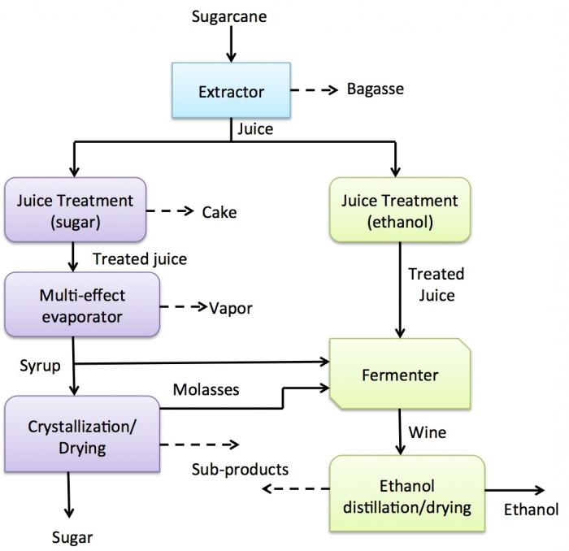

https://www.e-education.psu.edu/egee439/node/646

A plan for the possible use of ethanol would start with a change of pure gasoline to E10 (gasoline with 10% ethanol), which is described as ‘scenario 1’ in the NPC-commissioned draft Feasibility Assessment of Including Liquid Biofuels in the Transport Sector in the Context of Energy Transition and Carbon Neutrality in Barbados.

Assuming a gasoline demand of 110 million litres, the E10 demand will be 16.8 million litres annually. Adding the production for non-energy uses (rum) of an estimated 7 million litres of ethanol annually, total production in the case described here will need to be 21.42 million annually (see Box 28). It is assumed that all the ethanol is locally produced from 120,000 tons of sugarcane for 49.1 kilotons of molasses imports) while another 120,000 tons are specifically grown for ethanol and processed in a new facility (where 1 ton of sugarcane can produce 80 litres of ethanol).
Box 28 Production of ethanol in Barbados for energy and non-energy purposes and use of bagasse

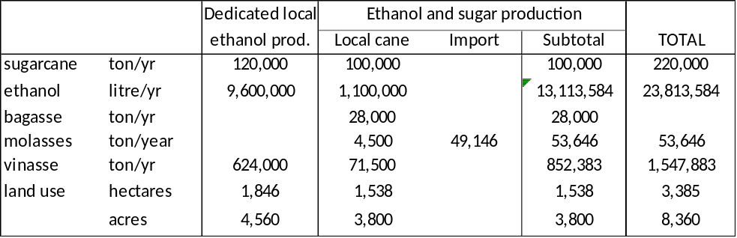

Assumed productivity is 65 ton of sugarcane per hectare.
Annual demand is based on E10 demand (16.81 million liters annually) for rum production (7 million liters annually).
The resulting production of the distillation residue wastewater (vinasse) of 1.39 million tons a year, is used as input data in Box ….
Assumption is that 1 liters of ethanol production generate 13 liters of vinasse (1 liter weighs 5 kilo).
Data are adapted and combined from various sources,. including the NPC feedstock assessment and biofuels study

Ethanol’s chemical characteristics complicate fuel supply logistics since ethanol cannot be used in the same pipelines with oil derivatives, or stored in the same tanks.

From the example in Box 29 follows that the E10 production cost will be in the order of USD 0.76 per litre of ethanol. For comparison, the price of gasoline traded in the period Nov’21-Nov’22 was about USD 0.66 for gasoline and USD 0.68 for ethanol. A litre of gasoline was sold for USD 1.895 in 2021 at Barbadian filling stations, reflecting the cost of production, distribution and margin as well as taxes (discounting the taxes the value is USD 0.863 per litre).
Box 29 Production costs and benefits of using E10 and bagasse power generation

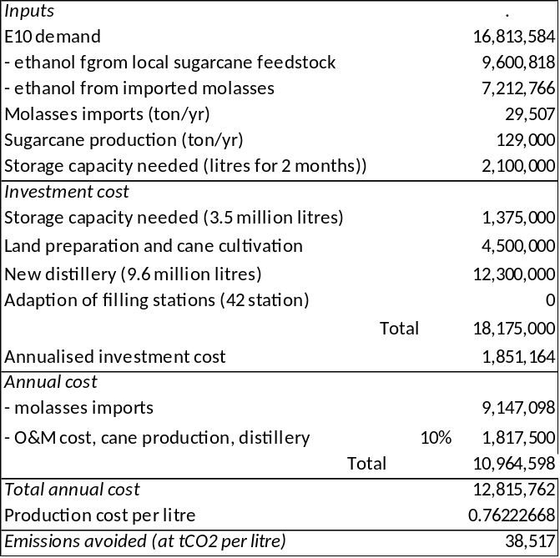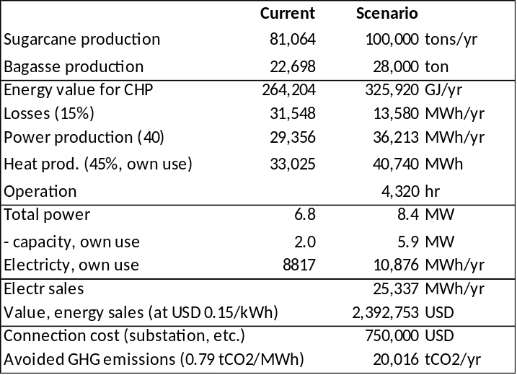

The storage system and distillery type and costs considered are based on a Brazilian example referenced in the NPC biofuels study. See CGEE. Bioetanol Combustível: Uma Oportunidade para o Brasil. 1. ed. Brasília (CGEE, 2009). The ethanol input data (locally produced and from imported molasse taken from Box 28

The bagasse produced in sugarcane production is used within the sugarcane sector on-site in combined heat-power schemes (cogeneration). Currently, the excess power produced is not delivered to the grid as this would need compliance with the grid code and additional investment (e.g., in a substation). The capacity installed currently can deliver 5-6 MW but only 1.5-2 MW is used for on-site power consumption. However, in the past, a total of up to 10 MW of power capacity was installed at sugarcane processing facilities. It is assumed in the calculation example of Box 29 that the bagasse produced in the cultivation of 100,000 tons of cane per year, is utilized for power generation with the excess electric energy (an estimated 25.3 GWh per year) sold to BLPC.

Other scenarios in the NPC biofuels study consider a more aggressive penetration of ethanol in the vehicle park by a) replacing gasoline vehicles with flex-fuel vehicles (that can run on pure ethanol). Having the whole vehicle park in flex-fuel mode would require gas stations (tanks and pumps) to adapt their storage and pumping infrastructure ensuring the use of ethanol-compatible materials. Scenario 3 of the NPC study considers a distillery capacity of about 27 million litres. The production cost, quoted in the NPC study is an estimated USD 23.3 million Bwhich is ethanol production at USD 0.89 per liter. This does not include the cost of importing flex-fuel vehicles.
Box 30 Annual cost and benefits of substation of gasoline and diesel by ethanol E10 and biodiesel B20

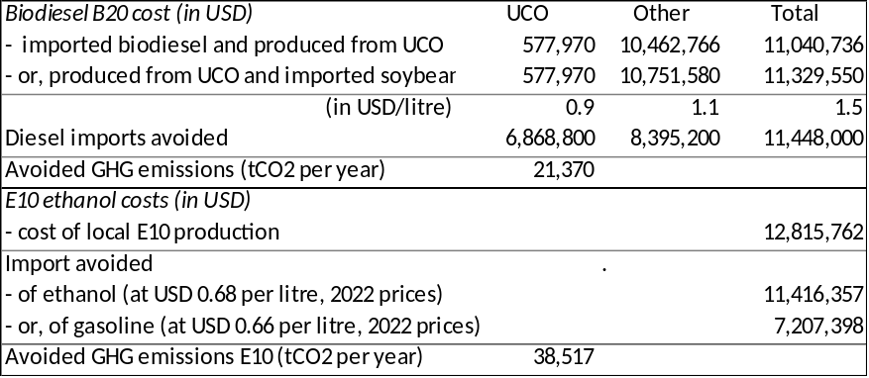

Box 30 gives a summary of the annual cost implications of the nationwide introduction of B20 biodiesel and E10 ethanol in the transport fuel supply system

  - Business case 6: vehicles running on bio-CNG

Apart from powering vehicles with biodiesel or ethanol, a third bioenergy option is powering them by bio-CNG (compressed natural gas), produced in anaerobic digestion. Biomethane, which consists of the same molecule as natural gas, namely CH₄ or methane, can be compressed in a CNG installation to be used as a transport fuel. Cars can be converted from gasoline consists which requires a CNG kit and a refueling cylinder. The kit consists of high-pressure regulators (which reduce and regulate the pressure of the fuel exiting the tank from about 200 bars to the 10 bars required by the engine’s fuel injection system), a gas filter, and natural gas sensors (which monitor the pressure of the gas). The technology as such is a mature, commercial, technology and available in many countries. Worldwide, about 28.54 million vehicles were fueled by CNG which was made available in over 33,000 filling stations in 2019.

The University of West Indies (UWI) is carrying out research on using Sargassum seaweed mixed with vinasse from ethanol producers as feedstock for bio-digestors. After experimenting with various Sargassum-vinasse ratios, as a next step, UWI will carry out a pilot with two bio-digesters (15 m³ each) and initially two vehicles. The cost of the pilot is an estimated USD 200,000.

For bio-CNG to be introduced on a more commercial, this section describes the business case of 3,000 vehicles powered by CNG produced in anaerobic digestion. It is assumed in the case described that the biogas is produced separately in biodigesters fed by vinasse and sargassum feedstock with the purpose of producing bio-CNG to make clear the production and cost numbers behind the case. Alternatively, the biodigesters can feed the already existing infrastructure of a nationwide natural gas grid that can then be delivered to the filling stations or the bio-CNG is simply produced in the larger facility as described in Business case 3 on bio-methane.

At an average consumption of 885 litres of gasoline per year, a car user would have spent USD 1,677 on gasoline per year (at the 2021 retail price of USD 1.895 per litre)
In the case described in Box 31, the cost of the bio-CNG produced is USD 29.2 per GJ (or 1.118 per m³). If the CNG would be taxed as diesel, the cost of 1 m³ of CNG would be USD 1.8959. Converted to CNG, the car user would have used the equivalent of 744 m³ of CNG (per year) with an annual cost of USD 1410 per year. Thus the car owner would save about USD 226.41 per year (under all the assumptions mentioned). At an average cost of a CNG kit of about USD 750, this implies that the car owner would see his investment in a CNG installation paid back in about three years.
Box 31 Analysis of bio-CNG production for fueling 3,000 vehicles
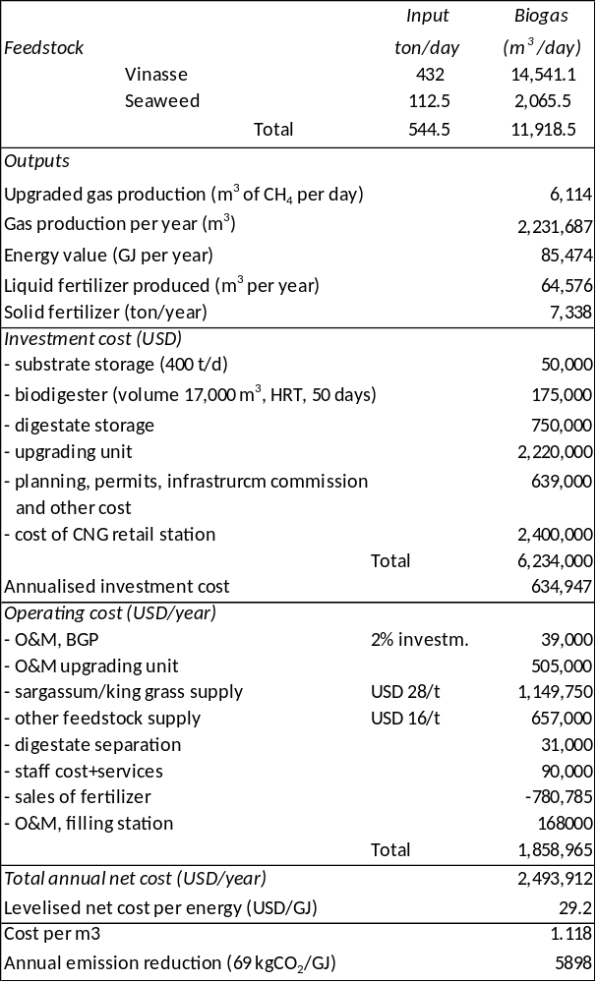

Cost of biodigester and O&M is derived from same sources as Business case 3. Data on cost of CNG compression and filling stations derived from figures mentioned in Perspectives of Biogas Conversion into Bio-CNG for Automobile Fuel in Bangladesh, M.S. Shah, et.al. (2020) in Hindawi Journal of Renewable Energy (August 2017) and Costs Associated With Compressed Natural Gas Vehicle Fueling Infrastructure, by M. Smith (US Department of Energy) and J. Gonzalez (NREL), 2014. The cost of a medium station (supplying 500-800 gallons of gas equivalent a day) is about USD 800,000. Tio supply the annual need of the 3000 CNG vehicles (with a need of about 1900 gge a day), three such stations are assumed in the calculations. The gas demand is based on the consumption if 885 liters of gasoline per vehicles per year bout 116,200 registered vehicles (Energy Bulletins, MEB).
Retailer prices in 2021 were:
- Gasoline: USD 1.895 per liter (without tax: USD 0.8634 per liter)
- Diesel: USD 1.52 per liter (without tax: USD 0.834 per liter)

  - Environmental aspects of anaerobic digestion

The business cases study the use of available useable agro-industrial substrates of value for the digestion process namely poultry dropping, pig manure, animal waste (slaughterhouse) as well as residues (vinasse) of the rum distilleries. The vinasse and further organic wastes treatment in a biogas plant have a couple of direct and indirect benefits for the environment and hygiene. In the case of vinasse, the vinasse digestion will be the protection of the water resources as after digestion the vinasse will be used as an efficient fertilizer which does not cause plant damage when released into the sea. Marine pollution is further diminished by finding a use for the collected seaweed (Sargassum).

Globally the reduction of greenhouse gas emissions, especially the direct greenhouse gases methane and nitrous oxide is important. Both are generated by normal manure storage and then emitted into the atmosphere. Methane has a 25-fold greenhouse effect compared to carbon dioxide, nitrous oxide is 300 times more strong. The anaerobic digestion in a biogas fermenter avoids the generation of nitrous oxide, which is formed especially under semi-oxigenous conditions, when nitrogen-rich substrates are degraded. The methane generation is enhanced, but in a controlled process with the utilization of the generated gas. In this way, the methane is transferred to CO₂ by a factor of 25. This carbon dioxide is climate neutral as it is generated from manure as a renewable resource.

The biogas digestion of organic wastes has several indirect and direct hygiene effects. The reduction of pathogens by the biogas process depends strongly on some technical parameters like digestion temperature level, pre-treatment, heat step in between the process, average and secure retention time, cascading and more. As named before, the process takes place in a closed tank under anoxic conditions. The easily degradable organic compounds are degraded in the process. This means that insects, rodents and other animal vectors lose their feed base and sometimes their habitat. If one of these vectors comes into a plant, it will die and will be degraded. Those are very strong indirect effects to enhance hygiene in organic waste management.

  - Potential of bioenergy production in Barbados’ energy transition

This section provides a summary of the potential contribution to the energy system by the year 2040, if the business cases discussed in this Annex (sections G.2 to G.7) will actually be implemented within the limits posed by feedstock availability and collection (see the potential feedstock amounts provided in Box 19, in section G.1).

- Business cases 1 to 3 will be implemented twice each, so the amounts of electricity and renewable natural gas generated will double those mentioned in the Boxes will be doubled to provide
- If Business Cases 4 to 5 will implemented, these will provide sufficient amounts of biofuel to have B20 and E10 inserted in the transport fuel distribution system according to the ‘all-or-nothing’ principle. Business Case 6 will provide bio-CNG to power 3000 vehicles. more renewable natural gas could be provided to power more cars through the country’s national gas pipeline system, but then less would be available for use in other sectors (residential, commercial, industry).
- If the business cases will be implemented as described, the bioenergy system will reach its limits in terms of domestically available feedstock. Here it should be noted that already the amounts of used cooking oil (UCO) for biodiesel production the Business case 4 already assumes that most of the biodiesel (to be able o fully supply B20 given the size of the diesel-powered vehicle park) either have to be imported or produced locally from imported feedstock such as soybean. The amount of vinasse produced is linked with E10 production. If it is decided not to introduce E10 in the Barbados transport fuel mix, the ethanol production will remain at current levels (mainly for sugar and rum production at current levels) and the vinasse output would one be a third only. With less vinasse, there will also be less feedstock for anaerobic digestion.
Box 32 Feedstock availability and potential to generate the bioenergy requirements of the business cases

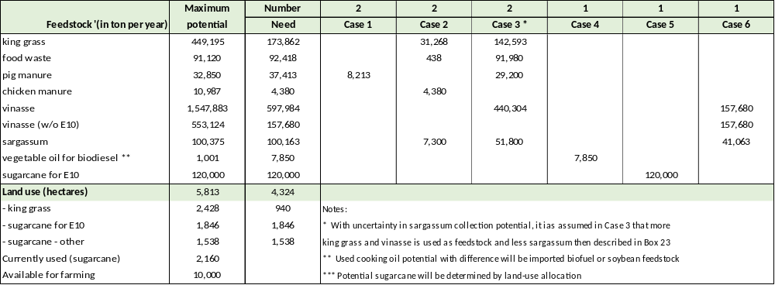

- A potential large biomass resource is the sargassum seaweed, but it is not very well known what the options for cost-effective onshore or offshore harvesting will be. The figures mentioned in this Annex G are very preliminary estimates of potential and costs.
With limited feedstock and alternative uses, competition from other renewable energy technologies (solar, wind), and choices will have to be made. The description of business cases and level of inclusion in the bioenergy production, as described in this section, does not imply a preference for certain cases over other cases, but to have a quantitative estimate of the order of magnitude of feedstock and potential bioenergy production for a range of uses.

Currently, bioenergy provides only a small part of the primary energy supply of Barbados, about 2.5%, as visualized in Box 34. The figure on the right in the box gives the energy flows in a future low-carbon scenario for the year 2040, in which:
Box 33 Potential bioenergy production for electricity or fuel needs

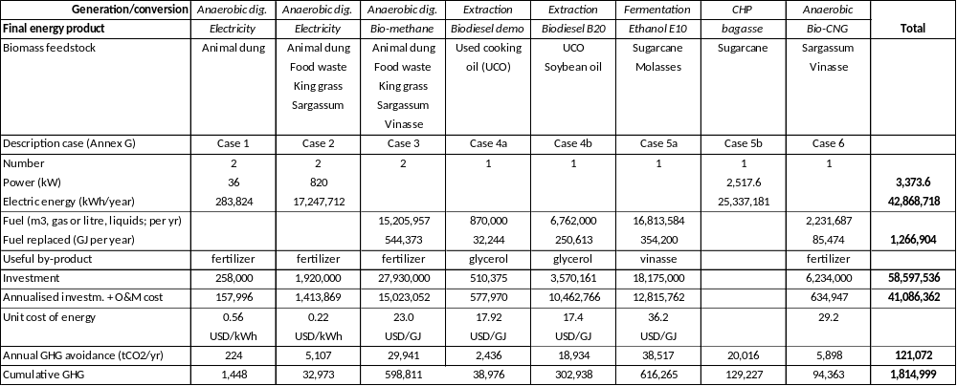

- Despite a modest population and economic growth, the energy demand has decreased due to higher efficiency and lower energy intensity of the economy;
- Most energy resources are locally produced rather than imported;
- Almost 100% of electricity is generated by renewables, including bioenergy (from the application of Business cases 1,2 and 3)
- Significant electrification of end-use resulting in a much higher share in final energy demand (more than half).
- The amount of bioenergy has risen more than 15-fold and forms almost 20% of the energy supply.

For transport, it has been assumed that by 2040, the same amounts of biodiesel and ethanol are produced as given in Box 33, but as B100 and E100 usage (i.e., with fuel supply infrastructure and vehicle engines adapted to the use of pure biodiesel and bio-ethanol. These amounts can power 3,843 B100 vehicles and 4,352 E100 vehicles, assuming that all E100 and B100 are locally produced. Assuming that in 2040, 146290 vehicles will be circulating, this assumes that 92% of vehicles will be electric (in line with the high demand-high EV scenarios of the IRRP 2021) in a full net-zero carbon scenario. If the share of electric vehicles is less than either E100 or B100 needs to be imported (or more feedstock imported for local production or by fossil fuels.

In the 2040 scenario, still, about 34% of the energy supply needs to be imported. To be 100% RE, these will need to be imported, either biofuels, green hydrogen (or derivative fuels, methanol, ammonia), or fossil fuels that have been produced with carbon collection and storage (CCS).
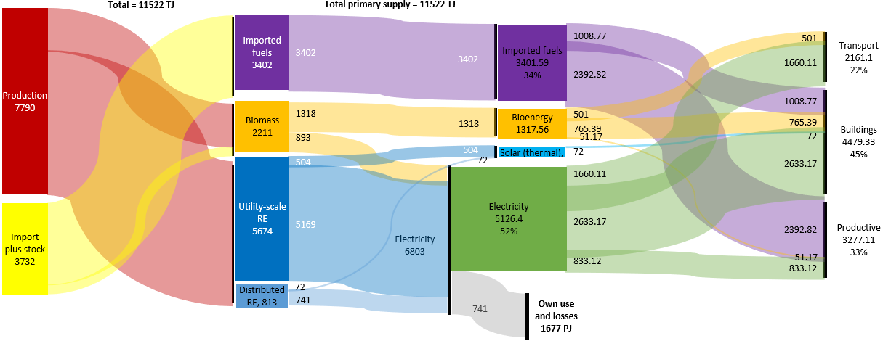
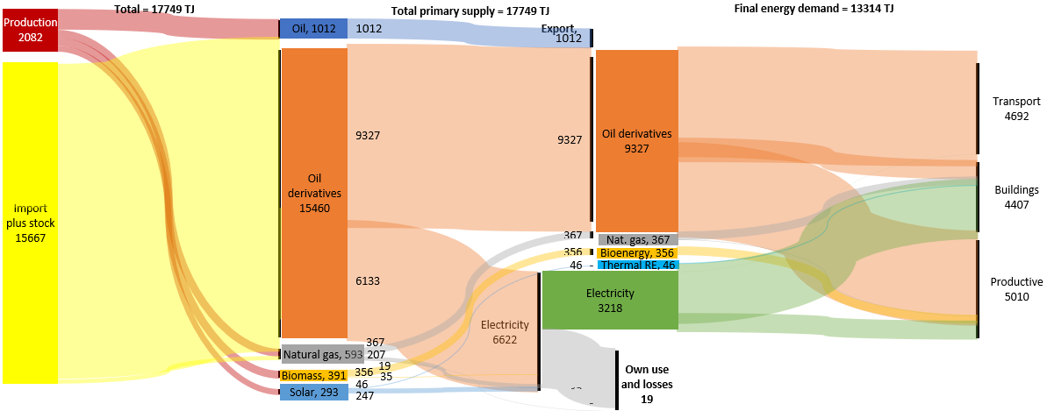
Box 34 Contribution of bioenergy to energy supply and demand in 2020 and 2040

Energy supply and demand, 2020 (see Box 1) Projection of low-carbon energy supply to meet 2040 demand

- GEF core indicators and GHG emission reduction

  - Introduction; applicable GEF core indicators

This annex presents the results and the methodology used for estimating project contributions to the following applicable GEF-7 Core Indicators: (i) Direct and indirect greenhouse gas (GHG) emissions mitigated; (ii) Increase in installed renewable energy (RE) capacity per technology; and (iii) Number of direct beneficiaries disaggregated by gender as co-benefit of GEF investment. The resulting targets have been included as part of the project documentation (GEF CEO endorsement/approval request (CEO ER) and/or UNDP Project Document).

Indirect GHG emissions reductions (ER) are the result of the broad adoption of the project’s outcomes. As such, indirect GHG ER has been estimated at the CEO endorsement phase following a similar approach as that used at the concept approval (PIF) phase. In contrast, direct GHG ER, increase in RE power capacity, Energy produced, and Number of direct beneficiaries will result from the project’s bioenergy pilot(s) specifically. The SMARTER project will provide partial capital expenditure (CAPEX) subsidies as direct financial support for one or more eligible bioenergy pilots/demos to purchase appliances/equipment. The remaining investment costs not covered by the project’s CAPEX subsidy will have to be funded by other sources, i.e., the confirmed co-financiers and other sources.

The cost-benefit analyses of the bioenergy Business Cases, presented in Annex G, have been used to estimate the emission reduction targets. The resulting targets are presented in Annex H.3 and have been included as part of the project documentation (GEF CEO endorsement/approval request (CEO ER) and/or UNDP Project Document). The methodology used to estimate project targets is described in Annex H.4 and the differences with respect to PIF-phase methodology and targets are explained in Annex H.3.

It is important to note that the project’s pilot(s) have not been fully identified as such during the project preparation (PPG) phase. Various key aspects may change or remain to be defined during project implementation (e.g., pilot type and feedstock used, investment and operational costs, % of CAPEX subsidy required, expected bioenergy electricity or fuel production and/or sales). Assumptions and calculations as described in this annex have been made for the sole purpose of estimating project targets.

The SMARTER project will report on the following GEF-7 Core indicators:

Core indicator 6: Greenhouse Gas (GHG) Emissions Mitigated (tCO2e). This indicator captures the amount of GHG emissions expected to be avoided through the GEF project’s investment in the bioenergy pilots/demos. It should be measured above a baseline value. Mitigation benefits include both direct and indirect GHG emissions reductions:
- Direct emissions reductions are attributable to the investments made during the project's supervised implementation period, totalled over the respective lifetime of the investments (16 years). For AMP national projects, direct emission mitigation arises from the bioenergy investments under program Component 3.
- Indirect emissions reductions result from broader adoption of the outcomes of the project plus longer-term emission reductions from new bioenergy investment opportunities in the post-project period. Broader adoption of the project proceeds through several processes including replication, scaling-up and market change as well as resulting from creating a general enabling investment environment for sustainable bioenergy development supported by the SMARTER project as well as other development partners’ projects.

Context Sub-indicator 6.2: This indicator captures the increase in renewable energy generation (electricity in MWh and fuels in GJ) and is disaggregated by type of renewable energy technology (biomass, solar photovoltaic, other).

Context Sub-indicator 6.4: Increase in installed renewable energy capacity per technology (MW, MWh). This indicator captures the increase in renewable electricity generation and/or storage capacity and should be disaggregated by type of renewable energy technology (biomass, solar photovoltaic, and others). Since all the main PV application is rooftop PV on public buildings that provide excess power to the grid, the increase of storage capacity is not considered. Therefore, this indicator will measure the increase in renewable energy generation capacity (MW).

Core indicator 11: Number of direct beneficiaries disaggregated by gender as co-benefit of GEF investment. This indicator captures the total number of direct beneficiaries including the proportion of women beneficiaries. Normally, direct beneficiaries are all individuals receiving targeted support from a given project. However, the energy produced (except for the case of bagasse) is not specifically for the project or site but delivered to be injected into the national power grid, gas pipeline systems, or in the case of liquid fuels, in the national system of filling stations. Thus, all the clients of these national energy distribution systems benefit in a way, and are regarded as ‘indirect beneficiaries’.

As direct beneficiaries of the project are considered the participants in SMARTER’s training, workshops and seminars as well as direct job creation associated with the pilots/demos. This is further explained in the next section of this Annex.

  - Project’s target contributions to GEF-7 Core Indicators

At the PIF stage, it was assumed that the main emission reduction would come from directly supporting the implementation of about 7.5 MW of on-grid renewable energy (read: solar PV) projects, for which co-finance is confirmed by GOB. The data derives from the UNDP/GEF DREAM project. The justification for inclusion is the facilitation of the implementation of these renewable energy systems by the SMARTER’s project’s capacity and institutional building activities of Component 1 (that builds on and aims to strengthen the results of the DREAM project). Second, the PIF assumes the establishment of a 250 kW biogas facility (based on biogas production at swine or chicken farms).

The PPG Phase has provided more nuance as to the types of pilots that will receive Program support and their respective direct beneficiaries. First, in the PPG phase, it was noted that a bioenergy programme (which is the core of SMARTER’s activities) should have a larger part of its direct emission reduction attributed to bioenergy technologies. Being linked to Component 1 activities, the position of linking distributed renewable energy systems has been maintained, but in the form of rooftop PV on public buildings at a lower capacity (1.2 MW on 100 public buildings, instead of the PIF’s 7.5 MW).

A second difference is SMARTER’s expanded focus, not only on power generation with biogas plants, but encompassing a much wider range of bio-conversion routes (including fermentation, and biodiesel production) as well as potential applications (such as the use of methane biogas to be injected into the country’s gas pipeline system as well as the option of introducing biofuels for transportation). Their potential is recognized, for example, by NPC/BNOC which has started investigations on the possible use of bio-methane and biofuels.

Thus, the amount of bio-energy power generation is still higher than in the PIF (428 kW instead of the 250 kW pilot) but the total power capacity (distributed RE and bioenergy) of 1.61 MW is smaller than the PIF’s 7.5-8 MW. The combined energy generation (202 TJ or 57,000 MWh ) of bioelectricity and biofuels is higher than the PIF’s 26,000 MWh per year.

A third difference is the introduction of a baseline shift occurring to the rapid increase of the share of renewable energy in the country’s power generation following the BNEP’s targets. Box 31 gives a conservative estimate of the growth of RE share in the power system, affecting the grid emission factor to be used. For the bio-methane, such a baseline shift is not considered to such an extent as there is no easy replacement for the gas, while for the transport fuels (B10 and E10) is assumed that small amounts would increasingly be imported thus lowering the system emission factor (an average reduction of 20% is considered).
Box 35 Assumed grid emission factor evolution

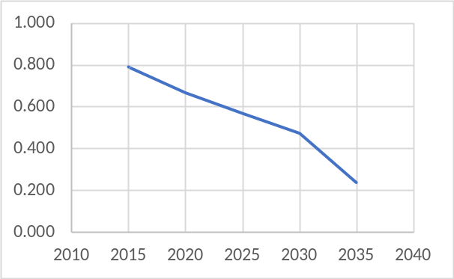.
The base year (2015) grid emission factor of: 0.79 tCO₂/MWh I taken from Analysis of Grid Emission Factors for the Electricity Sector in Caribbean Countries, Cubaenergía, UNEP DTU (2015). The analysis assumes that by 2040 the grid emission factor is only 10% of the 2015 value

Summary of the project targets – direct benefits

Box 36 shows the project’s target contributions to GEF-7 Core Indicators as updated at CEO ER and compares them to those expected at the PIF phase. The direct emission reduction is based on Business Case 2 (anaerobic digestion for power), Case 3 (anaerobic digestion for renewable natural gas) and Case 4a (biodiesel from UCO), described in Annex G. It is assumed that at least one of these will be a pilot/demo under construction or in operation and two have advanced to the stage of approved business planning to be counted as contributing to direct emission reduction.

These bioenergy pilots/demos together with the anticipated project-induced installation of PV on public buildings will lead to 215,903 tCO_{2e} direct GHG ER over the 20-year period 2024-2035; generating renewable electricity of 10,463 MWh (with an installed capacity of 1,610 kW) and fuels of 168,337 GJ respectively. The projects will benefit a total of 196 people directly in terms of full-time employment (FTE), while an additional 570 people will profit form SMARTER’s training and workshop activities.
Box 36 Project results – expected at PIF and at CEO endorsement

Expected at PIF and CEO endorsement
Project GEF-7 Core Indicators |  | Expected at PIF | Expected at CEO Endorsement
6.1 | Greenhouse Gas Emissions Avoided (metric tons of CO2e) – cumulative (20 years) | 213,000 (direct)  210,000 (indirect) | 215,503 (direct)  329,311 (indirect)
6.3 | Energy substituted (cumulative)  - electric energy (in GJ)  - gaseous and liquid fuels (in GJ) | 245,000 MWh (882,000 GJ) | 4,120,114 (GJ)  * 753,369 GJ (209,269 MWh)  * 3,336,745 GJ
6.4 | Increase in installed renewable energy capacity – biomass for power (MW) | 7.75 MW  * 7.50 MW (solar PV)  * 0.25 MW (bio-power) | 1.61 MW  * 1.20 MW (solar PV)  * 0.41 MW (bio-power)
11 | Number of direct beneficiaries disaggregated by gender as co-benefit of GEF investment  Units of measure: number of people; number of connections disaggregated by customer segment | Not determined | Total direct: 766 (of which 306 women)  - through direct employment (FTE): 196 (of which 78 women)  - through capacity building: 570 (of which 228 women)  -------  Indirectly – distribution system customers:  - 21,200 (clients BNOC)  - 130,000 (clients BLPC)  - 19,200 (diesel vehicles)

Indirect greenhouse ER

Indirect GHG ER is the result of investments that are expected to occur in the 10 years after the project has ended due to enabled investment environments for distributed RE and bioenergy investment. The replication relates to how the project has contributed to the implementation of project concepts developed further during the Project implementation period
- For the distributed (rooftop PV) RE on public buildings, a replication factor of 3 is used, giving an indirect GHG emission reduction impact of 36.7 kilotons of CO₂.
- For bioenergy, the estimates of potential, are based on the six business cases described in Annex G and feedstock availability, giving a total potential emission reduction of 1,815 kilotons of CO₂ (see Box 33). This amount is the sum of both direct and indirect emission reduction. Subtracting the bioenergy-related direct GHG ER (205.2 ktCO₂) gives bioenergy indirect emission reduction of 1,609.8 ktCO₂.

The sum of the two is 1,645.6 kilotons of CO₂. However, only part of this emission reduction can be attributed to the project’s interventions. A causality factor of 20% is assumed to realistically determine SMARTER’s indirect (lifetime) GHG ER of 5329,311 tCO_{2e.}
Box 37 Indirect GHG emission reduction

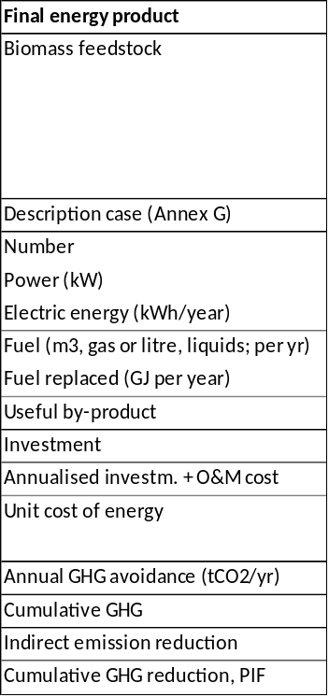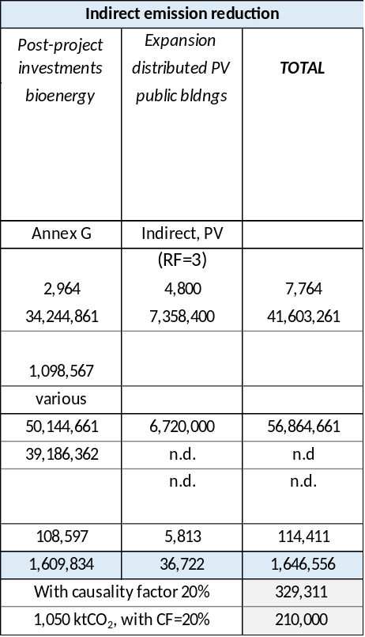

Indirect beneficiaries are all the users of the pipeline system (in which bio-methane will be injected), the power system (receiving biomass-generated power) and the fuel distribution system (19200 diesel-fueled vehicles) (with 50% female beneficiaries)

Core Indicator 6: Greenhouse gas emissions mitigated (metric tons of carbon dioxide equivalent)
6.2 Emissions avoided
GHG emission type | Metric tons CO₂-eq (expected at PIF) | Metic tons CO₂-eq (expected at CEO ER) | Metic tons CO₂-eq (expected at MTR) | Metic tons CO₂-eq (expected at TE)
Lifetime direct project GHG emissions mitigated | 213,000 | 215,503 | 49,314
Lifetime post-project missions mitigated | 213,000 | 215,503 | 49,314
Lifetime indirect GHG emissions mitigated | 210,000 | 329,311
Anticipated year |  | 2024-2048

6.3 Energy saved (megajoules)
Type of Intervention  (related to direct GHG emissions) | MJ  (expected at PIF) | MJ  (expected at CEO ER) | MJ  (achieved at MTR) | MJ  achieved at TE)
Electric energy production (PV and bioenergy) | 882,000 GJ (245,000 MWh) | 753,369 GJ (202,269 MWh)
Liquid and gaseous biofuels |  | 3,366,745 GJ (935,207 MWh)

6.4 Increase in installed renewable energy capacity per technology
Technology  (related to direct emissions) | MW  (expected at PIF) | MW  (expected at CEO Endorsement) | MW  (achieved at MTR) | MW  (achieved at TE)
- Additional capacity for power generation (solar and bioenergy)  - Addittional battery storage | 7.75 MW  --- | 1.61 MW  ---

Core  Indicator 11 | Number of direct beneficiaries disaggregated by gender as co-benefit of GEF investment
 |  | PIF stage | CEO Endorsement | MTR | TE
 | Female | Not determined | 266 | 70
 | Male | Not determined | 500 | 125
 | Total | Not determined | 766 | 190

- Project staff, consultancies and subcontracts

A) Key project staff

Project Manager (PM) - Full-time (48 months)

The Project Manager (PM), together with the Lead Advisor will be responsible for the overall management of the project, including the mobilization of all project inputs, supervision over project staff, consultants and sub-contractors.

Duties and Responsibilities

Manage and supervise the project to ensure achievement of results:
- Oversee the day-to-day project implementation and ensure achievement of targets as outlined in the project document, inception report and subsequent work plans;
- Leads and supervise project team, builds team coherence and establishes clear roles and responsibilities among team members; Conducts internal capacity-building training for project staff to facilitate appropriate management and timely delivery of project outputs;
- Executes activities by managing personnel, goods and services, training and low-value grants, including drafting terms of reference and work specifications, and overseeing all contractors’ work.
- Takes overall responsibility for the project and performs oversight roles for project compliance against the relevant government and UNDP regulations for project management;
- Develops the project standard operating procedures in line with the government and UNDP’s regulations; seeks the Project Board’s approval; and takes responsibility for updating and revising it as necessary;
  - Consult with the project board through the National Project Director for any issues that require their attention, including issues related to deviation from the approved work plans and its tolerance (e.g., deviation from the approved target, and/or budget).

Ensure effective planning, budgeting and monitoring:
- Performs project management duties on UNDP’s ERM (ATLAS) in line with the NIM manual and as outlined in the delegation of authority for Project Manager. Prepare revisions to the multi-year work plan, as needed, as well as annual and quarterly plans
- Monitor and track progress against the GEF Core indicators; Ensure that these and other indicators (e.g. gender) included in the project results framework are monitored annually in advance of the GEF PIR submission deadline so that progress can be reported in the GEF PIR.
- Ensures effective monitoring of project performance. Watch for plan deviations and ensure that changes are controlled and problems addressed when needed within Project Board-agreed tolerances to achieve results. Assess major and minor amendments to the project within the parameters set by UNDP-GEF;
- Prepare the GEF PIR and perform regular results-oriented progress reporting to the project board as agreed with the board, including measures to address challenges and opportunities. Provide support for the completion of assessments required by UNDP, spot checks and audits.
- Manage and monitor the project risks – including social and environmental risks - initially identified and submit new risks to the Project Board for consideration and decision on possible actions if required; update the status of these risks by maintaining the project risks log;
- Monitor implementation plans including the gender action plan, stakeholder engagement plan, and any environmental and social management plans;
- Manage requests for the provision of UNDP financial resources through funding advances, direct payments or reimbursement;
- Mobilize goods and services and other project inputs, including preparing ToRs for expert consultants, meetings, and workshops; Ensure that the quality of project inputs meet the expected standards and are sufficient to produce project outputs and targets;
- Monitor financial resources and accounting to ensure the accuracy and reliability of financial reports.
- Prepare and submit financial reports to UNDP on a quarterly basis.
- Support the Mid-term review and Terminal Evaluation process.
Create and nurture strategic partnerships and support the implementation of resource mobilization
  - Establish and maintain good working relationships with the relevant public and development partners who are the principal counterparts for the project;
  - Initiate and maintain partnerships with development partners, government institutions, private sector, civil society and other stakeholders to contribute to the achievement of project results;
  - Build project reputation for quality design, reliable delivery as well as integrity and accountability;
  - Identify and work with key partners/stakeholders to ensure synergies with other projects/initiatives and to avoid duplication of activities among actors;
  - Identify opportunities for mobilizing resources for the project, and prepares substantive briefs on possible areas of cooperation.

The following are Component-specific tasks that will take about 55% of the person’s time:
- In Outcomes 1, 2 and 3, he/she provides a technical review of studies (design, advice and comments) in the various components and provides technical backstopping to all activities in the three Components of the Project for technical matters related to biomass feedstock production, conversion routes and bioenergy uses (electricity, fuel, other
- Outcome 4: Identifies best practices and lessons learnt from the project and from other initiatives that can be helpful to the project in achieving its goals and objectives; Leads in generating knowledge products such as best practices and lessons learned for knowledge sharing; Contributes to knowledge networks and communities of practice; Capture lessons learned during project implementation.

Project financial-administrative assistant – Full-time (48 months; MEB co-financing)

Duties and Responsibilities

Under the guidance and supervision of the Project Manager, the Project Assistant will carry out the following:

Administrative
- Assist the Project Manager in day-to-day management and oversight of project activities;
- Assist in the preparation of reports; Review project documents, especially cost plans/budgets, for completeness and compliance with relevant rules and procedures prior to submission for final approval and signature; Distribute project documents to relevant parties upon approval
- Ensure all project documentation (progress reports, consulting and other technical reports, minutes of meetings, etc.) are properly maintained in hard and electronic copies in an efficient and readily accessible filing system, for when required by PB, TAC, UNDP, project consultants and other PMU staff;
- Provide PMU-related administrative and logistical assistance. Follow-up on administrative actions and resolve issues related to project implementation (e.g. recruitment and appointment of personnel, travel arrangements, training/study tours, authorization of payments, disbursement of funds, procurement of equipment and services, security compliance, etc.
- Updated database of the relevant public and development partners private sector, civil society and other stakeholders who are counterparts for the project;

Financial
- Keep records of project funds and expenditures, and ensure all project-related financial documentation are well maintained and readily available when required by the Project Manager;
- Review project expenditures and ensure that project funds are used in compliance with the Project Document and GoI financial rules and procedures;
- Validate and certify FACE forms before submission to UNDP;
- Provide necessary financial information as and when required for project management decisions;
- Provide necessary financial information during project audit(s);
- Review annual budgets and (quarterly) project expenditure reports, and notify the Project Manager if there are any discrepancies or issues;
- Consolidate financial progress reports submitted by the responsible parties for implementation of project activities;
- Liaise and follow up with the responsible parties for implementation of project activities in matters related to project funds and financial progress reports.
Technical and pilot coordinator - 80% time (48 months)

Description of responsibilities:

The incumbent will be responsible for the implementation of Outcome 2, including assistance to mobilize all component resources, and supervision of consultants and sub‐contractors. Under the direction of the PM, the Coordinator will liaise with the national and local governments, UNDP, and all stakeholders involved in Outcome 2 of the project. She/he will be specifically responsible for:
- Overall management of component 3, in particular by providing technical guidance on the planning of the pilot and demonstration projects and investment replication plan
- Serve as a focal point for coordination, monitoring of project implementation activities; Oversee and guide the design of surveys/ assessments commissioned for monitoring and evaluating project results; Monitor project progress and participate in the production of progress reports ensuring that they meet the necessary reporting requirements and standards; Ensure project’s M&E meets the requirements of the Government, the UNDP Country Office, and UNDP-GEF; develop project-specific M&E tools as necessary; Oversee and ensure the implementation of the project’s M&E plan,
- Provide technical support on the formulation of Call for Proposals text and annexes (such as site and thematic information); liaise with relevant stakeholders to initiate requests, prepare standard terms of reference against project objectives, obtain necessary clearances, process
- Coordination of policy, bioenergy potential and feedstock assessments of Components 1 and 2 and draft Terms of Reference
- Provides technical review of studies (design, advice and comments) in the various components and provides technical backstopping to all activities in the three Components of the Project for technical matters related to biomass feedstock production, conversion routes and bioenergy uses (electricity, fuel, other)
- Work closely with relevant actors to collect, analyse, and consolidate data as well as verify the internal consistency and validity of data.
- Oversee and guide the design of surveys/ assessments commissioned for monitoring and evaluating project results; Facilitate mid-term and terminal evaluations of the project; including management responses; Facilitate annual reviews of the project and produce analytical reports from these annual reviews, including learning and other knowledge management products;
- Ensure management of component funds is consistent with UNDP requirements, and budget planning and control.
- Assist the PM in the submission of progress reports and key‐issues reports to the PB (PSC) of annual and quarterly progress reports, Project Implementation Reports, Technical reports, s, and other reports as may be required by UNDP, GEF and other oversight agencies.
- Undertake other activities as assigned by the PM.

Lead (technical) Advisor - (part-time, 20 working days a year)

Description of responsibilities:

Under the overall supervision of the Project Manager, the non-resident Lead (technical) Adviser will:
- Provide guidance and assistance to the PM and project staff to ensure that the project activities conform to the approved project document;
- Assist the PM during the initiation of the project, in the preparation of an “inception report” which will elaborate on the project Logical Framework Matrix and planned project activities, the Annual Work Plan and Budget, and M&E plan; ▪ In close cooperation with the PM and UNDP’s Focal Point on Energy and Environment,
- Assist the PMU in the development of relevant ToRs and recruitment/mobilization of qualified national and international experts and organizations as needed to provide specific consultancy and engineering services;
- Support formulation of policy and bioenergy assessment of Components 1 and 2 and advice on the content of feasibility studies, including drafting of Terms of Reference with the Technical/Pilot Coordinator Provide technical backstopping to all activities in the three Components of the Project for technical matters of Component 3,
- Support the PM in reporting to the PB on the progress of project implementation and achievement of project results in accordance with the project's logical framework matrix, including guidance to the PMU on the tracking and measurement of project success indicators, e.g., energy savings and substitution, GHG emission reduction
- Support the PMU in project-related meetings, as required;
- Review reports of national and international consultants;
- Support the PM in preparing project progress reports, and in the preparation and implementation of Mid-Term Review and Terminal Independent Evaluation Missions
- Assist in the preparation of the project scale-up activities (Component 3), formulation of a detailed end-of-project report and, on an as-needed basis, preparation of project results/impacts communication articles

Social safeguards and gender – (part-time, 3.5 years at 43% of full-time)

Duties and Responsibilities

Gender
- Monitor progress in the implementation of the project Gender Action Plan ensuring that targets are fully met and the reporting requirements are fulfilled;
- Oversee/develop/coordinate the implementation of all gender-related work;
- Review the Gender Action Plan annually, and update and revise corresponding management plans as necessary;
- Ensure reporting, monitoring and evaluation fully address the gender issues of the project;

Social safeguards
- Monitor progress in the development/implementation of the project ESMP/ESMF ensuring that UNDPs SES policy is fully met and the reporting requirements are fulfilled;
- Oversee/develop/coordinate the implementation of all safeguard-related plans;
- Ensure social and environmental grievances are managed effectively and transparently;
- Review the SESP annually, and update and revise the corresponding risk log; mitigation/management plans as necessary;
- Ensure full disclosure with concerned stakeholders;
- Ensure environmental and social risks are identified, avoided, mitigated and managed throughout project implementation;
- Ensure reporting, monitoring and evaluation fully address the safeguard issues of the project

B) Consultants and contracts

The tables below give an overview of short-term staff and subcontracts hired with GEF funding. Please note that tables correspond with the figures given in the detailed GEF budget overview (Annex B).

Consultants | Inter-national | National | Main tasks
Consultants | (person.weeks) |  | Main tasks
Policy analysis and advice on bioenergy | 6 | 6 | - Assessment of the potential of renewable energy sources (incl. bioenergy) in the planning of energy and electricity and review of relevant sector policies (power, transport, waste, marine) (Output 1.2, 2.1, 2.2)  - Advice on bioenergy planning capacity needs and establishment of a bioenergy task force (Output 2.3, 2.4)  - Take part in knowledge management and info dissemination activities of Component 4
Integration of distributed RE in power | 4 | 7 | - Technical analysis and capacity building on the integration of variable sources of energy and baseload in the national grid system and role of bioenergy in power (Output 1.2, 2.1 2.3)  - Quality check of feasibility studies in bioenergy and grid connection (Component 3)  - Take part in knowledge management and info dissemination activities of Component 4
Sectoral energy demand and end uses |  | 9 | - Analysis of the supply and use of fuels and electricity from the sector perspective (transport, buildings, productive), indicating the potential role of bioenergy vis-à-vis one another and in comparison, with other energy carriers (Output 1.1, 2.1, 2.2, 2.4)  - Take part in knowledge management and info dissemination activities of Component 4
Legal and regulatory aspects |  | 9 | - Provide advice on legal-regulatory issues and options in bioenergy policy and energy transition policy (100% RE) (Outputs 1.1, 2.2)  - Advice on licensing of distributed RE, management of RE in public buildings and licensing, permits and procedures regarding grid-connected bioenergy (Outputs 1.2, 2.2)  - Quality check of feasibility studies in bioenergy and legal-regulations-permits issues (Component 3)  - Take part in knowledge management and info dissemination activities of Component 4
Anaerobic digestion technical expertise | 7 | 9 | - Provide technical analysis and advice in anaerobic digestion, feedstock needs and characteristics and applications as well as environmental and cost aspects; sources of technology (Output 2.1, Component 3)  - Take part in knowledge management and info dissemination activities of Component 4. Advice and support on course module development (Output 2.3)
Biofuels technical expertise | 7 | 10 | - Provide technical analysis and advice on biofuel development (biodiesel, bio-gasoline, bio-ethanol) feedstock needs and characteristics and applications as well as environmental and cost aspects; sources of technology (Output 2.1, Component 3)  - Take part in knowledge management and info dissemination activities of Component 4. Advice and support on course module development (Output 2.3)
Total | 34 | 58

Contract | Value  (USD) | Description
Bioenergy assessment | 40,000 | - Integral bioenergy resource mapping and assessment of conversion & end-use options: mapping existing biomass streams and assessing the potential, costs and benefits of various feedstock-conversion-application combinations in various demand scenarios. Cost aspects and suitability of (foreign) technologies under local conditions will be reviewed, logistics, effects on employment, and social and environmental externalities. Apart from their use for energy purposes, biomass resources will be assessed on the value-added of the resource or its residues (e.g., fertilizer,) as well as their environmental role (e.g., wastewater and water treatment). Advice on elements for bioenergy policy (supply-demand options, environmental aspects, stakeholder engagement and governance; roadmap) – Output 2.1 and 2.2
Bioenergy feasibility studies | 93,000 | - Three to four feasibility studies of selected bioenergy systems (anaerobic digestion for power or fuel; biodiesel, bio-ethanol, bio-CNG; to be decided): supply-demand, technology options, investment and O&M cost; financial and economic analysis; social and environmental aspects, other) – Cost: 3 * USD 30000 + USD 10000  (Outputs 3.1 and 3.2). Note: it is assumed that project partners/beneficiaries financially support part of feasibility study cost
Investment prospectus | 10,000 | - Compilation of results of feasibility studies and other possible bioenergy business cases (project concepts/pre-feasibility)  - Assessment of financing issues and options; regional networking  (Output 3.2)
Call for Proposals, bioenergy pilots/demos | 450,000 | - Depending on the investment mechanism and the features of the pilots , one (or more) of contracts or performance based payment agreements will be awarded to successful bidders for the development of the bioenergy supply system (see business cases, Annex G, for examples)  (Output 3.3)
Website portal development; IT support RE monitoring | 17,500 | - Web portal development and maintenance of bioenergy task force  - Needs assessment and advice on digitization at MEB (in particular monitoring of RE in public facilities and distributed RE in general)  (Outputs 1.2 and 2.4)
Waste and pollution management systems assessment | 15,000 | - Depending on the final site selection and scope and scale of demo projects, a contract will be awarded to successful bidders to conduct a waste and pollution systems assessment that will assess the capacity of existing systems to cope with residual waste from bioenergy production, assess the needs for treatment of hazardous and non-hazardous waste and identify steps need to avoid pollution of the air, land and water.  (Outputs 3.2, 3.3)
Livelihoods assessment | 15,000 | - Depending on the final site selection and scale of demo projects, a contract will be awarded to successful bidders to conduct an assessment and determination of possible livelihood benefits and risks from bioenergy production. Livelihoods to be considered include agricultural and fisheries-related livelihoods and will explore (i) job creation and (ii) income generation.  (Component 3)
Develop a bio-energy and energy-specific project GRM including forms;  Code of Conduct | 8,000 | - Based on recommendations emerging from the SESP and based on the ESM recommendations (see Annex L) a GRM will be developed for the project adapting from the UNDP GRM and noting considerations identified in the gender assessment and the SESP. Recommendations for process, forms for making registering grievances and response processes will be defined.  - As recommended in the SESP and the ESM, a code of conduct (Coc) for all stakeholders particularly those contracted parties who will be conducting activities in communities and at the community level. It builds on UNDP and GEF requirements for zero tolerance for SEA. Will require contractors and third-party contractors to sign a declaration of understanding and their willingness to be held accountable based on the requirements in the CoC.  (Component 3)
Capacity needs assessment and development  (two contracts) | 50,000 | - An analysis will be conducted of needs by private (and public) entities of technical, skilled labour well as renewable energy business operations and management; Recommendations for education and vocational training  - Development of selected course modules  (Output 2.3)
Awareness and info dissemination | 30,000 | - Design of publicity, PR on bioenergy development and application (using media, internet, social media)
Measurement of progress indicators | 8,000 | - Survey on capacity building and knowledge results (see Indicator in results framework)
Total, contracts | 690,500

- Gender analysis and action plan

  - Gender assessment

Objective of the assessment

The gender analysis of the SMARTE Project was conducted with the aim of identifying gender considerations and devising ways of streamlining gender equality in the project proposal. This analysis is intended to (i) provide an overview of existing national policies, strategies and action plans that elaborate on the importance of integrating gender perspectives into energy and climate change mitigation in Barbados, (ii) develop an understanding of the project partners' institutional capacity to meaningfully integrate gender considerations into the final project to align with best local, regional and international gender policies and practices, (iii) identify gender issues relevant for bioenergy highlighting the socio-political, and (iv) provide recommendations on how to mainstream gender in the proposal.

Labour, gender and poverty

In 2021, Barbados had a human development index of 0.79, a gender development index of 1.034 and a gender inequality index of 0.268 despite these significant strides in human development, 19.3% of the population live in poverty. Poverty is not necessarily equally distributed with St. John and St. Joseph recorded as having a higher share of poverty and with female-headed households experiencing more poverty than male-headed households. The country has a high cost of living which is partly due to the large fuel importation bill the country which affects the cost of various essentials. Coupled with the pre-existing high cost of living, the COVID-19 pandemic also exacerbated economic situations for many. With COVID-19 restrictions being implemented internationally and nationally, the tourism sector was hit hard as a result, resulting in numerous job losses and temporary business closures. The tourism sector accounted for about 40% of jobs, many of which are held by women (the financial impacts of Covid-19 were felt more disproportionately by women) and the country saw its economy contract by 18% in 2020.

From the 2021 labour market statistics, 85.5% of the female labour force is employed with 14.5% of the female labour force being unemployed. These figures represent the employment status of 57.6% of the total adult female population who participate in the labour force. In the electric, gas, steam, water and air conditioning supply industry, 0.7% of working women are involved in this sector which is half of their male counterparts has 1.4% of working men involved in this sector. This lower participation rate can be seen in other similar industries such as transportation & storage (men 3.7%, women 1.9%), construction, mining & quarrying (men 9.4%, women 0.6%) and agriculture, forestry & fishing (men 1.9%, women 0.9%). Considering the bioenergy aspect of this project, the lower participation rate of women in agriculture should be noted with regard to mainstreaming gender and having gender equality as a core principle of this project. Nearly 80% of farms are owned by men and men account for 81.8% of skilled agricultural labourers. In addition to this, there is a discrepancy in the amount of land owned by male and female farmers with men’s land acreage being 0-1,954 and women’s being 0-1,342. As of October 2022, the Barbados Statistical Service reports a total of 1500 persons employed in the electricity, gas, steam, water, and air conditioning supply industry (the industry most relevant to the SMARTER project and the electricity/energy sector in general) with 900 persons identifying as male and 600 persons identifying as female (an estimated 0.9% of the female labour force). The Continuous Household Labour Survey 2022, further reports that in the same industry, there are an estimated 400 persons unemployed, evenly distributed between men and women in contrast to the differentiated numbers observed in the fallout from COVID-19 as well as in other sectors.

Decision-making and control over resources
Box 38 Female representation across public and private companies in Barbados

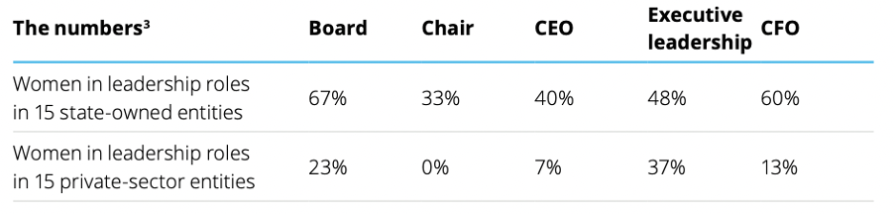
Source: https://www2.deloitte.com/content/dam/Deloitte/global/Documents/Risk/gx-risk-wob-caribbean-180222.pdf. Deloitte Barbados. (2021). Women in the Board Room
In May 2021, Deloitte Barbados conducted a study of 30 public and private companies in various industries and showed a start delineation in representation, especially between public and privately owned or managed institutions (see Box 38).

Given the focus and likelihood of the major changes in the electricity sector being more private sector-led or implemented than public sector-led, attention will need to be paid to these realities in being realistic about the level of impact to be achieved in the lifetime of a single project as well as the level of thought that will need to be given to policy, procurement including tendering documents as well as investment opportunities to ensure that these are equitably accessible as possible.

Looking specifically to the bioenergy sector, bioenergy production takes place within factory operations of the two remaining sugar cane factories in Barbados. In an annual report by the Barbados Agricultural Management Company for 2014, one (1) out of eleven (11) members on its board of directors is a woman, and three (3) out of six (6) managers were women. The Rum and Sargassum distillery has a male director with a technical advisory team consisting of eight (8) members, three (3) of whom are women, as well as research students, made up of eight (8) students, seven (7) of whom are women. Overall, there is adequate representation, except at the level of Board of Directors for the Barbados Agricultural Management Company, a critical decision-making space.

Since 1968, there have been policies and regulations implemented to ensure equal access for men and women to land ownership and tenure. The Town and Country Planning Act (1968) (Amended 2003) guarantees everyone, regardless of gender, access to land, water, and legal security of tenure. Under the Married Women Act, married women are explicitly protected to acquire, hold and dispose of by will, personal property. Irrespective of this, evidence shows that men own the majority of land and other productive resources. Looking specifically at agricultural land, men tend to own larger farms than women, and nearly 80% of all farms in Barbados are owned by men. Box 39 illustrates the ownership and land acreage of farms in Barbados, disaggregated by sex. This disparity in land ownership results in fewer women in decision-making positions in public and private spheres: “land ownership and water rights, positions of legal representation and oversight over forests, fisheries, protected areas and other resources. This undermines their autonomy and further marginalizes them.” Renewable energy production, such as biofuels, if not well managed and risk management and safeguard approach is taken proactively, may also contribute to the socio-economic marginalisation of women and female-headed households due to its high land requirement.
Box 39 Ownership and land acreage of farms by sex

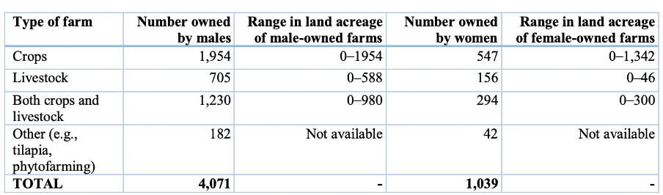
Source: Barbados Statistical Service (2021)

Although legal frameworks guarantee women’s and men’s equal rights in Barbados, access to financial services and opening a bank account or registering a business are less clear or assured. There is evidence of the existence of discriminatory practices that restrict women’s access to financial services. The 2016 CDB Gender Assessment for Barbados noted that the majority of self-employed persons and owners/managers of businesses are men, and listed the following challenges faced by women:
- Lack of access to credit, especially because of lack of collateral to secure loans
- Weaker professional networks than men
- Lack of knowledge about procedures for incorporation, registration and the taxation system
- Need to balance caring responsibilities with income-earning possibilities
- Credit is rarely granted to women who apply without a male partner or colleague.

Even though women receive less credit and receive funds that have an average lower value than that of men, the per cent of collateral required is also higher for women. Therefore, female-headed households, in relation to male-headed households, might face more barriers to accessing the market for external inputs and thus participate in bioenergy production. Studies have also shown a disparity in purchasing insurance or benefiting from insurance on agriculture investments. Owning assets, especially land is an important leverage point for empowerment in climate risk financing and insurance. Women’s lack of land ownership in the agriculture sector and ownership of smaller subsistence farms make them more vulnerable.
Box 40 Gender and access challenges

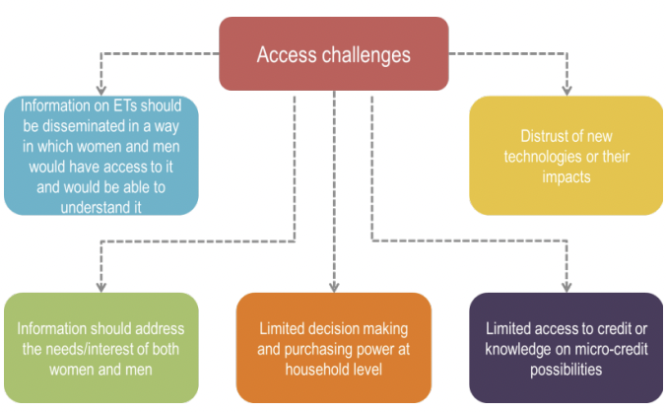
Source: Chinigo, D, & Kingiro, A. (2013). Mainstreaming Gender in Bioenergy Projects: Lessons from PISCES.

While all of these well-documented challenges for biofuel projects may apply to Barbados and or the SMARTER project, it is important that they be considered and that a proactive risk management approach is considered. Even so, some of these are relevant including the bottom three of Box 40. Additionally, there is expected to be some broader scepticism on the part of the broader public about any promised opportunities and so information and advocacy campaigns will need to be well-designed and targeted.

Livelihoods, ecosystems and gender

Over the years, the island has experienced a decline in its labour participation rate, reporting 136, 500 persons or 62.9% of the eligible labour force participating in the third quarter of 2022. Of 217, 000 persons eligible for the workforce, only 59.7 thousand of those (27.5%) are women, with no reports of those who identify as non-binary within the Barbadian labour force. Female employment stood at 6.9%, seeing a decline from 10% in the second quarter of 2022. This would have occurred as the Government of Barbados would have relaxed some policies such as its Covid-19 lockdown and movement restriction policies in its COVID-19 fight, seeing the return of major events such as the Crop Over (one of the main annual events for tourism industry). During and after the COVID-19 pandemic women were and continue to be impacted more severely than men by the various reductions in employment due to lockdown and other measures undertaken by the Government of Barbados. Given the high percentage of women employed within the accommodation and food services sectors, women’s employment is generally heavily reliant on the tourism sector and thus susceptible and vulnerable to any risks that could drastically impact the sector and also any issue that affects direct contact between worker and tourist (as the pandemic did).

The production of bioenergy also relies on agricultural and manufacturing industries. The Rum and Sargassum Project under the University of West Indies identified two potential materials for the generation of bioenergy from the country: wastewater from the rum industry and sargassum seaweed.

Currently, the bioenergy sector in Barbados is self-sufficient, as sugar cane factories across the island are self-powered, however, there has been no other nationwide use of bioenergy on the island. Dr. Henry from the Sustainable Development Solutions Network (SDSN) Caribbean's host institution and the University of the West Indies (UWI) in her study of bioenergy potential in Barbados reports that Barbados' declining sugar cane production would not be sufficient to support a biofuel industry as a feedstock for the country's energy needs.

No statistics were found with regard to the labour division within the two working sugar factories in Barbados (Portvale and Andrews Sugar Factory), however, generally, the agricultural sector has been known for high male participation as seen in the 2016 Caribbean Development Bank Country Assessment for Barbados. This highlights that with its current composition, the transfer of bioenergy knowledge within the sector is not likely to be equitably distributed and could lead, without countermeasures, to a large majority of the female population, not utilizing bioenergy as a main economic driver for income and empowerment or being passive rather than active participants in a bio-energy transition. Due to the reliance on the use of agricultural by-products, the bioenergy industry relies heavily on the agricultural sector. The agricultural sector often offers seasonal work, rather than full-time, which reduces job security. The seasonality of work also makes it difficult for such persons to access public sector incentives and other forms of financing and job insecurity may drive others including women to seek other forms of income.

Creating opportunities for women, men, part-time actors and persons with disabilities, to name a few, will require a rethinking of policy and intervention strategy, the consideration of investment windows and criteria and an expansion of financing instruments particularly if opportunities are to be afforded to those usually left behind. These will be relevant to Components 1 and 2, especially under the SMARTER project. Broader issues of information dissemination and access to knowledge including via training would be relevant to Components 3 and 4, as currently designed.

Capacity for gender mainstreaming in (bio)energy

The government in its oversight role of energy sector development and promotion is currently weak in its capacity to mainstream gender in energy including bioenergy and has limited experience in this area. The same is true for other government departments/Ministries expected to be involved in the project directly and indirectly including in SES monitoring. While the Ministry will benefit from a recently drafted Gender Equality Strategy for the Electricity Sector, significant capacity gaps do exist.

Discussions with MEB stakeholders also highlighted that current procurement processes have not considered gender and are not likely to currently comprise gender-sensitive procurement principles. Most units, in MEB or otherwise, have no experience with gender mainstreaming activities (SSA, NRD, EPD, ECREU, PPRU) although the PEU has been involved in the development of a gender equality strategy for the electricity sector. At present, the capacity to perform gender mainstreaming activities is non-existent or very low.

Gender mainstreaming approach

The SMARTER project is positioned to be a ground-breaking example and trendsetter in the region by leading the way as a gender-responsive energy project. It can do this by incorporating the recommendations made in the Gender Assessment enhancing the level at which gender is meaningfully integrated with this project. Through these actions, the project will not only be helping Barbados’ transition to be a 100% renewable energy country but also support gender equality and women’s empowerment. It has the potential to not only get more women involved in the energy sector as well as transportation and agriculture but also support women to become active agents in the renewable energy field and the climate change fight.

Implementation of this vision requires a robust gender mainstreaming approach. This gender-smart mainstreaming approach takes three main forms:
- Gender Equality, Women’s Empowerment and Social inclusion – addressing the roles and responsibilities, barriers and constraints imposed by gender inequality while considering the need for women to be economically and socially empowered on energy including bioenergy. The social inclusion aspect considers historically marginalized groups through an intersectional lens with age, geography, ability, ethnicity and livelihood source as the priority areas of focus.
- Institutional mainstreaming will be internally focused on key stakeholders including MEB and BIDC and will consider policies, strategies, practices, knowledge, attitude and behaviour on gender and gender mainstreaming. Gaps and barriers will be assessed and response strategies further identified and applied.
Box 41 Role of stakeholders in mainstreaming approach

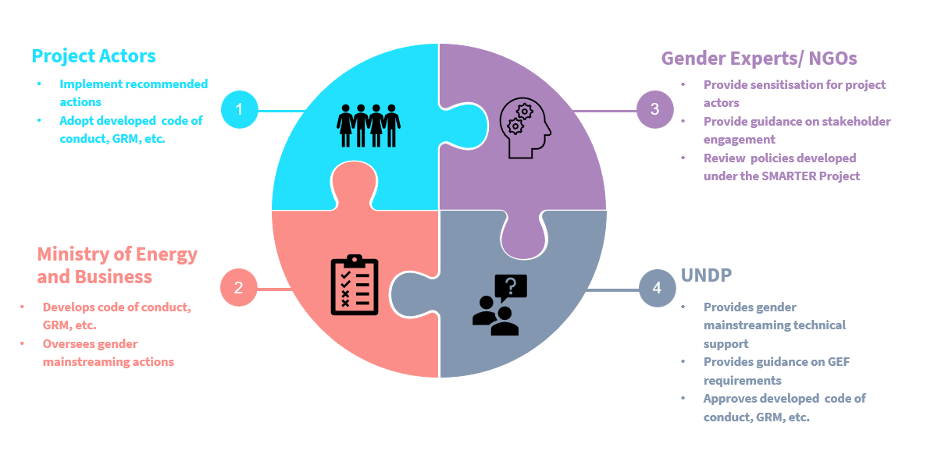

- Developmental mainstreaming will be more externally focused on beneficiaries (direct and indirect) and how the project can and will respond to their needs and the types of results that can be expected. This will include aspects of gender mainstreaming analysis including socio-demographic data and other analyses.

This approach relies heavily on key aspects such as cooperation for action on climate change as well as stakeholder engagement and partnership involving government, private sector, UNDP, project actors, NGOs and the University of the West Indies IGDS Nita Barrow Unit for example. Figure x outlines the roles that these stakeholders will play. “Gender and energy” is still relatively poorly understood by stakeholders and actors in the sector and capacity building will be key.

  - Gender action plan (GAP)
Box 42 UNDP gender marker and checklist

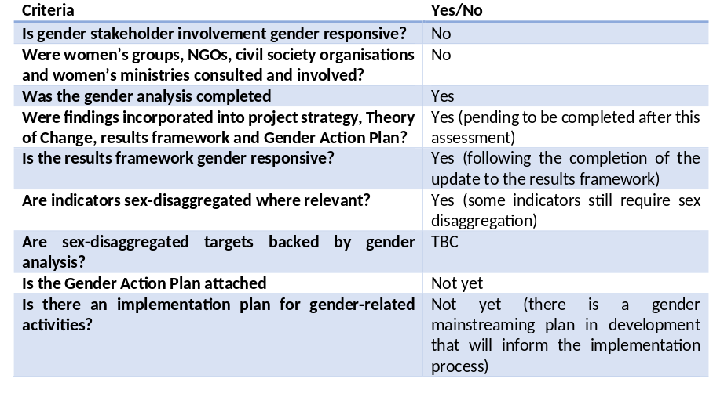
Code | Meaning
GEN O | Project is gender-blind and outputs are not likely to contribute to gender equality and may even exacerbate inequalities or exclude women or men
GEN 1 | Gender partially mainstreamed
GEN 2 | Gender is fully mainstreamed, and output is gender responsive
GEN 4 | Gender is the principle objective of the project

The gender mainstreaming plan outlines the actions being taken and that need to be taken to meet GEN 2 requirements for UNDP as well as meet the GEF’s requirements (see Box 42). Gender mainstreaming steps include some operational and some substantive actions. These actions will occur on a phased basis with some actions occurring during the process of the gender assessment and other actions occurring during project implementation.

This Gender Action Plan (GAP) has been developed during the SMARTER project formulation (during PPG stage) as part of the stakeholder engagement with gender groups and establishing working relationships with gender organisations.

The Gender Action Plan (Annex J2) outlines specific actions to be taken during the life of the project. Specific activities identified in the GAP are as follows:
- Capacity assessment to inform that capacity building for gender mainstreaming throughout the project: This action will be foundational for not only the capacity building to follow but will also influence what will be needed for gender-responsive tendering and procurement. This capacity assessment will target the project implementation team, related government ministries and agencies, service providers, pilot development and implementation teams and technical course providers. This action is expected to occur within the first year of the project’s lifespan and can be done mostly online. The majority of the time and cost would be for the analysis of the data generated.
- Capacity building for key implementing actors: This action will entail developing training content, and guidance tools and procuring expertise tailored to addressing the identified gaps found in the capacity assessment to support implementing actors’ ability to mainstream gender in their specific activities. This action is expected to occur within the first and second year of the project’s lifespan and will build on the capacity assessment.
- Development of gender-responsive tendering and procurement: This action entails developing guidelines and systems that ensure no one is discouraged or denied the opportunity to apply and offer services to meet the needs of the project. The system would ensure that women and other disenfranchised groups are supported to participate and are given a fair chance. This action is expected to occur within the first year of the project’s lifespan with an indicative budget of $ 7,000.00 which is mainly the cost of consultant time to develop the guidelines, engage with stakeholders on them and conduct sensitization and training. This investment is expected to redound beyond the project and be relevant for other energy projects funded by the GEF as well as the Green Climate Fund, the Adaptation Fund or other sources.
- Development of a Code of Conduct: This project involves a lot of front-facing activities that will have many actors engaging communities and there may be cases where these actors do not have any primary oversight. There is potential gender-based violence (GBV) risk that should be accounted for given the relatively high prevalence across the CARICOM region. Therefore, this is action is recommended to ensure that all actors have a common understanding, agreement and documented guidelines that they must abide by before signing to perform services and while executing those services. This Code of Conduct can be a part of an environmental and social management plan (ESMP) and can be simply done in 1-2 months. Once completed, the CoC can serve the Ministry and any other existing and future energy projects. This action is expected to occur prior to the start of the project or within the early implementation period.
- Development of energy and bioenergy-focused GRM: This project entails various stakeholders working together or performing tasks in communities which runs the potential for issues to pop up throughout the many levels of this project. With the various elements of this project, there is a need for a system that allows stakeholders (project actors, beneficiaries or otherwise) to file official complaints about the project or aspects of the project which are treated in a fair and efficient manner using established procedures. This GRM must be accessible to all, easy to utilise, gender-responsive and inspires confidence in its users.

Initially, the project will use the UNDP’s GRM but in the inception phase of the project, a more gender and energy-specific GRM focused on the Barbados context will be developed, adapted from UNDP’s and other relevant frameworks. This will include considerations specific to bio-energy production and development including possible conflicts and grievances that might arise (see also SESP). This GRM is intended to be a sustained element of SES monitoring for the MENB going forward that addresses general as well as gender-specific concerns that could arise from and in domestic and internationally funded energy initiatives.

Box 43 presents a timeline for gender action plan activities across the project’s lifespan.
Box 43 Indicative timeline for GAP activities
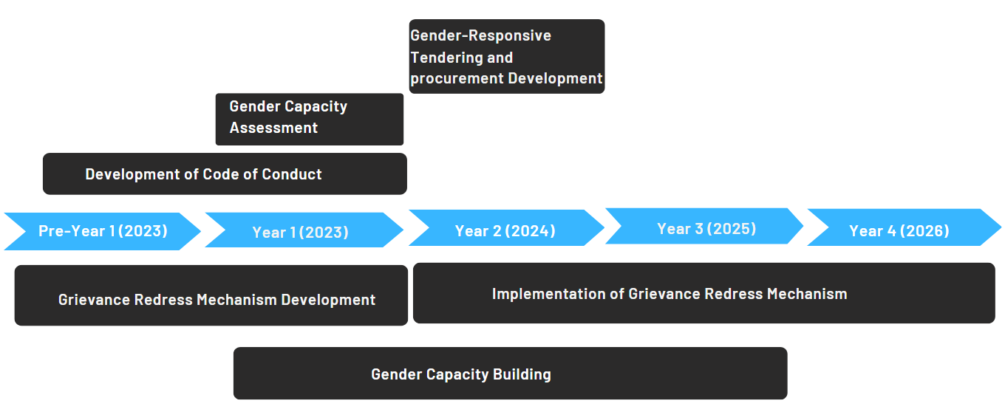

The following recommendations have been developed to incorporate gender findings throughout the project, or to assist in further understanding issues that need to be addressed:

Item | Action | Time  Responsible  Cost
Policy assessment and formulation  (Output 1.1 and Outputs 2,1 | Formulate institutional gender policy & partner with UWI IGDS to build capacity on gender and energy in Barbados. With respect to overall energy policy assessment (Output 1.1), attention will be given to the just energy transition, in terms of net socio-economic impacts (GDP growth, import/export, net and more equitable employment) as well as distributional aspects (affordability and energy prices; gender equality and women’s empowerment).  Regarding bioenergy policy analysis and recommendations, the project will avoid taking a generic approach and consult women, persons with disabilities and the elderly to capture their current and unique vulnerabilities. This will enable efforts to improve the likelihood of the potential for the bio-energy generated to meet certain needs in the long term. Assessing the social acceptance of biogas/biomethane/biofuel projects, as well as gender aspects. This includes issues of affordability, user needs as well as technology-appropriate needs and reduction of climate risk.  Opportunities may exist for the consumers of this energy, employment for those producing the energy and possible business ventures. Given women’s lower employment rates in relevant sectors such as energy, transportation, agriculture and construction, they may not benefit directly from project activities without deliberate intervention and or design. This can be a significant area of concern in that ensuring gender equality is mainstreamed throughout the project. Supporting women’s skills, removing barriers to entry or incentivizing women’s interest in the project can aid in helping women benefit directly from the employment opportunities to come out of this project. | - Year 1 and 2  - MEB; Social & gender safeguards expert  - USD 8,000 (cap. building, Comp.3 and policy inputs, Comp. 2)
Decision-making  (project governance; Bioenergy Task Force) | In addition to broader commitments to ensure gender-based rights and participation, focused efforts to include women, youth and PWDs in design, decision-making and beneficiary assessment and analysis are also key. The Project will ensure gender balance in the decision-making processes of the project’s governance structure (Project Board) and of the Bioenergy Task Force | - Year 1 to 4  - MEB; UNDP  - N/A
Training and capacity building  (Output 2.3; Outcome 4) | This will include an assessment of capacity needs for gender mainstreaming and ensuring gender equality and women’s empowerment outcomes in bio-energy production and any differentiated needs between state and private actors. The assessment will provide recommendations on how to develop and provide routine gender training to recognize and raise awareness of the disparity in stakeholder representation and take corrective action to balance stakeholder views. Current skill sets often bias allotment to men, there will be a need for targeted training, recruitment and promotion of women to fill these roles. This needs to be discussed with the technical training institutes that will partner with the SMARTER project. Linked to the Gender Equality Strategy of the MEB, the approach to energy sector planning and monitoring will take a more proactive and robust approach to gender mainstreaming – from an institutional perspective (internal) and developmental mainstreaming (external i.e. looking at the needs of beneficiaries).  The Project will produce educational materials on the rationale for the inclusion of gender perspectives in (bio)energy development and utilisation. Consideration should be given to developing a course on gender and bioenergy of the type developed by the Institute for Gender and Development Studies (IGDS) Nita Barrow Unit UWI Cave Hill for the Green Climate Fund-funded Water Resilience project implemented by the Barbados Water Authority. Given that the latter already includes energy elements, BWA staff could potentially support the delivery of this proposed training for bioenergy. | - Year 1 and 2  - MEB; UWI  - USD 10,000 (part of cap.building, Comp.2)  - N/A
Financing  (Bioenergy policy; Output 2.1; investments, Output 3.1) | Access to finance will consider sectoral access to domestic, regional and international finance including opportunities to engage in gender-lens investing. At the individual and innovator level, consideration will be given to access to credit, finance and incentives including tax breaks. Creating opportunities for women, men, part-time actors and persons with disabilities, to name a few, will require a rethinking of policy and intervention strategy, the consideration of investment windows and criteria and an expansion of financing instruments. This includes ensuring that access to finance is equitable and that structural barriers to women’s access to finance and credit are addressed in ways specific to the energy sector and to the needs of bioenergy development. This will need to be included in policies and strategies proposed under Components 1 and 2 including possible sources of bioenergy and related incentives that may be developed. Innovation in financing instruments engagement with private sector financial institutions will also be necessary to have gender lens investing. | - Years 2-4  - MEB; Gender & safeguards expert; consultants  - USD 10,000 (part of assessment and design, Comp. 3)
Risk monitoring;  Code of conduct | Critical for any gender assessment of risks are:  - Differentiated physical health effects on men and women including workers and members of the community;  - For noise and air pollution as well as hazardous and non-hazardous waste to disproportionately affect children, young people with respiratory illnesses and to affect some persons with disabilities including possibly, persons with autism;  - Implications of the above-mentioned risks to increase women’s unpaid care work and care burden if there is a disease outbreak, significant worker and or community health issues including respiratory illnesses; and  - Potential loss of access to land by women and other marginalized groups or increased competition for scarce and available land resources. | - Annually  - Gender & safeguards expert;  - N/A
Code of Conduct | The development of a Code of Conduct to inform and informed by project experience (linked to Component 3) will also be undertaken. This Code of Conduct will guide conduct in various contexts including governance, accountability, project design and demonstration project execution in ways that address gender needs as well as issues identified in the SESP relating to stakeholder engagement, community engagement, gender and human rights and the overall management of risks. The Project will develop clear communication policies (inclusive of a social media presence) on information dissemination and follow-up to address stakeholder concerns. | • Year 1  • MEB; Gender & safeguards expert;  - USD 5000, part of Code of Conduct contract
 |  | Total tentative budget: USD 33,000

Gender-specific indicators in monitoring and evaluation

Gender-specific indicators
 | Indicator |  | Target | Source, verification, and assumptions
Component 1 /  Component 2 | National dialogue and policy formulation  - M/F membership (Bioenergy Task Force)  - M/F representation on committees, boards, etc.  - M/F event attendance  - M/F presentations, speaking roles  - % of presentations, discussions, reports etc. that include a discussion of gender aspects |  | 35-40% F/M balance  100% of topics, discussions and reports acknowledge gender aspects | As in components 1 and 2  (see Monitoring Plan)
Component 2 | Training and capacity building  - Y/N Gender-differentiated analysis  - Y/N Gender-inclusive training and curricula  # of institutions supported with female majority client bases  National reports (policy, assessments)  Y/N gender mainstreamed in report |  | - yes  - yes  - TBD  - yes | As in component 2
Component 3 | Pilots developed and assessed (feasibility)  - Y/N gender review of proposal performed  -% Proposals received that are gender-responsive and include credible action & management plans  - % Proposals accepted that are responsive with credible plans  - Team composition (of proposed projects)  Pre-feasibility and replication:  % Feasibility studies mainstreaming gender |  | - Gender review performed  - 80% of proposals received are gender-responsive with credible action & management plans  - 100% of accepted proposals are responsive to plans  - 25% of the team consists of women  - 100% feasibility studies mainstream gender | As in component 3
Component 4 | - Y/N risks evaluated and accounted for  - M/F attendance at events  - Y/N gender mainstreamed into Insight Brief |  | - yes  - at least 40% of female attendance  - yes | As in component 4

- Stakeholder engagement plan

  - Stakeholder engagement plan

Introduction
This Stakeholder Engagement Plan (SEP) defines how SMARTER will identify and engage key stakeholders, and integrate their inputs into project implementation and risk management. Implementation of this plan will provide stakeholders with meaningful access to dialogue and decision-making in the development and implementation of the project. By providing channels for all stakeholders, including the disadvantaged and vulnerable, effective stakeholder engagement helps to ensure understanding, acceptance, and ownership of the project, thereby strengthening its benefits and sustainability.

Stakeholder engagement is an end in itself, ensuring that no one is left behind and that disadvantaged and vulnerable project stakeholders have a voice in project development and implementation. It is also a means for improving project design, identifying and managing risks, and ensuring transparency, accountability and integrity. In this light, one important purpose of this plan is to provide feedback and monitoring mechanisms to ensure the project is achieving its intended results and identifies potential unintended consequences. The development and implementation of the SEP are part of the UNDP Social and Environmental Safeguards (SES) requirements. Hence, the presented SEP will be reviewed and updated during the social and environmental assessment processes (see also Annex L)

Purpose and objective
The enhancement of the commercial viability and social acceptability of bioenergy systems depends on the level of flow of information between stakeholders from the private sector, public companies and government decision-makers. This flow will guarantee that the decisions made are well-informed and constitute the best use of resources to serve the best interest of the country and beneficiaries. The flow will also guarantee that investors, developers and social groups are actively engaged in the development of regulations governing the energy sector before they become legally binding and are allowed to utilize their technical expertise in the formulation of national plans and laws aiming to increase bioenergy development and application. Hence, this SEP is developed to ensure tripartite engagement of public entities, private sector actors, and representatives of beneficiaries in all stages of pilot development and overall project implementation.

Project preparation
As part of the project development phase, and in addition to the desk review and data collection exercise, the PPG team of National and International Consultants identified key stakeholders and engaged with them in a series of in-person and online meetings, during the PPG international consultant’s mission to Barbados, and thereafter by the PPG gender and social safeguards consultant (see list of stakeholders met on the next page). The purpose of these meetings was to share information about SMARTER, to seek first-hand information on baseline conditions and needs, and to scope out potential project activities and partnerships. The discussions also aimed to identify the gaps that SMARTER seeks to fill, especially in the presence of several projects targeting energy access and renewable energy development financed by development partners besides UNDP and the GEF.

The consultations served to accomplish the following:
• Validate the findings of the SESP.
• Identify additional risks to be considered in the SESP.
• Clarify the potential roles of stakeholders.
• Identify capacity needs.
• Validate the recommended mitigation measures.

Last but not least, a stakeholder workshop was organised in Barbados (with presential and online attendance by various stakeholders) on October 2022.
List of stakeholders met in PPG phase:

Meeting date | Organisation
24 Oct 2022 | UNDP Country Office  Ministry of Energy and Business (MEB)
25 Oct 2022 | Barbados National Standards Institute (BNSI)  Government Electrical Engineers Department  National Petroleum Corporation (NPC) / Barbados National Oil Company Ltd (BNOC)
26 Oct 2022 | Ministry of Environment and National Beautification  Barbados Agricultural Management Corporation  Ministry of Transport, Works and Water Resources / Barbados Water Authority  Fair Trading Commission  Inter-American Development Bank (online)
27 Oct 2022 | University of West Indies (UWI)  Barbados Renewable Energy Association (BREA)  Caribbean Centre for Renewable Energy and Energy Efficiency (CCREEE)
28 Oct 2022 | Online stakeholder workshop (hosted by MEB)
16 Jan 2023 | MEB – NRB (National Resources Department)
17 Jan 2023 | MEB – ECREU (Energy Conservation and Renewable Energy Unit)  MEB – PEU (Project Execution Unit)
18 Jan 2023 | MEB – PPRU (Programme Planning and Resources Unit)
19 Jan 2023 | MENB – SSA (Sanitation Services Authority)  Future Centre Trust
20 Jan 2023 | MEND – EPD (Environmental Protection Department
24 Jan 2023 | Barbados Environmental Conservation Trust

Project inception and implementation
The project will effectively engage the stakeholders involved in the project to get their support and guide the project implementation to achieve higher results.
- The project outreach proposed includes a project website (to continue as the Bioenergy Task Force’s website), media (print/audio-visuals), workshops, training, etc.
- The PMU and the Project Board will ensure that the Gender Action Plan recommended by the project is pursued and implemented. The various groups especially women will be engaged during the consultation meetings, prioritized to avail of the programme, and be included in the different capacity-building programs. The project will also ensure that SMARTER will be closely coordinated with the activities of NGOs, government bodies and development partners\
- Meetings, monitoring visits, surveys, and written communications will be used to receive feedback to continue the ongoing dialogue as well as during implementation.
- The project will follow a participatory approach in decision-making by engaging all the relevant stakeholders. Government agencies, NGOs, CSOs, and private sector actors will be actively involved during the project implementation. Special attention will be paid to ensure that PWDs are included not just in terms of information-sharing but also in terms of employment and livelihood benefits. Communications approaches will also consider the needs of PWDs including blind and deaf persons.

A detailed list of stakeholders and their involvement in particular project outcomes and outputs are given in Box 22. The key indicator for the engagement of each group of stakeholders is their practical involvement in implementation and dissemination.

Category | Stakeholder or group
Government and public sector | - Ministry of Energy and Business (MEB)  - Ministry of Environment and National Beautification (MENB)  - Ministry of Transport, Works and Water Resources (MTWW)  - Ministry of Agriculture and Food Security (MAFS)  - Fair Trading Commission  - National Petroleum Company (NPC)  - Barbados National Oil Company Ltd. (BNOC)  - Barbados Agricultural Management Corporation (BAMC)  - Export Barbados’  - Barbados National Standards Institute (BNSI)
Multilateral and bilateral development partners; Financial institutions | - Inter-American Development Bank (IDB)  - Caribbean Development Bank (CDB)  - Caribbean Community (CARICOM) – CCREEE  - Caribbean Community Climate Change Cente (CCCC)  - UN agencies (UNDP, UNIDO, UNEP, other)  - International Renewable Energy Agency (IRENA)  - LEDS LAC Low-Emissions Resilient Development Strategies  - Development Bank of Zambia; Pension Fund  - Commercial banks
NGOs, universities; | - UWI and other higher educational institutes; vocational training centres  - Non-governmental organisations (women, youth, environment, social)
Private sector and sectoral associations | - Barbados Light and Power Company Ltd. (BLPC)  - Fuel suppliers (Sol Group, Rubis)  - Barbados Sugar Industry Ltd  - Barbados Renewable Energy Association (BREA)
Direct beneficiaries | - Electricity and fuel consumers (residential, commercial, industry, transport, agriculture)  - Waste handling and processing companies  - Recipients of the project’s training and awareness-raising

SMARTER has not yet selected any pilot or demonstration activity (Outcome 3). These localities will be selected in the first year as part of the formulation and implementation of a ‘bioenergy pilot plan’ (Output 3.2) At that point, the project will identify and connect with all local stakeholders, including both partners and beneficiaries.

Engagement methods and communication mediums
The following list presents the main engagement mediums to be utilized by the project team during implementation to ensure continuous engagement and active participation of stakeholders.
1) In-person meetings:
o Consultation workshops: These workshops will have a pre-structured agenda which will be designed to present a specific result/report and discuss with stakeholders the best way forward. These workshops will also be an opportunity to gain consensus from stakeholders on a specific action plan prior to proceeding with implementation. Therefore, stakeholder consultation meetings and workshops are included in the project design as part of the main activities to be carried out by the consultants in charge of each output.
o Interviews and focus group discussions: These will be conducted with different groups of indirect beneficiaries, with special attention to ESPs and NGOs, to overcome their generally low participation capacity and ensure that their input is integrated into the different stages of project implementation. The Project Manager will be responsible for ensuring that these interviews and focus groups have been conducted by the responsible consultants, as appropriate.
o Community-based consultations: These consultations will focus on the pilot locations to identify and discuss stakeholder concerns within the community environment, but will also extend to neighbouring villages and communities. The Social Safeguards and Gender expert (PMU staff member) will be responsible for conducting these consultations on a regular basis and reporting findings, recommendations and concerns to the Project Manager.
2) Written communication:
- Emails: Emails will be used as the main tool for organizing meetings, i.e. sending invitations to participants, sending the meeting minutes after the meeting, etc.
- Letters: Being the formal method for communication and conveying messages between public parties, letters will be requested by the project team and provided by the relevant authority, as appropriate.
- Survey forms: Several activities under the project implementation strategy constitute undertaking a needs assessment or other types of analyses, with some requiring a survey to collect information. The responsibility for the surveys is that of the consultant undertaking the analysis. However, the Safeguards and Gender expert will be responsible for supporting the project consultants with the sampling process and surveying procedure to ensure that the results are as representative and inclusive as possible.
- Project brochures and manuals to present the results of specific studies and outcomes of certain activities.

3) Online meetings and phone calls: Virtual communication is sometimes preferred since it is quicker and easier compared with email and letters, and is a viable alternative to in-person meetings. Online applications and telecommunication tools will be used throughout project implantation to facilitate the work and ensure the project team have easy access to stakeholders, and vice versa.

Although the mode of communication may vary according to task and participants, all consultations and engagement activities will be undertaken with the goal of ensuring full participation of relevant stakeholders, whereby all participants will be provided sufficient notice to prepare well and provide input for the project. Moreover, SMARTER will also use all possible opportunities, i.e. workshops, meetings, training and awareness events, to promote diversity and gender balance. Balanced representation of relevant stakeholders will be ensured by reaching out to both men and women and different groups through appropriate communication mean and encouraging their participation, noting the most socially and culturally acceptable language and method of communication for each group of stakeholders.

Government stakeholders such as NRD (MEB) and EPD (MENB) note good practice and success that is relevant to the SMARTER project as follows:
- NRD notes their success in the usage of various media to disseminate information about project activities to ensure different demographics are captured in the stakeholder engagement process.
- EPD notes that Town hall meetings are used by developers as part of their stakeholder engagement and are highly effective for the dissemination of project activities to affected communities.

Public disclosure of information
Project-affected, marginalized, and disadvantaged stakeholders at the pilot location will be identified during site selection and assessment, including persons with disabilities and other disadvantaged groups as per the list of stakeholder groups provided above. For each group, the following assessments will be conducted as part of the stakeholder engagement activities, taking into account their involvement in each project component:
- Identify limitations for understanding project information and participating in the consultation process (e.g., language differences, lack of transportation, accessibility of venues, disability, etc.)
- Develop measures to support and accommodate engagement, e.g., provide information in accessible formats, choose convenient locations for consultations, ensure venues are accessible, provide transportation to meetings, change the time of meetings to accommodate needs, provide facilitation and explain complex issues and terminology, provide support workers for assisting participants with disabilities, provide simultaneous interpretation (including sign language). The project will also make sure that regular information on project activities, possible disruptions to life and any noisome activities are communicated well in advance. The deployment of measures in practice for physical development planning will be used as relevant.
- On the national level, methods to receive feedback and to ensure ongoing communications with stakeholders (outside of a formal consultation meeting) will be developed as part of the project’s knowledge management and dissemination plans (to be developed as part of the implementation of Component 4).

Diversity, inclusion and gender-balance
The inclusion of women and other relevant groups will be made possible through enhancing opportunities, improving access to resources, making their voices heard and ensuring respect for their rights. The process of identification of these groups and their representatives and engaging them through the various project activities is achieved using two approaches:
1) Conduct context-specific gender analysis using gender and mini-grid analysis framework and develop participatory action plans at the community level at locations where pilot projects and productive use will be supported. The analysis will be sensitive in scheduling community-level meetings selecting appropriate times and locations, giving deliberate attention to the participation of diverse groups to listen to their voice and applying appropriate language that fit the audience level. It will also explore the existing status of the different groups their roles, responsibilities, opportunities, and deprivations and seek participatory solutions in their engagement as consumers and actors at various levels of the mini-grid value chain. Women’s unpaid care work and triple burdens will need to be considered in terms of ensuring their participation in such analysis and consultation.
2) At every stage of the project implementation the project team will make a specific effort to make sure opportunities are created and accessed by women and other vulnerable groups while implementing institutional-level capacity-building training, policy-level discussions, access to education and financial opportunities

BECT notes that community approaches prove to be useful in bringing communities on board with projects. Providing information and education on aspects of projects can increase community buy-in. Building relationships with communities through involvement in the circular economy is beneficial to projects by creating interest and stakes in the project’s success and enhancing the livelihoods of communities through increased economic activities. The Fisheries department and fisher communities would be an important group to consult with regard to harvesting sargassum that could be used in bioenergy production.

Moreover, sensitisation and training for interacting with persons with disabilities would be necessary for project actors. Noting that ministries typically only interact with the persons with disabilities communities to gain feedback on legislation related to them. This presents an opportunity to change existing relationships and interactions with this community by giving them an opportunity to increase their capacities and improve their livelihoods.

Responsibilities
The PMU is primarily responsible for carrying out the specified stakeholder engagement activities. The stakeholders will be engaged while carrying out various assessments and studies, training, and workshop events.

Monitoring and reporting
The project stakeholders would be engaged at various levels to carry out the monitoring activities. Then the PMU will liaise with relevant Government agencies and other partners and collect data and monitor the activities regularly. The PMU will report back the results to the stakeholders at the earliest through letters or conduct meetings both individually as well as through the engagement of all relevant agencies.

Resources, responsibilities and timelines
The size of the project does not allow for extensive stakeholder engagement measures or dedicated staff for this purpose. Stakeholder engagement will therefore form part of the broader interactions with project stakeholders. The frequency of communication will be guided by the specific level of stakeholder interest. Specific opportunities for engagement will coincide with anticipated outputs and the development phases for deliverables and milestones towards outputs. More deliberate consultation and engagement activities will be implemented for the two pilot projects and as part of the project monitoring and reporting activities.
At the national level, project-affected, marginalized and disadvantaged stakeholders have been identified, including persons with disabilities and other disadvantaged groups as per the list of stakeholder groups provided above in this document. This list will also be completed at the local level for the pilot sites.

While the project financially supports the Social safeguard and gender officer (in the PMU), there is no budget specified for SEP activities but has been included in the budgets of related outputs, notably the design and implementation of the training and knowledge plan, national dialogue (bioenergy task force), stakeholder consultation for pilot projects and extensive data collection for the monitoring, review and evaluation of impacts.

  - Grievance mechanism

Grievance redress
Any project activity could potentially create or cause concerns on the part of various stakeholders. Bioenergy projects, though relatively new to Barbados, can generate a number of challenges and potentially negative impacts including but not limited to, as described in the SESP. Generating energy from biomass comes with some risks both directly from the production or indirectly from related activities. These risks include:
- Fire (improper storage of biomass)
- Respiratory health impacts (mould from improperly stored biomass, fumes emitted from burning biomass, etc)
- Disruption of food production
- Disruption of water availability
- Noxious odours
- Noise and vibration

A grievance redress mechanism enables stakeholders directly and indirectly affected or potentially affected to raise those grievances in three main categories:
➢ Environmental grievances: suggestions, concerns or complaints regarding the impact of project activities on the environment e.g contamination of water bodies, noise impacts, presence of construction waste or debris, etc.
➢ Social grievances: suggestions, concerns or complaints regarding the impact of project activities on community/work life e.g. restrictions on access to natural resources, discriminatory treatment, protection of vulnerable groups, use of local labour, child labour, gender including gender-based violence.
➢ Grievances related to project performance: suggestions, concerns or complaints regarding the performance of the project and people working for the project directly and indirectly including third-party contractors e.g. violation of obligations, absence of project team members, poor supervision of activities, delays in payment and delivery of materials, working conditions and occupational health, etc.

The GRM is a key aspect of stakeholder engagement and will combine with other mechanisms and approaches to ensure robust, regular and gender-sensitive involvement, engagement and consultation with and of stakeholders at multiple levels. A project-specific and energy-specific GRM will be developed during the implementation phase with guidance on the GRM and related forms available on the project webpage.

Project-level Grievance Redress Mechanism
During the design and implementation of any project, a person or group of people may perceive or experience potential harm, directly or indirectly due to the project activities. The grievances that may arise can be related to social issues such as eligibility criteria and entitlements, disruption of services, temporary or permanent loss of livelihoods (economic displacement) and other social and cultural issues. Grievances may also be related to environmental issues such as excessive dust generation, damages to infrastructure due to construction-related vibrations or transportation of raw material, noise, traffic congestion, decrease in quality or quantity of private/ public surface/groundwater resources during irrigation rehabilitation, damage to home gardens and agricultural lands, etc. Vibrations related to machinery operation may also be excessive and affect some persons negatively including persons with autism. Some environmental issues may have social impacts including on community health and may also trigger other social consequences such as ill health (e.g., excessive dust generation could trigger respiratory illnesses including asthma). There could also be incidences of suspected exploitation, abuse, sexual harassment or other forms of Gender Based Violence and or outright conflict and physical violence that might occur between someone working directly for the project and on behalf of the project (e.g., a sub-contractor) and a member of a community or the public or with a government official or NGO or other combination of persons. Grievances may also include or relate to the project not meeting its commitment to provide timely information about planned works and the risk they may pose to persons.

Should any of these situations arise, there must be a mechanism through which affected parties can fairly resolve such issues with the project personnel in an efficient, unbiased, transparent, timely and cost-effective manner. To achieve this objective, a Grievance Redress Mechanism will be agreed upon during the Inception Phase. The design of the Grievance Redress Mechanisms (GRM) will be discussed at the project inception workshop and operationalized before the initiation of activities. Information on the role and the application of the GRM should be presented to all stakeholders and should be clearly advertised and accessible during project implementation including access to the mechanism either via the project/UNDP website and/or via WhatsApp.

The Grievance Redress Mechanism will be designed to:
- be a legitimate process that allows for trust to be built between stakeholder groups and assures stakeholders that their concerns will be assessed in a fair and transparent manner;
- allow simple and streamlined access to the Grievance Redress Mechanism for all stakeholders and provide adequate assistance for those that may have faced barriers in the past to be able to raise their concerns;
- provide clear and known procedures for each stage of the Grievance Redress Mechanism process and clarity on the types of outcomes available to individuals and groups as well as clear timelines for responses;
- ensure equitable treatment to all concerned and aggrieved individuals and groups through a consistent, formal approach that is fair, informed and respectful to a concern, complaints and/or grievances as well as free from discrimination and bias;
- to provide a transparent approach, by keeping any aggrieved individual/group informed of the progress of their complaint, the information that was used when assessing their complaint and information about the mechanisms that will be used to address it as well as the amount of time in which they should expect updates and or a full response; and
- enable continuous learning and improvements to the Grievance Redress Mechanism. Through continued assessment, the learnings may reduce potential complaints and grievances.

The GRM will be gender- and age-inclusive as well as responsive addressing potential access barriers to women, the elderly, the disabled, youth and other potentially marginalized groups as appropriate to the Project, its operation and sustainability. This should include ensuring as many means of accessibility and media for submission are facilitated as possible. The GRM will not impede access to judicial or administrative remedies as may be relevant or applicable and will be readily accessible to all stakeholders at no cost and without retribution. For areas, where legal redress is more appropriate and where crimes may be suspected of taking place, the GRM process will give way to and or potentially inform those legal processes.

Information about the Grievance Redress Mechanism and how to make a complaint and/or grievance will be communicated and validated during the stakeholder engagement process and placed at prominent places for the information of the key stakeholders. Information on the GRM will be regularly communicated during other related project communication activities.

All complaints and/or grievances regarding social and environmental issues can be received either orally (to the field staff), by phone, in a complaints box, via WhatsApp or in writing to the UNDP. This may be done anonymously or declaratively. A key part of the grievance redress mechanism is the requirement for the PMU to maintain a register of complaints and/or grievances received, the timeliness of responses provided and the final conclusion/adjudication of the grievance. It will also be important that the record speaks to any repetitiveness of any specific grievances which should trigger more serious steps and consideration. The following information will be recorded:
- time, date and nature of the enquiry, concern, complaints and/or grievances;
- type of communication (e.g., telephone, WhatsApp, written communication or letter, personal /oral contact);
- name, contact address and contact number (where relevant);
- response and review undertaken as a result of the enquiry, concern, complaints and/or grievances;
- actions taken with the name/role/accountability of the person taking action as well as the formal response given to the complaint/complainant; and
- Any repetition and escalation of the same or related complaint and any additional measures taken (where relevant).

Communications related to the GRM are expected to be clear, easily understood and free of stereotypical language/images and biases. Guidance within the GAP will outline steps and considerations to ensure gender sensitivity and inclusive approaches.

UNDP SRM and SECU
In addition to the project-level and national grievance redress mechanisms, complainants have the option to access UNDP’s Accountability Mechanism, with both compliance and grievance functions.

The Social and Environmental Compliance Unit investigates allegations that UNDP's Standards, screening procedures or other UNDP social and environmental commitments are not being implemented adequately, and that harm may result to people or the environment as a result of a project/programme or other intervention with which UNDP is associated]. The Social and Environmental Compliance Unit is housed in the Office of Audit and Investigations and managed by a Lead Compliance Officer. A compliance review is available to any community or individual with concerns about the impacts of a UNDP programme or project. The Social and Environmental Compliance Unit is mandated to independently and impartially investigate valid requests from locally impacted people, and to report its findings and recommendations publicly.

The Stakeholder Response Mechanism offers locally affected people an opportunity to work with other stakeholders to resolve concerns, complaints and/or grievances about the social and environmental impacts of a UNDP project. The Stakeholder Response Mechanism is intended to supplement the proactive stakeholder engagement that is required of UNDP and its Implementing Partners throughout the project cycle. Communities and individuals may request a Stakeholder Response Mechanism process when they have used standard channels for project management and quality assurance and are not satisfied with the response (in this case the project-level grievance redress mechanism). When a valid Stakeholder Response Mechanism request is submitted, UNDP focal points at country, regional and headquarters levels will work with concerned stakeholders and Implementing Partners to address and resolve the concerns. Visit www.undp.org/secu-srm for more details.

All stakeholder and project-related engagement and communications are expected to be gender sensitive and inclusive, free of bias and discrimination as much as possible. They should also be accessible to persons without regular access to data, internet and online telephony or other technology. Low bandwidth solutions and low-resolution content should be an option where possible.

  - Communication and knowledge management plan

The Project will also emphasize strong communication with a broader range of stakeholders. Key elements of the project’s communication strategy are outlined in the table on the next page.

The budget for workshops, training and information dissemination (printed materials, etc.) is about USD 126,500 (not including consultancy or contracted services which are in separate budget lines).

All communications are expected to be gender-sensitive, non-discriminatory and free of bias. Gender-sensitive communications imply that imagery, writing and presentations will be non-stereotypical, free of patriarchy and misogyny and also empowering particularly for vulnerable and marginalized groups. Communications content will also consider visibility for key project partners including the Government of Barbados, UNDP and the GEF, consistent also with the GEF’s Communication and Visibility guidance.

Key element | Relevant group | Means | Timeframe
1. Project governance meetings; PSC meetings and its Working Group meetings | All stakeholders that are members of the PSC or its Working Groups or are invited to attend | Meetings | Periodically, depending on PSC and Advisory Committee frequency of meetings
2. Seminars/workshops and training events, including the Inception workshop, and final project workshop | National and sub-national government officials  Private sector; NGOs and CSOs | Workshop, meeting, seminar, training (gender-sensitive, socially inclusive)  On-the-job training  Budget: | Typically, workshops will be held to start up an activity and/or at the end to present results. The timeline of each activity is given in Annex D of the UNDP ProDoc
3. Project documents, thematic reports and publications; Technical and other reports | Government departments and decision-makers at the national and subnational level;  Development partners  Research institutes and academia; individual experts; NGOs | Direct dissemination (e.g., email or hard copy/ USB-drive). Regular access via website to reports and documents and database and info systems | Technical reports will typically be published at the end of an assignment (see Annex D of the ProDoc).
4. Project knowledge capturing and info dissemination (gender-sensitive, socially inclusive) | Government officials  Financial and private sector  Development partners;  NGOs and CSOs | Online access;  Printed materials;  Media | Thematic reports and knowledge products are published at the end of one or more outputs to provide a summary of findings, results, and lessons learnt
5. Communications on significant project- related works that could be disruptive to individuals, communities, recreation and or livelihoods. | All stakeholders but particularly government departments and decision-makers at the national and sub-national level; subcontractors working on behalf of the project and or project partners | Online access  Printed materials distributed and or pinned up in public and high traffic areas that meet gender sensitive standards  Radio (which is still a reliable source particularly for the elderly)  Media and Social Media including acebook/Instagram using gender sensitive communications principles or guidance | Periodically and at least 30 days before any significant physical works are to be undertaken.  During works if any significant changes are to occur (e.g., stoppages, intensification and or extension of the activity.

- Social and environmental Screening template (SESP) and SES Safegurads Risk management

  - Social and environmental assessment carried out in the PPG phase
- Project Information

Project Information
1. Project Title | Sustainable Management and Resilient Thinking for our Energy Revolution (SMARTER)
2. Project Number (i.e. Atlas project ID, PIMS+) | 6451
3. Location (Global/Region/Country) | LAC/Barbados
4. Project stage (Design or Implementation) | Design (PPG phase)
5. Date | March 9th, 2021 (first draft); updated December 7th, 2022; finalized (TBD)
Part A. Integrating Programming Principles to Strengthen Social and Environmental Sustainability

QUESTION 1: How Does the Project Integrate the Programming Principles in Order to Strengthen Social and Environmental Sustainability?
Briefly describe in the space below how the project mainstreams the human rights-based approach
The GEF project is expected to deliver positive social, environmental, and economic impacts for Barbados and its people. Decentralised Renewable Energy (RE) projects offer business opportunities for individuals, local companies and communities (referred to in the Barbados National Energy Plan BNEP as “democratisation of the energy sector”) and the project will conduct stakeholder consultations with these groups to tailor the solutions proposed by the project, in response to local demands for human, economic, social and environmental development. The project has a stakeholder engagement plan and gender action plan that outline how specific groups, including marginalized and vulnerable stakeholders, will be engaged and how their rights will be assured to include their direct participation in project implementation. Women and persons with disabilities are identified among vulnerable groups as potential beneficiaries of training and employment opportunities. The government of Barbados is concerned with the development and support of small and medium enterprises, hence a strong focus is put by the project on job creation for vulnerable groups including women and young people as well as under-served communities directly related to project activities. The project will set up a grievance redress mechanism to guarantee space for stakeholders to present formal claims or concerns and to have these addressed in a timely and transparent manner. Further, the project will support the development of local capacities of the government to enable proper implementation as well as oversight by the public administration of project activities during implementation and beyond the project, and support the development of regulations in line with the requirements of the project to manage the RE investments and ensure equal access to the public services that may benefit from such investments, such as public transportation. These will include gender mainstreaming as per the gender action plan as well as equal participation, transparency, and disclosure as per the stakeholder engagement plan. These capacity development interventions will address gaps in knowledge and practice identified during the project design and implementation stages.
Briefly describe in the space below how the project is likely to improve gender equality and women’s empowerment
The Project will support community-driven, decentralised Renewable Energy projects and identify and strengthen value chains sustaining bioenergy projects in the agricultural sector, hotel and tourism industry and sugar sector. The Project will monitor that women’s participation in decision-making is assured and seek opportunities for job creation and income generation that also benefit women as well young people and persons with disabilities. Project activities will be gender-responsive to ensure women and men are proportionally represented in the Project at all levels e.g. a quota for the representation of women is identified in capacity-building activities under Components 1 and 4. The project has a gender analysis that has been mainstreamed within the PRODOC strategy and a gender action plan that will guide project implementation.
Briefly describe in the space below how the project mainstreams sustainability and resilience
Environmental sustainability is the key driver behind the project concept by supporting the phasing-out of fossil fuels in Barbados’ electricity sector. This is expected to contribute to increased resilience at an energy systems level as well as support ongoing climate resilience efforts. Environmental aspects will further be mainstreamed into the licencing process of decentralised renewable energy and energy storage systems. From a planning perspective, environmental values and constraints will be addressed, to some extent, in the mapping of RE resources in the country, specifically bioenergy streams. Additionally, environmental safeguards driven by the project will contribute to reducing negative impacts on ecosystems and on people. Social and environmental risks related to labour and working conditions, community health, safety and security as well as resource efficiency and pollution will be managed throughout the project implementation process through the management actions prescribed in this SESP and the PRODOC.
Briefly describe in the space below how the project strengthens accountability to stakeholders
The project has a Stakeholder Engagement Plan, which established how stakeholders will be involved in project implementation including identification and management of SES risks, that will guide the inclusion and participation of all project-affected stakeholders. The project will support the inclusion of various types of stakeholders from private sector energy service providers as well as agriculture-related communities, vulnerable groups, women, youth, and people with disabilities, in project areas and areas of influence that are affected by project activities. A range of capacity-building activities will be implemented to enable inclusive participation and greater access to relevant information on Renewable Energy and bio-energy innovations. The project will set up a grievance and redress mechanism and stakeholders will be informed of the Government of Barbados and UNDP Stakeholder Response Mechanism, enabling stakeholders to channel their concerns and receive timely response to any potential grievance related to project activities.

Part B. Identifying and Managing Social and Environmental Risks

QUESTION 2: What are the Potential Social and Environmental Risks?  Note: Complete SESP Attachment 1 before responding to Question 2. | QUESTION 3: What is the level of significance of the potential social and environmental risks?  Note: Respond to Questions 4 and 5below before proceeding to Question 5 |  |  | QUESTION 6: Describe the assessment and management measures for each risk rated Moderate, Substantial or High
Risk Description  (broken down by event, cause, impact) | Impact and Likelihood (1-5) | Significance (Low, Moderate Substantial,  High) | Comments (optional) | Description of assessment and management measures for risks rated as Moderate, Substantial or High
Risk 1: Stakeholders (in particular marginalized groups) might face restricted access to basic services (electricity) as energy tariffs may become no longer affordable for low-income groups under a 100% RE scenario.  Human rights principle: P1.3 & P1.6.  Accountability Principle: P13 & P14 | I = 3  L = 2 | Moderate | Prior to the implementation of this project, the government of Barbados has set the target of 100% renewables by 2030. This project supports the government to achieve this target.  However, this scenario will not take place during the life cycle of this project. In any case, studies underpinning the Barbados National Energy Policy (BNEP) indicate that the Renewable Energy scenario will lead to lower average energy costs. | The project has developed a stakeholder engagement plan (Annex K) and has mainstreamed engagement into project design and implementation.  At the technical level, the strategy implemented by the Project will define Feed-in tariffs that are guided by the affordability principle.  A Grievance and Redress Mechanism will be set up for the project that can be used by the Ministry of Energy of Barbados.
Risk 2. Energy projects may affect livelihoods and access to services by women and men in different ways. Women may not be equally included in decision-making processes regarding decentralised energy projects and may not benefit equally as men in all areas/opportunities such as employment or business development.  Gender Equality Principle 2: P10, P11 and possibly P12 | I = 3  L = 3 | Moderate | Experiences in Barbados indicate that women have less decision-making power than men concerning investment decisions. A gender-bias may affect women participation in decisions.  The Barbados labour market remains segregated by gender particularly the category of jobs that are most closely aligned to energy and electricity generation. Additionally, women were disproportionately impacted by the COVID-19 pandemic including in sectors targeted by this project i.e. tourism. | The project has a gender assessment and action plan (Annex J.1) which focuses on both gender mainstreaming and women’s empowerment. The Assessment identifies a need to focus on women’s participation in the sector as well as the gender sensitivity of institutions and their energy development practice, very much in line with the draft Gender Strategy for the Electricity Sector developed for the Ministry with support from the Inter-American Development Bank (IABD).  A GRM system will be set up for the project which will be gender sensitive and energy-specific and focused on the Barbados context. This will include considerations specific to bio-energy production and development including possible conflicts and grievances that might arise.  A gender-sensitive targeted socio-economic assessment will be developed during project implementation, that will provide baseline information concerning the structure of local livelihoods and the type of activities in project areas. Recommendations will enable to update of the current gender analysis and action plan.  Persons with Disabilities including women with disabilities are normally poorly considered and integrated into project design including relating to job creation, livelihood enhancement or business development opportunities. The stakeholder engagement strategy and plan (Annex K) developed by the Project and the project governance arrangements address this concern including meaningful representation in the decision-making structures of the project.
Risk 3  Within demonstration sites, Economic displacement (temporary and mid-term) could occur. Loss and gains may occur from transitions from crop agriculture to feedstock production and the competition that may arise between feedstock production and crop and livestock agriculture for resource such as land and water.  Standard 5. Displacement and Resettlement (Project level): 5.2 | I = 3  L = 3 | moderate |  | To address this, the project will develop a targeted gender-sensitive socio-economic assessment and livelihood assessment. The livelihoods assessment will focus on risks related to project activities, within the pilot sites under the agriculture and tourism sectors. The assessments will enable determining whether a Livelihood Action Plan is required to ensure proper compensation of livelihoods by the affected stakeholders.
Risk 4. Land use issues may arise, resulting in habitats being negatively affected or even endangered as a result of inappropriate planning and design of RE projects and the lack of consideration of combined BD and CHSS risks  Standard 1. Biodiversity and Natural Resource Management: 1.1, 1.3, 1.9.  Standard 3: Community Health, Safety and Security: 3.6 | I = 4  L = 2 | Moderate | The GEF Project is concerned with bioenergy and will cover the mapping of the geographical locations for bioenergy potential in the country. Zoning of the land territory is an important instrument for wind energy and bioenergy planning. Barbados has experience with zoning, for example, the Barbados Water Protection and Zoning Policy (2020) which identifies 5 zones with increasingly restrictive conditions according to local sensitive parameters.  In the context of increasing land scarcity, the likelihood of new activities abutting critical biodiversity resources is also enhanced.  The Health Services Act of 1969 empowers the Minister responsible for the abatement of nuisances and the removal or correction of any condition that may be injurious to public health and may construct repair and maintain sewers. Moreover, Health Services Nuisances regulations identify what are nuisances and how they should be handled.  Based on the research carried out on other bioenergy projects, the potential increase in vector activity would be a nuisance and potential health risks may occur to communities more immediately in the medium and long-term. | For the policy support activities, the project will be designed to establish criteria for zoning bioenergy potential (in line with the Ministries of Environment’s and of Agriculture’s policies) and shaping the licensing process for bioenergy projects. These potential risks and adverse impacts to habitats on ecosystems and ecosystem services from these upstream activities may result from the implementation of future projects.  The current Project may have adverse impacts on nature in relation to the implementation of activities within the pilots/demonstration sites supported by the Project. This Project will assess conduct tarted risk assessment in each pilot site, related to biodiversity, soil and water protection, social impact, cultural values, etc in compliance with SES requirements, national legislation, international conventions and best practices. Some considerations have been integrated into the project document with respect to the approach for Component 2 and 3, particularly Output 3.3. Targeted assessments will be conducted before any demonstration site project is initiated and mitigation actions and plans will be developed to mitigate these risks  For demonstration activities, the Project in Outputs 1.1 and 2.1 (energy/bioenergy policy) will coordinate with existing natural resources, marine environmental and biodiversity plans as well as engage the Environmental Protection Department in the monitoring of risks.  Community health, safety and security issues may also arise from increased vector activity and habitat expansion engendered by poor storage and or poor disposal of organic waste. These are also considered in Output 3.3.  Careful monitoring and communicating with stakeholders and the Ministry of Environment and Beautification including the Sanitation Service Authority (SSA) and the Environmental Protection Department (EPD) should assist in proactively identifying any triggers or potential triggers that would affect Community Health Safety and Security, particularly for adequate waste disposal and new vector activity. An OHS manual will also consider some of these risks.  Additionally, the biodiversity risk and the CHSS risk will be tackled jointly for waste and vectors to ensure comprehensive monitoring and to address the reality that biodiversity risks could impact community safety and health and that CHSS risks could in the medium and long-term create biodiversity risks e.g. vector damage to flora. The involvement of multiple stakeholders in risk assessments and monitoring is expected to facilitate the identification and timely response to such combined risks.  The stakeholder engagement plan (Annex K) will address CHSS risk management as well as the Grievance Redress Mechanism (also see Annex L).
Risk 5. The Caribbean region is susceptible to hurricanes and natural disasters on an annual basis (occurrence and impact intensified by climate change) that can impact the functionality of bioenergy supply and systems (including delays to project implementation). Though Barbados has not had a serious hurricane event, it is regularly impacted by flooding, land degradation and household damage, most recently Hurricane/TS Elsa in 2021.  Flooding could also affect waste management systems creating knock-on risks that lead to waste and vector-related risks as per Risk 4 and also impact underground water as well as biodiversity in the medium-term.  Standard 2. Climate Change Mitigation and Adaptation: 2.1, 2.2. | I=3  L= 3 | Moderate | Despite being located in the Caribbean region, Barbados has not experienced an impact beyond Category 1 or 2 for more than sixty years. The country is also not geographically positioned in the most vulnerable area for hurricanes in the Caribbean Sea. Still, Barbados has accessed funds from the Caribbean Catastrophic Risk Insurance Facility and their analysis of events between 1990 and 2017 suggests that Barbados experienced 10 tropical cyclone-related events in this time period including 2 in 2007. In the same period, the island experienced 13 events of excessive rainfall which might affect project operations, transportation and delivery of feedstock and some equipment operations. | As Barbados is exposed to climate change and natural hazards, although only exposed to smaller events with frequency, and with the effects of decadal drought, the construction of any bioenergy facility or structure should continuously assess these risks and ensure that structures meet with hurricane/flooding resistance and requirements and are structurally sound. Siting places of low physical risk of land slippage and wind shear are also recommended.  The project will conduct site-based targeted assessments on climate change and natural hazards impact to inform the project activities. The recommendations will also be shaped by existing national requirements and the new Physical Planning and Control Act. Flood resistance in the building, placement and maintenance of physical infrastructure as well as any waste management facilities will also be addressed with guidance or oversight provided by the SSA as necessary.  The climate change and natural hazard analysis will integrate findings in the design and implementation of activities and outputs especially Outputs 2.2, 3.1., 3.2. and 3.3 as required in each project site. The Project teams and sub-contractors will include these requirements in their standard operating procedures. The Project Team will consult with the Caribbean Institute of Meteorology and Hydrology based in Barbados and website/relevant reports as necessary to ensure that the most up-to-date and accurate information is used in its monitoring and assessment of future risk scenarios. Contingency measures as well as a Business Continuity Strategy will also be developed.
Risk 6. Inadequate construction practices and operation may lead to occupational health and safety hazards for personnel and communities.  Standard 7: Labour and Working Conditions: 7.6 | I = 4  L = 2 | Moderate | The construction and operation of bioenergy systems bring potential safety risks and hazards including toxic gas (H₂S), suffocation (CO₂), explosion and fire (CH₄). While work in progress, international standards are being developed. These risks are well controlled if terms of references for installations are designed considering these risks and training and guidelines for operation safety procedures are defined beforehand and provided to workers and subcontractors. | An assessment of the specific risks for labour and working conditions will be conducted, for each of the specific technology options, as part of the general bioenergy policy formulation (Output 2.1) and for specific pilots/demonstration sites according to the type of feedstock and bioenergy conversion technology selected). In each pilot/demos targeted assessments will be conducted and an action plan developed to manage this risk that will delineate specific measures (to be developed and implemented during project implementation) to guarantee adequate construction practices.  A related Constructors Environmental and Social Management Plan (C-ESMP) will be developed to ensure adequate practices. TORs and bidding documents (in the call for Proposals, Output 3.2) will also include these requirements and contractors will be expected to develop their own ESMPs, a usual practice in infrastructure projects. The latter will be informed by UNDP SES guidance and International best practices provided by the project team and national regulations.  During implementation and as part of the project’s design, international standards and guidelines shall be adapted to the local context and industry safety measures and procedures will be applied, with adherence to the UNDP SES.  The project will develop a Grievance Redress Mechanism accessible to stakeholders at each project site and area of influence. This includes access to project workers.  An Occupational Health and Safety manual and a Code of Conduct will also be developed to support both processes and conduct related aspects of risk management in this area and to ensure that workers have clarity on regulations as well as their rights and roles and responsibilities.
Risk 7: The proposed Project activities may involve the handling and transportation of waste (both hazardous and non-hazardous). Waste generated by the project is expected to be minimal, inert and of potential fertilizer value. There may be some risks to water quality as well as human health from accidents or spills.  Standard 8: Pollution Prevention and Resource Efficiency Risk: 8.1, 8.2 | I = 4  L= 2 | Moderate | Biogas plants also generate digestates and (non hazardous) waste/ fermentation of organic waste) that can be used as fertilizers and compost suggesting positive environmental and social benefits as well.  The existence and/or types of hazardous waste have not been identified. This will depend on the biomass source (that will be selected during the implementation phase of the project) but wastewater regeneration, animal excreta as feedstock, other organic waste and sargassum contain some level of hazardous materials which are also expected to be a component of any waste derivatives. Batteries will also be a source of hazardous material and waste. These are known to include chemicals as well as other toxins. Leachate may also occur from the same and is a concern as it has potential for even minimal pollution of groundwater supplies.  Hazardous materials may be also formed, processed and stored in bio-energy facilities as part of the production process, creating various forms of waste – liquid and non-liquid - that need to be handled and potentially disposed of. | Non-hazardous waste generated by Biogas: The project will increase awareness among key stakeholders on these risks and include this in proposed capacity-building activities to be carried out under Component 4. The project will also seek synergies with peer initiatives in the region to devise appropriate disposal strategies learning from some of the lessons in addressing pesticides also funded by the GEF through the FAO Subregional Office in the Caribbean.  Waste management will be addressed at a policy level (bioenergy policy – Output 2.2.) and, depending on the type of the pilot/demo, at the project level (Output 3.3.), to guarantee the correct disposal digestates during the demonstration activities.  A waste and pollution assessment is to be carried out for all demo projects, particularly those using animal excreta and sargassum with strict attention to potential risks and measures to avoid or mitigate such risks. Good practice measures employed by the Sanitation Service Authority (SSA) in handling hazardous and non-hazardous waste are expected to be identified and adapted/adopted as relevant. In the latter case, this may require shipment overseas for proper disposal. The assessment will inform a Waste and Pollution Management Plan as part of an overall ESMP.  An emergency Response Plan will be developed as part of an OHS Manual to address any emergencies related to hazardous waste spills or exposure.
.
 | QUESTION 4: What is the overall project risk categorization?
 | Low Risk | ☐
 | Moderate Risk | x | The project has a range of potential moderate risks that are being assessed as part of project preparation by the PPG Team. The risk remains moderate upon their findings

 | QUESTION 5: Based on the identified risks and risk categorization, what requirements of the SES are triggered? (check all that apply)
 | Question only required for Moderate, Substantial and High Risk projects
 | Is assessment required? (check if “yes”) | X |  |  | Status? (completed, planned)
 | if yes, indicate overall type and status |  | X | Targeted assessment(s)  The focus of these assessments will be to identify the socio-environmental impacts and determine the mitigation/management requirements and measures | Completed during PPG: gender assessment, stakeholder analysis  Planned:  Socio-economic baseline and livelihoods analysis.  Waste and pollution assessments, Occupational Health and Safety assessments  Climate change and Natural Hazards Assessments  Construction Manuals/Safety measures Occupation health and safety  Community health, safety and security
 | if yes, indicate overall type and status |  | X | Site-based ESIA (Environmental and Social Impact Assessment) | Planned:  The need for an ESIA will be determined based on further screening, to be carried out for demonstrative sites and activities during the project implementation phase.  The project may conduct a series of targeted (impact) assessments as indicated in Section B or a tailored ESIA to focus on the various risks. The determination of the need for ESIA will be done after screening is conducted in the project sites, and deemed as a necessary requirement to comply with UNDP SES.
 | Are management plans required? (check if “yes) | X
 | If yes, indicate overall type |  | X | Targeted management plans (e.g. Gender Action Plan including GBV checklist; Stakeholder Engagement Plan) | Completed during PPG: Gender Action Plan, Stakeholder Engagement Plan  Planned: Emergency Response Plan as part of OHS Manual, Waste and Pollution Management Plan, and Business Continuity Plan for CC and NH risks  Livelihoods Management Plan if determined to be required after the screening of pilot sites.
 | If yes, indicate overall type |  | X | ESMP (Environmental and Social Management Plan) | Planned: ESMPs for pilot sites/ demonstration activities.  The pilot sites will be screened once identified/ defined and once tech options are determined.
 | If yes, indicate overall type |  | ☐ | ESMF (Environmental and Social Management Framework) | The PRODOC contains an Annex with a summary of the project social and environmental safeguards management system, Annex L
 | Based on identified risks, which Principles/Project-level Standards triggered? |  | Comments (not required)
 | Overarching Principle: Leave No One Behind
 | Human Rights | X
 | Gender Equality and Women’s Empowerment | X
 | Accountability | X
 | 1. Biodiversity Conservation and Sustainable Natural Resource Management | X
 | 2. Climate Change and Disaster Risks | X
 | 3. Community Health, Safety and Security | X
 | 4. Cultural Heritage | ☐
 | 5. Displacement and Resettlement | X | Economic displacement. In this case, there will be no physical displacement. Resettlement is not a risk for this project.
 | 6. Indigenous Peoples | ☐
 | 7. Labour and Working Conditions | X
 | 8. Pollution Prevention and Resource Efficiency | X

Final Sign Off

Signature | Date | Description
QA Assessor |  | UNDP staff member responsible for the Project, typically a UNDP Programme Officer. Final signature confirms they have “checked” to ensure that the SESP is adequately conducted.
QA Approver |  | UNDP senior manager, typically the UNDP Deputy Country Director (DCD), Country Director (CD), Deputy Resident Representative (DRR), or Resident Representative (RR). The QA Approver cannot also be the QA Assessor. Final signature confirms they have “cleared” the SESP prior to submittal to the PAC.
PAC Chair |  | UNDP chair of the PAC. In some cases, PAC Chair may also be the QA Approver. Final signature confirms that the SESP was considered as part of the Project appraisal and considered in recommendations of the PAC.

Appendix - SESP Attachment 1. Social and Environmental Risk Screening Checklist

Checklist Potential Social and Environmental Risks
INSTRUCTIONS: The risk screening checklist will assist in answering Questions 2-6 of the Screening Template. Answers to the checklist questions help to (1) identify potential risks, (2) determine the overall risk categorization of the project, and (3) determine required level of assessment and management measures. Refer to the SES toolkit for further guidance on addressing screening questions.
Overarching Principle: Leave No One Behind  Human Rights | Answer  (Yes/No)
P.1 Have local communities or individuals raised human rights concerns regarding the project (e.g. during the stakeholder engagement process, grievance processes, public statements)? | Yes. Some stakeholders raised concerns about access to information, rights to participate for persons with disabilities, access to livelihoods opportunities for women and also transparent processes for community and stakeholder engagement. Even so the time available to consult during the PPG was limited and site specific community consultations were not undertaken due to the lack of a decision on sites for demo projects. The expressed concerns have been integrated into the project governance and implementation arrangements including the proposed national dialogue and bioenergy task force as well as in the Stakeholder Engagement Plan (Annex K) and the Gender Action Plan (Annex J). A GRM will also be established to address this issue (during inception)When sites are selected, specific community engagement activities will also be undertaken as a prerequisite to approval .
P.2 Is there a risk that duty-bearers (e.g., government agencies) do not have the capacity to meet their obligations in the project? | Yes – on gender equality as there is no policy and or guidance on some of the gender implications that were identified by stakeholders. The Gender Equality Strategy for the Electricity Sector should be informative but may have some limited relevance to bioenergy activities and is bolstered by the GAP (Annex J)
P.3 Is there a risk that rights-holders (e.g., project-affected persons) do not have the capacity to claim their rights? | Yes. While mechanisms exist at the government level, it is not clear that the public knows about all of these and how to engage or deploy them to protect their rights. The existing regulations may also not be specific to energy and or bio-energy projects. Persons with Disabilities, in particular, may be affected due to the ability to consume information shared.
Would the project potentially involve or lead to:
P.4 adverse impacts on enjoyment of the human rights (civil, political, economic, social or cultural) of the affected population and particularly of marginalized groups? | Yes - potentially this could affect some rights of persons temporarily and in the medium term as transitions take place in terms of the economic impact of the transition. This will be analysed further in the Livelihoods Assessment
P.5 inequitable or discriminatory impacts on affected populations, particularly people living in poverty or marginalized or excluded individuals or groups, including persons with disabilities? | No
P.6 restrictions in availability, quality of and/or access to resources or basic services, in particular to marginalized individuals or groups, including persons with disabilities? | Yes
P.7 exacerbation of conflicts among and/or the risk of violence to project-affected communities and individuals? | No
Gender Equality and Women’s Empowerment
P.8 Have women’s groups/leaders raised gender equality concerns regarding the project, (e.g. during the stakeholder engagement process, grievance processes, public statements)? | No, but these kinds of engagement have been somewhat limited so far. This will need to be monitored continuously through the SEP and the GRM. Accordingly, select groups have been identified that could be integrated into project governance arrangements and considered for capacity building on gender mainstreaming.
Would the project potentially involve or lead to:
P.9 adverse impacts on gender equality and/or the situation of women and girls? | No
P.10 reproducing discriminations against women based on gender, especially regarding participation in design and implementation or access to opportunities and benefits? | Yes
P.11 limitations on women’s ability to use, develop and protect natural resources, taking into account different roles and positions of women and men in accessing environmental goods and services?  For example, activities that could lead to natural resources degradation or depletion in communities who depend on these resources for their livelihoods and well being | Yes
P.12 exacerbation of risks of gender-based violence?  For example, through the influx of workers to a community, changes in community and household power dynamics, increased exposure to unsafe public places and/or transport, etc. | GBV is a significant and widespread issue in the region and in Barbados. In this context would be more related to individual interactions and power dynamics particularly when there are limited opportunities available for a select few which has implications for community power dynamics. . This would include a spectrum of issues including possible exploitation, abuse or abuse of power and the potential for SGBV, particularly in more remote and insecure areas. A GBV checklist has been developed as part of the PPG Phase.
Sustainability and Resilience: Screening questions regarding risks associated with sustainability and resilience are encompassed by the Standard-specific questions below
Accountability
Would the project potentially involve or lead to:
P.13 exclusion of any potentially affected stakeholders, in particular marginalized groups and excluded individuals (including persons with disabilities), from fully participating in decisions that may affect them? | Yes. Without a stakeholder engagement plan and strategy that is gender sensitive and socially inclusive and deliberate efforts to consider the voices and opportunities that could be generated for those generally left behind, it is possible that they are not included and do not contribute to decisions. This is particularly so for PWDs of working age. The project has a SEP and GAP.
P.14 grievances or objections from potentially affected stakeholders? | Yes. An initial assessment suggests that some potential impacts in terms of air pollution and noise pollution could create grievances or objections. There may be other issues that arise as competition for resources arises.
P.15 risks of retaliation or reprisals against stakeholders who express concerns or grievances, or who seek to participate in or to obtain information on the project? | No.
Project-Level Standards
Standard 1: Biodiversity Conservation and Sustainable Natural Resource Management
Would the project potentially involve or lead to: | Yes. There may be short and medium terms impacts on land and water bodies as well as some modest impacts on shorelines due to sargassum collection activities.
1.1 adverse impacts to habitats (e.g. modified, natural, and critical habitats) and/or ecosystems and ecosystem services?  For example, through habitat loss, conversion or degradation, fragmentation, hydrological changes | No.
1.2 activities within or adjacent to critical habitats and/or environmentally sensitive areas, including (but not limited to) legally protected areas (e.g. nature reserve, national park), areas proposed for protection, or recognized as such by authoritative sources and/or indigenous peoples or local communities? | Yes. Restrictions ad or limited access to land due to bioenergy activities – collection
1.3 changes to the use of lands and resources that may have adverse impacts on habitats, ecosystems, and/or livelihoods? (Note: if restrictions and/or limitations of access to lands would apply, refer to Standard 5) | No
1.4 risks to endangered species (e.g. reduction, encroachment on habitat)? | No
1.5 exacerbation of illegal wildlife trade? | No
1.6 introduction of invasive alien species? | No
1.7 adverse impacts on soils? | No
1.8 harvesting of natural forests, plantation development, or reforestation? | Yes
1.9 significant agricultural production? | No
1.10 animal husbandry or harvesting of fish populations or other aquatic species? | No
1.11 significant extraction, diversion or containment of surface or ground water?  For example, construction of dams, reservoirs, river basin developments, groundwater extraction | No
1.12 handling or utilization of genetically modified organisms/living modified organisms? | No
1.13 utilization of genetic resources? (e.g. collection and/or harvesting, commercial development) | No
1.14 adverse transboundary or global environmental concerns?
Standard 2: Climate Change and Disaster Risks
Would the project potentially involve or lead to:
2.1 areas subject to hazards such as earthquakes, floods, landslides, severe winds, storm surges, tsunami or volcanic eruptions? | Yes, excessive rainfall and tropical cyclones.
2.2 outputs and outcomes sensitive or vulnerable to potential impacts of climate change or disasters?  For example, through increased precipitation, drought, temperature, salinity, extreme events, earthquakes | Yes. Extreme events, salinity, drought as well as increased temperatures and precipitation are likely throughout the life of the project.
2.3 increases in vulnerability to climate change impacts or disaster risks now or in the future (also known as maladaptive or negative coping practices)?  For example, changes to land use planning may encourage further development of floodplains, potentially increasing the population’s vulnerability to climate change, specifically flooding | No
2.4 increases of greenhouse gas emissions, black carbon emissions or other drivers of climate change? | No
Standard 3: Community Health, Safety and Security
Would the project potentially involve or lead to:
3.1 construction and/or infrastructure development (e.g. roads, buildings, dams)? (Note: the GEF does not finance projects that would involve the construction or rehabilitation of large or complex dams) | Yes. The digester may have to be built in a remote area where the substrate is available, and the road may not be in the best condition thus requiring some small infrastructural investment. The setup of operations may also involve some light construction.
3.2 air pollution, noise, vibration, traffic, injuries, physical hazards, poor surface water quality due to runoff, erosion, sanitation? | Yes. Digesters can generate unpleasant smells at times (e.g. when using a substrate that is likely to contain manure). This could occur every month but would dissipate quite quickly Additionally, lessons from the US suggest that there is the possibility of feedstock and effluent spills that may enter the substrate and contaminate sources.
3.3 harm or losses due to failure of structural elements of the project (e.g. collapse of buildings or infrastructure)? | Possibly. Vibrations from heavy machinery operating in a small area can affect the foundations of nearby buildings and it can also accelerate instability in areas (leading to cave development and sinkholes) which is a concern in Barbados.
3.4 risks of water-borne or other vector-borne diseases (e.g. temporary breeding habitats), communicable and non-communicable diseases, nutritional disorders, mental health? | Yes. Inappropriate and inconsistent disposal of waste, pollutants and residues could affect the underground water supply and create temporary water bodies which lead to breeding habitats (EPA, 2014). In addition, the Handbook also suggests that developing anaerobic digestion/biogas systems can generate hazards, but the details of these systems is not yet specified at the PPG stage and will be further defined at inception.  We cannot assess the geographic spread without site being selected and this would have required more specialist input and engagement.  The organic waste/biomass may serve as a habitat for vectors, increasing vector population growth. If it is stored outside and exposed to rain, the moisture can form ideal breeding grounds for certain vectors as noted by the SSA. Vector control management will be needed for biomass stored outdoors particularly (including temporary storage) as persons working onsite would be impacted but also nearby communities and the environment (see also Risk 3 and 6).
3.5 transport, storage, and use and/or disposal of hazardous or dangerous materials (e.g. explosives, fuel and other chemicals during construction and operation)? | Yes - some materials and byproducts as well as waste can be flammable. Bioenergy products may include fuels and production processes that can involve the use of chemicals and hazardous materials.
3.6 adverse impacts on ecosystems and ecosystem services relevant to communities’ health (e.g. food, surface water purification, natural buffers from flooding)? | Yes. Possible effects on water, natural buffers from flooding and patterns of food production as feedstock may be temporarily prioritized in some areas as opposed to food.
3.7 influx of project workers to project areas? | No
3.8 engagement of security personnel to protect facilities and property or to support project activities? | No
Standard 4: Cultural Heritage
Would the project potentially involve or lead to:
4.1 activities adjacent to or within a Cultural Heritage site? | No
4.2 significant excavations, demolitions, movement of earth, flooding or other environmental changes? | No
4.3 adverse impacts to sites, structures, or objects with historical, cultural, artistic, traditional or religious values or intangible forms of culture (e.g. knowledge, innovations, practices)? (Note: projects intended to protect and conserve Cultural Heritage may also have inadvertent adverse impacts) | No
4.4 alterations to landscapes and natural features with cultural significance? | No
4.5 utilization of tangible and/or intangible forms (e.g. practices, traditional knowledge) of Cultural Heritage for commercial or other purposes? | No
Standard 5: Displacement and Resettlement
Would the project potentially involve or lead to:
5.1 temporary or permanent and full or partial physical displacement (including people without legally recognizable claims to land)? | No
5.2 economic displacement (e.g. loss of assets or access to resources due to land acquisition or access restrictions – even in the absence of physical relocation)? | There will be no increased use of land for feedstock and bioenergy production (all on existing agricultural land) will not displace other activities.  However, there may be economic displacement may occur however in the competition for scarce land and feedstock resources between bioenergy and other agricultural activities. Moreover, the livelihoods opportunities that may arise due to the need for greater feedstock availability may result in some short-term displacement in terms of income loss and gains for farmers who shift to bioenergy feedstock production.
5.3 risk of forced evictions? | No
5.4 impacts on or changes to land tenure arrangements and/or community based property rights/customary rights to land, territories and/or resources? | No
Standard 6: Indigenous Peoples
Would the project potentially involve or lead to:
6.1 areas where indigenous peoples are present (including project area of influence)? | No
6.2 activities located on lands and territories claimed by indigenous peoples? | No
6.3 impacts (positive or negative) to the human rights, lands, natural resources, territories, and traditional livelihoods of indigenous peoples (regardless of whether indigenous peoples possess the legal titles to such areas, whether the project is located within or outside of the lands and territories inhabited by the affected peoples, or whether the indigenous peoples are recognized as indigenous peoples by the country in question)?  If the answer to screening question 6.3 is “yes”, then the potential risk impacts are considered significant and the project would be categorized as either Substantial Risk or High Risk | No
6.4 the absence of culturally appropriate consultations carried out with the objective of achieving FPIC on matters that may affect the rights and interests, lands, resources, territories and traditional livelihoods of the indigenous peoples concerned? | No
6.5 the utilization and/or commercial development of natural resources on lands and territories claimed by indigenous peoples? | No
6.6 forced eviction or the whole or partial physical or economic displacement of indigenous peoples, including through access restrictions to lands, territories, and resources?  Consider, and where appropriate ensure, consistency with the answers under Standard 5 above | No
6.7 adverse impacts on the development priorities of indigenous peoples as defined by them? | No
6.8 risks to the physical and cultural survival of indigenous peoples? | No
6.9 impacts on the Cultural Heritage of indigenous peoples, including through the commercialization or use of their traditional knowledge and practices?  Consider, and where appropriate ensure, consistency with the answers under Standard 4 above. | No
Standard 7: Labour and Working Conditions
Would the project potentially involve or lead to: (note: applies to project and contractor workers)
7.1 working conditions that do not meet national labour laws and international commitments? | No
7.2 working conditions that may deny freedom of association and collective bargaining? | No
7.3 use of child labour? | No
7.4 use of forced labour? | No
7.5 discriminatory working conditions and/or lack of equal opportunity? | Yes. The current labour market in Barbados experiences some level of inequality and segregation in the roles of men and women.
7.6 occupational health and safety risks due to physical, chemical, biological and psychosocial hazards (including violence and harassment) throughout the project life-cycle? | Yes – potentially biological and psychosocial (see also 3.4 and 3.6 and 8.1 and 8.2).
Standard 8: Pollution Prevention and Resource Efficiency
Would the project potentially involve or lead to:
8.1 the release of pollutants to the environment due to routine or non-routine circumstances with the potential for adverse local, regional, and/or transboundary impacts? | Yes. Possible emissions from anaerobic digestion at large scale.
8.2 the generation of waste (both hazardous and non-hazardous)? | Yes – hazardous and non-hazardous. There are no hazardous waste treatment facilities in the country. The country has a serious challenge with waste management particularly hazardous waste. There may also exist opportunities to repurpose or recycle organic waste generated from bioenergy production.  Soil and groundwater contamination may occur if waste is not properly handled. Additionally, there is a risk when transporting waste from one location to the next where potential leaks or accidents can occur and result in the release of the waste.
8.3 the manufacture, trade, release, and/or use of hazardous materials and/or chemicals? | No.
8.4 the use of chemicals or materials subject to international bans or phase-outs?  For example, DDT, PCBs and other chemicals listed in international conventions such as the Montreal Protocol, Minamata Convention, Basel Convention, Rotterdam Convention, Stockholm Convention | No.
8.5 the application of pesticides that may have a negative effect on the environment or human health? | No
8.6 significant consumption of raw materials, energy, and/or water? | No. There are potential benefits in the use of wastewater produced from other processes by the proposed investments. There may not be enough organics available for the project due to competition as other projects/organisations are seeking organics for their own use. There exists an opportunity to collect organic matter from homes (such as grass cuttings) that could be sorted and collected for bioenergy purposes. An additional opportunity exists with the waste generated from livestock production (such as entrails and manure) that could be used.

  - SMARTER’s social and environmental safeguards risk management

Social and environmental standards Risk Management Approach

Screening and categorization of the project's social and environmental risks is a key requirement of UNDP’s Social and Environment Standards UNDP Social and Environmental Standards and the GEF’s Environmental and Social Safeguard Standards.

The SESP serves to:
- Integrate SESP programming principles into projects to strengthen social and environmental sustainability by maximising social and environmental opportunities and benefits,
- Identify potential social and environmental risks of project-funded activities
- Determine the project’s risk category (Low, Moderate, Substantial or High)
- Determine the social and environmental assessment and management measures needed to manage and mitigate potential risks and impacts

The Environmental and Social Management Approach outlined in this section, is mainstreamed within the project implementation strategy. It is meant to provide indications to the Project Team on how to apply UNDP social SES Policy and serves as a simplified Environmental and Social Management Framework. This section summarizes and is complementary to the SESP. The SESP states the required actions and should be used by the Project Team as the main document to guide SES implementation, until the required targeted assessments and management plans, and site-based ESMP’s are developed. For site-based risk management, the latter assessments and management plans will be developed once further screening is conducted by the Project Team after project sites and activities are fully determined during the implementation phase of the project. No activities that have been identified as leading to potential SES risks will take place until such assessment and management plans are in place.

This section covers a summary of key project-related risks and benefits and proposed actions, relevant national legislation and institutional frameworks that guide SES risk management and monitoring in Barbados, required procedures for screening, assessment and management, stakeholder engagement and information disclosure, grievance redress mechanism, institutional arrangements and capacity building, monitoring and evaluation arrangements and specific planned actions and timelines.

The SESP screening review of the SMARTER project (see Annex L1) determined a project overall risk categorization of moderate risk, mainly focused on three standards: labour and working conditions, community health, safety and security and pollution prevention and resource efficiency. Other risks that were identified relate to UNDP programming principles of human rights, gender and accountability, related to the inclusion of vulnerable groups in decision-making processes and access to basic services, gender equality and women’s empowerment as well as stakeholder engagement, access to information and the ability to exercise socio-economic rights in the context of opportunities and benefits generated from bioenergy production. SES assessment and management will include key activities that may not proceed until they are screened and assessed during the project implementation phase, and confirmation that appropriate management measures are verified and operational. These relate specifically to activities under Output 3.3.

Summary of key risks and benefits:

Several risks were identified in the SESP screening for SMARTER, some general risks related to SES Principles and some risks specific to standards that may result from Component 3(the demo pilot activities) which are expected to take place in communities (sites are not yet identified during design).

In relation to the risks identified in the SESP related to pilot sites, the recommended assessments within the SESP and in this section, serve to describe the related procedures that the PMU and IP must conduct after the identified pilot sites have been identified and confirmed, and the activity that will take place is defined. Initially, the PMU and the project team will conduct re-screening and risk identification in each project pilot site to confirm the risks identified in the current SESP. Revision and updating of the current Stakeholder Engagement Plan will also take place to ensure that the relevant stakeholders are identified in each pilot site. Stakeholders will be involved in the process of screening and categorization, in addition to project staff/PMU.

Risks identified at the level of SES principles, are moderate, and include:
- Concern that communities are not yet aware of planned activities that might take place in their area (this is because site selection is still pending);
- Concern that rights holders may not be able to express clearly and in the most effective ways in which they have or could be affected by proposed activities and that they may not be aware of the channels they can utilise to express their grievances. Stakeholders lack specialized knowledge of bioenergy processes and of bio-energy which may limit their ability to identify concerns, express those concerns and how these are framed these in SES terms.
- Limited engagement with women’s groups/leaders on gender equality concerns regarding the process including the stakeholder engagement process, grievance processes and possible public statements. There are no obvious organizations in the NGO sector working on gender and energy except for the Ashley Lashley Foundation and the Barbados Professional Women’s Club more indirectly due to their focus and prioritization of climate change. It has been hard to engage the Department of Bureau Affairs despite multiple attempts and there is currently no clear focal point for gender and environment/gender and climate change that can be identified.

Risks related to project level standards identified, are moderate category and include:
- Labour and working conditions:
  - Women’s participation in the RE/EE labour market remains relatively low and there is potential for women’s involvement to be overlooked, in the labour market related to bio-energy production, due to gender-blind approaches. The limited uptake of women to date of opportunities in the energy sector and their low involvement in the sector more generally reflects a somewhat historical bias and gender segregation of roles in the labour market wherein men work in certain industries and women work in others. Changing this dynamic will likely require education and promotion. More women are also getting involved in technical roles within the field and SMARTER could lend support to such efforts in how its approaches skills building, capacity building, job creation and livelihood enhancement.
  - The waste management field is also male-dominated and is largely influenced by traditional and social drivers. Most women in the field are involved in clerical and administrative roles. This means that the exposure to environmental and health risks may be skewed and also that the expansion of opportunities for women would also need to consider adequate working conditions including OHS concerns.
  - Similarly, working conditions and working arrangements in demo sites may not consider women’s needs and risks that may be gendered such as health and reproductive risks from exposure to hazardous materials without a specifically mandated focus on such issues Additionally, handling of any waste material used for bioenergy production and waste derived from the production process would need to be explicitly included in occupational health and safety guidelines as well as Code of Conduct on sites. These should follow explicit guidelines in existing legislation and or from agencies with the requisite mandates i.e. the Sanitation Service Authority or the Environmental Protection Department.
  - Construction activities are expected to be small in scale and to imply the need for attention to occupational health and safety related to the materials used and to safety during the construction process. Also to be considered would be any impacts of inappropriate practices on community health, safety and security.
- Community health, safety and security: there is potential for a number of disturbances, disruptions and annoyances from biofuel production including transportation that could affect communities and people within them. This includes noise and air pollution, sanitation, erosion as well as possible effects on structural integrity given the topographical features of Barbados. The possible creation of temporary breeding habitats for some vectors due to storage, transportation and disposal of biomass residue and other materials.
- Pollution prevention and resource efficiency: is the area of potential highest risk though of limited scale. The challenge is that SMARTER’s possible generation of waste comes on top of two challenges facing the waste management sector of Barbados. One is significant management challenges with municipal waste and solid and other forms of waste. The second is that there is limited capacity and land space for disposing of specialised waste. The country has a serious challenge with waste management particularly hazardous waste (e.g., batteries, leachate and other waste derivatives). Attention needs to be paid to the long-term handling of various batteries and other technologies brought to support renewable energy in the country.

The SSA noted that there is too much waste generated in the country with some types of waste not being handled by the SSA. Other waste risks derive from the transport and storage of waste. These issues in combination justify waste management as a moderate risk. However, it should be noted that while the project will produce its own waste, it could contribute a solution to the existing waste issues by utilizing some of that waste for its activities. There are also positive benefits that SMARTER will engender in addition to a small number of new jobs as well as livelihood enhancement opportunities for those who may be interested in feedstock production as part of climate-smart agricultural practice and given the presence of guaranteed market per se. Yet at this stage of bioenergy production and given the heavy emphasis needed on creating the enabling environment for its expansion, direct benefits will be relatively small and limited.

There may not be enough organics available for the project due to competition as other projects/organizations are seeking organics for their own use. There exists an opportunity to collect organic matter from homes (such as grass cuttings) that could be sorted and collected for bioenergy purposes. An additional opportunity, therefore, exists with the waste generated from livestock production (such as entrails and manure) that could be used. This would serve to alleviate some burdens facing the waste management sector that require unique handling of hazardous waste off-shore by reducing the waste load and reducing the need for costly shipment. Waste management processes consider regulations and regulator responsibilities for EPD and SSA. Additionally, since 2009, the Sustainable Barbados Recycling Centre, a privately owned waste transfer station, has been in operation with its primary objective being to maximise the landfill’s lifespan by diverting recyclable materials. At present, 65–70% of recyclable materials including glass, plastics, vegetation, rock and soil, electronic, construction and demolition waste, wood and metals are diverted from landfill. SMARTER builds on this tradition by also diverting organic waste matter, wastewater, sargassum and feedstock derivatives and residues also from the landfill.

The SMARTER project also will be positive for the environment by expanding the update and use of wastewater as well as organic waste that the sanitation and waste management regime has been challenged to address and manage. The wastewater co-benefit is in keeping with the National Water Reuse Policy agreed in principle by Cabinet three-four years ago. Additionally, any biofuels generated would be in keeping with the Sustainable Energy Framework of Barbados (SEFB and its objectives for health and safety by removing fossil fuels from use in transportation as well as for waste management.

Relevant legislation and institutional frameworks

Several pieces of legislation including recently updated legislation as well as enhanced institutional frameworks and positions inform the ESS management approach under SMARTER. These include:
- The 2021 Physical Development Plan Amendment has undergone wide consultation and will provide the framework for government decision-making across a number of key areas of development with a direct impact on climate change mitigation and adaptation. It addresses scarcity and irreplaceable resources, including through the shift from car-centric transportation to multi-modal mobility
- The 2021 PDP will guide future development in Barbados with respect to land use, settlement patterns, food production, infrastructure, mobility and environmental management, and informs the public and private sectors as to the nature, scope and location of both development and protection areas for core assets.
- Broadly speaking, adaptation in Barbados can be framed within the following legal tools: the Proclamation of the Planning and Development Act, and the 2021 Physical Development Plan (PDP), which includes climate change considerations for the first time and has been already approved by the Cabinet.
- National Water Reuse Policy, already agreed to in principle by Cabinet on April 18, 2019.
- Green Paper on 2020 Water Protection and Land Use Zoning Policy. This policy describes the existing groundwater protection zoning policy, outlines its strengths and shortcomings and proposes a new integrated approach to the protection of all of the island’s water resources, including coastal waters.
- Water Sector Resilience Nexus for Sustainability in Barbados (WSRN S-Barbados). This was Barbados’ first Green Climate Fund country project. It has a value of US$45.2 million and was launched in Barbados in May 2019 with a finalization date in 2024. The project will increase water security via the installation of photovoltaic solar and backup natural gas power for pumping stations, while implementing climate resilience actions in the water sector, including a water sector master plan, enhancing infiltration, and by reducing non-revenue water and improving overall water management.
- Barbados Employment Act (2020) seeks to protect persons from discrimination related to employment. Also known as the ‘Employment (Prevention of Discrimination) Act’ 2020 it provides for the parliament of Barbados to adopt within the act, protections for individuals of diverse sexual orientation and revised some descriptions of prohibited grounds for termination of employment, outlined in Employment Rights Act of 2012 ex. only covering bias against workers with HIV/AIDS based on a “medical condition”. The revised act gives employees the ability to appeal to the Employment Rights Tribunal if a formal complaint of discrimination in the workplace is not adequately addressed. Discrimination is defined on the basis of the following conditions: origin, political opinion, trade union affiliation, colour, creed, sex, sexual orientation, social status, marital status, domestic partnership status, pregnancy, maternity, family responsibility, medical condition, disability, age, physical feature. The act prohibits testing for medical conditions as a precondition to entering into a contract of employment or for the continuance of employment and -requires employers to (at the request of an employee) make adjustments for the employee ‘as may be reasonable in the circumstances’ where any item listed (origin, political opinion etc.) applies to the employee. Where ‘adjustment’ includes items, for example: altering hours of work, permitting absenteeism for treatment etc., assigning alternate work locations etc. as outlined in Sec. 7 (2) (a-l). Measures referred to in sub-section 1 are designed to: a) promote equality for disadvantaged groups b) provide fair and proportionate means of achieving equality of opportunity c) be used only for so long as is necessary for the attainment of equality of opportunity. The act does allow for qualification due to sex as a genuine occupational qualification ‘where it is an inherent requirement of a particular position’, for example: (a) the job can only be performed by a person who has physical attributes, other than stamina and strength, which only a person of a particular sex possesses; b) it is necessary to preserve decency or privacy etc. The act requires employers to have a clear, written policy against discrimination in the workplace, presentable to each employee within 6 months of the start of employment or the start of the act.
- The SEFB underscores maximising the use of waste resources in industrial processes for the generation of electricity within the industry and to the grid; providing a clear assessment of the potential of identified waste products in generating electricity or producing biofuels based on availability and energy calorific content; minimizing the impacts of wastewater production in generating electricity and other manufacturing processes.

Barbados is also a signatory to several international conventions relating to the handling of persistent organic pollutants, hazardous and non-hazardous waste and promoting decent work that is also relevant to ESS management (See Table 1)

Table 1: International Policy Frameworks/Agreements ratified by Barbados
International Agreements | Signed
Biodiversity Conservation and Sustainable Natural Resource Management
Convention on wetlands of international importance, especially as waterfowl habitat (1971) | 
Convention on international trade in endangered species of wild fauna and flora, with appendices (1973)
Convention on Biological Diversity (1992)
Inter-American convention for the protection and conservation of sea turtles, with annexes (1996)
Convention on Access to Information, Public Participation in Decision-Making and Access to Justice in Environmental Matters (1998)
Cartagena Biosafety Protocol (2000) to the Rio Convention on Biological Diversity (1992)
8. Minamata convention on mercury (2013)
Climate Change and Disaster Risks
Vienna Convention for the Protection of the Ozone Layer (1985)
United Nations framework convention on climate change, with annexes (1992)
Kyoto Protocol (1997)
Agreement Establishing the Caribbean Community Climate Change Centre (CCCCC) (2002)
Agreement Establishing the Caribbean Disaster Emergency Management Agency (CDEMA) (2008)
The Paris agreement regarding the United Nations Framework Convention on Climate Change (2015)
Community Health Safety and Security
The Universal Declaration on Human Rights (1948)
Inter-American convention on the granting of political rights to women (1948)
Convention on the Political Rights of Women (1953)
International convention on the elimination of all forms of racial discrimination (1965)
International Covenant on Civil and Political Rights (ICCPR) (1966)
Convention on the Elimination of all Forms of Discrimination Against Women (CEDAW) (1979)
Convention on the Rights of the Child (CRC) (1989)
UN Declaration on the Elimination of Violence Against Women (1993)
Inter American Convention on the Prevention, Punishment and Eradication of Violence (Belem do Para) (1994)
Beijing Declaration on and Platform for Actions (1995)
CARICOM Charter of Civil Society (1997)
3. Convention on the Rights of Persons with Disabilities (2007)
3. Brasilia Consensus (2010)
Labour and Working Condtions
Equal Remuneration Convention (1951) (No.100)
Discrimination (Employment and Occupation) Convention (1958) (No. 111)
Workers with Family Responsibilities Convention (1981) (No. 156)
Maternity Protection Convention (2000) (No. 183)
International Convention on the Protection of the Rights of All Migrants Workers and Members of their Families (2003)
Domestic Workers Convention (2011) (No.189)
Pollution Prevention and Resources Efficiency
Convention on long-range transboundary air pollution (1979)
Montreal protocol on substances that deplete the ozone layer, with annexes (1987)
Basel Convention on hazardous wastes (1989)
Helsinki Convention on Industrial Accidents (1992)
Rotterdam Convention on the Prior Informed Consent Procedure for Certain Hazardous Chemicals and Pesticides in International Trade (1998)
Stockholm Convention on Persistent Organic Pollutants (2001)
Minamata convention on mercury (2013)
Agreement on International Renewable Energy Agency (IRENA) (2009)
Agreement establishing the Caribbean Centre for Renewable Energy and Energy Efficiency (CCREEE) (2017)

Required procedures for screening, assessment and management
In addition to the continued application of UNDP Screening procedures throughout the use of the project as part of project monitoring which will help to also determine if and when risks change in nature or intensity, specific steps will need to be taken to assess some risks more deeply and specifically and to carefully manage these also due to their complexity. The SESP will be applied again during the implementation stage for each project site since these have not been identified during the PPG. The SES risk identification, determination of the category of risk and the Assessments and Management Measures will be needed to be further determined again during this process. No activities will be undertaken under Output 3.3. specifically, until the pilots are screened and management plans are developed (see Annex L1). Below are described the key assessments and management plans as management measures for the risks identified.

Livelihood Assessment will entail a review of:
- Number and type of jobs generated by bio-energy production in general and via specific types of activities including sargassum.
- Types of qualifications and skills needed for jobs that can be generated as well as any co-benefits from upskilling that could allow further penetration by individuals into the sector either as employees or employers.
- Livelihood opportunities are generated and or created from bioenergy production depending on biomass type and production output including to agricultural actors.
- Potential conflicts over resources i.e land, water and land use type might be generated.
- Type and scope of livelihood enhancement benefits including their durability.
- Requirements for access to finance and other assets and information.
- Negative impacts from livelihood activities as well as trade-offs between livelihood activity types. Scale and scope from possible social and economic displacement in the livelihood transition process including long-term livelihood substitution.
- Potential threats from climate change, economic uncertainty and other social unrest
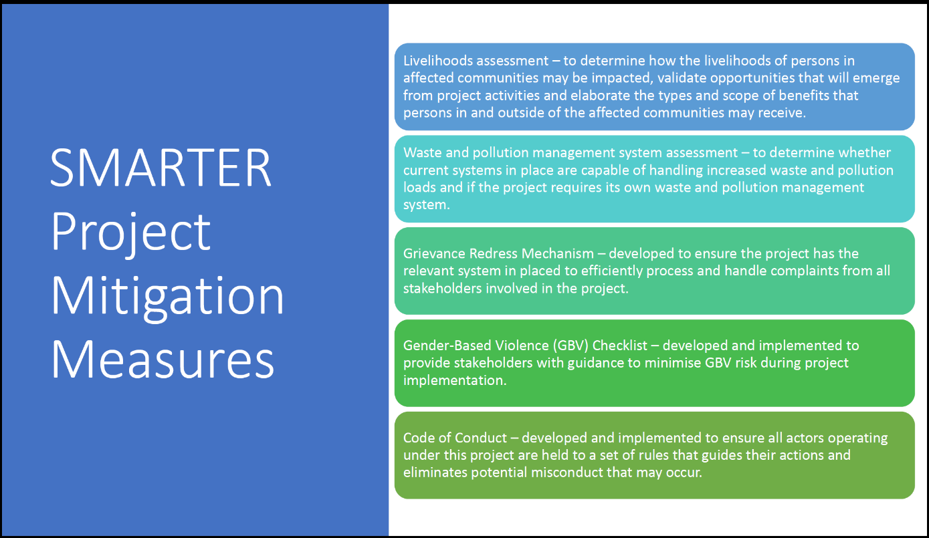
Proposed Project level Mitigation Measures

Waste and Pollution Management Assessment considers waste and pollution issues as well as the system's capacity to cope and manage with either waste or pollution generated by the SMARTER project. Specifically, the Assessment will need to consider:
- The existing capacity of the waste management system in Barbados and the additionality of the SMARTER project. Current coverage and quality of improved sanitation facilities in the immediate vicinity and especially for low-income communities.
- The types and scale of waste that could be generated by SMARTER project activities and the potential responsibilities and accountabilities for same i.e. Waste generation and composition.
- Data on the incidence of water and airborne diseases as well as vector-related incidents.
- Bioenergy waste disposal and management including storage and transportation including effective waste management routing procedures and management. This would include consideration of vector control management.
- Potential risks and hazards include accidents, contamination as well as any potential health risks and impacts.
- The scope and scale of pollution-related risks, waste handling and storage challenges and generation sources that will support the waste-to-energy pipeline.
- Sources of organic waste and residue and possible competition for same including procedures for registration or notification of the availability of waste that could be utilized by SMARTER.
- Presence of sanitation or waste private sector enterprises.
- The market for inputs and outputs.
- Potential other implications to the environment, society or the economy.
- The impacts and the assigned mitigation measures must be presented clearly for easy understanding and adoption of the mitigation measures.
- Other areas to be considered include:
  - Waste management and recycling systems (formal and informal)
  - Institutional capacity and ongoing initiatives
  - Community needs
  - Recycling options

The Livelihoods Assessment and the Waste and Pollution Systems Assessment, and the occupation health and safety manuals and code of conduct, will be carried out as a precondition for moving forward with any of the four demonstration projects and the projects will be assessed jointly with the assessment findings presented in general and specifically for each project and biomass/bio-energy output type. These will be carried out by specialized experts contracted by the project, either locally, regionally or internationally. If possible it will be possible it may be carried out by a consulting company that could implement this under one contract or alternatively, two separate individual consultancies may be needed. The findings will then be scrutinized by UNDP and MEB before advancing further with site finalization and subcontracting. These assessments are contingent on specific sites for demo pilots being identified and approved including the necessary consultation processes with relevant stakeholders. The assessments will also inform medium and long-term considerations for bioenergy policy and planning as well (in this way Component 3 is also expected to inform outputs under Components 1 and 2 as well as 4).

The GBV Checklist prepared during the project preparation phase will be used by the project team and MEB in the execution of project activities, particularly by the Safeguard and gender expert and also by contractors and other implementing partners. The checklist considers the context, scope and scale of GBV and GBV risks as well as GBV effects on project activities. The GRM will also be the space in which complaints of GBV will be first logged.

The Code of Conduct, a relatively new consideration of energy projects in Barbados, seeks to ensure that all stakeholders acting for and on behalf of the project have a clear understanding of the right-based principles and acceptable conduct for all actors. It facilitates stakeholder engagement, and information disclosure particularly on acceptable norms and practices and also enables effective grievance redress. The Code of Conduct alongside the GBV Checklist will be completed within the first six months of project execution. The GBV checklist developed during the PPG Phase is included in Appendix J2 – Gender Action Plan.

Additional targeted assessments that are included within the SESP are: Climate change and natural hazards assessment, socio-economic baseline, Occupational Health and Safety assessments; Construction Manuals/Safety measures related to environmental impacts, OHS and Community health safety and security.

Stakeholder Engagement, Information Disclosure and Grievance Redress

The SES review and this management approach were informed by stakeholder consultation through engagement, mostly with government entities but also to a limited extent environmental and gender-focused NGOs (see Table 2)

All NGOs consulted have a primarily national focus. Overall, 9 stakeholders were consulted including MEB and two other MEB units, providing critical insights on SES as well as gender mainstreaming, validating screening analysis and the proposed procedures and identifying any legislative requirements that would give ESS management.

Stakeholder engagement will continue throughout project execution and stakeholders have been identified for specific roles and will also inform technical outputs relating to risk mitigation as provided for in the Stakeholder Engagement Plan (Annex K). Various mechanisms exist for engagement on SES and these also have implications for the roles and activities undertaken by Project Manager, the Safeguards and Gender Expert and the Project Advisor. Their approach to Stakeholder Engagement will therefore have some influence on the implementation of the Plan (Annex K1) and stakeholder perception of the project.
The Grievance Redress Mechanism (GRM) identified in Annex K2 is based on UNDP’s institutional GRM. However, given the focus of the project to establish and build bioenergy production in Barbados over the long term, a more project- and bioenergy-focused GRM will be developed and supported by the project. The approach to the GRM will be gender-sensitive and will consider social as well as economic and physical risks. The project will therefore inform stakeholders of the existence of the UNDP SRM system, as a follow on of the GRM mechanism, and work with the government to identify/establish a sector-specific GRM.
In keeping with information disclosure requirements and commitments to transparency and integrity the GRM will be detailed and specific to conditions that could arise in a project like this and will be available on the project webpage and the MEB website.

Table 2: List of stakeholders met
Organisation | Representative | Date and Time
Ministry of Energy and Business
Natural Resource Department (NRD) | Jamar White | 16/01/23  1:30PM
Environment Conservation and Renewable Energy Unit (ECREU) | Frank Branch  Horace Archer | 17/01/23  8:30AM
Project Execution Unit (PEU) | Jillian Willoughby  Marvo Little  Ron Blades  Sherry Waithe  Rosalind Griffith  Chad Lavine  Andrea Squires  Damian Harewood | 17/01/23  1:00PM
Ministry of Environment and Natural Beautification
Policy, Planning and Research Unit (PPRU) | Ron Goodridge  Gina Bell | 18/01/23
Sanitation Services Authority (SSA) | Leona Deane | 19/01/23  10:00AM
Environment Protection Department (EPD) | Allison Reeves  Lisa Senhouse | 20/01/223  1:30PM
Non-governmental Organisations
Future Centre Trust | Barney Gibbs  Jessica Bensley  Sandra Hunte  Tara Inniss | 19/01/23  2:00PM
Barbados Environmental Conservation Trust (BECT) | Che Greenidge | 24/01/23  12:00PM
Institute of Gender and Development Studies (IGDS) | Leigh-Ann Worrell | 03/02/23  9:15AM

Institutional Arrangements and Capacity Building

The aforementioned stakeholder consultations helped to clarify potential roles and confirm responsibilities based on the existing legislative and institutional arrangements in place, particularly for government/public sector entities in Barbados. The proposed arrangements also take into consideration available guidance from the 2021 Physical Development Plan Amendment, the Proclamation of the Planning and Development Act and the 20332 Physical Development Plan (PDP). Also considered are elements of the National Water Reuse Policy and the Green Paper on Water Protection and Land Use Zoning Policy (see earlier subsection on legislation etc).

- Environmental Protection Department (MNEB): The department will play a role in a waste management system assessment as one of the stakeholders that would be consulted (as it is a regulator). It can assist in identifying or defining the standards that would need to be met for the assessment as well as identifying who provides what type of waste management service. This would be a part of the ESIA about how the project plans to manage waste.

- SSA (MNEB): The Authority would be involved in the review and design of any related targeted assessments or focused ESIAs even of a limited focus that would be undertaken by the project, particularly on waste management and pollution and occupational health and safety. The Authority has developed its own SOP manual that deals with landfill development which could serve as a good guideline for dealing with biogas. An example of livestock production waste and the possible creation of vector habitats and ways of managing these risks is one of the areas in which SSA’s experience could be valuable to SMARTER.
- NRD (MEB): Noting the department’s expertise in social and environmental impact assessments and work with onshore land development and offshore oil and gas, NRD can be involved in providing technical inputs to environmental risk management planning. The department can assist in identifying standards used for biofuels in the various sectors (transport, manufacturing and fishery sectors) and reviewing and updating standards, identifying and sourcing the products, and utilising expertise for stakeholder engagement.

- Deaf Heart Project (NGO): This NGO can provide sensitisation and training for interacting with persons with disabilities.

More broadly, the management arrangements for managing ESS risks will involve several stakeholders as per Figure 2 below with critical roles identified for MENB through EPD and SSA as well as NGOs, MEB and UNDP in key areas of focus. Gender expert should be consulted related to social and gender aspects of the ESIAs and ESMPs.

SES Management for SMARTER project – Role of Stakeholders
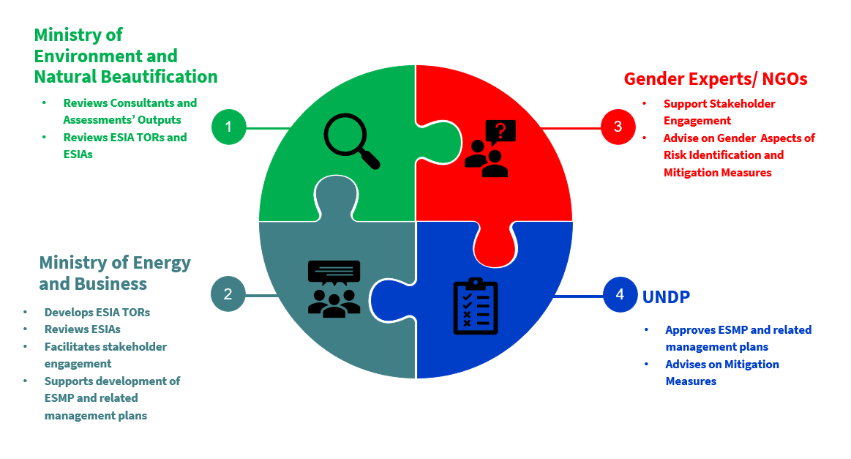

SES Monitoring and Evaluation

SES results and monitoring will be evaluated in the Mid-Term Review as well as EoP evaluation. SES Monitoring will be led by MEB and supported by UNDP and will be regularly reported on including as part of quarterly risk monitoring as well as annual reporting e.g PIRs. Successful SES risk management and benefit creation will also be assessed as part of regular M&E activities and considered in the MTE and EoP evaluations. Additionally,
- M&E Templates will be included in the ESMP;
- Information for UNDP will be provided for the PIR and quarterly monitoring; and
- Grievances will be documented in a log and shared with UNDP and included in reporting to GEF.

The consultancies required will include the Livelihoods Assessment and Waste and Pollution Assessment as well as the development of a Code of Conduct. Specific actions entailed in the Gender Action Plan also will influence SES monitoring for gender and are detailed and budgeted separately including the Code of Conduct since it addressed gender as well as other OHS-related areas.

SES monitoring is reflected in the cost of specific project staff such as the project management and the safeguards expert which are budgeted separately. Separate budget costs are anticipated only for the required targeted ESIAs and ESMPs as well as the related assessments for aprox. USD 95,000.00. The Livelihoods Assessment is estimated at USD 15,000; the Waste and Pollution System Assessment at 25,000.00, the ESIA at 35,000.00 including OHS analysis, the ESMP at 15,000.00 including the OSH Manual and the Emergency Response Plan and the GRM at USD 5,000.00.

- GEF Taxonomy

Level 1 | Level 2 | Level 3 | Level 4
Influencing models
 | Transform policy and regulatory environments
 | Strengthen institutional capacity and decision-making
 | Convene multi-stakeholder alliances
 | Demonstrate innovative approaches
 | Deploy innovative financial instruments
Stakeholders
 | Indigenous Peoples
 | Private Sector
 |  | Capital providers
 |  | Financial intermediaries and market facilitators
 |  | Large corporations
 |  | SMEs
 |  | Individuals/Entrepreneurs
 |  | Non-Grant Pilot
 |  | Project Reflow
 | Beneficiaries
 | Local communities
 | Civil Society
 |  | Community Based Organization
 |  | Non-Governmental Organization
 |  | Academia
 |  | Trade Unions and Workers Unions
 | Type of Engagement
 |  | Information Dissemination
 |  | Partnership
 |  | Consultation
 |  | Participation
 | Communications
 |  | Awareness Raising
 |  | Education
 |  | Public Campaigns
 |  | Behavior Change
Capacity, Knowledge and Research
 | Enabling Activities
 | Capacity Development
 | Knowledge Generation and Exchange
 | Targeted Research
 | Learning
 |  | Theory of Change
 |  | Adaptive Management
 |  | Indicators to Measure Change
 | Innovation
 | Knowledge and Learning
 |  | Knowledge Management
 |  | Innovation
 |  | Capacity Development
 |  | Learning
 | Stakeholder Engagement Plan
Gender Equality
 | Gender Mainstreaming
 |  | Beneficiaries
 |  | Women groups
 |  | Sex-disaggregated indicators
 |  | Gender-sensitive indicators
 | Gender results areas
 |  | Access and control over natural resources
 |  | Participation and leadership
 |  | Access to benefits and services
 |  | Capacity development
 |  | Awareness raising
 |  | Knowledge generation
Focal Areas/Theme
 | Climate Change
 |  | Climate Change Mitigation
 |  |  | Agriculture, Forestry, and other Land Use
 |  |  | Energy Efficiency
 |  |  | Sustainable Urban Systems and Transport
 |  |  | Technology Transfer
 |  |  | Renewable Energy
 |  |  | Financing
 |  |  | Enabling Activities
 |  | United Nations Framework on Climate Change | Nationally Determined Contribution
 | Rio Markers
 |  | Paris Agreement
 |  | Sustainable Development Goals
 |  | Climate Change Mitigation 0
 |  | Climate Change Mitigation 1
 |  | Climate Change Mitigation 2
 |  | Climate Change Adaptation 0
 |  | Climate Change Adaptation 1
 |  | Climate Change Adaptation 2

- Procurement plan

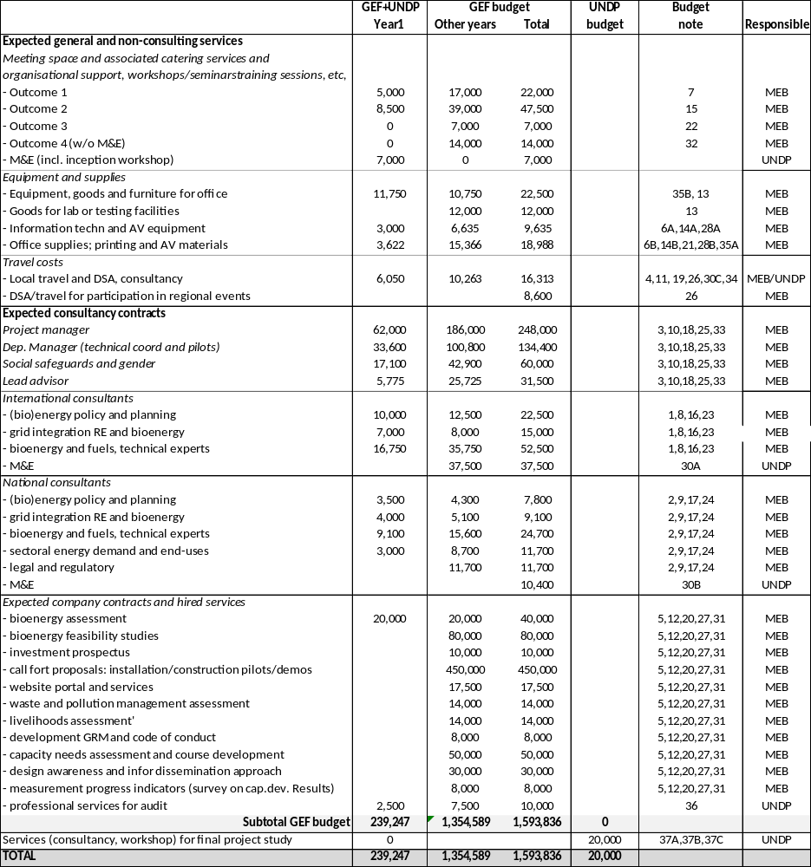

The budget note explanation is given in section 9 (UNDP budget and work plan)

- Project capacity and HACT assessment

The HACT will be available in a separate electronic file

- UNDP quality assurance report

See separate electronic files

- Agreements (co-financing letters)

The co-financing letters can be seen from the following link:

Barbados is densely populated with 668 people per m² (source: knoema.com). Population growth is small, 0.13% in 2019 and 0.12% in 2020
The economy increased from USD 3.1 billion in 2002 to USD 4.9 billion in 2021. Per capita GDP increased from USD 11,284 in 2001 to USD 15,163 in 2020. Barbados position on the Gender Development Index (GDI) was 1.034 (on a scale 0.45-1.1) in 2020
Scoring 0.788 in 2020. For comparison, Norway scored highest in 2021 at 0.957 and Niger lowest, 0.394. The country’s Gross National Income (GNI) was USD 12,167 (in constant 2017 PPP USD). Source: hdr.undp.org
Gender Development Index of 1.034 (UNDP, 2021, available at https://hdr.undp.org/gender-development-index#/indicies/GDI
For example, in worddata.info’s cost-of-living index Barbados is placed 121 (USA=100). However, the purchasing power index is 19.5 (again, USA=100), implying that in relation to the monthly income (USD 1392 in Barbados vs USD 5869) people can buy less goods.
In 1978, an ‘Energy Division’ was created under the Ministry of Commerce. Over time, ‘energy’ has been under the purview of various government entities. Over time, ‘energy’ has been under the purview of various government entities. For example, in 2010, the Division of Energy and Telecommunications (DOET) was set up within the Prime Minister’s Office in 2020 ‘energy’ came under the purview of Ministry of Energy, Small Business and Entrepreneurship (MESBE) which was rebranded Ministry of Energy and Business (MEB) in 2022.
Based on statistics at OLADE website and the from Energy Bulletins 2020 and 2021
In 2017, BLPC commissioned a 10 MW solar farm, while over 1,900 rooftop systems are installed by households, private business and public sector. Data: BLPC website
Source: Energy Bulletins 2020 and 2021
Due to abandonment of managed lands (plantations), forest and grassland conversion and removals from soils
Source: sielac.olade.org
Despite the fact that Barbados has not suffered a catastrophic hurricane impact in the last 50 years, it has suffered loss and damage from 13 rainfall events between 1998 and 2017 and 10 tropical cyclone events between 1990 and 2017. Source: CCRIF Excess Rainfall and Tropical Cyclone models. Retrieved from https://www.ccrif.org/sites/default/files/riskprofiles/XSR2.5_Annex2_r1.pdf and https://www.ccrif.org/sites/default/files/riskprofiles/TC_Annex2_r2.pdf
The current license will expire in 2028. The Government has progressively sold its shares in the company until BLPC became 100%-owned by Emera Caribbean Inc in 2015. https://www.emera.com/companies/regulated-electric/emera-caribbean
Customers are billed under one of the two arrangements: A) All/Sell All Arrangement (customers are billed under their regular electricity rate (inclusive of VAT) for all the energy consumed, regardless of the source. They then receive a credit on the bill for all the electricity generated from the RE system at the FIT or RER credit rate. Presently, customers with systems larger than 3 kW must be billed under this arrangement). B) Sale-of-Excess (customers with renewable energy systems 3kW or smaller are permitted be under this arrangement, in which customers are billed under their regular electricity rate (inclusive of VAT) for what they use from the grid and will receive a credit for the excess electricity sold to the grid. Customers under the pre-existing RER programme maintain their arrangement (BBS 0.416/kWh for solar PV)
Since February 2022 the new online system is the only method to apply for an ELPA licence. Applicants must complete the ELPA application on the system and submit all requisite documents related to the project, such as analyses, regulatory certificates, correspondences from financial institutes and other related documents
More details on incentives can be found in the Renewable Energy and Energy Efficiency Fiscal Incentives Booklet for Individuals and Companies (Energy Division, MESBE)
US Department of Energy, Energy Transitions Initiative, Barbados Energy Snapshot, https://www.nrel.gov/docs/fy20osti/76636.pdf
The milestones and specific targets are as follows: fossil fuel reduction: 49% (2023) and 100% (2030). Increase in renewable energy: 52% (2023) and 100% (2030)
Based on The Future Role of Biomethane, NPC position paper
Source: https://www.ctc-n.org/resources/seizing-sunshine-barbados-thriving-solar-water-heater-industry Barbados Sustainable Energy Industry Market Assessment Report (CCREEE, UNIDO; 2019)
The IRRP scenario 3 mentions 141 MW of fossil fuel based capacity, 223 MW of storage and 750 MW of non-fossil energy (337 MW solar, 166 MW wind, 23 MW biomass/waste/landfill) available installed capacity by 2030 (IRRP, MottMcDonald, 2021). About 390 MW to be installed in the period 2020-2025, in addition to the available capacity of 42 MW renewable energy (basically distributed solar PV) in 2020. Of which in 2025: 151 MW solar, 66 MW wind and 23 MW of biomass/waste/landfill, backed up by 250 MW of storage capacity.
Supported by IFC and IDB financing. Source: https://h2eg.com/h2-view-news-ifc-and-idb-invest-support-plans-for-green-hydrogen-plant-in-barbados/. Hydrogen storage uses surplus electrical energy to generate hydrogen that acts as the energy carrier. The operation consists of an electrolyser and a storage medium, typically a high-pressure vessel. During the charge cycle the electrolyser splits water molecules into oxygen and hydrogen. The hydrogen is then stored or can be injected into the gas network. During discharge, the hydrogen can be combusted in boilers, turbines, or reciprocating engines to produce electricity in conventional power plants along with natural gas or in a fuel cell can be used to directly convert the hydrogen into electricity and water. In general, there are concerns about water for hydrogen, stating that obtaining water for the economy will be too expensive or demanding on the water and energy requirements. Barbados is the most water-scarce western hemisphere nation. The production of 128 MWh requires 1 ton of H₂, for which 9 ton of water is needed. to avoid creating any additional burden on freshwater usage, seawater can be used can be purified through desalination processes before being used as an electrolysis feedstock. adding a desalination process increases the energy requirement of the life cycle of electrolytic hydrogen production, but this too is negligible in comparison to powering the electrolyzer itself.
BNEP 2019-2030
Including the UNDP/GEF Disaster Risk & Energy Access Management (DREAM) project, 2015-2019 and the IDB/EU projects Public Sector Smart Energy Programme (PSSEP), since 2013m, and Smart Fund II (since 2019). See Box 12 for more details
Of the 140,830 tonnes, about 100,985 was produced on plantation area, 45,208 by BAMC and 638 by small farmers. Source: Barbados Economic and Social Report 2018
knoema.org. The decline was influenced by the end of the preferential treatment of Caribbean nations by Europe. Agricultural land area fell from 19,700 hectares to 10,000 in the same period. Correspondingly, Barbados produced more than 159 000 tonnes of sugar in 1968, in 2018 sugar production was just about 11,700 tonnes. https://basonevoice.org/wp-content/uploads/2018/01/AgroFestMag-17.pdf
Foursquare, Mount Gay, WIRD (West Indies Rum Distillery) and St Nicholas Abbey. Barbados exports some USD 80 million worth of rum annually. https://barbadostoday.bb/2020/01/17/rum-makers-report-rising-sales/
Four species are referred to as ‘elephant grass’, including the African Cenchrus purpureus, also known as Napier grass, Uganda grass or king grass
During the purification process, sugarcane juice is separated from solids that collect to the bottom of the storage material. This fibrous solid component is known as filter cake. Filter cake is used to fertilize soils and replenish nutrients.
Apparently, land could be leased for about USD 5 per acre in Guyana. Source: p.c. stakeholder meetings
Barbados Waste Characterization Study 2015, Ministry of Environment and Drainage; Simmons & Associates
Sargassum, named after the Sargasso Sea in the North Atlantic Ocean, is a genus of brown macro-algae
Johns, Elizabeth M., Rick Lumpkin, Nathan F. Putman, Ryan H. Smith, Frank E. Muller-Karger, Digna T. Rueda-Roa, Chuanmin Hu et al. "The establishment of a pelagic Sargassum population in the tropical Atlantic: biological consequences of a basin-scale long distance dispersal event." Progress in Oceanography 182 (2020): 102269.
Decaying sargassum releases hydrogen sulphide that can kill marine life while sea turtles may become entangled in sargassum rafts or impede access to beach nesting sites blocked by sargassum.
https://www.nationnews.com/2019/07/30/us120m-for-seaweed-clean-up/
Resiere, Dabor, Hossein Mehdaoui, Jonathan Florentin, Papa Gueye, Thierry Lebrun, Alain Blateau, Jerome Viguier et al. "Sargassum seaweed health menace in the Caribbean: Clinical characteristics of a population exposed to hydrogen sulfide during the 2018 massive stranding." Clinical Toxicology 59, no. 3 (2021): 215-223.
One reported issue is these mechanical collection vehicles may disrupt turtle nests and kill baby turtles who might be asleep just under the surface of the sand
Henry, Legena, Brittney McKenzie, Aria Goodridge, Karyl Pivott, Joshua Austin, Kristen Lynch, Shamika Spencer et al. "Experimental evidence on the use of biomethane from rum distillery waste and Sargassum seaweed as an alternative fuel for transportation in Barbados." Energy Division/Infrastructure and Energy Department: Washington, DC, USA (2021).
Thompson, Terrell M., Pedram Ramin, Isuru Udugama, Brent R. Young, Krist V. Gernaey, and Saeid Baroutian. "Techno-economic and environmental impact assessment of biogas production and fertiliser recovery from pelagic Sargassum: A biorefinery concept for Barbados." Energy Conversion and Management 245 (2021): 114605.
https://www.abc.net.au/news/2022-08-04/caribbean-sargassum-seaweed-endangers-animals-industry/101298784
https://optics.marine.usf.edu/projects/SaWS/pdf// See Sargassum outlook_2022, Bulletins 01, 04, 07 and 10
See the website www.rumandsargassum.com
Combined production of heat (used on-site) and electricity (used on-side or delivered to power grid)
https://sielac.olade.org
2014 respectively, https://www.tilasto.com/en/topic/energy-and-environment/bagasse/production/bagasse-production/barbados. 2020: own estimate
The total Barbadian MSW would be sufficient to/ generate only about 20%, so 3-5 MW, thus implying that other feedstock is used, such as agricultural or imported food waste from Caribbean neighbours.
https://www.nationnews.com/2020/07/09/waste-to-energy-plant-on-the-way/
In 2021, natural gas production was 372.9 billion ft³, imports were 301.2 billion ft³ and sales 576.2 ft³ (the difference is formed by stock). Sources: a) Energy Bulletin 2021; b) BNOC Request for Proposal Services for the designing, building and commissioning of a Biomethane Facility (2018);c) The Future of Biomethane, NPC Position Paper
See NPC Feasibility Assessment of Including Liquid Biofuels in the Transport Sector (2020) based on data provided by Ministry of Transport, Works and Maintenance (2020). This includes 35 electric buses, of which some were provided by IDB projects (see Box 12)
A two-year tax holiday on electric vehicles was introduced in April 2022, while discussion is ongoing whether to extend to hybrid vehicles as well. Hybrid electric vehicles (HEV) are powered by an internal combustion engine and an electric motor, which uses energy stored in batteries and cannot be plugged in to charge the battery. Plug-in hybrid (PHEV) can be plugged in, while still having an internal combustion engine. Government workers (who had been allowed to borrow up to BDS 50,000 interest-free for vehicle purchase) will now have that increased to BDS 100,000 if they purchase an electric or hybrid vehicle. https://barbadostoday.bb/2022/03/15/electric-cars-tax-breaks-but-new-alternate-levy/
The IRRP 2021 sees electricity demand in transport increase from the current 2 GWh to between 273 and 455 GWh (of a total electric energy demand of 1,424 GWh) in 2030, depending on the electric vehicle penetration
Henry, Legena, Brittney McKenzie, Aria Goodridge, Karyl Pivott, Joshua Austin, Kristen Lynch, Shamika Spencer et al. "Experimental evidence on the use of biomethane from rum distillery waste and Sargassum seaweed as an alternative fuel for transportation in Barbados." Energy Division/Infrastructure and Energy Department: Washington, DC, USA (2021).
http://www.ngvjournal.com/noticias/trinidad-and-tobago-to-install-five-cng-stations-2/?lang=es
Another smaller disadvantage is a power drop experienced depending on the driving. Sufficient CNG filling stations and service and maintenance facilities need to be available
Henry, Legena, Brittney McKenzie, Aria Goodridge, Karyl Pivott, Joshua Austin, Kristen Lynch, Shamika Spencer et al. "Experimental evidence on the use of biomethane from rum distillery waste and Sargassum seaweed as an alternative fuel for transportation in Barbados." Energy Division/Infrastructure and Energy Department: Washington, DC, USA (2021). Thompson, T. M., B. R. Young, and S. Baroutian. "Pelagic Sargassum for energy and fertiliser production in the Caribbean: A case study on Barbados." Renewable and Sustainable Energy Reviews 118 (2020): 109564.
See https://www.cavehill.uwi.edu/cermes/projects/sargassum/docs/sams/draft_vol_02_barbados_sams_appendices_12feb21.aspx
Planning and Development Department. (2017). PDP Resources. Retrieved from http://townplanning.gov.bb/physical-development-plan/pdp-resources/
The Government of Barbados. (2021). Planning Development (Environmental Impact Assessment) Regulations, 2021. Retrieved from https://www.barbadosparliament.com/uploads/bill_resolution/0179f618229127d8d28f9ee3dd239511.pdf
Behind the meter energy solutions, smart-buildings and smart-charging of EVs can add to system ancillary services proving more energy resilience.
Safety guidelines for natural gas may offer Barbados a kick-start for biogas installations, but should be reviewed and adapted. Key stakeholders are the National Petroleum Corporation (NPC) and the Barbados National Standards Institution (BNSI).
IRRP (201=21)
Current application time is between 60-120 days
See Box 11 and Box 12
For social-environmental and gender-related risks, the reader is referred to Section 4.4 and Annexes J and L.
Including, for example, women’s role in leadership and decision-making, employment and business opportunities, gender-sensitive monitoring, gender-responsive budgeting and financing
This includes the includes issues of affordability as well as user needs and access to bioenergy technology
Regulatory aspects include safety, occupational hazards and air pollution from particle emissions. Without standards and certifications, it is difficult to assure quality of services and products within the sector. This barrier will need to be addressed either by developing indigenous programs for standards or adopting standards commonly adopted internationally.
Incentives including grants and tax benefits can help mitigate upfront capital costs, moreover if the environmental benefits of organic waste processing in biomass plants, and the creation of employment along the value chain, are taken into account
This could be part of the Barbados Sustainable Energy Conference that is organized annually in November
For example, NPC’s
Where possible, the team composition for each should consist of at least 25% women, who are involved at various levels of the projects.
Cave Hill (Barbados), Mona Campus (Jamaica), St. Augustine Campus (Trinidad & Tobago), Five Islands Centre (Antigua & Barbuda) and through cooperation with knowledge centers in Europa, Africa and the Americas
Such as: Caribbean Export Development Agency (CEDA), Caribbean Association of Investment Promotion Agencies (CAIPA), Caribbean Association of Industry and Commerce (CAIC), Compete Caribbean, Caribbean Knowledge and Learning Network (CKLN), Caribbean Association of Electric Utilities Corporation (CARILEC)
Climatic impact, future biomass production, and local adaptation of four switchgrass cultivars - Zhang - 2019 - GCB Bioenergy - Wiley Online Library
Challenges of Biomass Utilization for Bioenergy in a Climate Change Scenario (mdpi.com)
Critical infrastructure (e.g.: health facilities and emergency shelters) need back-up power to prevent disruption to service provision. For solar to be used for this purpose, there would need to be adequate battery storage. The issue has been addressed in UNDP’s Disaster Risk Assessment Management Project by installing battery backups using PV-generated power for polyclinics.
See activity 3.1.1. Financing and insurance needs and options will also be a part of the formulation of the SMARTER-supported pilots (activity 3.2.2)
Dunn, L. (Ed.). (2013). Gender, Climate Change and Disaster Risk Management. Working Paper Series Number 7. Jamaica: Institute of Gender and Development Studies Mona Unit, The University of the West Indies and the Friedrich Ebert Stiftung, Jamaica and the Eastern Caribbean. Hannan, C. (2001). Gender mainstreaming: strategy for promoting gender equality. United Nations Office of the Special Advisor on Gender Issues and Advancement of Women. United Nations Framework Convention on Climate Change (UNFCC). (2015). Green Climate Fund Gender Policy and Action Plan.
UNDP. (2021). Human Development Index. Available at https://hdr.undp.org/data-center/human-development-index#/indicies/HDI
UNDP. (2021). Gender Development Index. Available at https://hdr.undp.org/gender-development-index#/indicies/GDI
OECS. 2017. Child Poverty in the Eastern Caribbean Area. Retrieved from https://www.unicef.org/easterncaribbean/media/1176/file/child-poverty-in-the-eastern-caribbean-area-2017.pdf
World Bank. (2021). World Bank Approves US$100 Million for Barbados’ COVID-19 Response and Recovery. Retrieved from https://www.worldbank.org/en/news/press-release/2021/06/24/world-bank-approves-us-100-million-for-barbados-covid-19-response-and-recovery
Barbados Statistical Service. (2021). Labour Market Statistics. Retrieved from https://stats.gov.bb/subjects/social-demographic-statistics/labour-market-statistics/
CDB. (2016). Country Gender Assessment. Retrieved from https://www.caribank.org/publications-and-resources/resource-library/gender-assessments/country-gender-assessment-barbados-2016
CDB. (2016). Country Gender Assessment. Retrieved from https://www.caribank.org/sites/default/files/publication-resources/CountryGenderAssessment_Barbados.pdf
The indicator 13) on measurement of capacity and awareness will be used to measure capacity increase of government staff
The indicator 13) on measurement of capacity and awareness will be used to measure capacity increase of government staff and practitioners (incl. course participants)
The expected energy production is based on a) installed solar-PV (in public buildings, 12. MW) and b) three bioenergy investment opportunities that have reached signed business/investment plan stage, assumed to be one (01) biogas-for-power project, one (01) bio-methane production planned and one (01) biodiesel pilot (as explained in Annex G). The expected energy production by EoP by the public building PV and three bioenergy pilot/demos is 4,122 terajoules (TJ, as mentioned in Indicator 1), of which 753 TJ is electric energy and 3,367 TJ of gaseous or liquid biomass fuels. The installed power capacity by EoP is 1.61 MW (of which 1.2 installed PV in public buildings and 0.41 MW of biomass-fueled power
A summary of possible concepts (business cases) is given in Annex G.
Knowledge and communication plan (see Annex K.3). On a scale of 1 to 5, an average score of at least 2 is achieved: in which “1” represents a low level of capacity and “5” represents a strong capacity to understand relevant issues and apply knowledge and skills to find effective solutions. (1)
See https://www.thegef.org/gef/policies_guidelines
See http://www.undp.org/content/undp/en/home/operations/transparency/information_disclosurepolicy/
See https://www.thegef.org/gef/policies_guidelines
Knowledge and communication plan (see Annex K.3). On a scale of 1 to 5, an average score of at least 2 is achieved: in which “1” represents a low level of capacity and “5” represents a strong capacity to understand relevant issues and apply knowledge and skills to find effective solutions. (1)
The article was drafted by J.H.A. van den Akker and is available at www.ascendis.nl
Renewable Natural Gas (Biomethane) Feedstock Potential in Barbados (NPC)
Based on NPC study Renewable Natural Gas feedstock Potential in Barbadios (2022) and IDB article IDB-TN-02183, Experimental Evidence on the Use of Biomethane from Rum Distillery Waste and Sargassum Seaweed as an Alternative Fuel for Transportation in Barbados (Henry, et.al. 2021). These amounts are a result of the ethanol production of about 15-19 million liters annually in recent (in 2020); own estimate based on above data and https://www.selinawamucii.com/insights/market/barbados/rum/
Own estimate, based on estimated export (about 12 million liters in 2020; https://www.selinawamucii.com/insights/market/barbados/rum/) and consumption figures.
Own estimates. The current sugarcane production (81,400 tons yielding about 3650 tons of molasses is not sufficient; only for about 900,000 litters of ethanol). Thus, we estimate about 18,900 tons of molasses has to be imported. For comparison: Barbados imported about 4,000 tons of molasses in 2015. Source: Barbados in the Rum Global Value Chain (Duke University, 2017)
The NPC study gives an estimate of 684 m3 per day.
For example, WIRC has reportedly a production capacity of about 13 million liters (https://rum.cz/galery/cam/bb/westind/index-en.htm).
Assuming production is about 300 days a year, so average production is 84 m³ per day in a year. One m³ has a mass of 5 kg, so production is 4240 tons a day, averaged over the year.
Described in Bioenergy Assessment in the Caribbean. Report on Promising Bioenergy Projects Concepts (GFA, 2015). The Armag Farms and Armag Manufacturing Ltd. sell under the brand “Sunbury Harvest”. Products are convenient foods based on sweet potato (100 acres at Armag), corn, cassava, breadfruit
BNOC has commissioned the study on Renewable Natural Gas (Biomethane) Feedstock Potential in Barbados (NPC-BNOC)
Bioenergy Assessment in the Caribbean (GFA, 2015), cases Armagh Farms (Barbados) and Antigua Distelleries (Antigua and Barbuda), the latter using a mix of vinasse, king grass and other feedstock. Biogas-to-biomethane upgrading: A comparative review and assessment in a life cycle perspective, by Ardolino, F. et.al. in Renewable and Sustainable Energy Reviews, Vol. 139, April 2021, 110588, and Techno-Economic Assessment of Biological Biogas Upgrading Based on Danish Biogas Plants, by N. Lawson et.al, in Energies 2021, 14, 8252.
See article by F. Ardolini et.al. (2021)
Based on Unveiling the Natuiral Gas Opportunity in the Caribbean, R. Yépez, F. Anaya, IDB (2019) giving prices of LNG for Barbados of USD 9.7-12.7/MMBTU (plus transport USD 0.37/MMBTU). US LNG export prices stood at USD 15.59/GJ in August 2022. Thanks to natural shortage and supply issues in Europe, the global LNG benchmark price amounted to USD 42.35/GJ. Sources: http://www.eia.gov/dnav/ng/hist/n9133us3m.htm, and Energy Prices in Latin America and the Caribbean, Annual Report 2021, World Bank/OLADE
The cost of setting up the pump and blending infrastructure for dispending biodiesel at the loading rack is an estimated USD 180,000. The biodiesel B100 and B10 will be tested in a cross-section of vehicles (NPC/BNOC/BNTC diesel fleet, diesel generators, buses, fishing vessels, construction and delivery vehicles.
For comparison: diesel prices were USD 0.80 per liter in 2020 and USD 1.1 per liter in May 2022 in Europe and USD 0.50 and USD 0.90 in USA respectively. The diesel price in Barbados was about USD 1.5 per liter. Biodiesel prices were USD1.5 per liter in 2020 and USD 1.8 per liter in May 2022 in Europe and USD 1.3 and US1.7 in USA respectively. Source: IEA website; Energy Bulletin 2021 (Energy Division, MEB)
Figures: own elaboration based on data provided in Feasibility Assessment of Including Liquid Biofuels in the Transport Sector in the Context of Energy Transition and Carbon Neutrality in Barbados, draft report (NPC)
Figures mentioned in Renewable Natural Gas (Biomethane) Feedstock Potential in Barbados (NPC). See also https://indianexpress.com/article/explained/explained-why-govt-encouraging-ethanol-production-sugar-mills-molasses-6106610/
Water and yeast are added to the molasses, and the mixture is then fermented. After fermentation of the molasses, the liquid undergoes a process of distillation before a rest period in barrels, known as repose. The distillation process is straightforward—fermented liquid is heated in sealed vats, also known as stills, to a temperature of 78.3ºC, which causes the alcohols to evaporate. Evaporated alcohol, once re-condensed, is then collected as a raw spirit, which is then aged in charred oak barrels. Aging time varies among producers and can range from no time to decades. After aging, rum can be passed through a charcoal filter to give it a clear appearance, making light rum. Alternatively, it can be left as is, resulting in a different flavor profile and a darker rum. Source: Barbados in the Rum Global Value Chain, by D. Hamrick and K. Fernandez (Duke University, 2017)
https://barbadostoday.bb/2020/01/17/rum-makers-report-rising-sales/
A back-of-the-envelope calculation shows that with Barbados producing about 5.7 million liters of ethanol in 2020 (for export and local consumption of about 2 million liters) and assuming that the 81,000 tons of sugarcane processing yielded 3650 tons of molasses, the difference of about 19,560 tons of molasses had to be imported.
In 2000 Barbados produced half a million tons of sugarcane, which had dropped to 160,000 tons of sugarcane (of which 44% by BAMC and the rest on about 30 smaller farms), while also productivity dropped from 61 ton/ha in 2000 to about 48 ton/ha in 2015 37,5 t/ha in 2020. It is interesting to note that with the declining sugarcane production, also the use of bagasse for energy (heat and electricity) production declined from 1.38 TJ in 2000 to 0.46 TJ in 2015 and 0.39 TJ in 2020. Source: OLADE
The other residues, such as sugarcane straw, bagasse, nor filter cake are not seen as viable option for anaerobic digestion the short term due to competing uses of these feedstock.
Based on the figure of 5.67 million liters of ethanol production (in 2020, see footnote) the vinasse production equaled about 74,000 m3. The IDB report Experimental Evidence on the Use of Biomethane from Rum Distillery Waste and Sargassum Seaweed as an Alternative Fuel for Transportation in Barbados (Legena Henry, et.al.) gives estimates of 213,600 m³ (60 m³/day during 160 days by Four-Square Rum and 600 m³ a day during 330 days by West Indies distilleries.
Import in Barbados were 116.3 million (2019), 102.8 million (2020) and 101.2 million (2021)
This is more than 10% of gasoline substitution due to energy density differences (gasoline: 32.2 MJ/liter; ethanol: 21.1 MJ/liter)
A technical analysis of the existing fuel storage system in Barbados must be conducted to evaluate the possibility of converting the system to ethanol usage, similar to the biodiesel. To mix the E10 with gasoline, a method known as splash blending to mix the fuels, mixing made inside the tank truck compartment itself through its movement. The installation of the ethanol distribution center incorporated into the container port and the fuel mixing being done directly in the truck leaves the supply chain logistics leaner and requiring fewer investment. Mixing higher percentages will adaptation in the distribution system (storage and filling stations) and the combustion engine of the vehicles (see next section of this Annex)
See https://tradingeconomics.com/commodity/ethanol. Barbados prices based on Energy Bulletin (Energy Division, 2021)
Adapting the 42 filling stations in Barbados would will cost about USD 1.9 million
http://www.iangv.org/current-ngv-stats/
See website http:// rumandsargassum.com and the IDB technical report Experimental Evidence on the Use of Biomethane from Rum Distillery Waste and Sargassum Seaweed as an Alternative Fuel for Transportation in Barbados, IDB-TN-02183 by L. Henry et.al. (2021)
With annual cost of about USD 170,000. Data provided by UWI, L. Henry, p.c.
Based on an average energy yield of 1,533 MWh per MW installed, the total estimated energy production is about 11,500 MWh/yr. The associated annual GHG reductions by replacing thermal-based grid electricity is 10,060 tCO2eq/yr. Typical daily energy production (solar PV) 4.2 kWh/kWp
At 6,000 operating hours would deliver an energy yield of 15,000 MWh and GHG emission reduction of 12,000 ton CO2eq over the expected 10-year lifetime by off-setting fossil-based grid electricity.
It might be noted that t the installed capacity of all distributed RE in Barbados in 2027 (EoP, end of the project) will be 94 MW (up from 60 MW in 2021) and increase to 100 MW by 2030. Source: Energy Bulletin 2021 (MEB) and IRRP (2021)
UNDP. (2021). Human Development Index. Available at https://hdr.undp.org/data-center/human-development-index#/indicies/HDI
UNDP. (2021). Gender Development Index. Available at https://hdr.undp.org/gender-development-index#/indicies/GDI
OECS. 2017. Child Poverty in the Eastern Caribbean Area. Retrieved from https://www.unicef.org/easterncaribbean/media/1176/file/child-poverty-in-the-eastern-caribbean-area-2017.pdf
World Bank. (2021). World Bank Approves US$100 Million for Barbados’ COVID-19 Response and Recovery. Retrieved from https://www.worldbank.org/en/news/press-release/2021/06/24/world-bank-approves-us-100-million-for-barbados-covid-19-response-and-recovery
Barbados Statistical Service. (2021). Labour Market Statistics. Retrieved from https://stats.gov.bb/subjects/social-demographic-statistics/labour-market-statistics/
CDB. (2016). Country Gender Assessment. Retrieved from https://www.caribank.org/publications-and-resources/resource-library/gender-assessments/country-gender-assessment-barbados-2016
CDB. (2016). Country Gender Assessment. Retrieved from https://www.caribank.org/sites/default/files/publication-resources/CountryGenderAssessment_Barbados.pdf
Barbados Statistical Service. (2022). Statistical Bulletin – Continuous Household Labour Survey. https://stats.gov.bb/wp-content/uploads/2022/11/LFS_3Q2022.pdf
Organisation for Economic Co-operation and Development. (2019). Social Institutions and Gender Index. https://www.genderindex.org/wp-content/uploads/files/datasheets/2019/BB.pdf
Caribbean Development Bank. (2016). Country Gender Assessment Barbados. https://www.caribank.org/publications-and-resources/resource-library/gender-assessments/country-gender-assessment-barbados-2016
Economic Commission for Latin America and the Caribbean. (2021). Implications of gender roles in natural resource governance in Latin America and the Caribbean.
Food and Agriculture Organization. (2008). Gender And Equity Issues in Liquid Biofuels Production.
Central Bank of Barbados. (2022). Labour Statistics 1975-2022 Q3.
Rum and Sargassum. (2022). Products and Services. https://rumandsargassum.com/products-services/ and Sustainable Development Solutions Network. (2022). Rum & Sargassum: the biofuel potential for Barbados and beyond. https://www.unsdsn.org/rum-sargassum-biofuels-in-barbados
Smith, D. & Barbour, J. (2019). Caribbean Solutions Forum 2019
A feed-in tariff is an energy policy focused on supporting the development and dissemination of renewable power generation. In a feed-in tariff scheme, providers of energy from renewable sources, such as solar, wind or water, receive a price for what they produce based on the generation costs.
Principle of affordability is used for assessing the highest possible tariff rate that a family with median household income can monthly pay from its income for the average consumption per person, and where other main financial obligations (e.g. for education or health) would not be threatened.
TC_Annex2_r2.pdf (ccrif.org)
XSR2.5_Annex2_r1.pdf (ccrif.org)
Prohibited grounds of discrimination include race, ethnicity, sex, age, language, disability, sexual orientation, gender identity, religion, political or other opinion, national or social or geographical origin, property, birth or other status including as an indigenous person or as a member of a minority. References to “women and men” or similar is understood to include women and men, boys and girls, and other groups discriminated against based on their gender identities, such as transgender and transsexual people.
See the Convention on Biological Diversity and its Cartagena Protocol on Biosafety.
See the Convention on Biological Diversity and its Nagoya Protocol on access and benefit sharing from use of genetic resources.
https://www.epa.gov/sites/default/files/2014-12/documents/agstar-handbook.pdf,
Forced eviction is defined here as the permanent or temporary removal against their will of individuals, families or communities from the homes and/or land which they occupy, without the provision of, and access to, appropriate forms of legal or other protection. Forced evictions constitute gross violations of a range of internationally recognized human rights.
Experimental evidence on the use of biomethane from rum distillery waste and sargassum seaweed as an alternative fuel for transportation in Barbados / Legena Henry, Brittney McKenzie, Aria Goodridge, Karyl Pivott, Joshua Austin, Kristen Lynch, Shamika Spencer, Felicia Cox, Nikolai Holder, Renique Murray, Veronica R. Prado, Pauline Ravillard, 2021.
https://www.pgaction.org/pdf/Barbados_Employment_Act_2020.pdf

